Stroke Thrombolysis

Usage: This document is an example pathway for stroke thrombolysis by medical teams and is based on the protocol used at Waitemata DHB. This is not a replacement for you own institution’s policies and pathways.

Step 1: Diagnosis
- Are you confident this is a stroke? If not then Stop
- Perform NIHSS (scored neurological examination – Appendix 1, recommended)
- General clinical exam (exclude bleeding contraindications)

Step 2: Initial selection criteria
- Timing
  - Woke with symptoms? If Yes then Stop unless asleep <3-4h
  - Onset > 4h ago or unknown? If Yes then Stop
- Deficit
  - Trivial ie NIHSS < 3 : Stop
  - Terrible ie NIHSS > 22 : Stop
  - Rapidly improving : Stop

Step 3: Activate pathway
- Make sure FBC, coag (if indicated) and glucose (capillary OK) sent
- Is someone available for consent?
- Request urgent CT

Step 4: Confirm formal inclusion/exclusion criteria (Appendix 2)

Step 5: Confirmation – This step must be made by the appropriate on call medical CONSULTANT
- You are confident the diagnosis is stroke and the time of onset is reasonably established?
  - This step requires sufficiently reliable assessment by your registrar or your own review of the patient
- The stroke is sufficiently severe to warrant the risks (see below) but is not beyond help?
  - Use NIHSS and clinical judgement to decide
- History, exam and invx reveal no contraindication to thrombolysis?
- The CT is acceptable?
- The current BP is acceptable (SBP < 185, DBP < 110)
- An onset to needle time of < 4.5h is still achievable?
- “Yes” to all 6 items above? Proceed, else Consultant to Consultant discussion with oncall neurologist, or Stop

Step 6: Consent
- Obtain written (preferably) consent from family member and/or patient if suitable
  - See Appendix 5 for a patient information page to be given to patient/relative IF thrombolysis recommended
- Benefit : “Improves your chance of complete recovery by 30-50%”
  - eg 0-3h tx: chance of complete recovery (Mod Rankin 0-1) increases from 25% to 39%
- Risks
  - Approximately 5% risk of ICH which could be fatal
  - 1% risk of bleeding elsewhere
  - Rare allergic reactions
- Overall significantly more likely to help than to harm

Step 7: Administer
- Use alteplase – do NOT use tenecteplase or any other thrombolytic
- Total dose is 0.9mg/kg up to max 90mg – 10% bolus, rest over 60min (see nomogram Appendix 3)
- Alteplase should be given in resus, stroke unit or HDU as appropriate with minimum delay
- Nursing observations q15min during infusion, q30min next 4h, q1h next 4h, q4h next 8h
- IMPORTANT: maintain BP < 180/105 (Appendix 4)

Step 8: Aftercare
- At completion of infusion transfer pt to stroke unit or other HDU/monitoring equivalent area
- Withhold aspirin/warfarin/heparin 24h and avoid invasive procedures
- Repeat CT after 24h
Appendix 1: NIHSS – Circle the score for the patient’s best effort for each examination item.

1. Level of consciousness
Alert |  |  |  | 0
Not alert but easily rousable |  |  |  | 1
Not alert, requires repeated stimulation to arouse |  |  |  | 2
Coma (no or reflexive responses only) |  |  |  | 3
1b. Ask “What month is it?” “How old are you”
Answers both correctly |  |  |  | 0
Answers one correctly |  |  |  | 1
Answers neither correctly or too dysphasic or stuporous to reply |  |  |  | 2
1c. Ask “Open and close your eyes”, “Grip and release your hand”
Performs both correctly |  |  |  | 0
Performs one correctly |  |  |  | 1
Performs neither correctly |  |  |  | 2
2. Best Gaze. Assess horizontal conjugate gaze to each side
Normal |  |  |  | 0
Partial gaze palsy (can be overcome by turning head) |  |  |  | 1
Forced deviation (both eyes deviated to same side, can’t move to opposite side) |  |  |  | 2
3. Visual. (Assess blink to visual threat if aphasic or stuporous)
No Visual Loss |  |  |  | 0
Partial hemianopia |  |  |  | 1
Complete hemianopia |  |  |  | 2
Bilateral hemianopias/cortical blindness |  |  |  | 3
4. Facial paresis. (Assess grimace to pain if aphasic or stuporous)
Normal symmetrical |  |  |  | 0
Mild weakness (eg asymmetric smile) |  |  |  | 1
Moderate weakness |  |  |  | 2
Paralysis (UMN or LMN) |  |  |  | 3
5/6. Limb voluntary motor function | RUL | RLL | LUL | LLL
Normal | 0 | 0 | 0 | 0
Drift | 1 | 1 | 1 | 1
Some effort against gravity | 2 | 2 | 2 | 2
No effort against gravity | 3 | 3 | 3 | 3
No movement (or coma) | 4 | 4 | 4 | 4
7. Limb ataxia. Perform FNF and HKS on both sides
Normal (or too aphasic/stuporous/paralysed to test) |  |  |  | 0
Abnormal in 1 limb |  |  |  | 1
Abnormal in 2 or more limbs |  |  |  | 2
8. Sensation. Test pinprick face, trunk, arm, leg both sides
Normal |  |  |  | 0
Mild to moderate loss |  |  |  | 1
Severe bilateral loss (or coma) |  |  |  | 2
9. Best language output
No aphasia |  |  |  | 0
Mild to moderate expressive dysphasia |  |  |  | 1
Severe expressive dysphasia |  |  |  | 2
Mute or global aphasia (or coma) |  |  |  | 3
10. Dysarthria
None |  |  |  | 0
Mild-Moderate |  |  |  | 1
Severe (or coma) |  |  |  | 2
11. Inattention
No inattention, appreciates bilateral simultaneous stimuli |  |  |  | 0
Inattention to one of : tactile or spatial or sensory |  |  |  | 1
Severe inattention to > 1 modality (or coma) |  |  |  | 2
TOTAL (score < 4 or > 22 may exclude patient from treatment)
Appendix 2: Inclusion/Exclusion criteria for stroke thrombolysis

INCLUSION CRITERIA
Age >= 18 and reasonable premorbid functional level (Discuss pts < 18y with on call neurology)
Confident diagnosis of acute stroke (rapid onset FOCAL neurological deficit)
Reliable stroke onset time. If unknown or wakes with stroke, onset is last awake and normal
Stroke onset to thrombolysis needle < 4.5 hours. This is unlikely possible if pt arrives after 3.5h.
NB: Treatment of elderly patients > 80y with large strokes in the 3-4.5h timeframe is controversial – recommend discuss with on call neurology
The patient MUST meet ALL of the above criteria

EXCLUSIONS
Clinical
Seizure at stroke onset
Comatose/obtunded with fixed eye deviation and complete hemiplegia (eg NIHSS > 22)
SBP >= 185 or DBP >= 110 despite up to 2 doses of IV Labetolol 10-20mg
Features suggestive of subarachnoid haemorrhage (thunderclap headache) – even if CT normal
Minor deficit (NIHSS < 4) (*) or sustained major improvement (consider review in 15-30min)
Possible septic embolus
Active or recent haemorrhage that could not be managed by local compression (menstruation *)
Historical
Known bleeding diathesis or LMW heparin < 48h or warfarin with INR > 1.3 (*) or dabigatran (*)
Intracranial neoplasm (NB: incidental meningioma or acoustic neuroma may be acceptable)
Non-compressible arterial puncture < 7 days
GI or GU bleed (other than normal menstruation) < 21 days
Major surgery, trauma or organ biopsy < 30 days
Pregnancy or childbirth < 30 days
Myocardial infarct < 30 days
Stroke or head trauma < 3 months
Ever history of intracranial haemorrhage, aneurysm or AVM
Laboratory
Baseline glucose < 2.8 or > 22.0 mmol/L
Platelets < 100
Hct < 0.25
Positive pregnancy test (if applicable)
Radiological
Non-stroke etiology
Intracranial haemorrhage
Hypodensity > 1/3 MCA territory
Other
Consent cannot be obtained (severe dysphasia and NOK unavailable) (*)
Severely impaired premorbid functional status with limited life expectancy
Should not have any exclusions - items marked (*) may be considered in certain circumstances

Appendix 3: Alteplase dosage nomogram

 |  | Vol 1mg/1ml |  |  |  |  |  | Vol 1mg/1ml
Patient weight  (kg) | Total dose@ 0.9mg/kg | 10% Bolus  (ml) | 90% infusion (ml) |  |  | Patient Weight  (kg) | Total dose@ 0.9mg/kg | 10% Bolus  (mL) | 90% Infusion  (mL)
40 | 36 mg | 3.6 | 32.4 |  |  | 70 | 63 mg | 6.3 | 56.7
41 | 36.9 | 3.7 | 33.2 |  |  | 71 | 63.9 | 6.4 | 57.5
42 | 37.8 | 3.8 | 34.0 |  |  | 72 | 64.8 | 6.5 | 58.3
43 | 38.7 | 3.9 | 34.8 |  |  | 73 | 65.7 | 6.6 | 59.1
44 | 39.6 | 4.0 | 35.6 |  |  | 74 | 66.6 | 6.7 | 59.9
45 | 40.5 | 4.1 | 36.4 |  |  | 75 | 67.5 | 6.8 | 60.7
46 | 41.4 | 4.1 | 37.3 |  |  | 76 | 68.4 | 6.8 | 61.6
47 | 42.3 | 4.2 | 38.1 |  |  | 77 | 69.3 | 6.9 | 62.4
48 | 43.2 | 4.3 | 38.9 |  |  | 78 | 70.2 | 7.0 | 63.2
49 | 44.1 | 4.4 | 39.7 |  |  | 79 | 71.1 | 7.1 | 64.0
50 | 45.0 | 4.5 | 40.5 |  |  | 80 | 72.0 | 7.2 | 64.8
51 | 45.9 | 4.6 | 41.3 |  |  | 81 | 72.9 | 7.3 | 65.6
52 | 46.8 | 4.7 | 42.1 |  |  | 82 | 73.8 | 7.4 | 66.4
53 | 47.7 | 4.8 | 42.9 |  |  | 83 | 74.7 | 7.5 | 67.2
54 | 48.6 | 4.9 | 43.7 |  |  | 84 | 75.6 | 7.6 | 68.0
55 | 49.5 | 5.0 | 44.5 |  |  | 85 | 76.5 | 7.7 | 68.8
56 | 50.4 | 5.0 | 45.4 |  |  | 86 | 77.4 | 7.7 | 69.7
57 | 51.3 | 5.1 | 46.2 |  |  | 87 | 78.3 | 7.8 | 70.5
58 | 52.2 | 5.2 | 47.0 |  |  | 88 | 79.2 | 7.9 | 71.3
59 | 53.1 | 5.3 | 47.8 |  |  | 89 | 80.1 | 8.0 | 72.1
60 | 54.0 | 5.4 | 48.6 |  |  | 90 | 81.0 | 8.1 | 72.9
61 | 54.9 | 5.5 | 49.4 |  |  | 91 | 81.9 | 8.2 | 73.7
62 | 55.8 | 5.6 | 50.2 |  |  | 92 | 82.8 | 8.3 | 74.5
63 | 56.7 | 5.7 | 51.0 |  |  | 93 | 83.7 | 8.4 | 75.2
64 | 57.6 | 5.8 | 51.8 |  |  | 94 | 84.6 | 8.5 | 76.1
65 | 58.5 | 5.9 | 52.6 |  |  | 95 | 85.5 | 8.6 | 76.9
66 | 59.4 | 5.9 | 53.5 |  |  | 96 | 86.4 | 8.6 | 77.8
67 | 60.3 | 6.0 | 54.3 |  |  | 97 | 87.3 | 8.7 | 78.6
68 | 61.2 | 6.1 | 55.1 |  |  | 98 | 88.2 | 8.8 | 79.4
69 | 62.1 | 6.2 | 56.0 |  |  | 99 | 89.1 | 8.9 | 80.2
 |  |  |  |  |  | 100kg | 90.0 | 9.0 | 81.0
Appendix 4: Management of complications

Hypertension
- BP > 180/105 – increases the risk of ICH
  - Use repeated doses of IV labetolol 10mg or GTN infusion
    - Labetolol 10mg slow IV push with cardiac monitoring (unless asthma, heart block, CHF)
    - Repeat Labetolol prn q10min up to maximum 200mg
    - GTN is per CCU protocol
  - Avoid sudden large reductions in BP

Bleeding
- Intracranial
  - Usually presents as worsening or new deficit, or fall in LOC in first 12h post thrombolysis
  - Stop infusion if still running
  - Urgent PR (prothrombin ratio), APTT and fibrinogen
  - Urgent repeat CT
  - Discuss with on-call haematologist re possible FFP/Cryoppt
  - Discuss with on-call neurosurgical team (surgery is usually not appropriate)
  - Intensive care, steroids, and osmotherapy are usually not appropriate
  - Note: Minor asymptomatic haemorrhage is common and does not worsen outcome. Large symptomatic haemorrhage has a poor prognosis and may be fatal.
- Extracranial
  - Compression, transfusion if indicated. Surgical treatment if indicated
  - Discuss with on-call haematologist as above

Anaphylaxis
- Typically manifests as orolingual angioedema, unilateral or bilateral during or shortly after thrombolysis
- Usually responds promptly to standard treatment.
  - Stop infusion if still running and swelling is more than mild or is progressing rapidly
  - If airway compromise give 0.5ml IM Adrenaline 1:1000
  - Otherwise consider Hydrocortisone 100mg IV, Loratidine 10mg PO or Promethazine 50mg IM
- Monitor airway carefully.
Appendix 5
Stroke Thrombolysis

Information for Patients and Families

Our tests indicate that you or your family member is having a stroke. This has been caused by a blood clot blocking an artery in the brain. It is possible that we can unblock this artery by giving a clot dissolving medication (Thrombolysis).

If successful this will increase the likelihood of making a good or complete recovery. The sooner the treatment is given the better the chances.

There are also some risks associated with this treatment. The most important risk is bleeding into the brain. This happens to about 1 in 20 patients. This complication is very serious, is difficult to treat and may be fatal. We will undertake careful monitoring to try to manage this risk.

Other risks include bleeding elsewhere in the body (1 in 50) and rare allergic reactions. These are usually treatable.

The treatment will not work in everyone and has some risks but overall is 5-10 times more likely to benefit than to harm (see the pictures below). This is the only treatment we have that can potentially stop or reverse the stroke.

Your doctor has given you this information because it is his/her recommendation that you or your family member receives this treatment – this means in his/her opinion the benefit outweighs the risk. However, it is important before we start the treatment that you understand there are some risks. We will ask you if you understand and agree to accept these risks before we start the treatment. Please ask the doctor if you have questions or are uncertain.

If the treatment is given to 100 patients (each small square) within a certain timeframe after the onset of the stroke each blue square represents a patient who has an improved outcome, each red square a patient with a worse outcome (ie a complication) and each white square is a patient where the treatment had no effect good or bad.

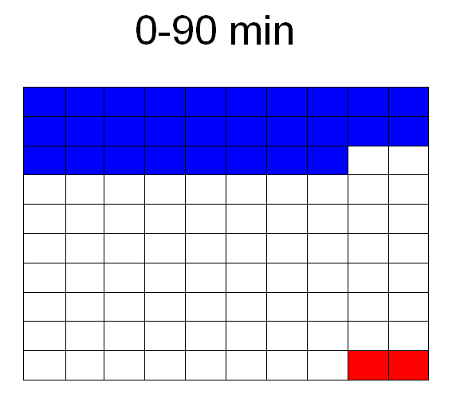 | 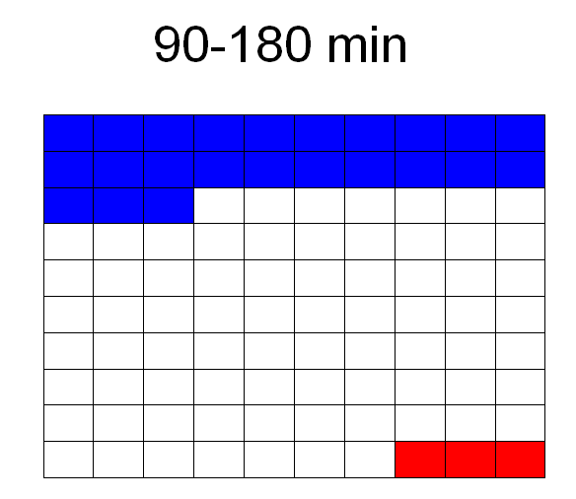 | 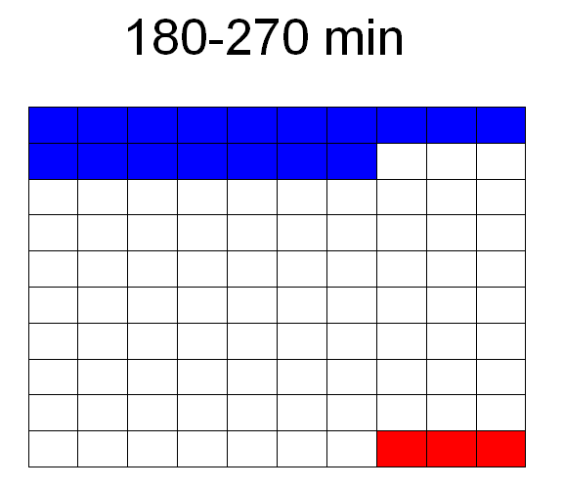

(Your doctor will circle which one of these three pictures is appropriate to you/your relative)

