Research Agenda 4
Psoriasis skin (GSE173706) — applying the PBMC pipeline to a second tissue
Continues from Agenda 3 at [Drawing UMAP]. The IDS math, the sparse-matrix handling and the batch-effect reasoning are unchanged — only what is different for skin is written down here.
[What to take note of]
Five things. Everything after this is the evidence for them.
# | Take note of | Why it matters
1 | The stratum choice decides the whole result. | First run used PP_929 → 96% keratinocytes → mostly noise. Same settings on PP_8940 (36% keratinocyte) → 8 real programs. For skin, pick by cell-type EVENNESS, not cell count.
2 | 8 of 10 programs land on a real cell population. | Treg, fibroblast, lymphatic endothelium, melanocyte, mast cell, eccrine gland, cornified keratinocyte — all found bottom-up, no labels used.
3 | score > 0 saturates in skin. | Mast-cell program: mean score 5.64 in mast cells vs 1.64 next — but EVERY cell type reaches proportion 1.00, so it reads 'not specific'. False negative from the cutoff, not the biology.
4 | The 3–50 gene filter dropped the main psoriasis biology. | A 279-gene community holds IVL, SPRR1A/2A-2G, S100A7/A8/A9 — involucrin, small proline-rich proteins, psoriasin/calprotectin. Density 0.13 → built too loosely. Raise --min-ids, don't raise the cap.
5 | 2 of 10 programs are artifacts. | Mitochondrial (MT-ND1…) and MHC class I (HLA-A/B/C/E, B2M). Both correctly flagged 'diffuse'. A mitochondrial program will appear in BOTH tissues and register as 'shared' — worst possible false positive for the abstract.
[Getting the psoriasis skin data]
Source: https://www.ncbi.nlm.nih.gov/geo/query/acc.cgi?acc=GSE173706
Which file to download
- GSE173706_RAW.tar (251.9 MB) — the only series-level file. Contains 33 per-sample .csv.gz, one per GSM.
- GEO lists 33 GSM samples; the metadata has 33 orig.ident values. They match exactly.
Three phenotypes
- NS = normal skin (healthy donors)
- PN = non-lesional skin (from psoriasis patients)
- PP = lesional psoriasis
Design facts read off the metadata (not assumed)
 | Value | Consequence
Samples | 33 (8 NS, 11 PN, 14 PP) | One sample = one donor × one phenotype
Cells (metadata) | 67,378 | Down from 96,057 raw — the study's own filtering
Paired donors | 11 have BOTH PN and PP | 929, 8940, 31170, 31277, 369PC, 5851, 7802ED, 8659ED, 9709PC, 30696, 30696V3. PBMC had no analogue — this is the strongest design feature here
Chemistry | v2_lib / v3_lib | CONFOUNDED with phenotype: NS is 100% v3, PN/PP ~2/3 v2. Any NS-vs-PP difference is partly v2-vs-v3.
Stratum sizes | 25 ≥ 1000 cells; 32 ≥ 500 | Only NS_AR008 (42 cells) unusable
Control for the chemistry confound
Donor 30696 appears twice — as '30696' (v2_lib) and '30696V3' (v3_lib). Same person, two chemistries. Use it to measure how big the chemistry effect actually is before trusting any NS comparison. Stratifying on orig.ident holds chemistry constant WITHIN a run; only across-phenotype comparisons are exposed.
[Reading the data — 4 things that differ from PBMC]
All four were read off the metadata / the files, not guessed. Each one silently produces a wrong answer if you get it wrong, rather than erroring.
1. Barcode suffix is not −1
- The metadata is ONE merged Seurat object, so every cell is <barcode>-<n> where n = that sample's index in the merge (1…33).
- Each per-sample CSV from GEO uses -1 for all of its own cells.
- Checked: suffix ↔ sample is exactly 1:1 (33 ↔ 33, no collisions), so the key can be rebuilt deterministically. The code verifies this is still 1:1 rather than assuming it.
- If you get this wrong it does not error — it silently matches ~1/33 of the cells.
2. There is no IncludedInStudy column — membership IS the QC gate
- PBMC published a per-cell keep/drop verdict. This study doesn't; only cells that passed its filtering appear in the metadata at all.
- So the join itself is the QC step. qc_gate = None is correct here, not an omission.
3. The cell-type mapping came free — no file needed from the lab
- fullsubtype (26 granular labels) → celltype (10 main labels), both already in the metadata.
- 7 granular labels carry 1–4 cells under a different main label (annotation noise, 13 cells total). Resolved by majority vote, and the disagreement is reported rather than swallowed.
4. Gene IDs are Ensembl, and genes are ROWS
- CSVs are genes × cells → needs transpose. PBMC was cells × genes.
- IDs are ENSG00000244734, not HBB. Mapped to symbols using PBMC's own features.tsv.gz (32,991 / 33,538 mapped).
- This is not cosmetic: it puts skin and blood programs into ONE symbol space. Without it no cross-tissue comparison is possible at all.
[QC check — does our filtering reproduce theirs?]
Matthew's stated test: the metadata has fewer cells than GEO because only filtered cells are in it. If our QC is right, we should land on exactly the metadata count.
 | Cells | Note
Raw, all 33 GEO files | 96,057 | everything in the archive
After the metadata join | 67,378 | = the metadata count, exactly
Dropped | 28,679 (29.9%) | the study's own filtering, inherited rather than re-tuned
→ PASSES. Per-sample counts also match one-for-one (e.g. NS_AR001: 1,148 raw → 643 kept).
[Handling batch effects — what changes for skin]
Same conclusion as PBMC: stratify, don't correct. Harmony fixes map coordinates, IDS reads the table, so Harmony cannot help IDS. What changes is what a stratum IS.
 | PBMC (GSE194315) | Skin (GSE173706)
One file = | one 10x lane, 9 donors pooled by demuxlet, all cell types | one biopsy, one donor, one phenotype
Stratum | (file × subject) → 18 strata | orig.ident alone → 33 strata
What it holds constant | batch + donor | batch + donor + phenotype + chemistry, all at once
Doublets | ~25%, demuxlet-flagged | none — not multiplexed
The skin stratum is actually cleaner than PBMC's — there is nothing left to hold constant. But see [The stratum trap] below: it is also much poorer in cell types, and that turns out to matter more.
[Choosing min-ids for skin]
min_ids is the score at which we draw a link between two genes. PBMC used 0.5. Do we reuse it?
The code refuses to guess: it registers no default for skin, prints the percentiles, and stops. The IDS matrix is cached so choosing the value costs one cheap rerun, not a recompute.
IDS off-diagonal: p50=0.062 p90=0.129 p99=0.251 p99.9=0.387 p99.99=0.548 max=0.999
--min-ids was not given and this dataset registers no default.
Rerun with --reuse-ids --min-ids <value>
Decision: keep 0.50. Reason:
 | PBMC PSA26 | Skin PP_8940
genes | 9,542 | 11,998
gene pairs | 46M | 72M
pairs ≥ 0.50 | 9,114 | 13,866
= tail position | 0.0200% | 0.0193%
- 0.50 sits at essentially the same place in the tail (~99.98th percentile) in both tissues.
- Neither distribution has a real gap — both decay smoothly. So PBMC's 'gap at 0.5' was always a defensible cut, not a discovered boundary. Worth being honest about.
- One absolute threshold in both tissues is what makes a program edge mean the same thing in each — a precondition for ever comparing them.
[The stratum trap — the most important thing in this document]
I first ran on PP_929, picked for cell count (3,292) and because donor 929 is one of the paired donors. The result was mostly noise. Same settings on PP_8940 changed everything.
 | PP_929 (first try) | PP_8940 (rerun)
cells | 3,292 | 2,764
Keratinocyte | 3,163 (96%) | 988 (36%)
Fibroblast | 0 | 778
Endothelial | 0 | 332
Smooth muscle | 0 | 295
T cell | 97 | 229
Mast / Myeloid | 16 / 16 | 70 / 43
evenness rank | 32nd of 33 | top third
result | 1 real program (melanocyte, from 16 cells) + noise | 8 of 10 programs interpretable
Why this happened — it's our own rule biting in a new place
The handoff already says: stratification level determines what IDS can see. When every cell in a stratum is one type, identity genes stop varying and IDS cannot detect them. In PBMC a file pooled 9 donors and every cell type, so 'one sample' was a rich stratum. A skin sample is one biopsy dominated by one lineage. The PBMC analogy broke, and I should have checked composition before running.
→ Rule for skin: choose the stratum by cell-type evenness, not by cell count, and check composition before every run.
[Drawing UMAP]
Same chain as PBMC: PCA → neighbors → UMAP. No Harmony here — one sample is one machine run, so within a stratum there is no batch to correct. The UMAP is drawn on all 67,378 cells.
UMAP w/ main cell type (= 10 lineages)
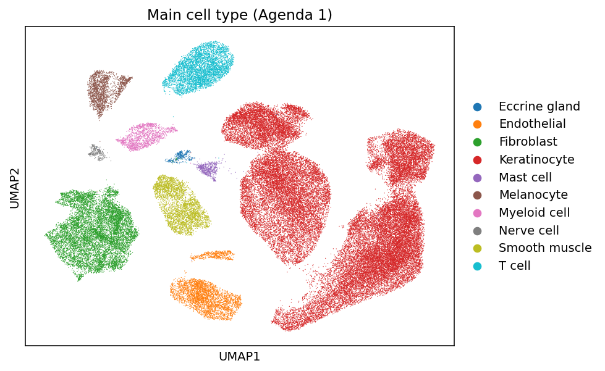
results/skin-PP8940/umap_celltype_main.png
- 10 clean, well-separated lineages. Keratinocyte (red) is the largest by far at 62% of all cells.
- Agenda 1a works on skin with no extra work — the mapping came out of the metadata.
For comparison, UMAP w/ granular cell type (26 labels)
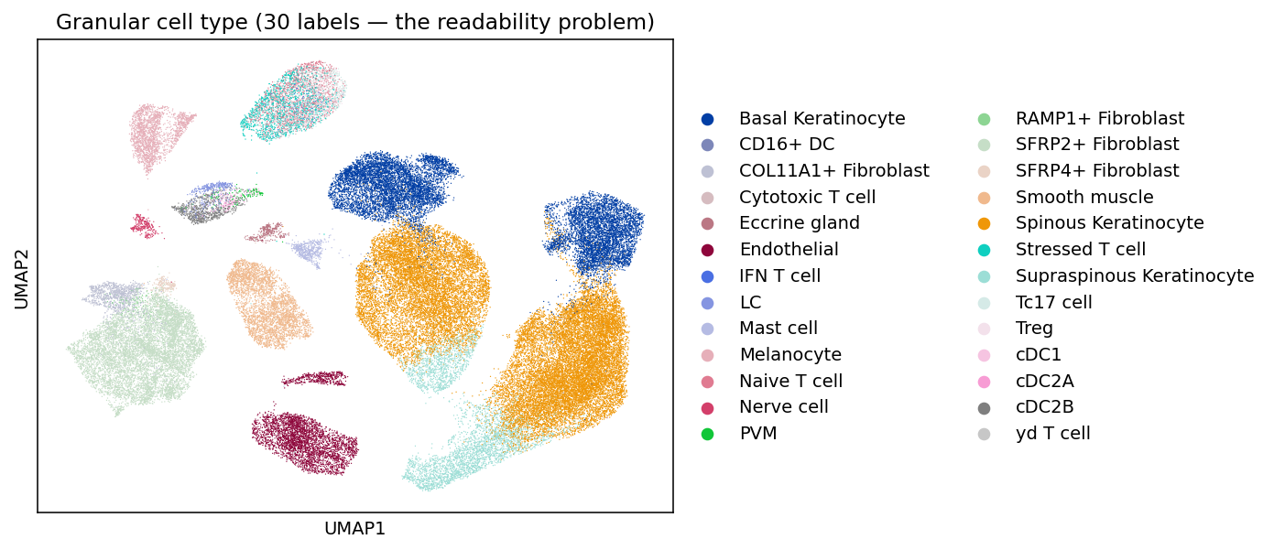
results/skin-PP8940/umap_celltype_granular.png — the readability problem
[Mapping subtypes to main cell types]
Unlike PBMC, no celltype_mapping.txt was needed — the metadata already carries both levels.
 | PBMC | Skin
granular | 30 labels (CellType) | 26 labels (fullsubtype)
main | 5 lineages | 10 lineages (celltype)
source of mapping | celltype_mapping.txt from the lab | read off the metadata, majority vote
coverage | 30/30, zero unmapped | 26/26, zero unmapped
- Main types: Keratinocyte, Fibroblast, T cell, Endothelial, Smooth muscle, Melanocyte, Myeloid cell, Mast cell, Eccrine gland, Nerve cell.
[Systematic Program Selection]
Same pre-registered rule as PBMC, unchanged: keep 3–50 genes → rank by recurrence, then median IDS → report all that pass, no top-N cherry picking. Recurrence is still undefined from a single run, so this ranks on median IDS and says so in its own output.
Result — programs_ranked.csv (10 programs)
# | program | n | med IDS | top cell type | enrich | reading
1 | P01_HLA-A | 5 | 0.629 | Treg | 1.02 | ARTIFACT — MHC class I (HLA-A/B/C/E, B2M), on every nucleated cell
2 | P02_MT2A | 3 | 0.562 | Melanocyte | 1.65 | metallothioneins — a stress response, density 1.00
3 | P03_PROX1 | 5 | 0.561 | see note | 4.98 | lymphatic endothelium: PROX1, MMRN1, CCL21, TFF3
4 | P04_MT-ND1 | 9 | 0.527 | PVM | 1.01 | ARTIFACT — the mitochondrial genome
5 | P05_PNPLA1 | 3 | 0.501 | Supraspinous KC | 4.10 | cornification (PNPLA1, HOXC13)
6 | P06_FCER1G | 16 | 0.477 | Mast cell | 1.04 | mast cell: CPA3, TPSAB1/B2, LTC4S, CTSG
7 | P07_COL11A1 | 9 | 0.441 | Fibroblast | 8.33 | fibroblast ECM: COL11A1, HAPLN1, TNMD, MFAP5
8 | P08_CHI3L1 | 10 | 0.437 | Eccrine gland | 2.56 | eccrine gland: DCD, SCGB2A2, MUCL1, KRT7
9 | P09_TNFRSF18 | 46 | 0.396 | Treg | 9.44 | T cell / Treg: TNFRSF18 (GITR), TNFRSF4 (OX40), CD2, CD247, PTPRC
10 | P10_QPCT | 10 | 0.362 | Melanocyte | 4.07 | melanocyte: MITF, PMEL, OCA2, GPR143
- 8 of 10 land on a coherent, textbook cell population — discovered bottom-up, no cell-type label ever entered the computation.
- P09's enrichment of 9.44 is the highest seen in either tissue (PBMC's best was 7.46).
- P10 replicates the melanocyte program independently found in the PP_929 run (MITF shared) — informal evidence of exactly the recurrence Agenda 2 formalises.
What the size filter dropped — and why it matters here
The audit trail (programs_dropped_by_size_filter.csv) recorded 12 gene-pairs as too small and 5 communities as too large: 52, 99, 121, 211 and 279 genes.
The 279-gene one is the central biology of psoriasis
It contains IVL (involucrin), SPRR1A / 1B / 2A–2G (small proline-rich proteins) and S100A7 / A8 / A9 — psoriasin and calprotectin. S100A7 is literally named after psoriasis. This is the cornified-envelope programme, and the 50-gene cap threw it away before ranking. Its density is 0.13, i.e. a real tight core with a huge loose fringe — not a genuine 279-gene program.
→ Same fix PBMC pointed to (the 57-gene platelet group): raise --min-ids so communities form tightly, rather than raising the size cap after seeing what it cut. Raising the cap after the fact is exactly the cherry-picking the rule exists to stop.
[Cell-type Enrichment]
Identical method to PBMC: for each program, what proportion of each cell type expresses it (score > 0), sorted highest first. 10 programs × 26 subtypes = 260 rows.
Result — enrichment_granular.png
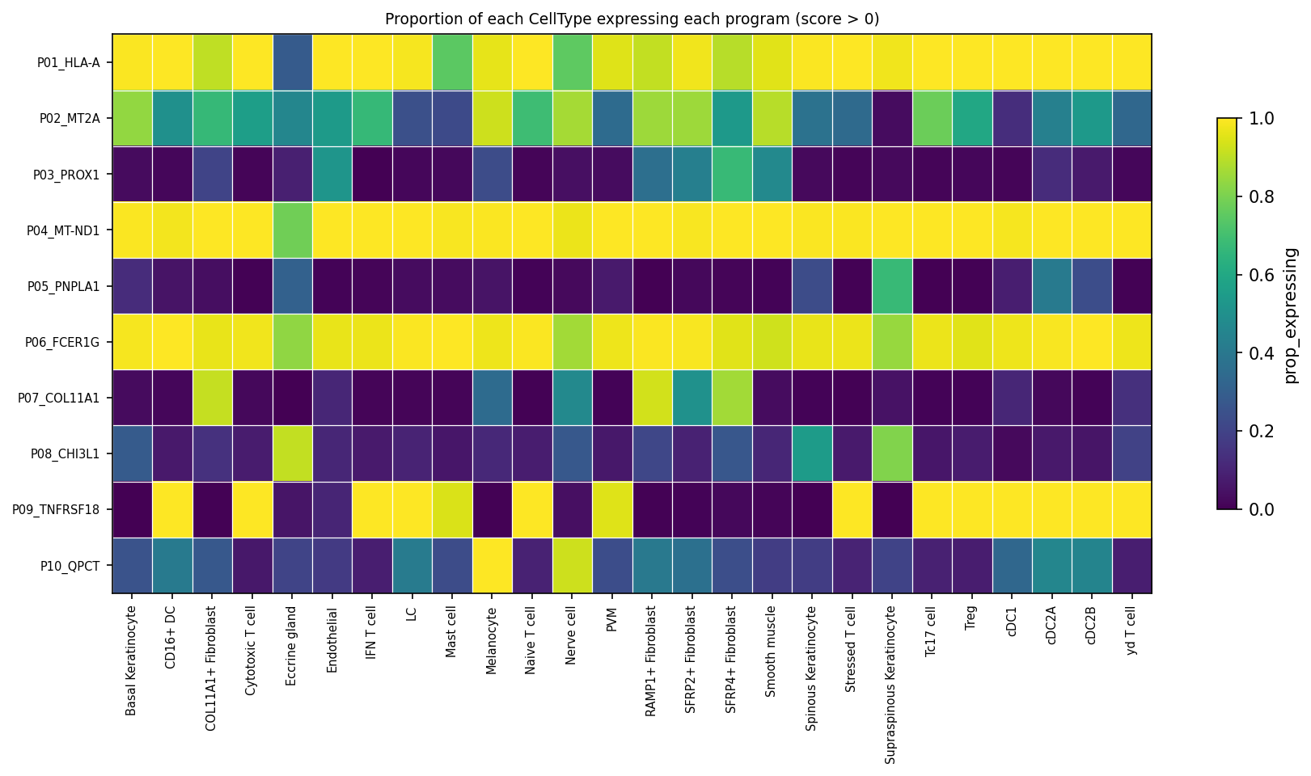
brighter = higher proportion; columns grouped by lineage
Two things skin exposed that PBMC did not
(a) score > 0 saturates far more in skin
P06_FCER1G is unmistakably mast cell — CPA3, tryptases TPSAB1/TPSB2, LTC4S, CTSG. But look at the proportions:
cell type | n cells | prop_expressing | mean_score | enrichment
Mast cell | 563 | 1.000 | 5.64 | 1.04
CD16+ DC | 58 | 1.000 | 1.75 | 1.04
cDC2B | 755 | 0.999 | 1.64 | 1.04
Naive T cell | 1,154 | 0.994 | 1.13 | 1.03
- Every cell type reaches ~1.00, so enrichment is 1.04 and specific reads False — a false negative caused by the cutoff, not by the biology.
- mean_score separates cleanly (5.64 vs 1.75 next). In skin, mean_score is doing the discriminating and proportion is nearly uninformative.
- → The cutoff should be revisited before any cross-tissue comparison — and changed for both tissues together or not at all.
(b) the agree flag earned its place
For P03, the two rankings disagree:
 | by proportion | by mean score
top cell type | SFRP4+ Fibroblast (0.67) | Endothelial (mean 1.20)
is it right? | WRONG | CORRECT
- PROX1, MMRN1 and CCL21 are lymphatic endothelial markers — PROX1 is the master regulator of lymphatic endothelium.
- So the mean-score answer is biologically right and the proportion answer is wrong. Quoting the proportion ranking alone would have mislabelled this program.
Result — specificity_summary.csv
Same columns as PBMC. Read top_cell_type as the answer and the rest as how much to believe it:
program | top cell type | top_prop | enrichment | agree | specific
P09_TNFRSF18 | Treg | 1.00 | 9.44 | True | True
P07_COL11A1 | RAMP1+ Fibroblast | 0.93 | 8.33 | False | True
P03_PROX1 | SFRP4+ Fibroblast | 0.67 | 4.98 | False | True
P10_QPCT | Melanocyte | 1.00 | 4.07 | True | True
P06_FCER1G | Mast cell | 1.00 | 1.04 | True | False (see (a))
P04_MT-ND1 | PVM | 1.00 | 1.01 | True | False — artifact
[Next steps, in order]
- Gene-family exclusion (MT-, RP-, HLA-).
  - 2 of 10 programs here are artifacts. A mitochondrial or MHC program will appear in BOTH tissues and register as 'shared' — the worst false positive available for the abstract.
  - Decide the exclusion list BEFORE looking at any overlap.
- Raise --min-ids and re-run.
  - Test whether the 279-gene keratinocyte community resolves into a reportable cornification program.
- Dissociation-stress genes.
  - PP_929 produced a JUN/FOS/EGR1/HSPA1A program — the classic solid-tissue dissociation artifact. It didn't survive in PP_8940 but it will recur. Treat it like the family exclusions.
- Agenda 2 (consensus) across the 33 samples.
  - 25 samples clear 1,000 cells, 32 clear 500. Recurrence is what makes the stratum-composition problem stop mattering — no single sample's cell mix can dominate.
- PN vs PP within donor — 11 donors have both.
  - Not built yet. For each program: per-cell scores already exist → group by (donor, disease) → PP-minus-PN difference → paired test across 11 donors. This is where the psoriasis biology is.
[Files]
# once: 33 gene-x-cell CSVs + metadata -> one sparse .h5ad (~10 min, 1.3 GB)
python -m sc_ids.datasets.psoriasis_skin --scratch /tmp
python -m sc_ids.analysis --dataset psoriasis_skin \
--data data/GSE173706_skin.h5ad \
--discovery-col orig.ident --discovery-value PP_8940 \
--min-ids 0.5 --out results/skin-PP8940
file | what it is
results/skin-PP8940/programs_ranked.csv | the 10 programs, ranked — the primary result
…/specificity_summary.csv | one row per program: which cell type, and can you trust it
…/enrichment_granular.csv | 260 rows, program × 26 subtypes
…/programs_dropped_by_size_filter.csv | the audit trail — where the 279-gene community is recorded
…/enrichment_granular.png | the heatmap above
…/umap_celltype_main.png, _granular.png | the two UMAPs above
src/sc_ids/datasets/psoriasis_skin.py | all four skin-specific facts, plus the one-time CSV→h5ad builder
docs/skin_first_run.md | the same content in the repo, in markdown

