[Step 1 — Standard QC on both tissues, including a gene filter]
All skin cells (GSE173706) + all PBMC cells from lane PBMC-01-1 (GSE194315). Script: scripts/qc_joint_pipeline.py · outputs: results/qc-joint/ and results/qc-joint-minfilter/

The question
Does skin separate from blood on the UMAP because each tissue contains genes the other does not? If so, filtering genes inside each tissue and keeping only the ones that survive in both should pull them together.
Short answer: no. That is not the reason. Filtering the genes changed almost nothing. Details in the last section.

1. Cell QC (the lab pipeline)
Thresholds from config_sample.json: at least 200 genes per cell, at most 10% mitochondrial reads, doublet score at most 0.15.
tissue | cells in | fail <200 genes | fail >10% mito | cells kept
PBMC (lane 01-1) | 17,858 | 0 | 5,094 | 12,764 (71.5%)
skin (33 samples) | 67,378 | 11 | 0 | 67,367 (100.0%)

- PBMC loses 28.5% of its cells, all on the mitochondrial threshold, as we already found.
- Skin loses 11 cells. Its source study already used the same 10% mitochondrial cut, so there is nothing left for us to remove.
- Gap: skin has no doublet filter. It is not multiplexed and the lab’s doublet step has never been run on it, so only two of the three cell filters apply there. For PBMC the doublet step is covered by demuxlet, which the source study already required.
- Starting point is cells that carry a cell-type label (all 67,378 skin, all 17,858 PBMC). Unlabelled droplets are left out, since later steps assign labels by majority vote and unlabelled cells cannot take part.

2. Gene QC
The lab pipeline has no gene filter. I checked every file in the repo: run_QC.py filters cells only, and nothing anywhere calls filter_genes or sets min_cells. The only gene-level step is taking the top 2,000 variable genes before PCA, which is not QC. So the threshold below is our choice, not theirs.
Method: a gene must be detected in at least N cells of that tissue, applied to each tissue separately; then keep only genes that pass in both.
threshold | genes in PBMC | genes in skin | kept (in both) | dropped
3 cells | 18,807 | 25,634 | 18,250 | 7,941
10 cells | 16,039 | 22,995 | 15,607 | 7,820
0.1% of cells | 15,478 | 18,769 | 14,413 | 5,421
1% of cells | 10,838 | 13,813 | 10,126 | 4,399
2% of cells | 9,334 | 12,219 | 8,627 | 4,299
Starting point is the 32,991 genes the two datasets share by name. I used the 1% row for the main run.
- Genes that pass in skin but not PBMC: 3,687. The other way round: 712. Skin has more because it has more cell types.

3. Result after QC + the gene filter
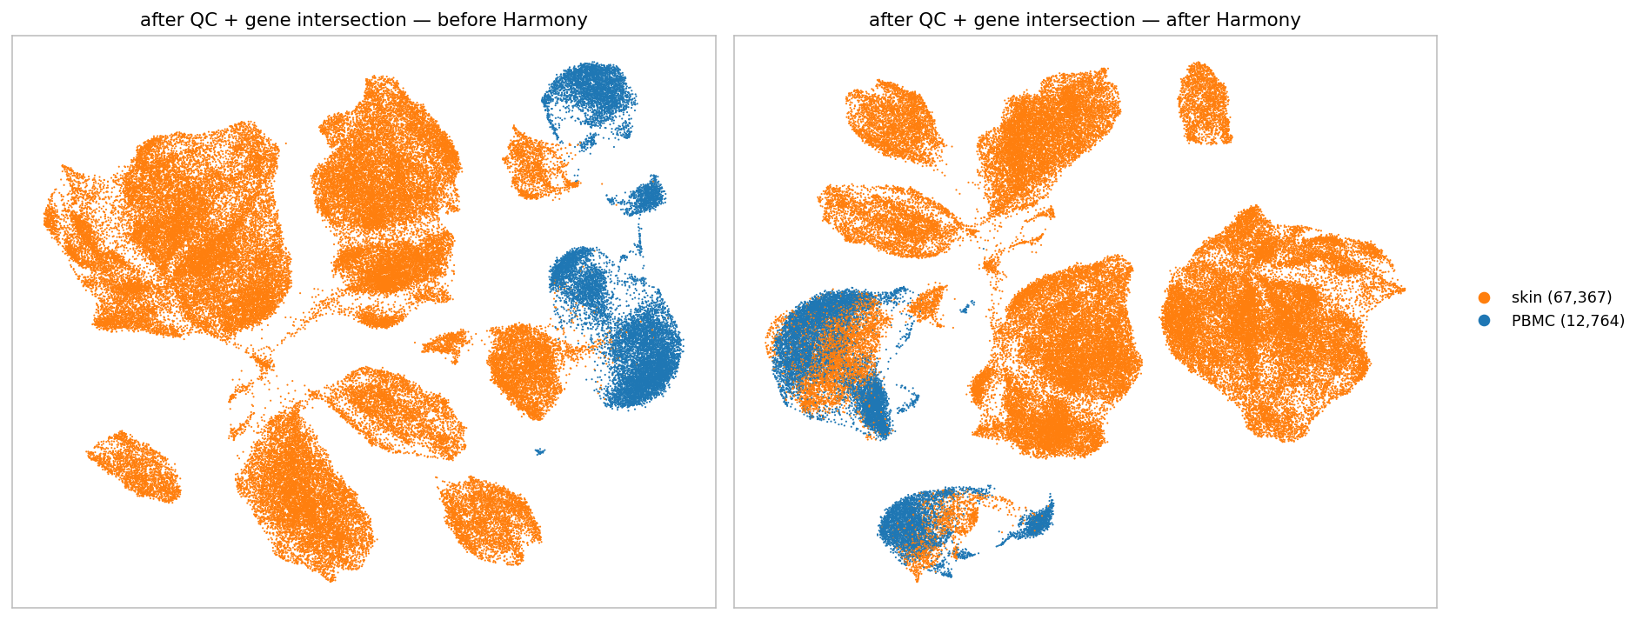
80,131 cells, 10,126 genes. Orange = skin, blue = PBMC.
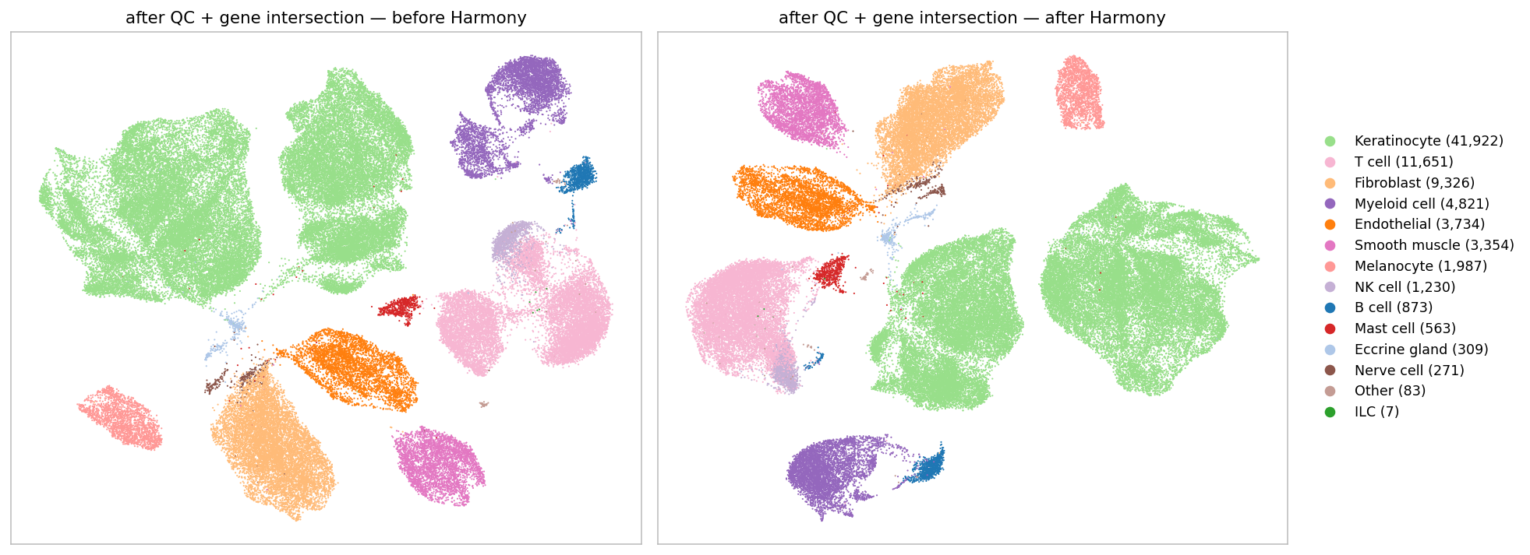
Same UMAP, coloured by cell type.
Harmony does line the two tissues up where they have the same cell type:
 | before Harmony | after Harmony | what they sit next to
skin T cells | 2.6% PBMC neighbours | 37.1% | 94% of them are PBMC T cells
skin myeloid | 1.1% PBMC neighbours | 31.4% | 94% of them are PBMC myeloid
PBMC is only 16% of all cells here, so 37% is well above what random mixing would give.
- Cell types stay separate (mixing 0.013 → 0.016 of perfect), so nothing was smeared together.
- Including the skin-only cell types does not hurt the alignment of the shared ones.

4. Testing the hypothesis
To see whether the gene filter is what matters, I ran the identical pipeline twice, changing only the gene threshold:
 | 3-cell filter (18,250 genes) | 1% filter (10,126 genes) | change
skin T cells with PBMC neighbours | 41.1% | 37.1% | worse
skin myeloid with PBMC neighbours | 33.0% | 31.4% | worse
tissue mixing among immune cells | 0.297 | 0.283 | worse

→ Removing one-tissue genes did not bring the tissues together — it made things very slightly worse. The differences are small enough to treat as noise, so the fair conclusion is that the gene filter makes no difference.
Two further observations that point the same way:
- Before Harmony, skin T cells have 2.6% PBMC neighbours with the filter and 2.8% without. The tissues are almost completely separate either way, so tissue-specific genes are not what is holding them apart.
- In the permissive run, 472 of the 2,000 variable genes driving the UMAP (24%) are ones the 1% filter would remove. Removing them replaced two thirds of the variable-gene list, and the result barely moved. So the separation does not rest on those genes.
What it is more likely to be: the same cell type genuinely differs between a tissue and the bloodstream, and PBMC here is one lane of 9 donors while skin is 22 donors on different chemistry. Those are differences in the cells themselves, not in which genes were measured.

Caveats
- Skin has no doublet filtering. This is the one lab filter we cannot apply.
- Keratinocytes are 52% of all cells, so any overall mixing number is dominated by cells that have no counterpart in blood. Use the per-cell-type numbers instead.
- The 1% threshold is a choice, not a standard. The table in section 2 shows what other thresholds would give, and any of them can be rerun in a few minutes.

Suggestion before Step 2
- Keep the 1% filter. It does not help mixing, but it removes 4,399 genes that are barely detected, which makes clustering cheaper and no worse.
- Do not expect the gene filter to be the fix. If Step 2 clustering still splits by tissue, stricter gene QC is unlikely to change that, and the donor and chemistry differences are the better suspects.

Files: results/qc-joint/ (1% filter) and results/qc-joint-minfilter/ (3-cell control) — gene_filter_thresholds.csv, gene_lists.json, mixing_scores.csv, other_tissue_neighbours.csv, cells_passing_qc.csv, and the UMAPs.

