[Steps 2–6 — Clustering, labelling, and Harmony within each lineage]
Input: the QC’d joint object from Step 1 (80,131 cells, 10,126 genes). Script: scripts/cluster_pipeline.py · outputs: results/clustered/

Headline
It worked, but only after turning Harmony up. At its default strength the second-stage correction left skin and blood almost completely apart. Raising one setting fixed that without disturbing the biology, and NK cells then separated from T cells as Matthew predicted.
of a skin T cell’s 30 nearest neighbours, how many are PBMC cells | no correction | Harmony, default | Harmony, stronger
T/NK lineage | 1.7 | 3.7 | 17.2
myeloid lineage | 0.6 | 1.7 | 11.8

Step 2 — Clustering and relabelling
Leiden clustering on the Harmony-corrected neighbours, at the lab pipeline’s four resolutions. I used 0.20 as the working one.
resolution | 0.20 | 0.40 / 0.60 / 0.80 | note
clusters found | 12 | 15 / 20 / 25 | all four are saved; 0.20 gives one cluster per main cell type

- T cells and NK cells landed in one cluster (11,637 T + 1,227 NK), exactly as expected.
- Myeloid cells formed their own single cluster (4,735).
- Keratinocytes split across four clusters, which is normal — they are 52% of all cells and have real sub-structure.
- Every cell was then relabelled with its cluster’s majority cell type. This moved 2,119 cells (2.6%) to a different label — the misplaced cells from the old per-dataset annotations being absorbed into the right group.
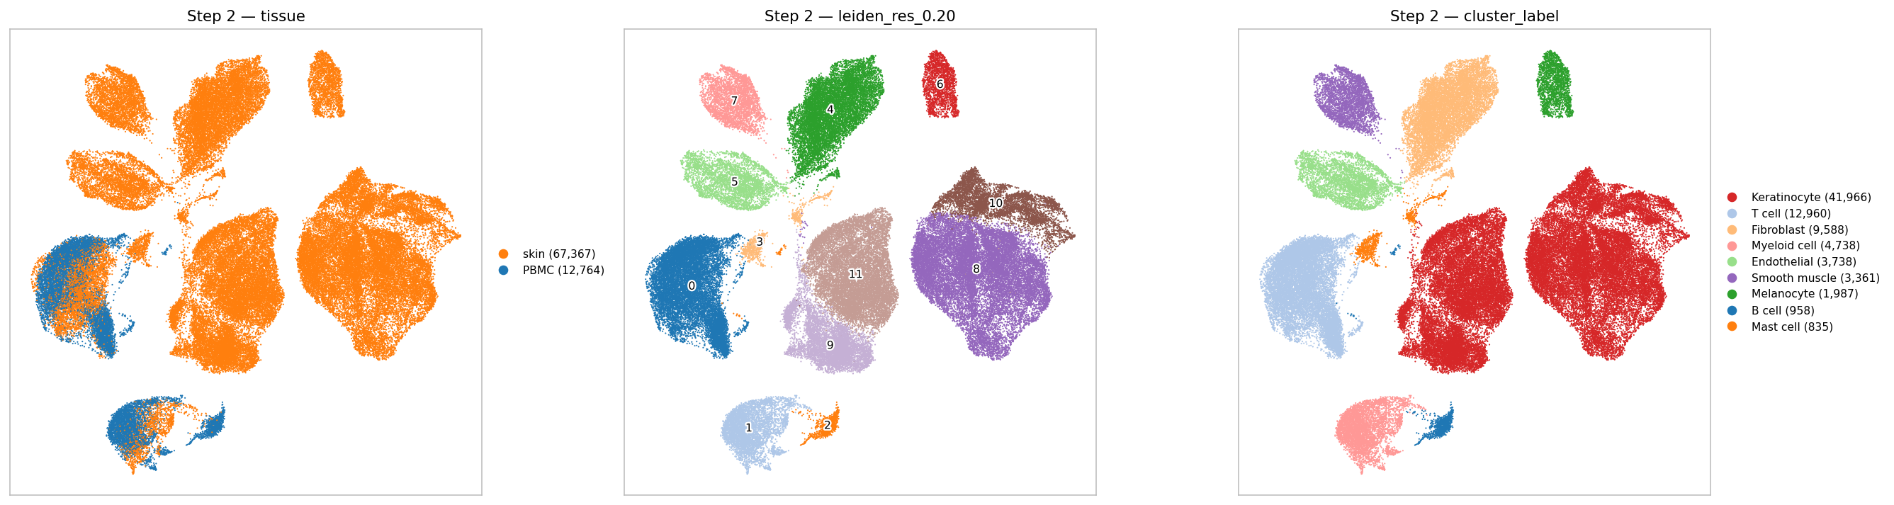
Left: tissue. Middle: the 12 clusters. Right: cell type after majority relabelling.

Step 3 — Removing the one-tissue cell types
Clusters whose majority label appears in only one tissue were dropped: keratinocyte, fibroblast, endothelial, smooth muscle, melanocyte, mast, eccrine and nerve on the skin side, B cells on the blood side.
 | before | after | kept
PBMC | 12,764 | 11,847 | 93%
skin | 67,367 | 5,851 | 9%
total | 80,131 | 17,698 | 22%

- Skin loses most of its cells, as before. This is a statement about immune cells in skin, not about skin.
- NK cells were kept, because they sit inside the T/NK cluster rather than forming their own.

Steps 4–6 — Each lineage on its own
The T/NK cluster and the myeloid cluster were pulled out as separate objects and re-processed from scratch: new variable genes, new PCA, new Harmony, new clustering.

The problem, and the fix
On the first attempt this made things worse: skin and blood pulled apart into separate halves of each UMAP. The cause is a Harmony setting called theta, which controls how hard it pushes the two groups together. The default (2) is tuned for batches of the same tissue; within a single lineage it is too weak.
theta | T/NK: skin nbrs from PBMC | T/NK: purity | myeloid: skin nbrs from PBMC | myeloid: purity
no correction | 1.7 | 0.635 | 0.6 | 0.939
2 (default) | 3.7 | 0.634 | 1.7 | 0.941
4 | 15.3 | 0.631 | 4.6 | 0.942
8 (used) | 17.2 | 0.631 | 11.8 | 0.937
16 | 18.3 | 0.631 | 16.0 | 0.930
"Purity" = of a cell’s neighbours from its own tissue, the share with the same subtype label. It barely moves, so the stronger setting is not scrambling the biology inside each tissue.
→ Raising theta from 2 to 8 took skin T cells from 3.7 to 17.2 PBMC neighbours out of 30, with purity unchanged (0.634 → 0.631).
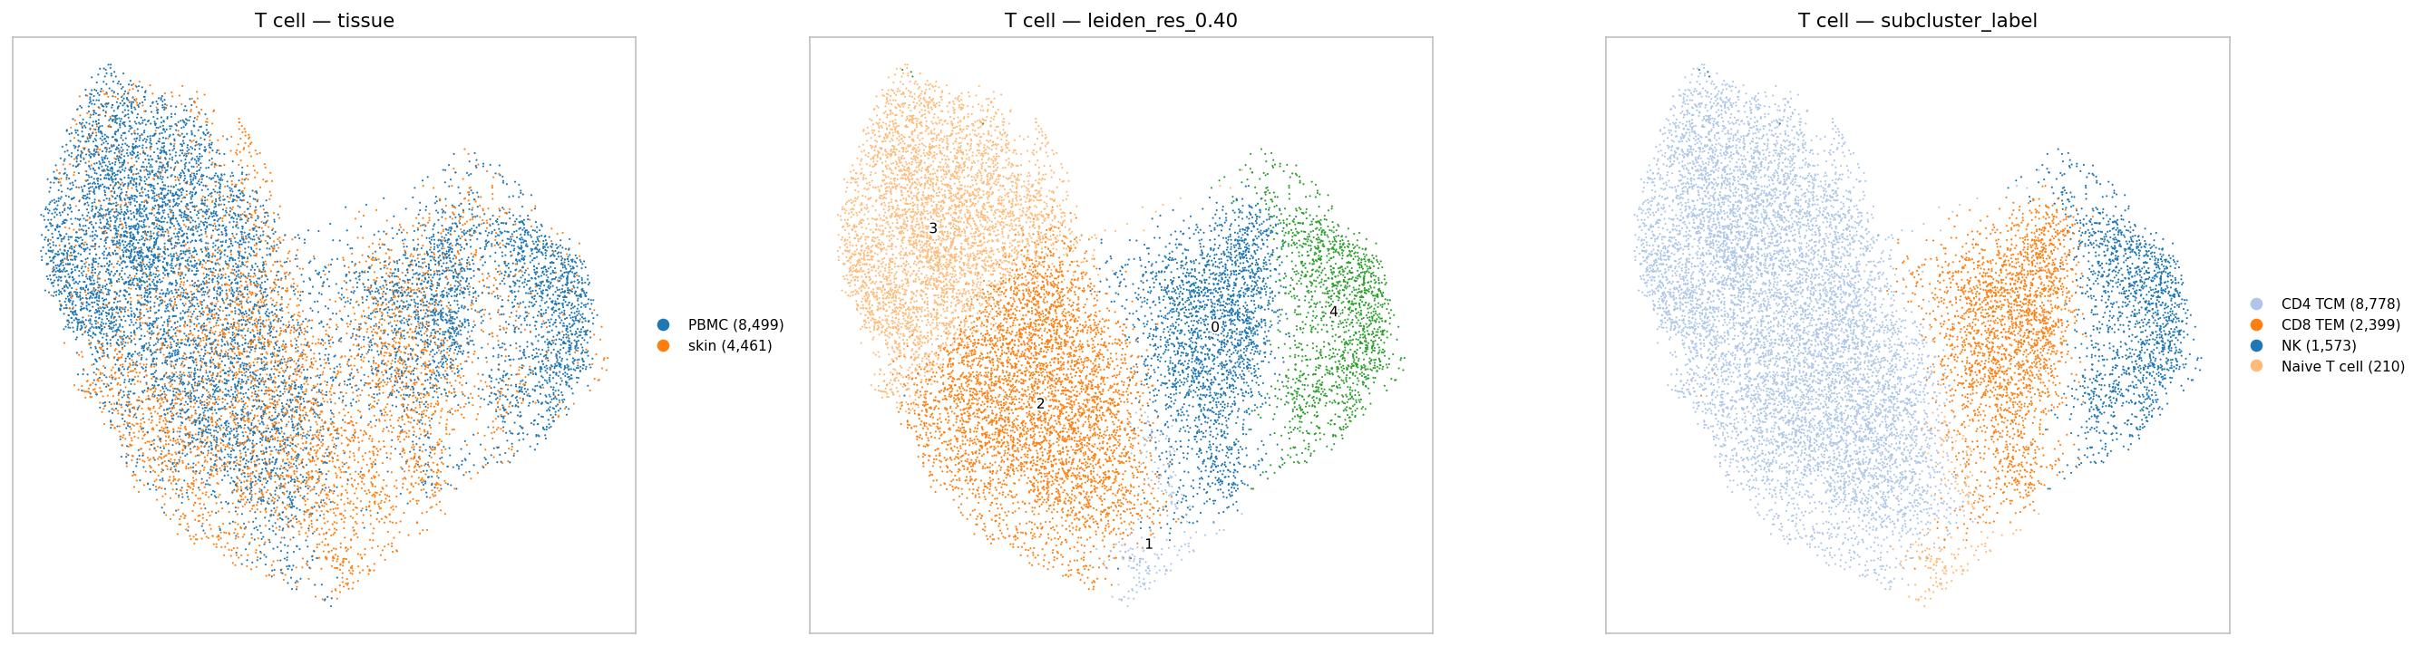
T/NK lineage after the stronger correction. Left: tissue — now interleaved. Middle: 5 sub-clusters. Right: majority label.
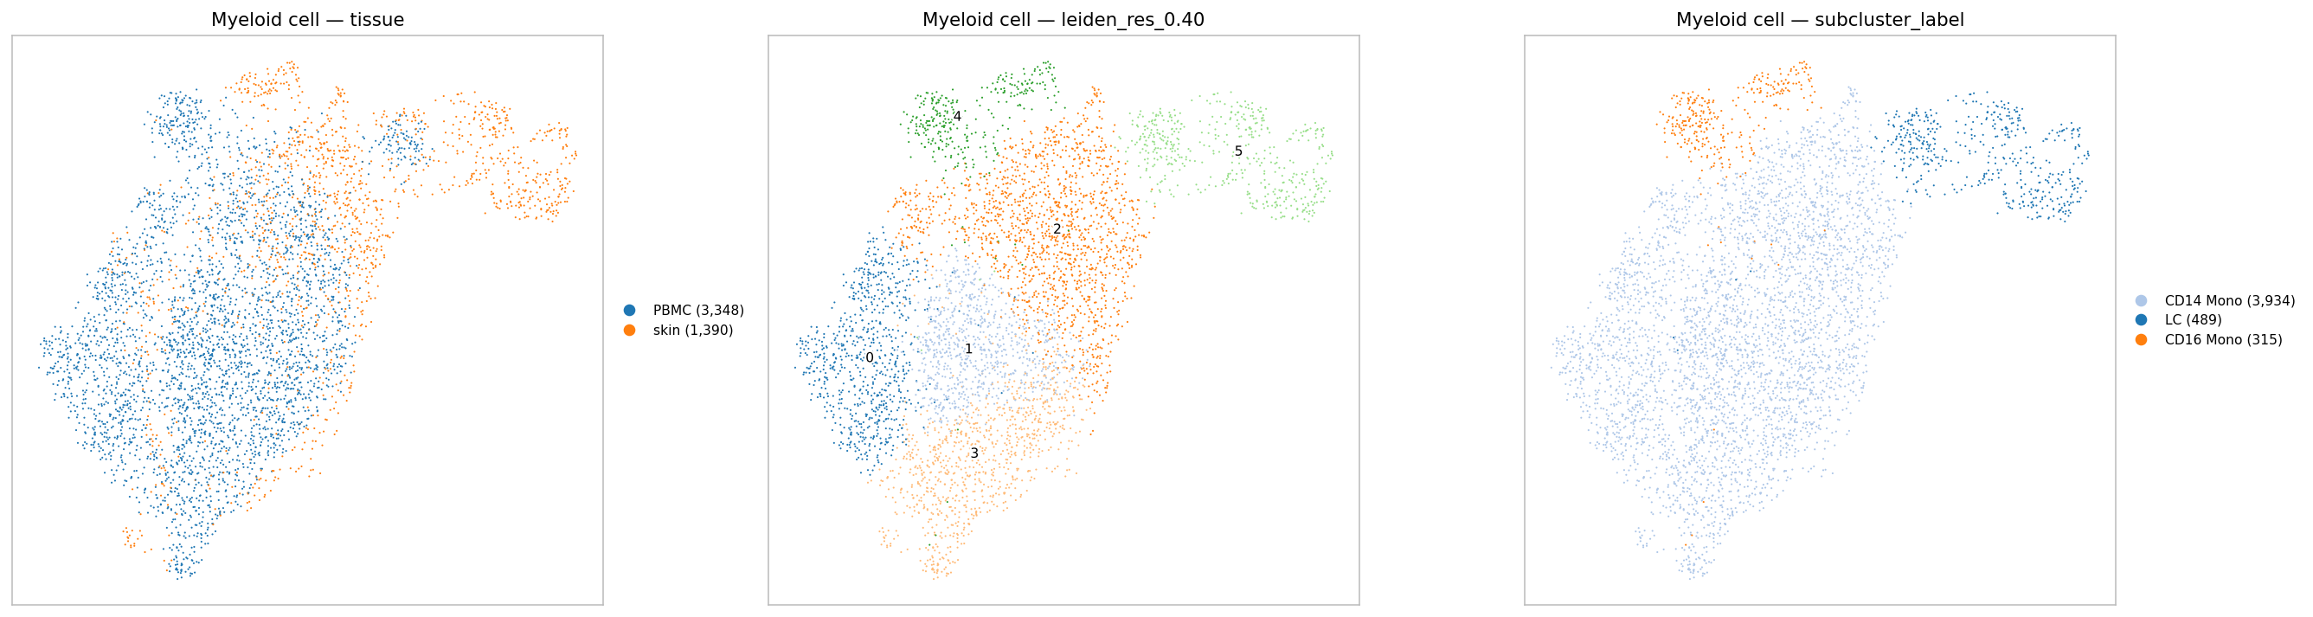
Myeloid lineage, same treatment.

What the sub-clusters are
A single majority label is dominated by the bigger tissue (PBMC), so the table gives the top label in each tissue separately.
T/NK — 5 sub-clusters
cluster | PBMC | skin | top PBMC label | top skin label
0 | 1,350 | 1,049 | CD8 TEM (67%) | Cytotoxic T cell (43%)
2 | 2,245 | 2,222 | CD4 TCM (80%) | Naive T cell (38%)
3 | 3,577 | 734 | CD4 TCM (46%) | Stressed T cell (65%)
4 | 1,313 | 260 | NK (83%) | gamma-delta T cell (55%)
1 | 14 | 196 | CD4 TCM (50%) | Naive T cell (48%)

- NK cells separated out as their own sub-cluster (cluster 4), which is what Matthew expected. The skin cells that joined them are gamma-delta T cells — the skin’s own killer cells. That is a sensible pairing.
- Clusters 0 and 2 are close to 50/50 skin and blood. Cluster 0 pairs blood CD8 effector cells with skin cytotoxic T cells, again sensible.

Myeloid — 6 sub-clusters
cluster | PBMC | skin | top PBMC label | top skin label
2 | 792 | 673 | CD14 Mono (95%) | cDC2B (90%)
5 | 97 | 392 | cDC2 (90%) | LC (80%)
4 | 213 | 102 | CD16 Mono (93%) | cDC2A (82%)
0 / 1 / 3 | 2,246 | 223 | CD14 Mono (99%) | mixed

- Myeloid is the weaker half. The one balanced cluster (2) pairs blood monocytes with skin cDC2B dendritic cells — different cell types. We saw the same wrong pairing last time. Cluster 5 (blood dendritic cells with skin Langerhans cells) is the sensible one.
- Most blood monocytes stay in their own clusters, which is correct: skin has no monocytes.

Did it pay off?
 | expected | what happened
skin and blood line up better | yes | yes, after raising theta
NK separates from T | yes | yes — cluster 4
myeloid sub-structure | Matthew was unsure | partly — one good pairing, one wrong one

Caveats
- Raising theta forces mixing. The purity check shows it does not scramble cells within a tissue, but it cannot tell whether a cross-tissue pairing is real. The monocyte–cDC2B pairing is probably an example of a forced one.
- Skin contributes only 5,851 cells after Step 3, from 22 donors on different chemistry; PBMC is one lane of 9 donors.
- Skin still has no doublet filtering.
- theta = 8 was chosen from the sweep table, not from a rule in the lab pipeline. Any value from 4 to 16 gives a similar picture.

Suggested next steps
- Take the T/NK result forward. It is the clean half: NK separated, two balanced sub-clusters with sensible cross-tissue pairings.
- For myeloid, check the monocyte–cDC2B pairing with marker genes before trusting it.
- Then rerun IDS inside these sub-clusters, which is the point of the whole exercise.

Files: results/clustered/ — theta_sweep.csv, step2_cluster_by_celltype.csv, step2_relabelled_cells.csv, step3_dropped_clusters.csv, step5_summary.csv, step6_{t,myeloid}_labels.csv, and the UMAPs.

