[Updates to the Steps 2–6 write-up: Harmony strength (theta) settled, and the labelling re-run at the settled value]
Two changes land in the same place, so they are written up together. Scripts: scripts/theta_tuning.py, scripts/rank_markers.py, scripts/nk_percell.py · outputs: results/theta/, results/clustered-theta4/, results/markers-theta4/

Where each piece goes in the existing document
piece below | replaces | why
Part 1 — theta table + decision | the theta table in the Steps 4–6 section (columns: theta / T–NK skin nbrs / T–NK purity / myeloid skin nbrs / myeloid purity), and the sentence after it that starts "Raising theta from 2 to 8…" | the old table measured only mixing and purity, which cannot show over-correction; two columns are added and the chosen value changes from 8 to 4
Part 2 — labelling at theta = 4 | the Step 6 labelling section, including the version sent earlier as Step6_labelling_v2 | that version was computed on the theta = 8 run; the cluster numbers in it no longer exist
Part 3 — one line to add under Step 2 | nothing — new sentence | records that the original annotations are retained in the object

Read this first: the earlier Step 6 write-up and the theta table disagree with each other, because one was built at theta = 8 and the other recommended 8 before the full sweep existed. Replacing both parts together is what makes the document internally consistent. Do not paste Part 2 while keeping the old cluster numbers.

Part 1 — How strong should the Harmony correction be?
Harmony has a setting, theta, that controls how hard it pushes the two tissues together. The question is not how high it can go. Three things have to be true at once:
- skin and blood line up — a skin cell’s nearest neighbours include blood cells;
- the sub-clusters stay distinct — the correction has not smeared everything into one blob;
- each sub-cluster contains both tissues, rather than one tissue each.
Pushing harder always improves (1). It eventually destroys (2). So the sweep has to measure the cost as well as the benefit, which the earlier table did not.

What the five columns mean
- skin nbrs from blood — of a skin cell’s 30 nearest neighbours, how many are blood cells, on average. 0 means the tissues sit apart; 15 means a skin cell is surrounded half and half. Measured in the 20-dimensional corrected space, not on the UMAP picture.
- clusters — how many sub-clusters Leiden finds at resolution 0.40.
- clusters with both tissues — how many of those clusters contain a real amount of each tissue (the smaller tissue at least 10% of the cluster and at least 20 cells). This is the goal stated in (3).
- distinctness — silhouette score of the clusters in the corrected space. It falls when correction blurs the boundaries between them. This is the cost column.
- agreement with skin annotation — how well the clusters match the cell-type labels the original skin study assigned, measured within skin only (adjusted Rand index). This is the guard against over-correction: if pushing theta has invented structure rather than aligned real structure, agreement with labels we did not compute ourselves goes down.

T / NK lineage
theta | skin nbrs from blood (of 30) | clusters | clusters with both tissues | distinctness | agreement with skin annotation
none (no correction) | 2.4 | 4 | 0 | 0.17 | 0.01
1 | 4.1 | 4 | 1 | 0.17 | 0.01
2 (default) | 4.6 | 4 | 1 | 0.17 | 0.02
4 | 15.9 | 4 | 4 | 0.16 | 0.20
8 | 17.4 | 4 | 4 | 0.11 | 0.22
16 | 18.6 | 4 | 4 | 0.11 | 0.16
32 | 18.9 | 5 | 4 | 0.07 | 0.19

→ theta = 4 is the choice. Going from the default 2 to 4 is where everything happens: skin cells go from 4.6 blood neighbours out of 30 to 15.9, all four sub-clusters go from one-tissue to two-tissue, and agreement with the skin study’s own labels rises from 0.02 to 0.20 — so the alignment is matching real cell types, not manufacturing new ones. Distinctness barely moves (0.17 to 0.16).
Going further buys little and costs real structure. Theta 8 adds 1.5 neighbours out of 30 and drops distinctness from 0.16 to 0.11. Theta 16 drops agreement with the skin annotation back to 0.16. Theta 32 splits a fifth cluster out of nothing and distinctness falls to 0.07.
This corrects the earlier recommendation of 8. Theta 8 was chosen when only mixing and purity were being measured, and on those two columns alone 8 does look better than 4. The distinctness and annotation-agreement columns are what show that the extra mixing at 8 is paid for.

Myeloid lineage
theta | skin nbrs from blood (of 30) | clusters | clusters with both tissues | distinctness | agreement with skin annotation
none (no correction) | 0.5 | 9 | 0 | 0.11 | 0.70
1 | 1.1 | 8 | 1 | 0.12 | 0.74
2 (default) | 1.2 | 7 | 1 | 0.11 | 0.72
4 | 1.6 | 8 | 1 | 0.12 | 0.71
8 | 7.0 | 6 | 2 | 0.08 | 0.50
16 | 15.4 | 6 | 6 | 0.08 | 0.43
32 | 16.4 | 7 | 7 | 0.07 | 0.45

→ Myeloid is left at theta = 4, which for this lineage means essentially uncorrected (1.6 neighbours out of 30). Mixing can be forced — theta 16 reaches 15.4 — but agreement with the skin annotation collapses from 0.71 to 0.43. That is the clearest over-correction signal in either table: the alignment is being bought by destroying cell-type structure the original study identified.
This is a finding, not a failure. Blood myeloid cells are monocytes; skin myeloid cells are Langerhans cells and dermal dendritic cells. They are not the same populations, so there is nothing for Harmony to align, and forcing it produces clusters that pair a blood monocyte with a skin dendritic cell because both are myeloid. The sensible report is that the myeloid compartment does not align across these two tissues.

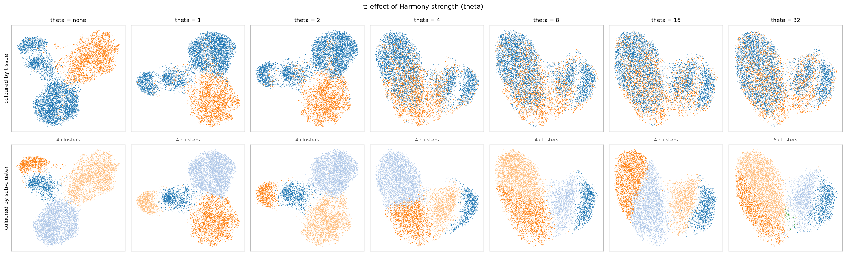
T/NK: the same cells at each theta. Top row coloured by tissue (blue = blood, orange = skin), bottom row by sub-cluster. The two tissues come together between theta 2 and 4; past 8 the cluster boundaries start dissolving.
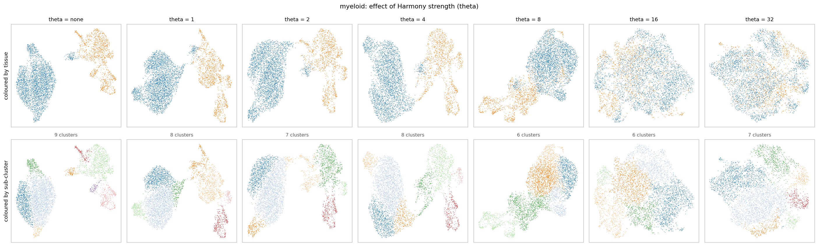
Myeloid: the tissues stay apart until theta 8, and the clusters that finally contain both tissues are pairing different cell types.

Part 2 — Testing the existing cell-type labels, at theta = 4
Replaces the Step 6 labelling section. Same method as the version sent earlier; re-run on the theta = 4 embedding so the cluster numbers match the settled parameters.

How the labels were decided
The per-cell annotations that came with each dataset are the starting point, not something to discard. They stay in the object throughout, and the "top label" columns below are those annotations. What changes is that we now test them rather than taking the most common one and stopping.
Two reasons the majority vote alone is not enough: the larger tissue dominates it, and a cluster holding two different cell types still receives one confident name.
The test asks which genes are turned up in each sub-cluster compared with the others, following the lab pipeline (run_Ranking.py): scanpy rank_genes_groups, Wilcoxon, each cluster against all the rest, kept at the lab thresholds (p < 0.01, log2FC > 1). Where genes and annotation agree, the annotation stands. Where they disagree, the disagreement is reported.
Run on the unfiltered gene set (18,250 genes). The 1% gene filter from Step 1 deletes FCGR3A, PRF1, KLRD1, TRDC, TRGC1 and TRGC2 — four of the five genes needed for the NK question. On the filtered object the question cannot be answered at all.

T / NK — 4 sub-clusters
cluster | genes most turned up | cells (blood / skin) | top annotation in each tissue | label
0 | GNLY, KLRD1, NKG7, TYROBP, PRF1, KLRF1, GZMB, GZMA, TRDC | 1,295 / 159 | NK 84% / γδ T 87% | NK — see below
1 | LTB, IL7R, TCF7, SELL, TXNIP, LDHB, RPL23 | 4,712 / 1,256 | CD4 TCM 54% / stressed T 62% | naive / central-memory CD4 T
2 | LMNA, RGCC, ZFP36, CREM, TNFAIP3, BIRC3, DUSP4 | 977 / 2,118 | CD4 TCM 86% / naive T 43% | activated T — disagreement, see below
3 | CCL5, NKG7, GZMA, CST7, GZMH, CD8A, GZMK, TRGC2 | 1,410 / 931 | CD8 TEM 67% / cytotoxic T 53% | CD8 effector / cytotoxic T

Cluster numbers changed from the earlier version. At theta = 8 the CD8 cluster was 1, activated was 2 and naive was 3. At theta = 4 they are 3, 2 and 1. The NK cluster is 0 in both. If any text in the document refers to "cluster 1" or "cluster 3" by number, it has to be re-pointed.

Cluster 0: NK cells, with a mixed fraction in skin
Using the definition the lab suggested — NK = FCGR3A, NKG7, GZMB, PRF1 present and CD3D absent — applied separately to each tissue inside the cluster. Numbers are the share of cells in which the gene is detected:
gene | blood half (1,295 cells) | skin half (159 cells) | reading
FCGR3A | 64% | 16% | NK marker — strong in blood, weak in skin
NKG7 | 99% | 65% | cytotoxic — both
GZMB | 84% | 47% | cytotoxic — both
PRF1 | 86% | 42% | cytotoxic — both
CD3D (should be absent in NK) | 9% | 16% | low in both — supports NK on both sides
CD3E | 31% | 16% | T-lineage — low
TRAC | 6% | 23% | T-lineage — low
TRDC (γδ receptor) | 64% | 67% | present in both halves
KLRD1 / KLRF1 | 91% / 79% | 53% / 35% | other NK markers — weaker in skin

→ The cluster is labelled NK. CD3D, the gene that should be absent in NK cells, is detected in 9% of the blood cells and 16% of the skin cells — low on both sides, which supports NK rather than T for the cluster as a whole. The blood half is unambiguous. The skin half is weaker on every NK marker and also carries the γδ receptor, so it is best described as an NK / γδ T mixture that cannot be cleanly separated at this resolution.

Why "mixture" and not "cells that are both"
A table of cluster averages cannot tell those two apart. So the same test was applied one cell at a time (scripts/nk_percell.py). A cell counts as NK+ if at least two of FCGR3A, NKG7, GZMB, PRF1 are detected, and T+ if any of CD3D, CD3E, TRAC are. Counts of cells:
group | cells | NK only | T only | both | neither
cluster 0, blood | 1,295 | 774 | 20 | 467 | 34
cluster 0, skin | 159 | 47 | 22 | 30 | 60
cluster 1, blood (reference: plain T cells) | 4,712 | 0 | 4,567 | 30 | 115
cluster 2, skin (reference: plain T cells) | 2,118 | 1 | 1,940 | 76 | 101

→ The reference clusters show what a single cell type looks like with this test: 4,567 of 4,712 blood cells and 1,940 of 2,118 skin cells fall in one column. The skin half of cluster 0 does not — its 159 cells split 47 / 22 / 30 / 60 across all four columns. That is the signature of a mixed population, not of cells that genuinely co-express both programmes.
The 159 skin cells also carry the γδ receptor in 121 cases, which is positive evidence for γδ T rather than merely weak evidence against NK.
Practical consequence for the IDS work: cluster 0 is used as NK, and the 159 skin cells inside it are flagged as mixed. Any statement that rests on skin NK cells specifically has to be hedged; there are too few of them, and they are not clean.

Cluster 2: the one place genes and annotation disagree
The annotation calls the blood side CD4 TCM (86%) and the skin side naive T (43%). The genes turned up in this cluster are LMNA, RGCC, ZFP36, CREM, TNFAIP3, BIRC3 and DUSP4 — an activation and immediate-early signature, not a naive or resting one. Naive T cells would show SELL, TCF7 and LEF1, which are the genes marking cluster 1 instead.
→ Reported as activated T cells, with the annotation disagreement stated rather than hidden. This is the honest outcome of testing labels instead of accepting them: three of four clusters confirm the annotation, one does not.

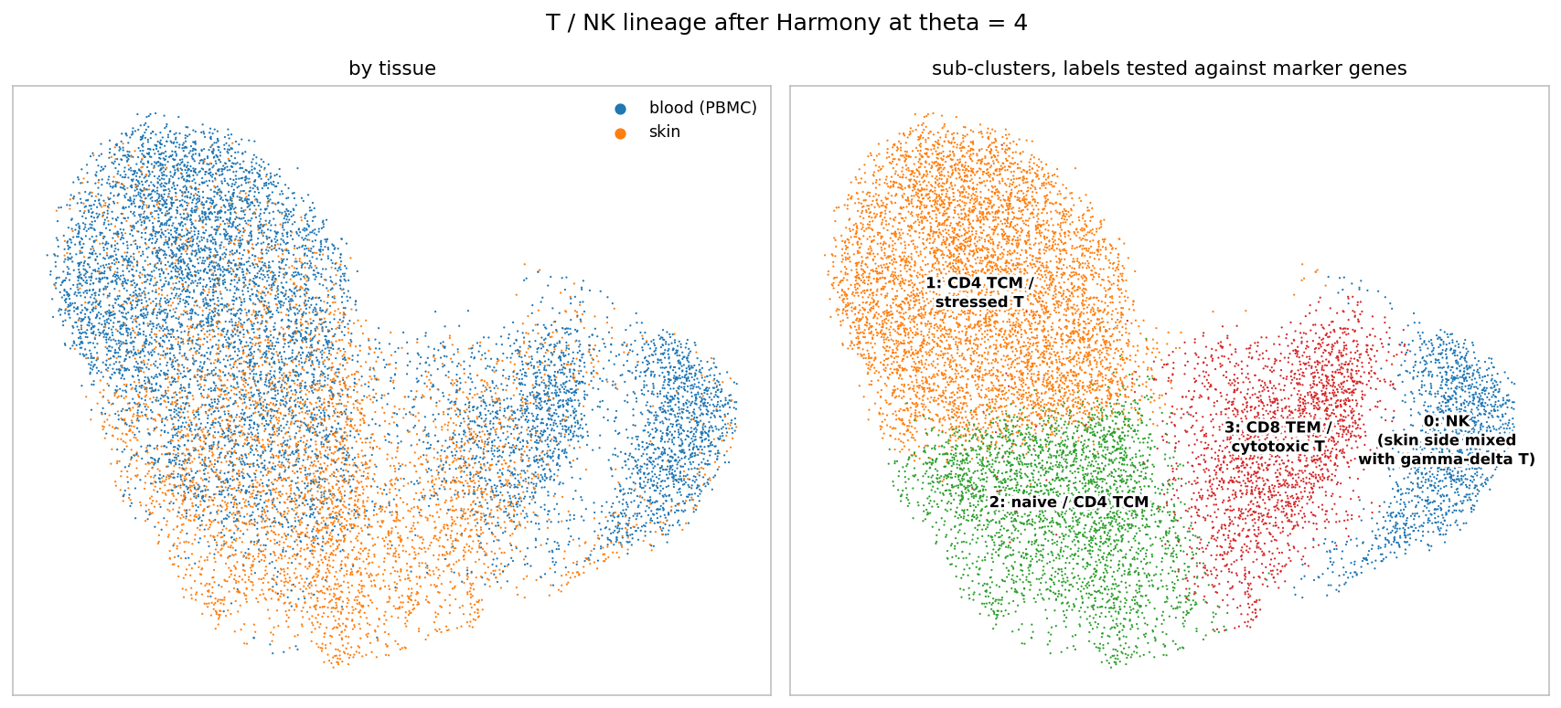
T/NK lineage at theta = 4. Left: by tissue — the two tissues now overlap. Right: the four sub-clusters with the tested labels. Figure replaces the equivalent one in the Step 6 section.

Myeloid — unchanged conclusion
At theta = 4 the myeloid lineage gives 8 sub-clusters and almost no cross-tissue alignment (a skin myeloid cell has 1.6 blood neighbours out of 30). Clusters 0–3 are blood monocytes, clusters 5–7 are skin dendritic cells and Langerhans cells, and only cluster 4 contains both tissues — 109 blood cells annotated cDC2 next to 243 skin cells annotated perivascular macrophage, which the marker check does not support as one population.
→ Reported as: the myeloid compartment does not align between blood and skin, and the reason is biological rather than technical.

Part 3 — Line to add under Step 2
"The per-cell annotations supplied with each dataset are kept in the object throughout (column subtype) and are never overwritten. Clustering adds new columns alongside them, so every cluster can be compared against the labels the original studies assigned. These annotations are used as the starting point for labelling; the marker genes test them."
This is a one-sentence addition that answers the concern directly and makes the rest of Step 6 readable as a test rather than a fresh start.

Files
path | contents
scripts/theta_tuning.py | the sweep; writes both tables and both UMAP grids
results/theta/theta_tuning_t.csv, _myeloid.csv | the full tables, including columns not shown above (blood-side neighbours, min and median tissue share, agreement with the blood annotation)
scripts/rank_markers.py | differential expression per sub-cluster and the marker panel
results/markers-theta4/ | marker gene lists and panels at theta = 4
scripts/nk_percell.py | the per-cell NK / T call, including the reference clusters
results/markers-theta4/nk_percell_cluster0.csv | the per-cell counts table above
results/clustered-theta4/ | the clustering run at the settled theta, with labels and figures

