[Cross-tissue UMAP follow-up — stranded cells, more cell types, per-lineage Harmony, subtype overlays]
Skin (GSE173706) + PBMC (GSE194315, lane PBMC-01-1). Same QC and same recipe as the Sep-14 joint UMAP. Script: scripts/joint_umaps.py · outputs: results/joint-v2/

Correction to the Sep-14 numbers (read first)
The Sep-14 note says "Tissue mixing 0.039 → 0.322 (perfect = 0.410)". The 0.322 is already a share of perfect (0.132 raw ÷ 0.410 perfect). So Harmony took tissue mixing to 32% of perfect, not 78%. I mixed up the two scales when I wrote it up. The numbers themselves are right; the "78%" in the joint write-up is wrong.
In this note every mixing number is a share of perfect: 0 = the groups never neighbour each other, 1 = fully intermingled.

Agenda 1 — cells in the wrong cell-type cluster

(a) Which cells are stranded?
Definition: a cell is stranded if most (>50%) of its 30 nearest neighbours on the after-Harmony UMAP are the other main cell type. A simpler rule, "which of the two islands is it on", gives exactly the same 15 cells.
Only 15 of 20,514 cells (0.07%). They were hard to see in the old plot because scanpy draws T cells last, so blue dots under the orange were hidden. The new plots draw cells in random order.
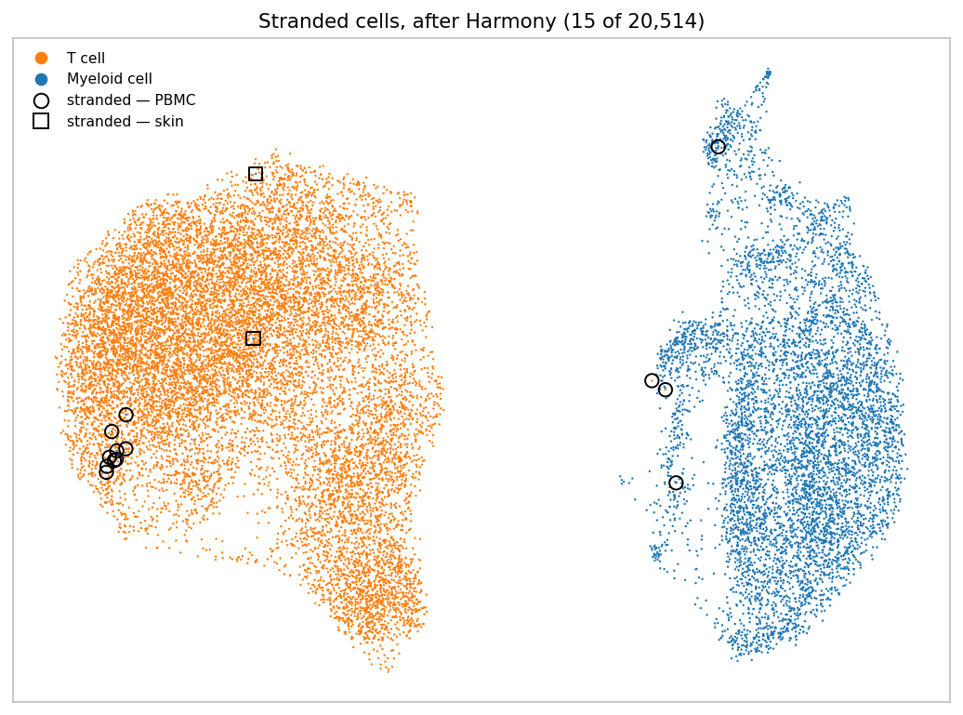
Circles = PBMC, squares = skin. Nine of the eleven myeloid-in-T cells sit together at the left edge of the T island.
sits in | tissue | labelled as | n | what the cells look like
T island | PBMC | CD14 Mono | 8 | 25–52% mito, 321–1,084 genes, almost no monocyte RNA
T island | PBMC | pDC | 1 | 23% mito, 658 genes
T island | skin | PVM | 2 | 380 and 471 genes, 5–6% mito, faint myeloid signal
myeloid island | PBMC | CD4 TCM | 3 | 2 look like T+monocyte doublets; 1 has monocyte genes and no T genes
myeloid island | PBMC | CD4 Proliferating | 1 | dividing (MKI67), no clear lineage genes, 13.6% mito
— | skin | any T cell | 0 | no skin T cell is stranded

(b) Are they mislabelled?
Mostly no. Most of them are poor-quality cells that do not carry enough RNA to belong anywhere.
- Myeloid cells in the T island (11): damaged/low-quality, not T cells. None expresses T-cell genes (CD3E, CD3D, TRAC = 0). Their monocyte genes are also nearly gone: LYZ 0–4 UMIs versus 65 in a typical CD14 Mono, S100A9 0–3 versus 78. The 9 PBMC ones have 23–52% mitochondrial reads (median for PBMC cells in this UMAP: 8.3%). With so little signal, the UMAP drops them at the edge of the biggest group.
- T cells in the myeloid island (4): a mix.
  - 2 CD4 TCM express T genes and monocyte genes, plus high haemoglobin (HBB 518 and 121 UMIs) → most likely doublets.
  - 1 CD4 TCM has S100A9 16, LYZ 5 and no CD3 at all → this one does look mislabelled; the RNA says monocyte.
  - 1 CD4 Proliferating is dominated by the cell-cycle signal (MKI67), which can pull a cell away from its lineage.
- One thing to check with Matthew: GSE194315 is CITE-seq, so labels may come partly from surface protein. That would explain a cell labelled CD14 Mono with almost no monocyte RNA.
→ 10 of the 15 stranded cells would be removed by our lab QC (pct_mt ≤ 10). The mitochondrial filter we discussed would clear most of this on its own.

(c) UMAP with B, NK and ILC from PBMC and Mast cells from skin
 | PBMC | skin
added | B 1,388 · NK 1,700 · ILC 10 | Mast 563
total | 17,711 | 6,464 (24,175 overall)
still left out | Plasmablast 13, Platelet 101, Eryth 28, HSPC 5 (not asked for) | keratinocyte, fibroblast, etc.

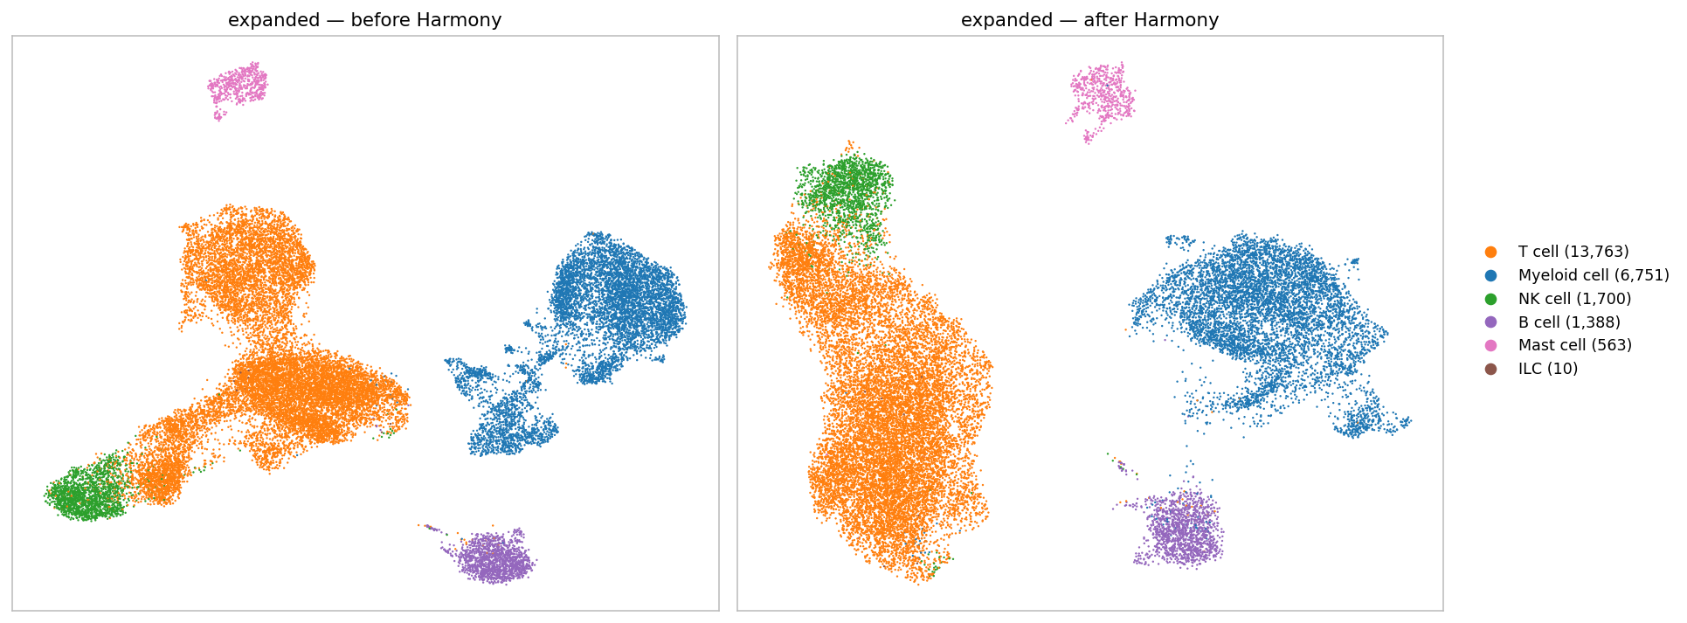
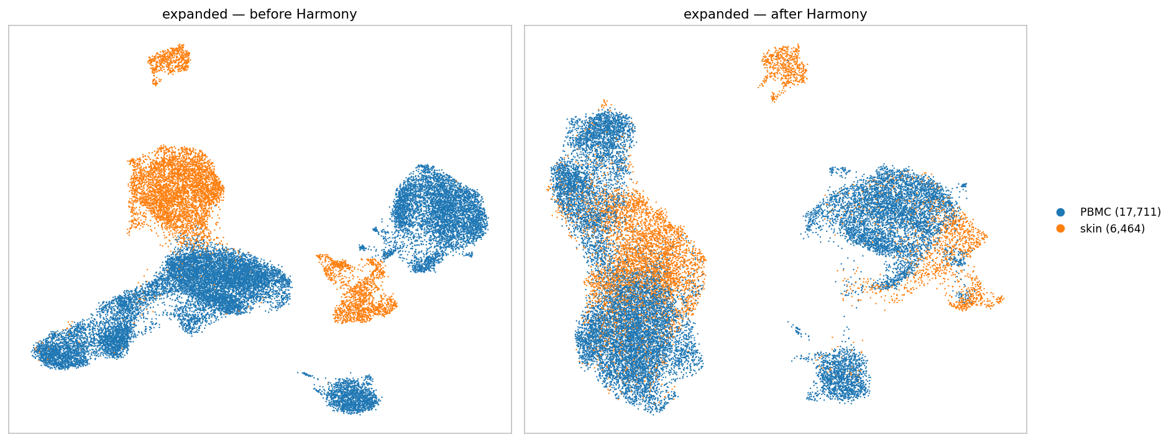
Expanded set, before | after Harmony. Top: cell type. Bottom: tissue.
- Adding cell types did not change the correction. Tissue mixing 0.038 → 0.314, the same as before (0.039 → 0.322). Cell types still stay apart (0.030 → 0.041).
- Mast cells and B cells stay on their own islands. Only 3.1% of mast-cell neighbours and 0.2% of B-cell neighbours come from the other tissue. That is correct: neither has a partner in the other tissue, and Harmony did not force one.
- 381 stranded cells (1.6%), almost all at the NK ↔ cytotoxic-T border. 81 PBMC NK sit with T cells; 59 skin γδ T, 45 PBMC gdT and 31 CD8 TEM sit with NK. These cells share the cytotoxic program, so this is expected biology, not mislabelling.
- Open: 25 skin cDC1 sit next to the PBMC B cells. I cannot explain this yet.
- ILC has only 10 cells, too few to read anything from.

Agenda 2 — Harmony on Myeloid and T cells separately
Each lineage re-embedded from scratch (its own highly variable genes, PCA and Harmony), so the two lineages no longer share the same 20 PCs.
tissue mixing (share of perfect) | before | after | Sep-14 joint, after
T cells alone | 0.059 | 0.378 | 0.322
Myeloid alone | 0.014 | 0.113 | 0.322

T cells: separating makes no real difference
Skin T cells have 43.0% of their neighbours from PBMC alone versus 42.9% in the joint run. Each skin T subtype pairs with the same PBMC subtype as before (e.g. skin cytotoxic T → PBMC CD8 TEM).

Myeloid: the score goes down, but the matching gets better
On the score alone, myeloid-only looks worse. But the score only asks "are the tissues mixed?", not "is each cell mixed with the right partner?". So I checked which PBMC subtype each skin subtype sits next to:
subtype |  | joint (T + myeloid together) | myeloid alone
skin cDC2B | neighbours from PBMC | 38.7% | 14.7%
 | mostly next to | CD14 Mono (88%) | PBMC cDC2 (49%)
PBMC pDC | neighbours from skin | 30.2% | 2.6%
 | mostly next to | skin LC (92%) | skin cDC1 (56%)
skin CD16+ DC | neighbours from PBMC | 43.9% | 10.5%
PBMC cDC2 | neighbours from skin | 9.9% | 19.9% (80% skin cDC2B)

- In the joint run, Harmony pushed skin dendritic cells onto blood monocytes. Skin cDC2B were paired with CD14 monocytes, and blood pDC with skin Langerhans cells. Those are different cell types.
- On its own, the myeloid run pairs dendritic cells with dendritic cells. Skin cDC2B now sit next to blood cDC2, and blood cDC2 get twice as many skin neighbours. Blood monocytes, which have no skin counterpart, are left on their own.
- Skin PVM (perivascular macrophages) still sit next to CD14 monocytes (74%). That is a plausible pairing, since these macrophages come from monocytes.
→ So your hypothesis is supported, for myeloid cells: correcting both lineages together was forcing the two myeloid populations to mix by matching the wrong cell types. The lower score in the myeloid-only run reflects less forced mixing. Mixing scores are a poor yardstick when the two tissues contain different cell types.
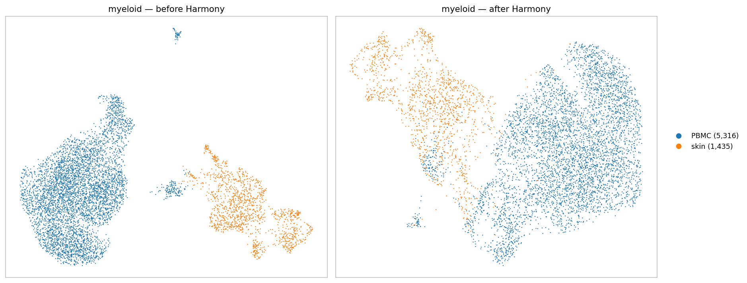
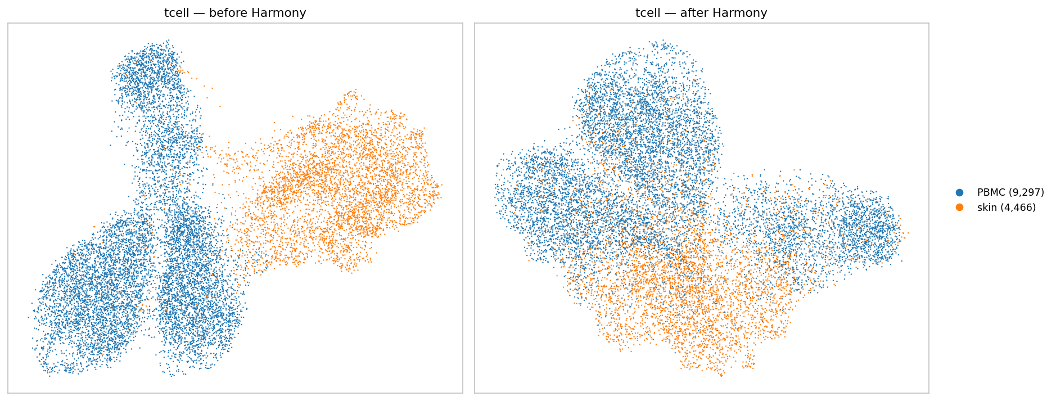
Myeloid alone (top) and T alone (bottom), coloured by tissue, before | after Harmony.

Agenda 3 — subtypes per tissue, other tissue in grey
Every UMAP, before | after Harmony, once per tissue. The other tissue is drawn first in light grey; the tissue being shown is drawn on top in random order, so no subtype hides another. Each subtype keeps the same colour in every figure, and subtypes with ≥ 40 cells are labelled on the plot.

Original (T + myeloid, as shown on Sep-14)
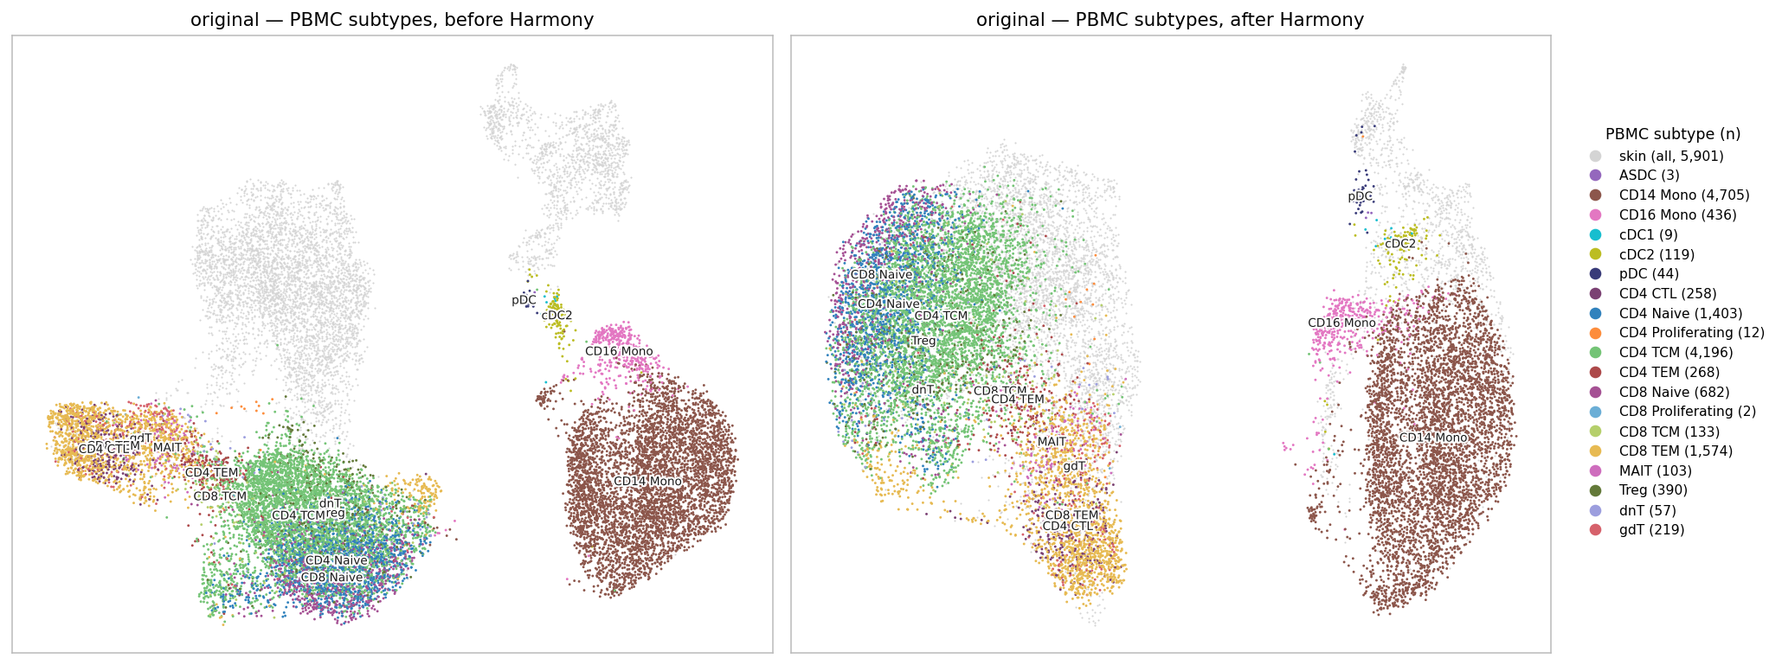
Original (T + myeloid, as shown on Sep-14) — PBMC subtypes coloured, skin in grey.
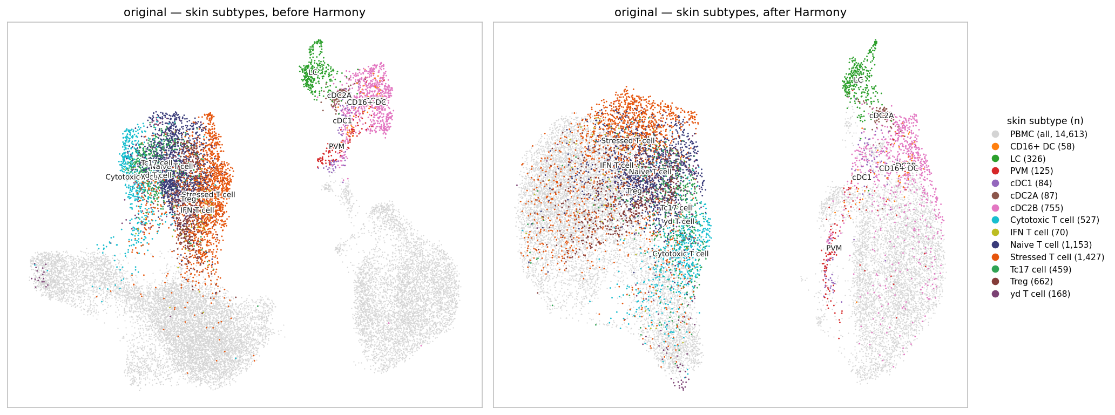
Original (T + myeloid, as shown on Sep-14) — skin subtypes coloured, PBMC in grey.

Expanded (+ B, NK, ILC, Mast)
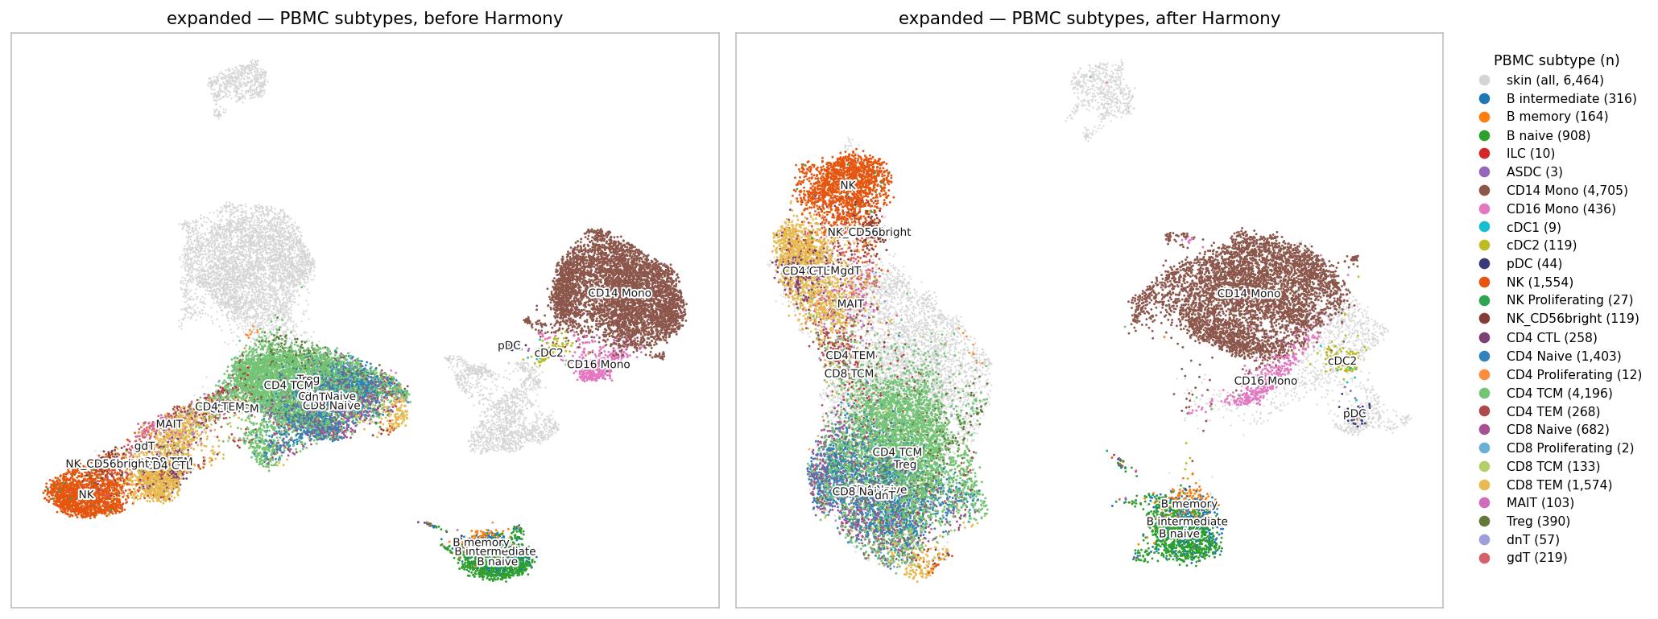
Expanded (+ B, NK, ILC, Mast) — PBMC subtypes coloured, skin in grey.
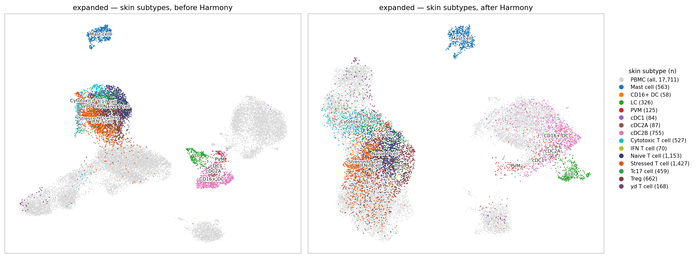
Expanded (+ B, NK, ILC, Mast) — skin subtypes coloured, PBMC in grey.

Myeloid alone
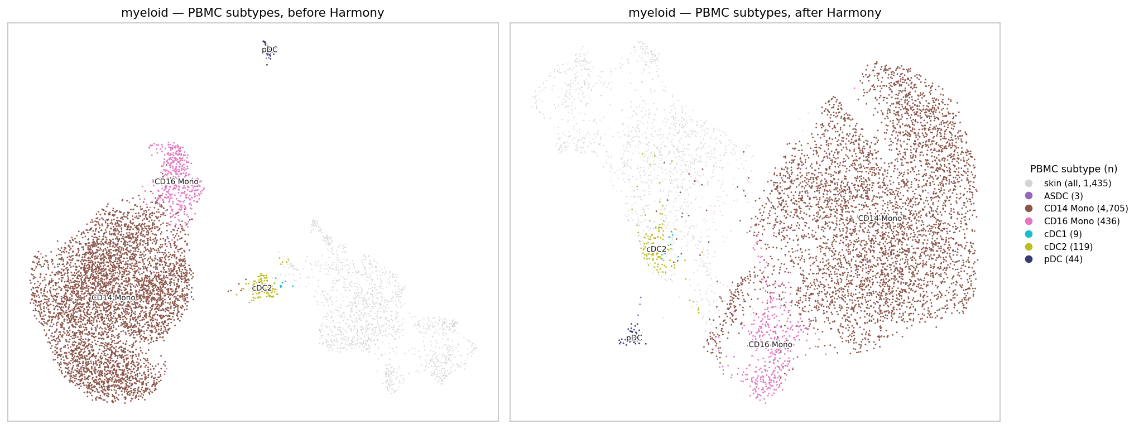
Myeloid alone — PBMC subtypes coloured, skin in grey.
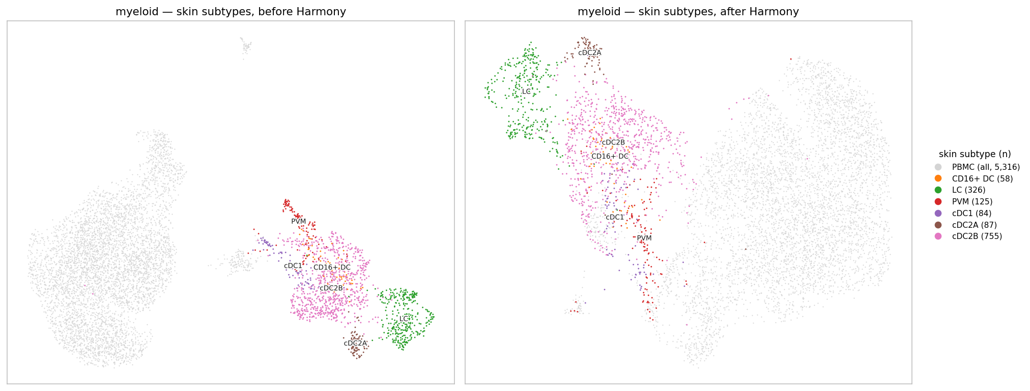
Myeloid alone — skin subtypes coloured, PBMC in grey.

T cells alone
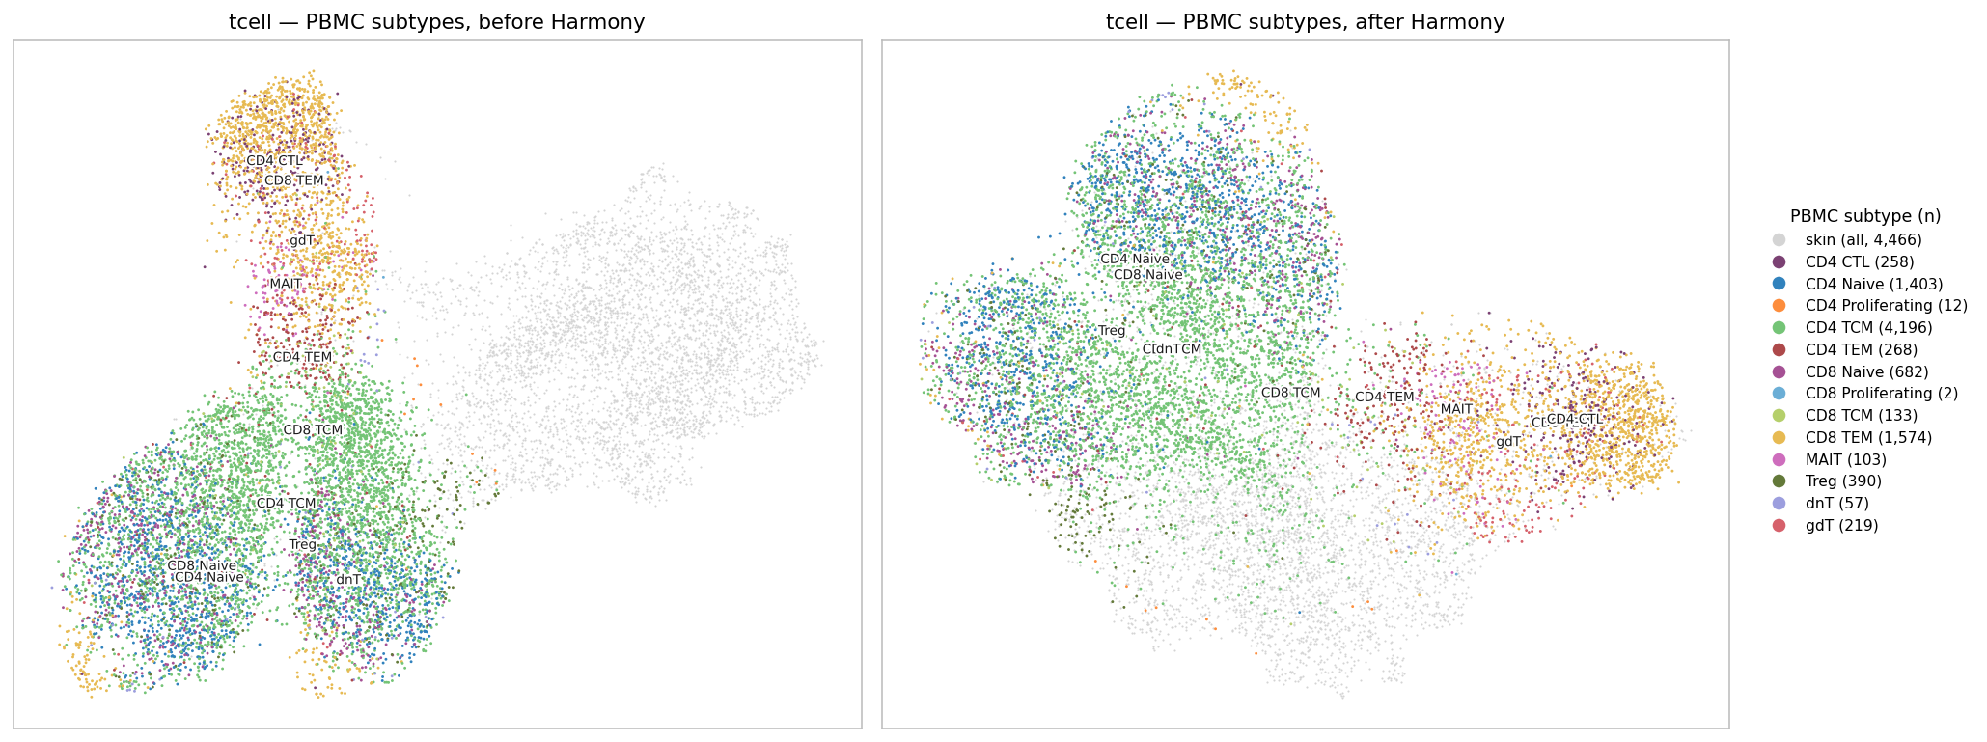
T cells alone — PBMC subtypes coloured, skin in grey.
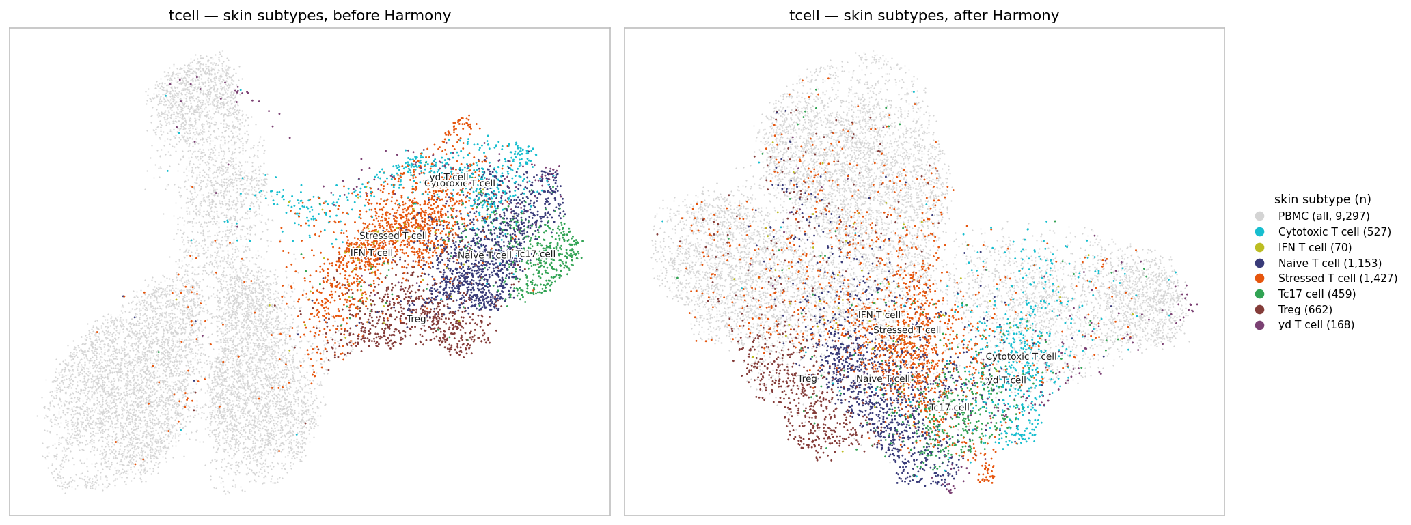
T cells alone — skin subtypes coloured, PBMC in grey.

What to look at
- Original, skin, after Harmony: skin cytotoxic T cells land on PBMC CD8 TEM / CD4 CTL, which is a sensible pairing. Skin cDC2B are spread over the CD14 monocyte island, which is the wrong pairing shown in Agenda 2.
- Myeloid alone, both panels: skin cDC2B and PBMC cDC2 end up in the same area; monocytes stay separate.
- T alone: skin Treg, naive and Tc17 cells sit at the edge of the PBMC CD4 cells rather than inside them. As on Sep-14, the tissues are only partly aligned.

Caveats
- PBMC is one lane (PBMC-01-1, 9 donors). The lab mitochondrial cut is not applied, the same as the Sep-14 run; 27.7% of the PBMC cells in these UMAPs (T + myeloid) would fail it.
- "Mislabelled" is judged from a handful of marker genes. It is a flag, not a verdict.
- UMAP positions are for viewing. All numbers above are computed in the Harmony PCA space, not on the 2-D picture (except the stranded definition, which is about the picture by design).

Suggested next steps
- Apply pct_mt ≤ 10 to PBMC and redraw. I expect most of the 15 stranded cells to disappear.
- Use the per-lineage embeddings (especially myeloid alone) for any skin ↔ blood comparison of myeloid cells.
- Ask whether GSE194315 labels are protein-based, which bears on the "mislabelled" question.

Files: results/joint-v2/ — stranded_cells.csv (per-cell detail), stranded_by_subtype.csv, mixing_scores.csv, other_tissue_neighbours.csv, partner_subtypes.csv, and {original, expanded, myeloid, tcell}/ figures.

