**P2 Deliverable**

Team Number: 13

Team Name: GTRideShare

We are making a design where commuter students at Georgia Tech can organize carpools with other students based on class time and location.

Sally Park, Michael O’Mara, David Kim, Mylon Craig, Chris Yun, Jin Woo Lee

Part Brainstorming and Communicating Design Solutions

**Executive Summary**

We are working on a rideshare design to connect Georgia Tech commuters who have similar schedules and destinations. While a majority of students do live on campus, there are still accommodations that can be made that will benefit both the environment and Georgia Tech. Single-rider commuters face the frustration of high gas prices, expensive parking passes, and what can be a long and lonely commute. Carpooling is a viable option for the single-riding commuters to reduce the cost of commute, but they have hard time finding partners to carpool with or managing the carpool in an efficient way.

**1. Problem Insights**

The primary problems which we are looking to solve through our solution are excessive commuting expenses and times along with increasing levels of carbon output. Upon first taking on this project we imagined that we would have a clear understanding of both our user groups and the problems that they face as the majority of our team members commute. We learned that we had a limited view of what the problem was after completion of user research. We learned that we need to make more of a concerted effort to identify areas where we should direct our focus and additionally work on having a better understanding of the problems our user groups face.

We identified that the primary expressed concern of current commuters is traffic and added time due to limitations. Among such limitations is their inability to use HOV lanes for instance. We determined that specific user groups consisted of slightly more than half of our four different types of predicted users. This ultimately identified our understanding of the other methods in which people decide to commute. Had we only focused on commuters that drive themselves to and from campus, we would have made light of the problems experienced by a large group of our target users.

Additionally, we were able to also increase our understanding of the scope of the problem, the types of target users, as well as the target user’s feelings regarding the idea of carpooling with others. We determined that the majority of our target user groups’ daily commute consists of more than 30 minutes, users on average pay more than $750 for parking per year, and users have at least 2 unused seats during their daily commute even if they already carpool. Moreover, we also identified what users find to be most uncomfortable when finding new carpool members. After taking this information into account we are confident that we have a solid foundation of the our problem space and understanding of the initial steps we need to take in order to establish an improved alternative to the current methods of commuting back and forth from Georgia Tech.

**2. Brainstorming Solutions**

1. The necessary profile should not take longer than five minutes to complete.
2. There should be a penalty or ranking system for each profile - lateness, cleanliness, etc.
3. There should be an option to choose same-gender or opposite.
4. There should be an option to cancel a carpool (with prior notice).
5. There should a central place to meet up decided by the the drivers/riders, rather than the driver picking everyone up to protect privacy.
6. There should be both short-term and long-term options.
7. There should be a priority on safety.
8. There should be a verification process for GA Tech community. (GTID etc)
9. The design should provide a GPS system.
10. The design should show a way to split expenses.
11. The design should avoid personal details such as address being shown publicly.
12. There should be a place for drivers to write down preferences on cleanliness.
13. The design should have an account system.
14. There should be a feature for backups (in case driver has to leave in case of emergency).cx
15. The app could show how much carbon emission is being saved.
16. There could be an option to deny rides based on mismatching profiles.
17. An option for riders with disabilities.
18. Make an app
19. Phone number registration system
20. Local commuting location decided by the app.
21. Share permits (off days)
22. Form groups to live more near campus for cheaper
23. MPH for car should pop up next to their name
24. Group car rental system (avoid permit responsibility)
25. Incentive program
26. Users can list their favorite activities
27. Electronic car systems - list if the car is electronic car
28. Designated time to leave
29. Use only the most fuel efficient car
30. Initial control of preferred members
31. At least one member in every group above certain age to encourage safety
32. Option to choose whether their cars will have certain functionalities such as air conditioning, accessibility to AUX cables, etc.
33. Sleeping allowed?
34. Eating allowed?
35. Preferences on music played.
36. Designated drop off spot in case of driver misconduct
37. Show driver’s license before riding
38. Housing application style of preference profile
39. Parents who give ride to children can match with each other
40. People must take and upload a picture of their buzzcard to the platform before they can be approved for an account
41. People should be able to filter potential carpool members based on association to school
42. People should be able to list the number of seats in their car
43. There should be a feature that allows people to match based on the time they get to school
44. Show statistics about how much money a certain user is saving on gas/wear and tear
45. Design should allow for people to send instant messages
46. There should be a feature that allows people to match based on the time they leave school
47. There should be an option for people to choose last minute/ or demand carpool
48. The service should be accessible from the phone and the desktop
49. There should be an option that allows parents to arrange drop offs for their children
50. Parents should be able to list if they would like their children to participate in the carpool
51. There should be a way to have a webcam conversation through the app with those you’re matched up with
52. matching should take place based on parking on campus place
53. People should be able to list on their profile if they have a peach pass or not
54. Access to driving records can be a requirement to use the app as a driver
55. The implementation of the design can predetermine a route based on the agreed upon pickup location
56. People should be able to list preferences about if their route takes the highway
57. People should be able to list what their preferred highway speed is
58. People should be able to filter based on how talkative they want to be in the morning
59. List Myers Briggs
60. Input for phobias
61. Searching algorithm for finding carpoolers near you should be a quick process.
62. Career aspirations
63. Favorite conversion topics
64. Relative leg space of vehicle
65. Single or Not
66. Gas refills mid-route
67. Vehicle insulation from outside noises
68. Wheelchair accessibility
69. Major and School
70. Smoking allowed?
71. Side airbags?
72. Graduation date
73. Willingness to listen to podcasts
74. Favorite radio station/music
75. Split costs of potential ticket or not?
76. App should require you upload a personal photo
77. Link app with pre-existing background check service
78. List whether you are a “morning” person or an “evening” person by nature
79. Users who have drove with a particular user should have the option of saying whether or not they believe a certain user’s profile selection info is accurate.
80. Users should be able to rate other users they have ridden with based on an array of things
81. Temperature preferences
82. Some cars are more prone to getting people car sick than others. Users should list whether or not they believe their car is good or bad for car sickness and other users can later say whether or not they agree after their ride.
83. Option for commuting with therapy pet
84. Vehicle safety index
85. Take BAC test before driving
86. Will illegal paraphernalia ever be in a user’s car at any given point in time (legal implications for both parties in the event of a vehicle search).
87. Willingness to stop for food options
88. Commuting outside of GT option
89. “Yes” or “No” metric system showing how many previous riders would again ride with a particular user
90. Option to ride based on a certain size of vehicle (i.e. sedan vs SUV)
91. An option in which you list how much a priority safe driving
92. Users should be able to list the longest that they will be willing to wait for other members of the carpool to come before they can just leave
93. Users who missed their carpool ride should still be given an option to find one on-demand
94. Option to arrange a non-commute ride share
95. Option to upload your specific route to school each morning
96. Provide first aid kit
97. Provide measurement of success and efficiency to GT PTS
98. A feature to show the level of carbon saving by carpooling instead of single riding
99. Users should be able to choose to either show or hide certain information that isn’t hard required.
100. Users will be barred from using the apps after three strikes have been made against their account
101. An algorithm to calculate the gas cost of a carpool trip. Users either take the suggested price or agree upon a new price on their own.
102. Credit based give-ride and take-ride economy

**3. Design Criteria**

During our prior research, we finalized our data into five central ideas. Among those five, we have selected three ideas most integral to our user’s problems to be our design criteria. They are:

1. *I want to be able to control who I ride with*: Our users should have sufficient information and full control over who they share their ride with.

This criterion will be helpful in assessing the effectiveness of how we address our users’ primary concern: who they share their ride with. Currently, users are forced to find in person people whom they wish to carpool. This from, our research was found to be too much of a burden and ultimately resulted in carpools not being made due to frustrations for example of not knowing anyone to carpool with. With this in mind, our users want adequate information of their potential partners through detailed user profiles and the freedom to pick and choose carpool partners. This criterion’s success or failure therefore will be determined by the overall satisfaction from a scale of 1 to 5 of how easy it is for the user to form a group.

1. *I want to always arrive at my destination on time without unnecessary delay*: Our users should not experience delays due to carpooling or end up spending more time on arranging a carpool than riding alone.

Second criterion will evaluate our efforts to minimize the time loss for joining a carpool group rather than commuting alone. From our research, we found that one of the main reasons for why most users who no longer carpool but carpooled in the past was due to frustrations from being late because of members being late themselves or having to make unexpected stops. In order to make sure our users are incentified, not penalized for using our design, we must develop a way to encourage punctuality among our users and a fail-safe feature to commuters if their partners are not punctual for a particular ride or continuously. This criterion’s success or failure therefore will be determined by the overall satisfaction from a scale of 1 to 5 of our users ability to arrive on time.

1. *I want my commute to be as safe as possible*: Our design must provide safety measures like GT verification to our users.

The third and last criterion will cover our approach to safety implications of our design. Measures to ensure all users are GT community members and all users who show up at an arranged carpool are indeed who they claim to be falls under this criterion. We found from our research that a primary concern whether it was driving alone or with a carpool was how safe it was. Although carpooling provides a nice incentive for saving money, we found that most of the time it was outweighed by the safety concerns people had when forming carpools which also contributed as a reason for the lack of carpooling. Therefore, this criterion’s success or failure will be determined by the overall satisfaction from a scale of 1 to 5 of how our user views our design address safety.

**4. Converging: Idea Selection**

When trying to find three candidates for an overall solution, we started with the brainstorming process. Each member of the group was given the task of coming up with twenty unique ideas over the weekend. These ideas were allowed to be either ideas for overall solutions to the defined problem space or features they believe a solution should have. The following Monday each member of the group brought their ideas to the group meeting and added the to a single Google Doc. We went through and read everyone’s ideas together out loud. We discarded from the list any ideas that were complete duplicates. But there were some unique ideas that some people came up with. These unique ideas spawned discussion that lead to the creation of even more ideas for the solution. These brainstorming ideas can be seen in the appendix.

Following the completion of the brainstorming portion of the solution making process, we wrote down the aforementioned ideas and began to create a physical affinity diagram. This affinity diagram can be seen in the appendix. But there were too many sticky notes to keep track off and place in order efficiently outside of the classroom. So these ideas were added to an excel document on Google Drive and were culminated into a virtual affinity notes diagram. Each member explained the motivation behind the affinity notes they had personally created to aid in deciding what category their note should belong to. We wound up having 12 separate columns of features and overall solutions. We thought about the types of solutions the combination of certain columns would create, many columns naturally fit in together others columns forced us to refer back to the problem space before we could merge them. So through combination and discussion we were able to group our 12 columns into 6 basic ideas for a solution.

At first the base size ideas seemed completely different, but then we noticed that some of the basic intentions behind the different solutions were the same. Some were based on customization, some were based on efficiency. We also rated and defined each of the six ideas based on how much the idea fit the design criteria. We used these common intent principles and ratings to combine the six columns into create three refined solution ideas. The finished affinity diagram with the top three ideas, six intermediate ideas, and 102 brainstorming ideas can be seen in the appendix.

1. *Users can find exactly the type of person they would be most comfortable with to carpool with.*

This solution relies heavily on having users create an in depth profile that will give them the option to conduct extremely specific filtering searches when finding people to match with. They can search through potential carpool members based on any description listed in the detailed user profile. This includes anything ranging from the gender the user prefers to carpool with to what type of music they like to listen to.

1. *Users make their own template on our platform for how carpooling costs and liabilities are to be separated amongst the members in their group.*

This solution allows users to enter their carpooling group into our system. The system will allow groups to work collaboratively to define how their carpool arrangement will manage specific criteria the carpool members might not have stopped to consider. The platform will require the group to make specific decisions on matters such as how liability will fall in the case of an accident, how payments needed to fund regular gas stops will be distributed, and how often and on what schedule the carpool will meet. After the carpool contract is completed, members will be barred from making edits unless all group members agree, and it will be archived on the platform so that users can refer to it at anytime.

1. *Platform makes sure that the carpool arrangement is the most environmentally friendly*

This solution puts an emphasis on maximizing the reduction of the environmental footprint of commuters. The platform matches users with less efficient cars to those with the more fuel efficient cars. Carpool matches are made with the intent to fill up existing carpools with as many members that the users’ vehicles can handle, so that the environmental effect of commuting can be even further decreased. The miles that users carpool are tracked on the platform so that figures of how commuting reduces each users environmental blueprint can be calculated and displayed each time a user enters the platform.

1. *A platform where those that already carpool can automatically split up the cost of carpooling*

The purpose of this platform is solely managing the financial expenses of those that carpool. User’s enter the distance of their average carpooling commute, the amount spent on gas each week, and other criteria. The platform then generates a financial figure of how much each carpool member should be contributing to the driver that week in expenses. If everyone in the group agrees on the weekly cost, carpool members can transfer the agreed upon fee to the driver through the platform.

1. *A platform where we just make sure that those that are on the platform trying to carpool are responsible and who they say they are.*

The emphasis of this design is on safety. Members must upload their buzzcard or gtiID number to verify their identity before they can create an account. If members plan on being a driver in their carpool, they must upload their driver’s license or driving history before they can be eligible to act as a driver. Both drivers and riders can rate each other through the app. Low scores can be given out to tardy riders or dangerous drivers. Those that consistently have less than three stars will have their accounts removed. Users can then choose carpool members without having the worry that users are irresponsible drivers or lying about who they are.

1. *App automatically creates defaults for use and matches carpoolers on demand.*

This solution allows users the options to fill their carpool in real time. Users upload the time they need to leave or arrive to campus, the city their either leaving from or heading to, and the platform automatically connects them with another user to carpool with. Based on the locations of the carpoolers, the app predetermines where users should meetup for either the pickup or drop off of their carpool, and the app determines which route to or from campus would be the quickest.

From the process above, we have arrived at below three solutions:

1. *An app with a user driven, detailed selection system*

This solution helps users to find and manage their own carpool groups. This app will require users to make a primary user profile that details the users’ essential information which includes neighborhood and schedule. Users will also fill out a preference profile. (An example question included in the preference profile would be: “How often do you smoke?) Users can then filter by categories in the app to find other carpoolers that meet their specific criteria. After they find a carpool group, they make a carpool contract through our service where they detail how often their group will meet, how they want to split expenses, and carpool rules.

1. *Create bus routes akin to the stingers and trolleys that have routes to pickup locations in cities where a significant amount of Georgia Tech Commuters live.*

This solution helps users to have a reliable and safe ride home. Qualified drivers will be evaluated and hired to run these bus routes. Unlike the stingers or trolleys, these buses will have only one designated stop in which they will be traveling to and from throughout the day. Additionally, depending on the distance and demand of certain locations, buses will arrive in longer intervals in comparison to the intervals of stingers and trolleys

1. *Designate a waiting room with a buzzcard sign-in kiosk where drivers can find carpool members to commute home with and earn money.*

At the end of the day a room in the culc will be designated as a carpool waiting room. This waiting room will have a sign in kiosk located outside the door. In the kiosk, users write down what city their trying to get to and can see if there is a driver in the waiting room that is going their way. Drivers can use the kiosk to see if there are riders there going to the same city. They use their buzzcard access to enter the room and find their driver. If they decide to commute together, the users can use the kiosk to transfer a flat rate from the riders buzzcard account to that of the driver.

**5. Low-Fidelity Prototypes**

Solution #1 GT Bus Carpool

This solution is based on what is currently used in grade schools where they have buses with predetermined routes that encompass a large section of certain areas of heavily populated students that go to school. This variant however will be different in where rather than making several stops, each generalized area will have only one designated stop. The designated stop will be the gathering point similar to that of marta where students who commute to and/or from Georgia Tech can choose to park and ride the bus to school. Through this solution, it addresses the problems commonly found from our affinity notes which include: decreasing the amount of cars on the road resulting in less traffic and improved environmental health, emphasis on safety by having a designated driver approved by Georgia Tech through their standards already used to qualify their drivers used in today’s transportations systems, and stress on punctuality by having standard times of arrival and departure.

This prototype’s main purpose is to provide an efficient and reliable method of carpooling; therefore it primarily focuses on both commuters who currently do not carpool and dependents who are susceptible to complications such as being late due to factors out of their control. Although they are the primary focus of this prototype, it also affects those who already carpool as well as those responsible for handling parking and transportation systems of Georgia Tech. Therefore, the stakeholder groups of this prototype include single-rider commuters, dependents, carpoolers and the GTPTS. Single-rider commuters, carpoolers and dependents are affected either by being direct users of this prototype or by enduring more competition on HOV lanes generally not accessible by most commuters. The GTPTS are included as stakeholders of this prototype because this will affect their current system by influencing the need and number of parking locations as well as requiring the use of resources of buses currently used for transportation around campus as well as involving the faculty of drivers who currently provide transportation services.

Objects relevant to this solution include buses, a system comprised from an alteration in GTPTS’s organization of transportation across campus, a method to figure out where and how many designated stops are needed, the creation of them if they do not already exist, and a GT specific method of access to them, for example a buzzcard reader. Buses and the locations for designated stops are crucial because they are necessary in order to achieve the carpooling aspect of this solution. Users who arrive at the designated location on time, will be able to get on the bus and have a safe carpool to and/or from Georgia Tech. In order to accommodate those who arrive late while keeping the commute as timely as possible, the bus will have a wait time of 10 minutes before departure. Those who do not arrive on time will have to wait for the next ride to arrive. Students will receive the feedback of having a secure and timely ride due to having the drive operated by a Georgia Tech approved driver and by having no additional stops, addressing the problems concerning safety and punctuality. Figuring out the the number and best locations for the designated stops are also crucial because without it, it will greatly influence the amount of people who may and can use this service. It is also necessary to have a georgia tech specific method of entry into the parking lot in order to provide further safety to students using this service. Lastly proper scheduling method is also necessary because people will use that information to determine when they should leave in order to arrive on time to the stop and plan their schedule. accordingly. Proper decision regarding locations and its construction as well as the schedule are necessary in achieving a timely and reliable commute further addressing the problem concerning punctuality and safety.

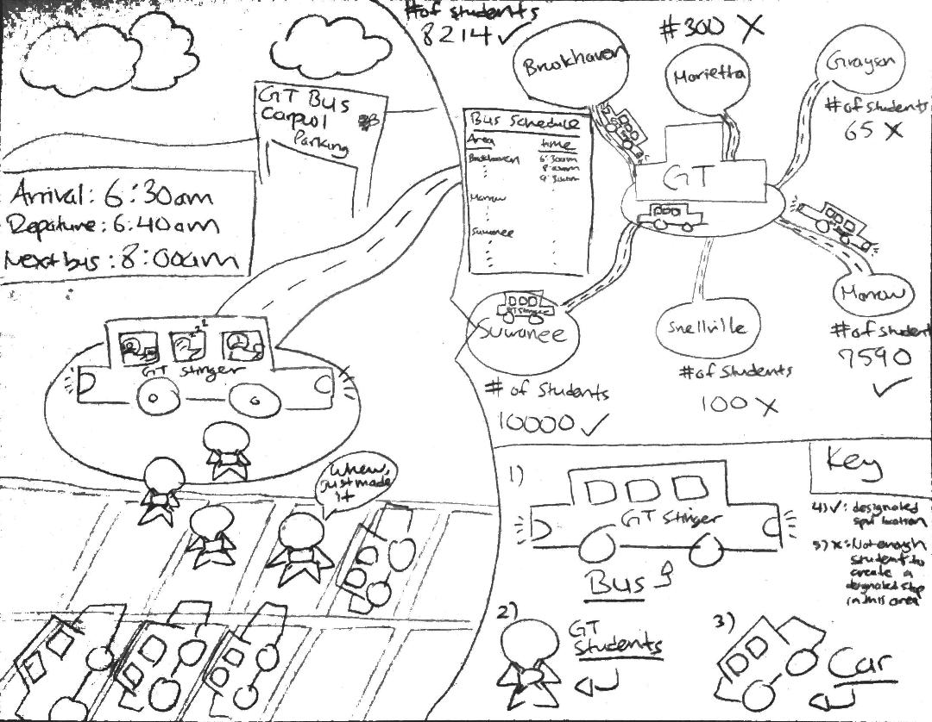

Solution 1 Sketch

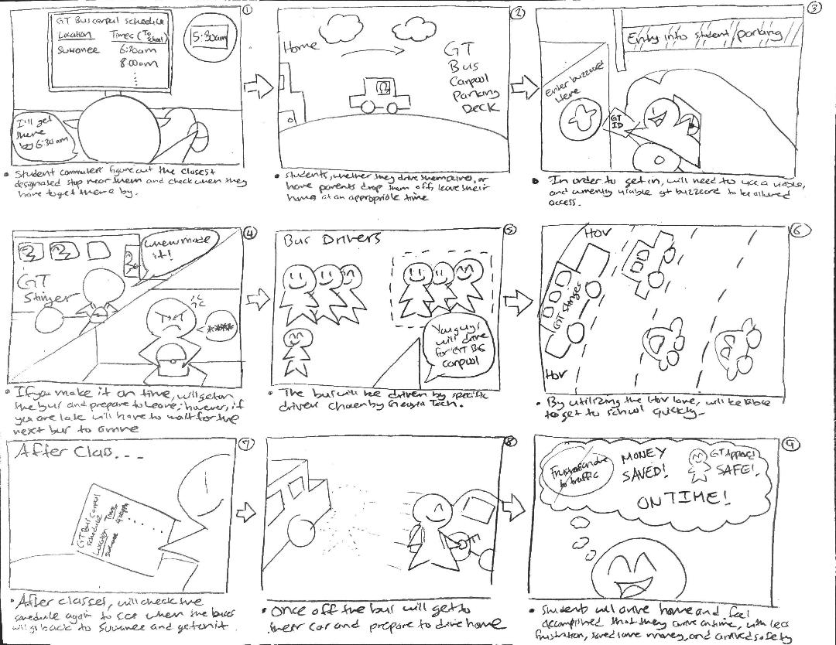

Solution 1 Storyboard

Solution #2 GT Carpool

GT Carpool is a carpool app that mainly focuses on solving the disconnection between GT commuters by providing its users a social platform to arrange carpools as they see fit. With GT Carpool in hand, commuters will be not only be able to search for other commuters in their neighborhoods, but will also have freedom to choose their carpool partners based on schedule and preference.

Users will interact with the app in the following way: first, upon account creation, users fill out their essential profile and preference profile. Essential profile includes basic personal information such as name, age, sex, occupation, etc. It will also include neighborhood and school schedule. Preference profile includes questions that ask user’s preference on specific items such as smoking, eating inside the vehicle, and talkativeness. Users will also provide a scanned image or a photo of their GT ID for verification. Upon completion of two profiles, users will be able to search for other users. User search can be filtered by personal information recorded in users’ essential profile: neighborhood and schedule, for example. Users then can go into each user’s preference profile from the list of users and choose carpool partners of interest. They can invite the user of interest to either a new carpool group or an existing one. Once a carpool group is created, participants can then create their own carpool contract that records in detail the frequency of carpool, driver rotation, the amount for financial compensation, etc. A template contract can be provided, but it is up to users to create a set of rules that they will agree to follow.

Giving our users the freedom to choose carpool partners and manage each arrangement on their own satisfies the first design criteria: users want to control exactly who they ride with. In addition, users will be able to rate other users who have been in their carpool. Rating system combined with GT ID verification will satisfy the third design criteria of safety. Users will also be able to agree on a designated time of departure when the carpool will depart whether all the participants are there or not. Such a feature will satisfy the second design criteria of timeliness.

GT Carpool’s user group is commuters of GT community, student or faculty/staff, who are either looking for a carpool for various reasons or are already in a carpool and are looking for an efficient way to manage it. As it is a social platform, commuters will be both the providers and consumers of its service depending on situations. Single riders, who already commute regularly by their personal vehicle will be providers when they are the drivers of the carpool they are in. They will turn consumers when, depending on the carpool arrangement participants agree to, become riders instead of drivers. On the other hand, dependents, commuters who do not own a vehicle of their own, will most likely stay as consumers. Drivers will be incentified to take part in a carpool by financial compensation by the riders and, if there are multiple drivers in the carpool group, being able to take a free ride to the campus and back without the hassle or the cost of driving.

Because it is an app, GT Carpool will depend on users having access to a smartphone and wireless internet. Providing our solution as an app will allow our users to have access to individual profile management, carpool management and the ability to search for a new carpool group if a sudden change of schedule were to occur on the move.

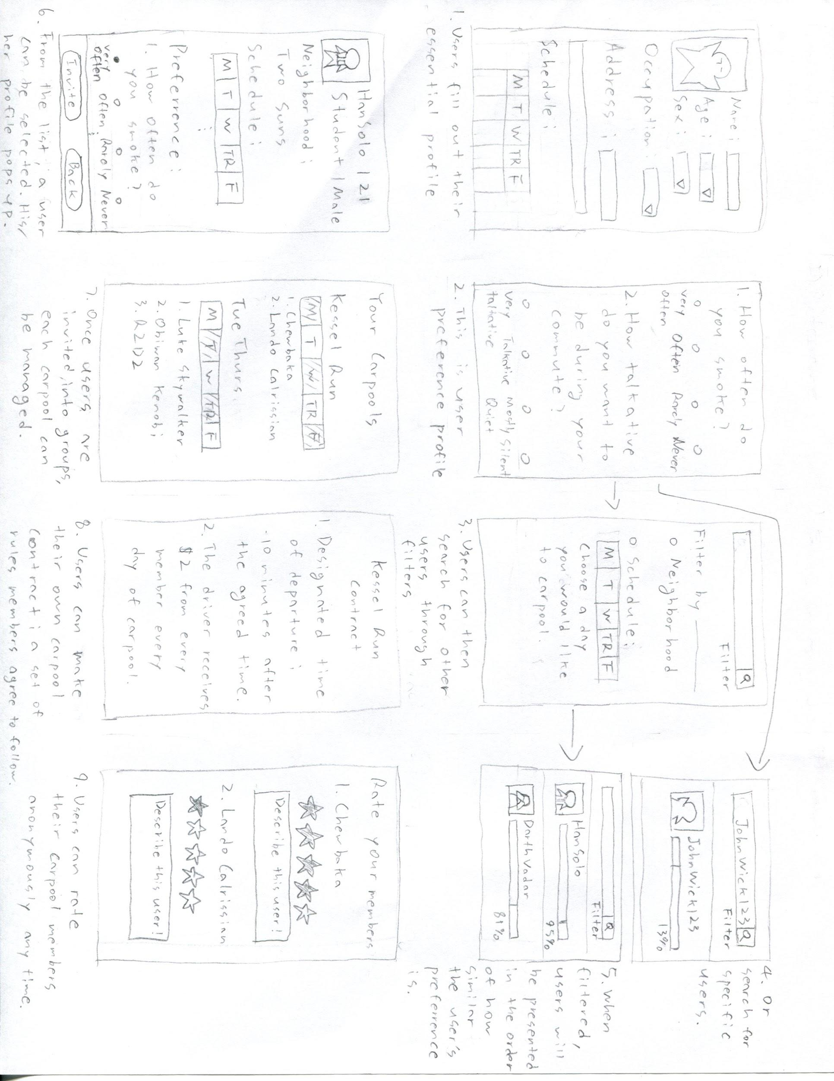

Solution 2. Sketch

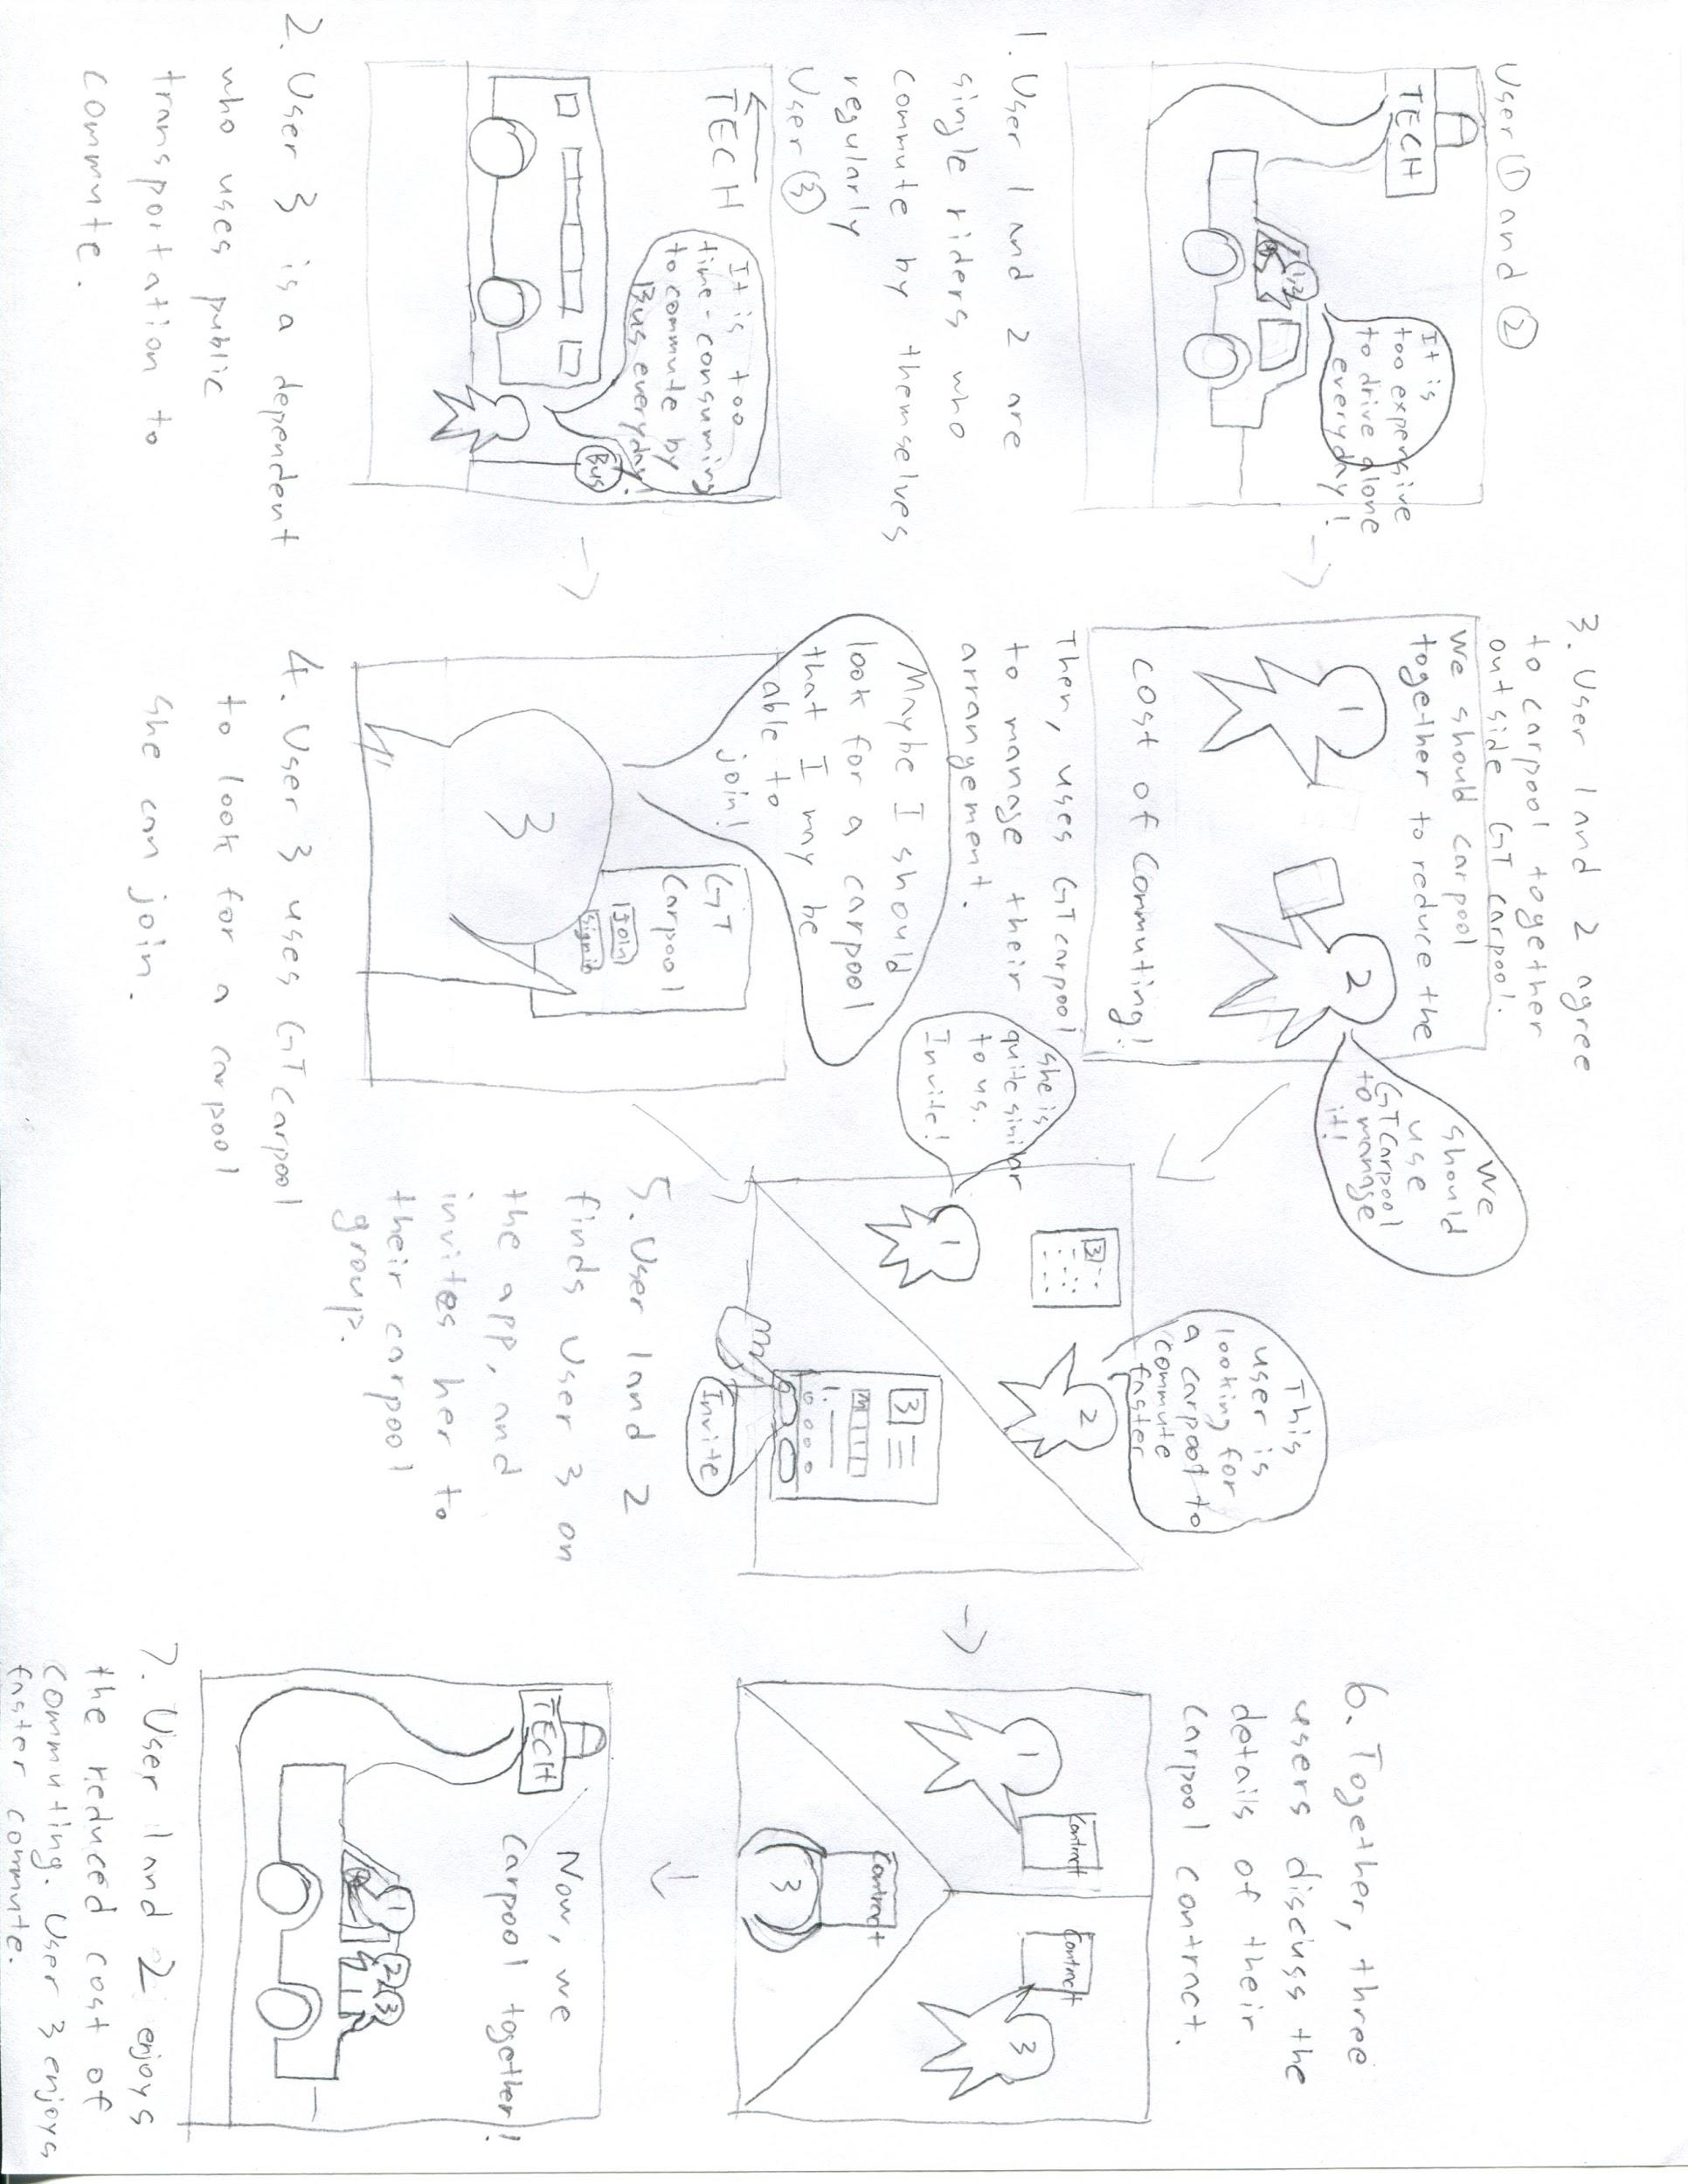

Solution 2. Storyboard

Solution #3 The Efficient Waiting Room

The next solution for the problem space is called the Efficient Waiting Room. This solution tries focuses on the creation and management of carpooling following the end of the school/work day when people are trying to get home. Those on campus who either cannot drive that evening or prefer not to might consider carpooling to be a viable option for getting home. But oftentime the choice to get a ride home is an impromptu affair that requires on demand accommodations. For example, someone who pulled an all nighter the evening before might feel that driving themselves home isn’t a safe option as they progressively get more tired throughout the day. Or a homesick student might decide halfway through the day that they would like to go home and see their family, but their car isn’t on campus. Now during the evening, Uber and Lyft prices surge to match the rising demand for rides, making the normal routes for obtaining on demand rides less financially feasible options. In both situations, there are three common problems. One, the ride need to have the ability to be created on demand. Two, the ride needs to be cost efficient. Lastly, the driver needs to be someone credible. These are the specific problems the efficient waiting room tries to tackle.

The focus of this prototype is on both the provider and supplier. For the consumer side this prototype assists those in the Georgia Tech community that need an affordable ride home. On the other side of this issue are the providers. There are single rider commuters that perhaps wait for a little bit after their day ends to drive home in order to avoid the traffic or to talk to a friend. These drivers might be interested in making some extra money by taking others to the same place they’re already heading to. So the provider focus of this prototype is on single rider drivers that would like to earn some extra cash, help out fellow members of the Georgia Tech community and reduce their environmental footprint through carpooling. There is also a third party stakeholder in this solution design: the Georgia Tech Parking and Transportation Services. GTPTS is a stakeholder due to the fact that this design focuses on issues that affect both transportation matters on campus and the Georgia Tech community as a whole.

At four in the afternoon a room in the Student Center will be designated as a waiting room for commuters. On the outside of this waiting room there will be a kiosk that requires a buzzcard swipe to use. On the side of the producer, single rider drivers will use the kiosk to enter their status as a driver, the number of available seats in their car, the city they’re heading to, and the time they plan to head home. The kiosk will then record this information and assign the driver a specific table number to sit at in the waiting room. If there are riders already in the waiting room heading to the city that they are, the kiosk will let them know what table number these riders are sitting at and the riders’ names. The driver will then use their buzzcard to enter the room.

On the side of the consumer, riders will head to the kiosk and enter the name of the city they’re heading to. This will allow the riders to see if there are already drivers in the waiting room heading to the entered city. If so, they can see what table numbers those drivers are sitting at and what time the driver will be leaving campus. If there are no drivers assigned to their destination city, the rider enters their destination city and is assigned a table number to sit at. Riders then use their buzzcard to enter the waiting room.

Riders and drivers can then communicate in the waiting room to negotiate their drop off locations, preferred route, and riding preferences. If they decide to ride together, the users can return to the kiosk to transfer a flat rate in buzzcard funds from the riders account to that of the drivers. Of course during their negotiations users can come to their own agreement, but the kiosk will be the standard option. After a payment transaction has occurred, both the rider and driver’s information will be removed from the kiosk. In the case that no carpooling agreement has been reached, ten minutes after the driver’s indicated leaving time has been reached, their information will be deleted from the kiosk. And both riders and drivers can logout of the kiosk whenever they like if they change their minds.

In the case of an unsatisfactory riding experience, users can use the kiosk to see the ride history attached to their buzzcard. They can click on the listing of the unsatisfactory ride and choose the option to report a driver or a rider. This button will send a ride review form to their Georgia Tech email address. The user can then write their review of their experience discreetly. The report will then be reviewed and depending on the content of the report, the reported user will be asked to revise their behavior, be barred from using the waiting room, or the proper authorities will be contacted.The user will be notified when their report has been reviewed.

In the beginning of this solution description, we listed three key problems that this solution should answer.

1. Consumers need to be able to find a ride home in real time.
2. The ride home needs to be affordable.
3. The driver needs to be someone credible.

For the first problem, the waiting room allows for a driving arrangement to be made in real time. When you want to head home, you can just go to the waiting room and find someone headed where you are that is leaving at a time that suits your needs. As more and more people use this system, it will become even more efficient, as the odds of finding someone heading your way will increase.

For the second problem, the flat rate ensures that the price will be reasonable for the rider and consistently profitable for the driver. With riders being able to avoid the surge pricing the evening brings, they will save money. Also, if riders more consistently choose the cheaper option, drivers will make more money more regularly making it profitable to be a rider.

For the third problem, members of the Georgia Tech Community might feel more at ease taking a ride with another member of their community who they know is held to the standards as themselves than taking a ride with a complete stranger. And by requiring both riders and drivers to scan their buzzcard before they can enter the waiting room or use the kiosk, both consumers and producers can be assured that all users are who they say they are. Also, having the ability to report reckless drivers or riders will make the waiting room even more safe, as only those without negative reports will be allowed to participate in the service.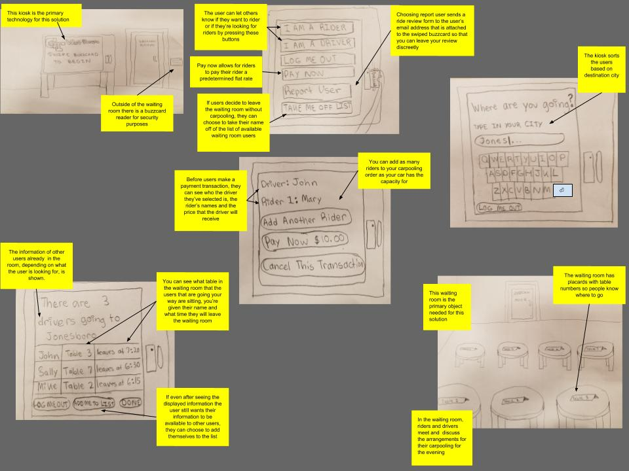

The storyboard and sketch are located at the end of this document!

**6. Reflection (6 points)**

There was a definite correlation between the tasks to complete in both Part 1 and Part 2. Although Part 1 was problem based, and Part 2 solution based, we were able to utilize the skill set acquired through the process of diverging upon an idea and expanding, and later condensing to specific problems or solutions respectively. Likewise, the measures taken into account to complete P1 of the project, such as surveys and interviews, allowed for a better understanding of the problem space we chose to tackle, and resulted in an increased ability to empathize with our target groups, as well as a better frame of mind to discuss and converge upon possible solutions.

The interviews and surveys have had a huge impact to our preparation to this project. Without that base foundation, we would only have our limited views and opinions on our chosen problem space. As mentioned prior, the ability to empathize with our target group for our selected problem space is what keeps our project intact, because it becomes the “why” or purpose behind our process. Also, the feedback received through those activities served to diverge upon hundreds of ideas, and later group them together in a specific manner.

Although the in class brainstorming activities were performed after the P1 deadline, the process by which we came upon the problem space sparked deviations to our initial thoughts, as we later defined as the process of brainstorming. However, due to the timing of those in class activities, we may have been unable to completely take advantage of the skill set. Most people have done their own definition of brainstorming in the past, but only when it was concretely described, and the activities were performed were we able to utilize the skill set to a higher degree. We also felt we needed a more clarification of the solutions we were converging upon. At times, we found that during this process, we struggled to find the line between a solution and a feature of our prototype aimed towards.

**APPENDIX**