**Getting Started with WileyPlus**

**We will not use WileyPlus for assignments** this semester, but if you prefer an e-book, it is available through WileyPlus.

**Registration**

You will self-register for WileyPlus. To do so, visit <https://www.wileyplus.com/WileyCDA/>.

1. Click “Find Your Course.”

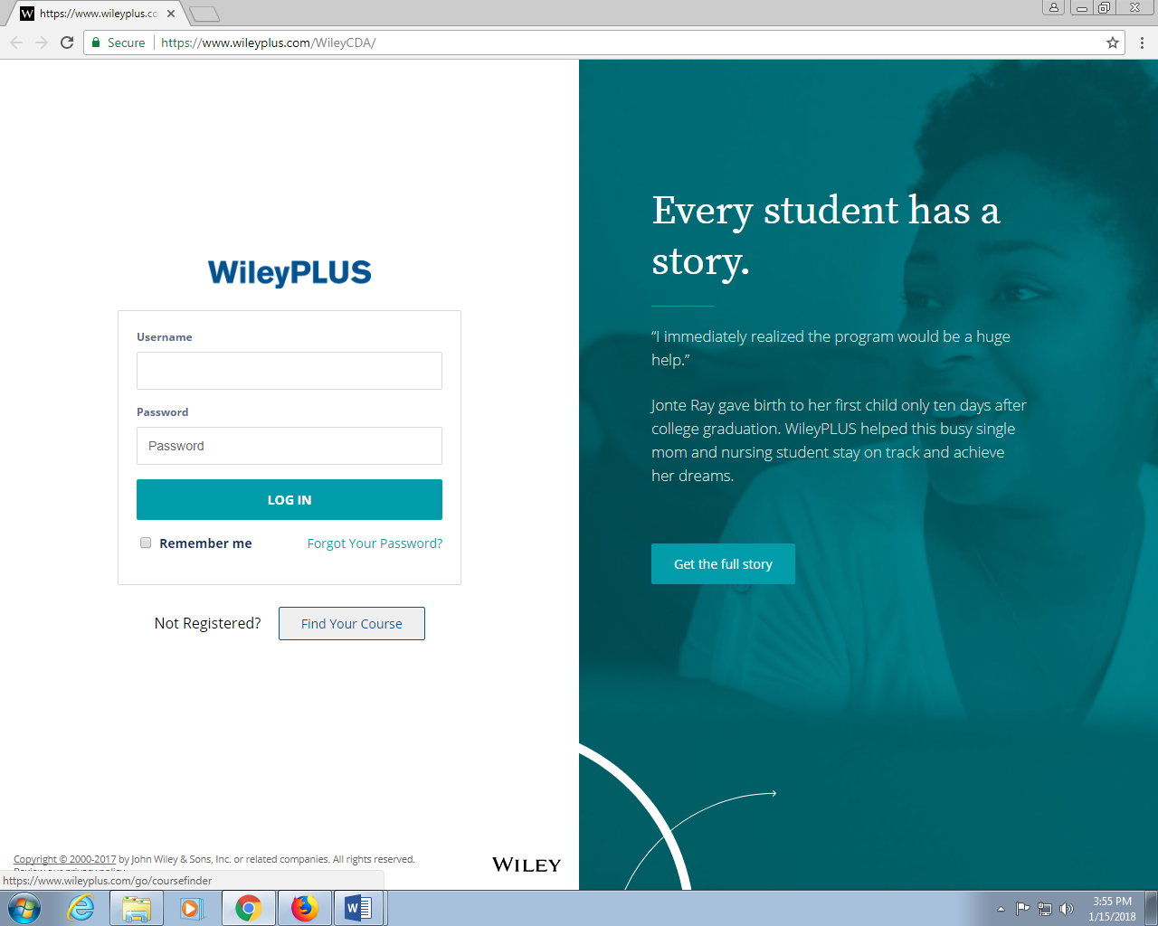

1. The easiest way is to use your 6-digit Course ID. If your instructor has provided a Course ID, enter it in the box in the lower left corner and then skip to step 4.

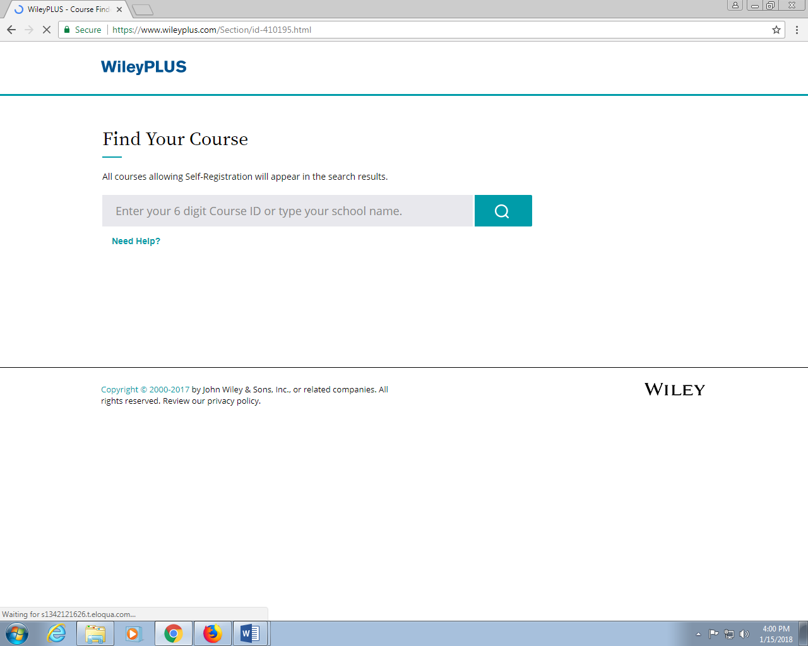

**Otherwise** in the in the search box, type “University of SC Columbia” and click the magnifying glass icon.

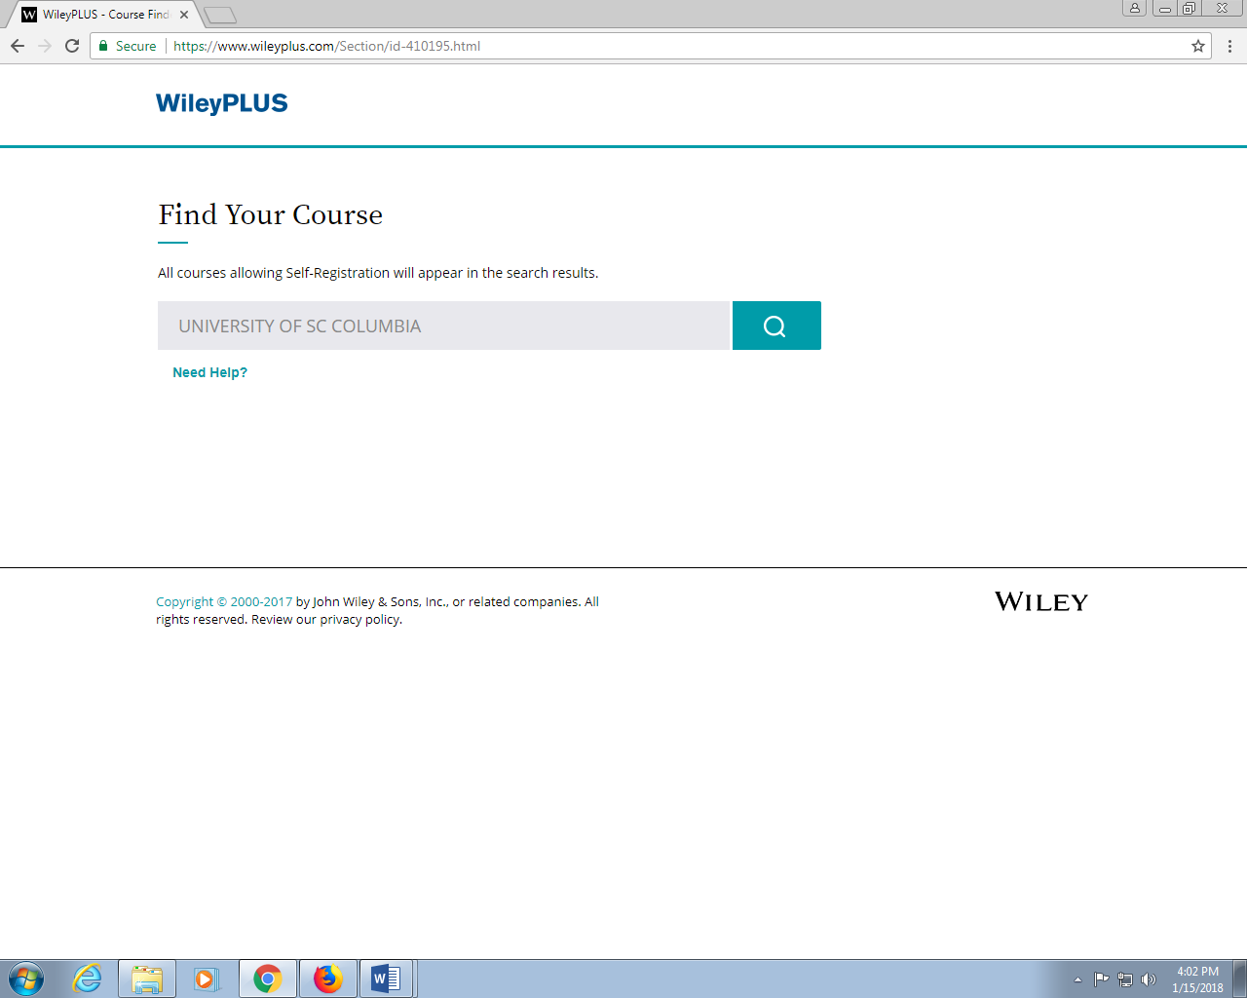

1. Choose “APPLIED CALC / MATH 122” and find your instructor’s name. The term should say  
   “**Spring 2018**.” Click the teal arrow next to your instructor’s name.

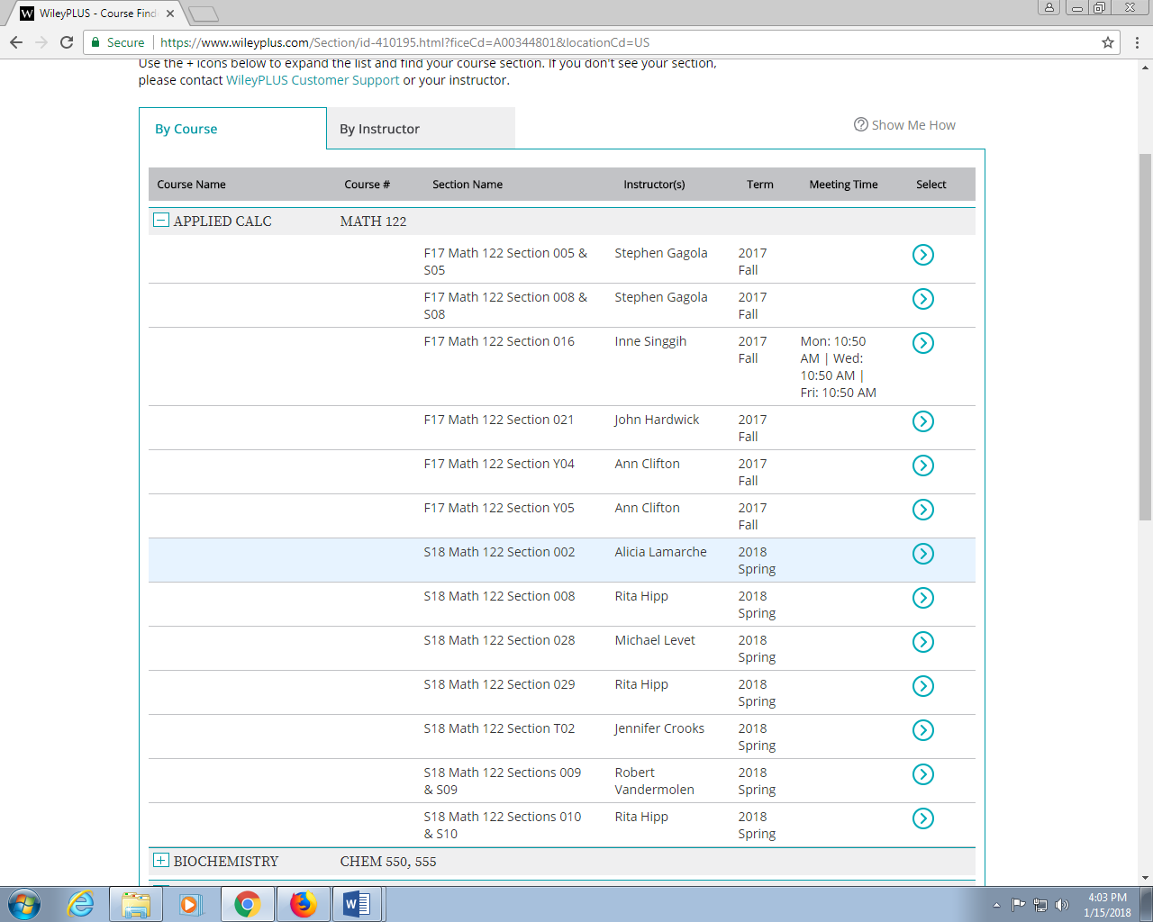

1. On the next screen, you will be prompted to create an account. If you have used WileyPlus before, you can log-in with this screen as well. The rest of these instructions assume you are new to WileyPlus.

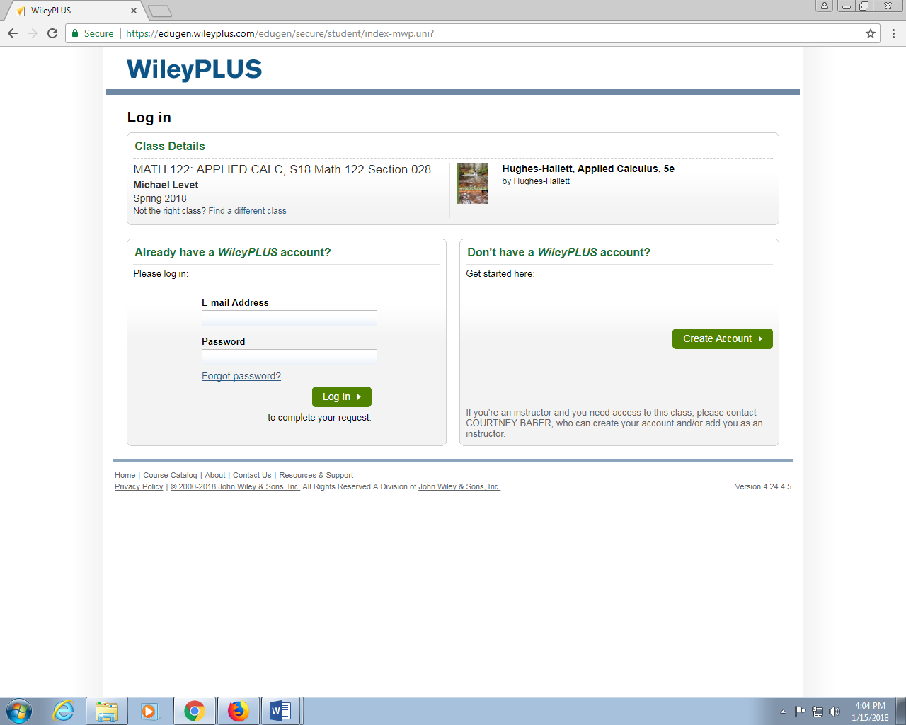

1. Click “Create Account.” You will be prompted to read and agree to a licensing agreement. If you agree, you will be able to continue with the registration process.
2. Once you have agreed to the licensing agreement, you will find yourself with three options:

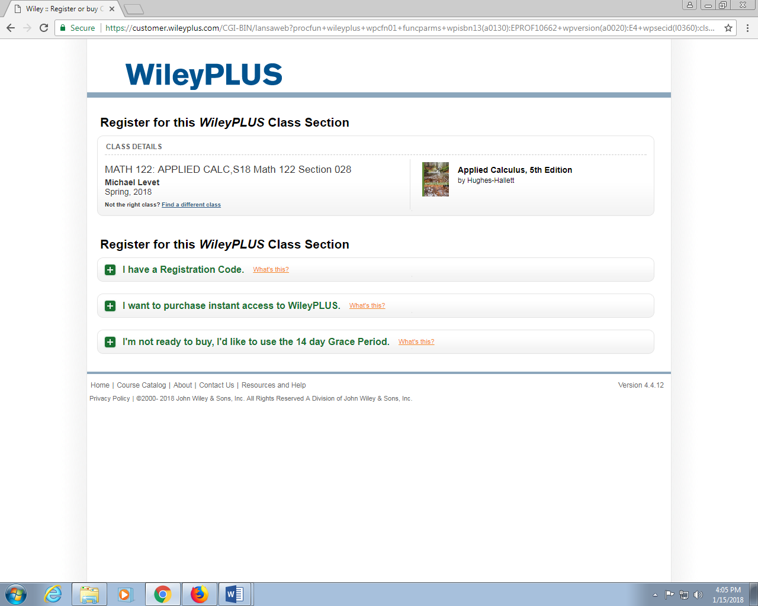

Option 1: If you purchased a textbook that came with a registration code, you can enter the code now.  
  
Option 2: You can purchase a code for **$100.00**. You may also order an eBook for offline use or a printed copy of the book at a discount.  
  
Option 3: You can use the WileyPlus **free for 14 days**. The grace period starts on the day you register for the course in WileyPlus. After 14 days, you will be locked out of WileyPlus until you purchase a code.  
  
Choose one of the options above and follow the prompts to pay and/or create a student account.