Predicting Exoplanets by Model Fitting Kepler Objects of Interest Data

David G. Kinney

Bellevue University

DSC 680 – Professor Catherine Williams

**Abstract**

The NASA Exoplanet Archive is an online astronomical exoplanet and stellar catalog and data service that collates and cross-correlates astronomical data and information on exoplanets and their host stars. These data include stellar parameters (such as positions, magnitudes, and temperatures), exoplanet parameters (such as masses and orbital parameters) and discovery/characterization data (such as published radial velocity curves, photometric light curves, images, and spectra). [1]

Keywords: exoplanet, NASA

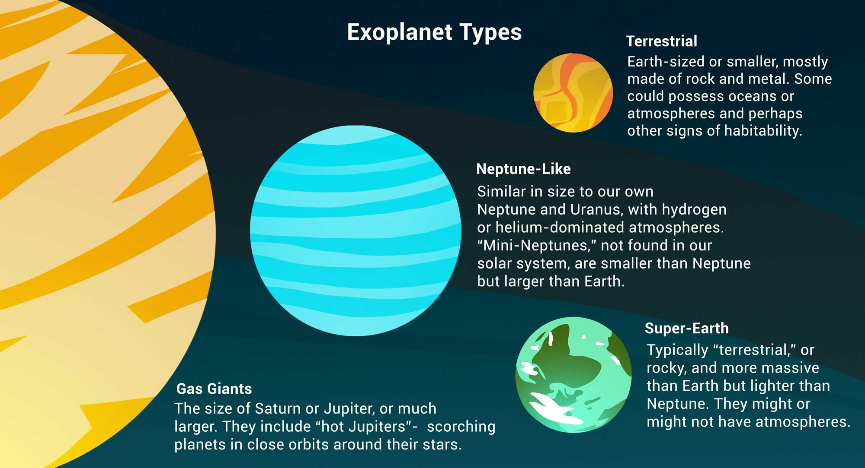

Image credit: NASA/JPL-Caltech/Lizbeth B. De La Torre

* APA references
* Summarize your business problem/hypothesis
* Walk through your method
* 5-8 Pages, 4000-8000 words
* Up to 3 Illustrations @ ¼ page each
* Up to 1 Illustration @ ½ page
* PDF
* 1 Appendix
* Submit your 10 questions

# Introduction & Hypothesis

Here is a simplified example of what the lightcurve from a transit looks like. It shows that as the planet passes in front of its host star, the light that we receive decreases.

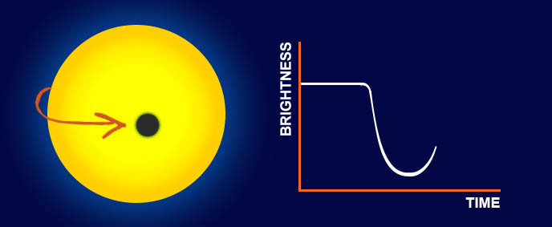

###### Photo credits: Nora Eisner

In order for us to be able to observe a transit we require the planetary system to be oriented so that the **planet passes between us and the host star** (as shown on the right hand side of the image below). If this is the case, we will see a dip every time that the planet completes one full orbit around the star. If the planet does not cross our line of sight, we will miss the transit (shown on the left).

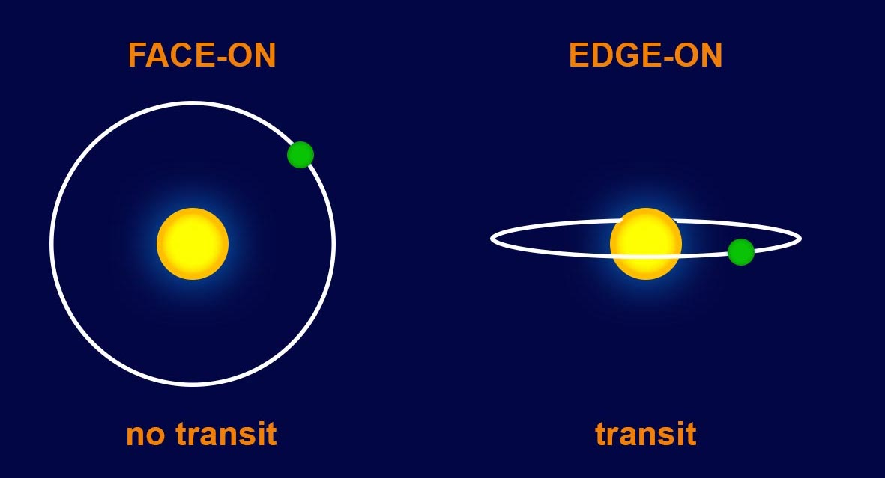

###### Photo credits: Nora Eisner

## Data

The dataset I am leveraging is the **Kepler Object of Interest** (KOI) table, located on the NASA Exoplanet Archive website noted above. The **Data Columns** documentation can be reviewed here: [Data columns in Kepler Objects of Interest Table (caltech.edu)](https://exoplanetarchive.ipac.caltech.edu/docs/API_kepcandidate_columns.html). The dataset can be found here: [Kepler Objects of Interest (caltech.edu)](https://exoplanetarchive.ipac.caltech.edu/cgi-bin/TblView/nph-tblView?app=ExoTbls&config=cumulative). The dataset consists of 9,565 rows with 2,358 confirmed exoplanets, 2,366 candidates and 4,840 false positives.

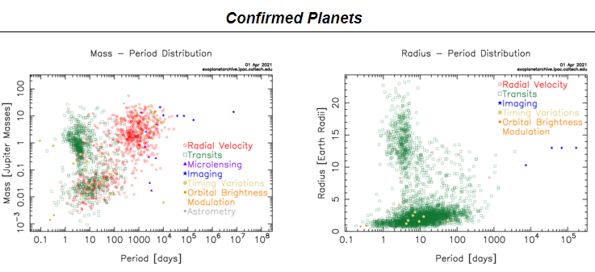

Source: NASA Exoplanet Archive

### **Research**

Include a period at the end of a run-in heading. Note that you can include consecutive paragraphs with their own headings, where appropriate.

#### Method

I intend to initially employ a Decision Tree algorithm; depending on the results, it is likely I will fit a Random Forest algorithm as well. In addition, it is possible that as a pre-processing step I will leverage Principal Component Analysis (PCA) for the purpose of dimensionality reduction. The KOI dataset is rich in features and therefore conducive towards predicting whether a candidate astral body is an exoplanet (or not). However, quantity of features is both a blessing and a curse, so as mentioned I will also apply dimensionality reduction and will decide if it improves model performance.

##### **Conclusions**

“Whether life exists beyond Earth is one of the most profound questions of all time. The answer will change us forever, whether it reveals a universe rich with life, one in which life is rare and fragile, or even a universe in which we can find no other life at all.” [3]

Exoplanets are planets that orbit around a star, as in our solar system. These bodies are very hard to see directly with telescopes since they are hidden by the bright glare of the stars they orbit. The Kepler Objects of Interest (KOI) dataset contains various measurements of transit, in addition to many others that aid in identifying exoplanets. In 2009, NASA launched the **Kepler** spacecraft to search for exoplanets. Kepler looked for planets in a wide range of sizes and orbits that circled around stars of varied size and temperature. [2] The Kepler spacecraft detected exoplanets using the **transit** method. As a planet passes (transits) in front of a star, it blocks out a bit of the star’s light. By observing the stars’ change in brightness astronomers can figure out the size of the orbiting planet as well as how far away it is from the star. Further, this data then aids in calculating the planet’s temperature, and the chances that it may contain liquid water—the stuff of life…

Why expend all this effort in time and resources to discover potentially habitable planets, when we fully realize we can never visit even one of them? One simple answer is, *because we can.* It seems that humans, by their very nature, are explorers, unable to sit idly by while a vast, mysteriously beautiful universe unfolds before us. When we look up at the night sky, we are alternately comforted by its splendor, and saddened while we wonder, *are we alone in all this vastness?* Perhaps searching for exoplanets is our way—possibly our only way—of ever concluding that there is at least a chance that we are *not* alone…

**References**

[1] NASA Exoplanet Archive – NASA Exoplanet Science Institute <https://exoplanetarchive.ipac.caltech.edu/index.html>

Last Name, F. M. (Year). *Book Title.* City Name: Publisher Name

Footnotes

1Add footnotes, if any, on their own page following references. The body of a footnote, such as this example, uses the Normal text style. (Note: If you delete this sample footnote, don’t forget to delete its in-text reference as well. That’s at the end of the sample Heading 2 paragraph on the first page of body content in this template.)

Appendix

Table 1

Table Title

| Column Head | Column Head | Column Head | Column Head | Column Head |
| --- | --- | --- | --- | --- |
| Row Head | 123 | 123 | 123 | 123 |
| Row Head | 456 | 456 | 456 | 456 |
| Row Head | 789 | 789 | 789 | 789 |
| Row Head | 123 | 123 | 123 | 123 |
| Row Head | 456 | 456 | 456 | 456 |
| Row Head | 789 | 789 | 789 | 789 |

Note: Place all tables for your paper in a tables section, following references (and, if applicable, footnotes). Start a new page for each table, include a table number and table title for each, as shown on this page. All explanatory text appears in a table note that follows the table, such as this one. Use the Table/Figure style, available on the Home tab, in the Styles gallery, to get the spacing between table and note. Tables in APA format can use single or 1.5-line spacing. Include a heading for every row and column, even if the content seems obvious. A table style has been setup for this template that fits APA guidelines. To insert a table, on the Insert tab, click Table.