U.S. Airline Safety – Statistics in Perspective

David Kinney – Data Scientist, Some Major Airline

# Introduction

Due to recent unfortunate airline crashes, the media has been promoting statistics stating air is no longer a safe way to travel. The news and media outlets have been bombarding the public with reports and figures about the trends of airline safety and that things are not looking good. What was previously thought as the safest way to travel, especially when compared to automobiles, is now being presented as one of the most dangerous to the public. But are any of these claims based on facts?

# Research

Numerous websites were explored for pertinent data regarding air travel incidents and fatalities over the past two decades—2000 through 2019. In addition, for comparison, statistics on traffic fatalities in the United States were also extracted.

In short, there does not appear to be any *unbiased* data corroborating the misguided claims of the media. I will not belabor the point, but Cole Nussbaumer Knaflic admonishes in her book, “Storytelling with Data” (Knaflic 2012), “Don't compel your audience with visual misrepresentations; rather, convince them with accurately displayed data that backs up the point you are trying to make." Unfortunately, the media is in the business of making money by garnering reader/viewer volume, *not by presenting accurate data.*

[Intentionally left blank – continue to next page]

# Conclusions

* While departures remained fairly consistent over the previous 20-year span, both accidents and casualties, as a percentage of departures, have continued downward trends.

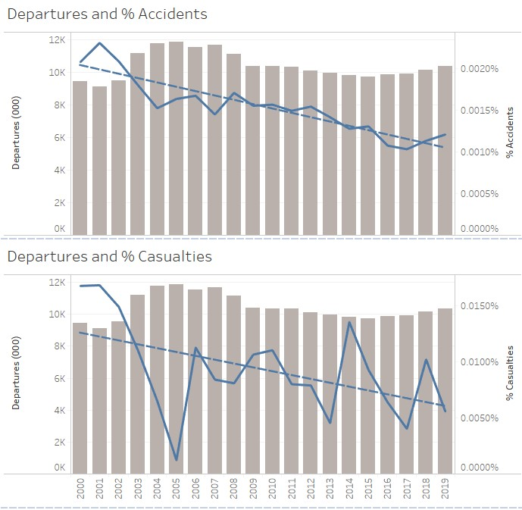

* Traffic fatalities continue to outpace airline fatalities by an order of magnitude, which would indicate that air travel remains safer than travel by automobile.

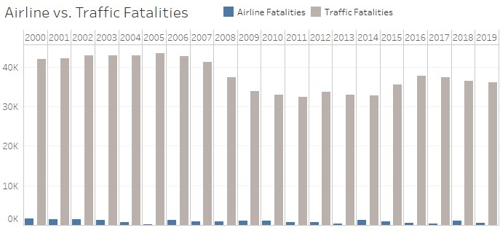

* U.S. Passenger airlines account for a relatively small portion of total air *travel* related fatalities.

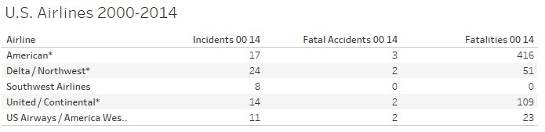

[Intentionally left blank - continue to next page}

* While the major U.S. Passenger airlines struggled financially during the first decade of the 21st century, Net Profit has remained positive in recent years (through 2019).

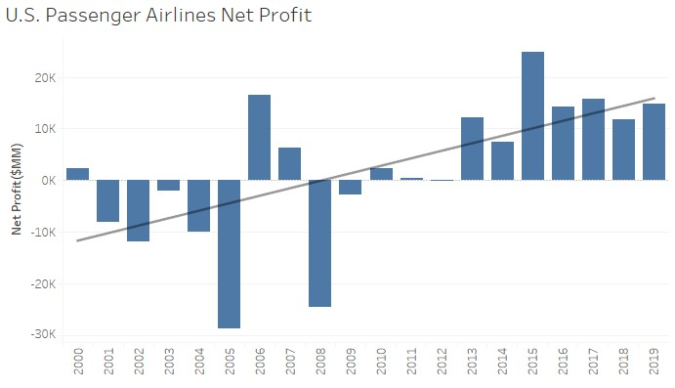

# Summary

In contrast to the sensational reports by the media, factual evidence supports declining fatalities in air travel, a continuing conclusion that air travel if far safer than on the roads and highways of the U.S. and no negative impact on net profit, despite the “bad press”, over the most recent years.

# References

Departures: [https://www.airlines.org/dataset/annual-results-u-s-airlines-2/#](https://www.airlines.org/dataset/annual-results-u-s-airlines-2/)

Accidents & Casualties: <http://www.baaa-acro.com/statistics>

Airline Safety: <https://github.com/fivethirtyeight/data/tree/master/airline-safety>

Traffic Fatalities: [https://en.wikipedia.org/wiki/Motor_vehicle_fatality_rate_in_U.S._by_year N](https://en.wikipedia.org/wiki/Motor_vehicle_fatality_rate_in_U.S._by_year)et Profit: [https://www.airlines.org/dataset/annual-results-u-s-passenger-airlines/#](https://www.airlines.org/dataset/annual-results-u-s-passenger-airlines/)

Github repo: <https://github.com/dkinneyBU/DSC640>