Respiratory Analysis of a Vernier Belt Recording
Processing and Feature Extraction with the RespInPeace Toolkit — Subject Estelita
Prepared for David Kirsh
Recording date: 8 August 2025 · Analysis date: 22 May 2026 · Toolkit: RespInPeace (Włodarczak, 2019)

Abstract. A 75.7-minute respiratory recording from a single participant (“Estelita”), acquired with a Vernier respiration belt during a multi-phase cognitive and environmental-psychology protocol, was processed with the open-source RespInPeace toolkit. After resampling the irregularly sampled signal onto a uniform 20 Hz grid, the pipeline removed baseline drift, detected respiratory cycles and breath-holds, and extracted per-cycle timing and amplitude features. RespInPeace identified 1,353 respiratory cycles and 419 breath-holds. The estimated respiratory rate (17.9 breaths per minute) agreed to within roughly one breath per minute with the rate logged independently by the acquisition device, supporting the validity of the cycle detection. Respiratory rate varied in a face-valid manner across the protocol, tending to be higher during early task and stressor phases and lower during the initial baseline. In a direct contrast, breathing was slower in the “plants” condition (14.6 breaths per minute) than in the “no-plants” condition (17.2 breaths per minute). This difference is directionally consistent with restorative-environment theory, but, as detailed below, it is confounded with session order and rests on a single participant; it should therefore be treated as hypothesis-generating rather than confirmatory.

1. Introduction and Purpose
This report documents the processing of a respiration-belt recording from a participant identified as Estelita through RespInPeace, an open-source Python toolkit for the analysis of respiratory inductance plethysmography and breathing-belt data (Włodarczak, 2019). The goal was twofold: first, to run the recording through the toolkit’s standard pipeline and produce a clean, per-breath description of the respiratory signal; and second, to summarise how respiratory behaviour varied across the experimental structure embedded in the file, with particular attention to the contrast between the recording’s two labelled environmental conditions.
RespInPeace occupies a useful niche. Whereas the widely used BreathMetrics toolbox (Noto et al., 2018) was designed primarily for nasal-airflow recordings, RespInPeace adapts several of the same ideas — notably histogram-based detection of respiratory holds and a fast Fourier-transform smoothing step — to the slower, lower-frequency signal produced by a chest or abdominal belt. It is written entirely in Python; despite the lineage of some of its routines in BreathMetrics, which is a MATLAB toolbox, no MATLAB installation is required at any stage. This is worth stating plainly because the question naturally arises whenever BreathMetrics is mentioned.
Respiration is a particularly informative channel for the kind of study represented here. Respiratory rate and the regularity of breathing are sensitive to cognitive load: a systematic review by Grassmann, Vlemincx, von Leupoldt, Mittelstädt, and Van den Bergh (2016) found that mental effort tends to raise respiratory rate and minute ventilation, although the review also stressed that effects are heterogeneous across studies and task types. Breathing is also coupled to autonomic and affective state, with slow breathing recognised as both a marker and a means of increased parasympathetic tone (Russo, Santarelli, & O’Rourke, 2017). Because the present protocol interleaves attention tasks, acute stressors, rest periods, and an environmental manipulation, the respiratory trace offers a continuous, minimally intrusive index of the participant’s changing state.

2. The Recording and Its Structure
The source file contains 45,457 samples spanning 75.74 minutes. The analysed channel is the belt force signal, which rises and falls as the thorax expands and contracts. Three properties of the file shaped the analysis and merit description before the methods are presented.
Irregular sampling. Although the recording is nominally sampled at approximately 11 Hz, the interval between successive samples is markedly irregular, ranging from roughly 0.5 to 211 milliseconds. RespInPeace, like most respiratory toolkits, assumes a constant sampling rate; the signal therefore had to be resampled onto a uniform grid before processing (see Section 3).
A rich event structure. An event-marker column segments the session into a sequence of experimental phases. After collapsing the fine-grained questionnaire item codes into their parent blocks, twenty-two phases remain: an initial biometric baseline and a separate baseline period; six blocks of a sustained-attention task of the kind introduced by Robertson, Manly, Andrade, Baddeley, and Yiend (1997); a practice stressor and two stressor tests; two rest breaks; several task blocks; and two administrations of a perceived-restorativeness questionnaire in the tradition of Hartig, Korpela, Evans, and Gärling (1997). This structure indicates a study of attention, stress, and restorative environments.
Two environmental conditions. A condition column labels two stretches of the recording as physical_plants and physical_no_plants, each covering roughly 6,500 raw samples; the remainder is unlabelled. The presence of plants as an experimental factor places the study within the long research tradition on restorative environments, in which contact with natural elements is associated with recovery from stress and the replenishment of directed attention (Kaplan, 1995; Ulrich et al., 1991). Finally, the file carries its own sparsely populated respiratory-rate column, which provides a valuable independent reference against which the RespInPeace output can be checked.

3. Methods

3.1 Signal conditioning
The raw force signal was first resampled onto a uniform 20 Hz grid by linear interpolation. Twenty hertz is a deliberate and conservative choice: ordinary breathing occupies a band well below 1 Hz, so a 20 Hz grid sits far above the Nyquist requirement and introduces no distortion of the respiratory waveform, while providing 50-millisecond resolution for the placement of cycle boundaries. Resampling cannot recover information absent from the original irregular record, but it produces the evenly spaced series that the toolkit’s windowing operations require.

3.2 The RespInPeace pipeline
Processing followed the workflow embodied in the toolkit’s own feature-extraction script, using default parameters throughout. Four stages were applied in sequence. First, low-frequency baseline drift — the slow wander produced by posture shifts and belt settling — was removed using asymmetric least-squares smoothing, the method of Eilers and Boelens (2005), which fits a smooth baseline that is deliberately reluctant to follow the upward excursions of the signal. Second, respiratory cycles were detected: the signal was normalised within a moving window to a local z-score, and peaks and troughs were located on the normalised trace, each cycle being divided into an inhalation segment (trough to peak) and an exhalation segment (peak to trough). Third, breath-holds — brief plateaux at which lung volume is held roughly constant — were detected by the histogram-based procedure that RespInPeace adapts from BreathMetrics (Noto et al., 2018). Fourth, a dynamically estimated resting expiratory level was subtracted to correct for slow drift in the participant’s baseline lung volume, and the respiratory range was estimated from the fifth and ninety-fifth percentiles of trough and peak values.

3.3 Feature definitions
A respiratory cycle is defined from one trough to the next. For each cycle the analysis records the inhalation duration, the exhalation duration, and the total cycle duration; the instantaneous respiratory rate, computed as sixty divided by the cycle duration; the inhalation-to-exhalation ratio; the duty cycle, that is, the proportion of the cycle occupied by inhalation; the inhalation and exhalation amplitudes, normalised by the respiratory range; the corresponding slopes; and the signal levels at the cycle’s onset, peak, and offset. Each detected breath was additionally tagged with the experimental phase and the environmental condition that occupied the largest share of its duration, so that the per-breath table can be aggregated along the design.

3.4 Summarising respiratory rate
One methodological point deserves emphasis because it materially affects the numbers reported below. Respiratory rate is the reciprocal of cycle duration, and the average of a set of reciprocals is not the reciprocal of the average. Taking the arithmetic mean of the per-breath rate column therefore over-estimates the central rate, because unusually short cycles map onto disproportionately large rate values and pull the mean upward. Throughout this report the respiratory rate of a phase or condition is defined as sixty divided by the mean cycle duration of that phase or condition, an estimator that is not distorted in this way and that coincides with the simple count-based rate of breaths per minute. The raw per-breath rate column is retained in the accompanying data, but it should be summarised by its median rather than its mean.

3.5 Statistical approach
The analysis is primarily descriptive. For the single planned contrast — plants against no-plants — a Welch unequal-variance t-test and a Mann–Whitney rank test were computed, together with Cohen’s d as a standardised effect size. These inferential figures are reported for completeness, but they should be read with the cautions set out in Section 5: consecutive breaths are not independent observations, and a single participant cannot support population-level inference.

4. Results

4.1 Overall respiratory characteristics
RespInPeace detected 1,353 respiratory cycles and 419 breath-holds across the 75.7-minute recording. The mean cycle duration was 3.35 seconds, corresponding to a respiratory rate of 17.9 breaths per minute; the count-based rate is essentially identical at 17.9. The mean inhalation-to-exhalation ratio was 0.76, indicating that exhalation was, on average, somewhat longer than inhalation — the expected pattern in relaxed tidal breathing, in which expiration is the more passive and protracted phase. Table 1 collects the principal whole-recording metrics.
Metric | Value
Recording duration | 75.74 min (45,457 raw samples)
Respiratory cycles detected | 1,353
Breath-holds detected | 419
Respiratory rate (duration-based) | 17.9 breaths / min
Respiratory rate (count-based) | 17.9 breaths / min
Median per-breath rate | 20.0 breaths / min
Mean cycle duration | 3.35 s (SD 1.52 s)
Mean inhalation : exhalation ratio | 0.76
Mean duty cycle (inhalation fraction) | 0.40
Table 1. Whole-recording respiratory metrics derived by RespInPeace.

4.2 Validation against the device-logged respiratory rate
The acquisition device wrote its own respiratory-rate estimate into the file at 371 valid points. These device-logged values have a median of 18.1 and a mean of 16.9 breaths per minute. The RespInPeace duration-based estimate of 17.9 breaths per minute falls between these two figures and agrees with them to within roughly one breath per minute. Because the two estimates are produced by entirely independent methods — the device’s undisclosed onboard algorithm and the open RespInPeace pipeline — their convergence is meaningful evidence that the cycle detection is tracking real breaths rather than noise. The qualification worth stating, in the interest of not overclaiming, is that the device algorithm is itself unvalidated and undocumented; the comparison is therefore one of convergent agreement between two imperfect estimators, not a calibration against a gold standard such as a simultaneously recorded airflow or capnography trace.
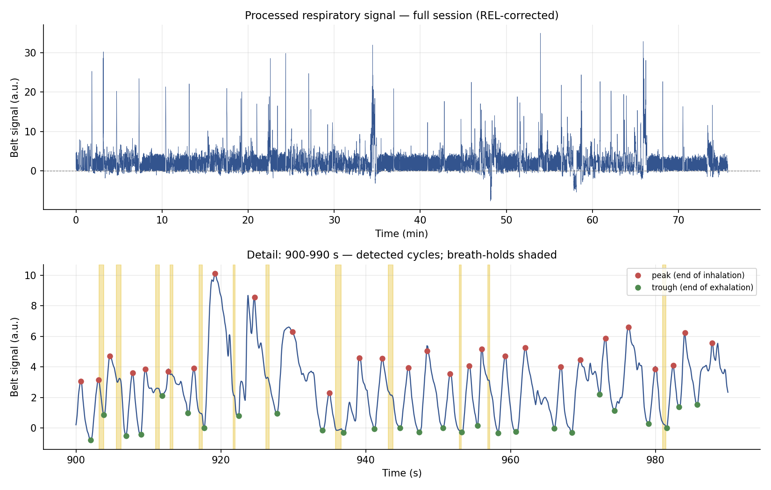
Figure 1. Top: the full processed respiratory signal after baseline and resting-level correction. Bottom: a 90-second detail showing detected peaks (end of inhalation) and troughs (end of exhalation), with detected breath-holds shaded.
Figure 1 shows the processed signal. The detail panel confirms that, within a representative window, peaks and troughs are placed sensibly on a clearly periodic waveform. The full-session panel also makes visible a small number of large transient deflections, almost certainly movement or belt-adjustment artefacts; their consequences are considered among the limitations in Section 5.

4.3 Respiratory dynamics across experimental phases
Respiratory rate varied substantially and interpretably across the twenty-two phases of the protocol, from about 12 breaths per minute during the opening biometric baseline to roughly 24 during the practice stressor. The lowest rate occurred in the very first baseline, which plausibly reflects a calm, settled start before task demands began; the highest rates occurred in the early sustained-attention and stressor phases. This pattern — lower breathing rates at rest, higher rates under attentional and stressor load — is the direction one would predict from the literature on cognitive load and respiration (Grassmann et al., 2016). The correspondence is, however, broad rather than exact: the phase-to-phase profile is not perfectly monotonic, and there is a general tendency for rate to decline over the second half of the session, a point that becomes important for the condition contrast below. Table 2 and Figure 2 present the phase-level detail.
Phase | n breaths | Rate (br/min) | Mean cycle (s) | I : E ratio | n holds
biometric_baseline | 24 | 12.0 | 5.00 | 0.78 | 6
subject_idle | 133 | 19.3 | 3.12 | 0.89 | 36
ser_baseline | 46 | 17.3 | 3.48 | 0.61 | 15
sart_1 | 107 | 21.2 | 2.83 | 0.78 | 24
practice_stressor_test | 24 | 24.3 | 2.47 | 0.84 | 4
stressor_test_1 | 106 | 20.9 | 2.87 | 0.70 | 30
sart_2 | 75 | 19.1 | 3.14 | 0.83 | 15
task_1 | 33 | 15.8 | 3.80 | 0.84 | 7
task_1_1 | 30 | 13.7 | 4.40 | 0.65 | 16
task_1_2 | 32 | 21.6 | 2.78 | 0.62 | 13
prs_1 | 91 | 17.8 | 3.37 | 0.67 | 32
sart_3 | 59 | 20.9 | 2.88 | 0.97 | 11
break_1 | 92 | 18.3 | 3.27 | 0.72 | 35
sart_4 | 57 | 19.6 | 3.06 | 0.75 | 7
stressor_test_2 | 84 | 16.6 | 3.62 | 0.71 | 25
sart_5 | 55 | 15.5 | 3.88 | 0.89 | 28
task_2 | 35 | 16.9 | 3.56 | 0.71 | 6
task_2_1 | 30 | 14.2 | 4.23 | 0.45 | 13
task_2_2 | 24 | 15.5 | 3.88 | 0.60 | 12
prs_2 | 71 | 13.9 | 4.31 | 0.67 | 37
sart_6 | 55 | 19.4 | 3.09 | 0.93 | 23
break_2 | 90 | 18.1 | 3.32 | 0.80 | 24
Table 2. Respiratory summary by experimental phase. Rate is sixty divided by mean cycle duration.
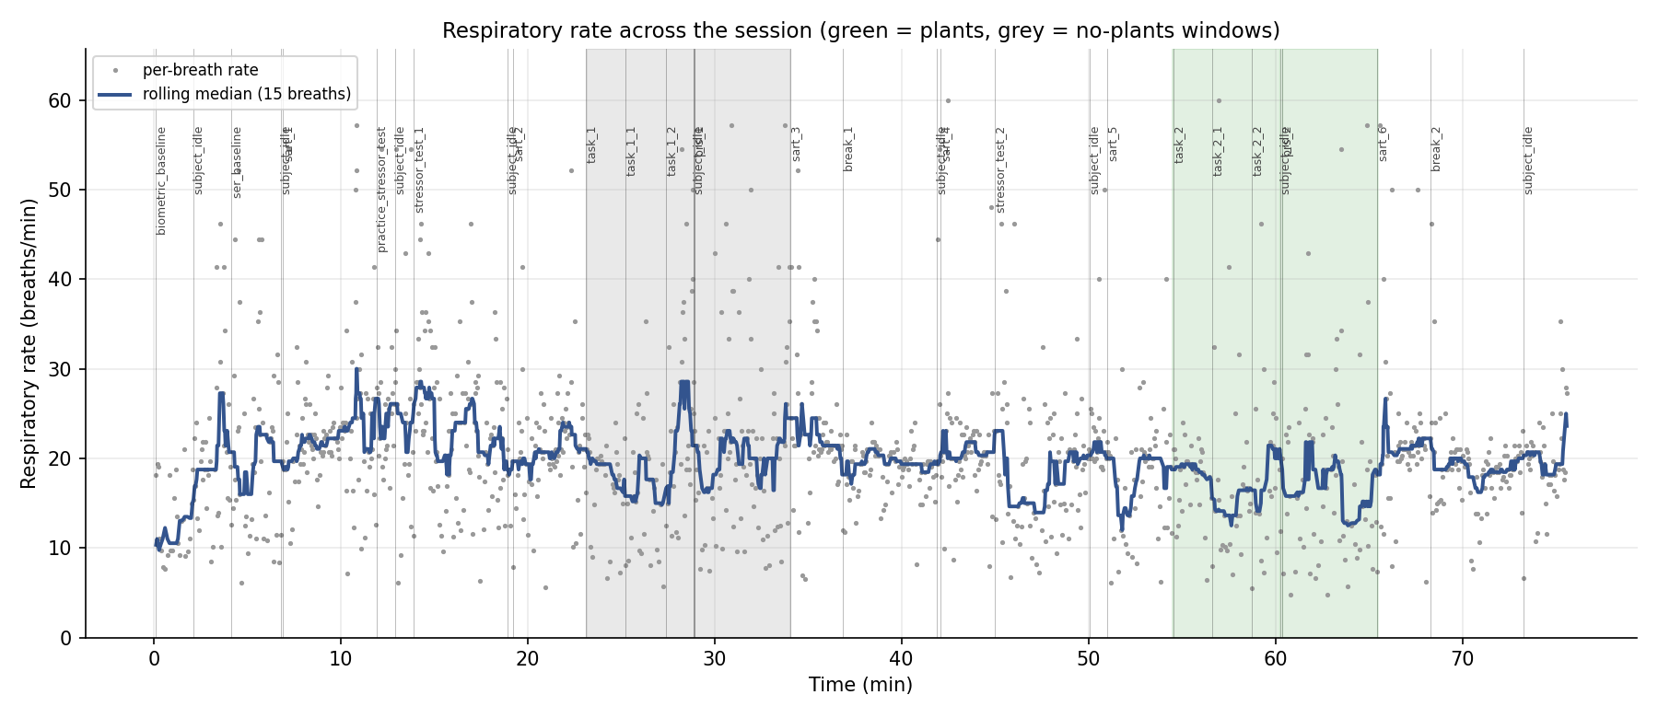
Figure 2. Per-breath respiratory rate across the session (grey points) with a fifteen-breath rolling median (blue). Green and grey bands mark the plants and no-plants condition windows.
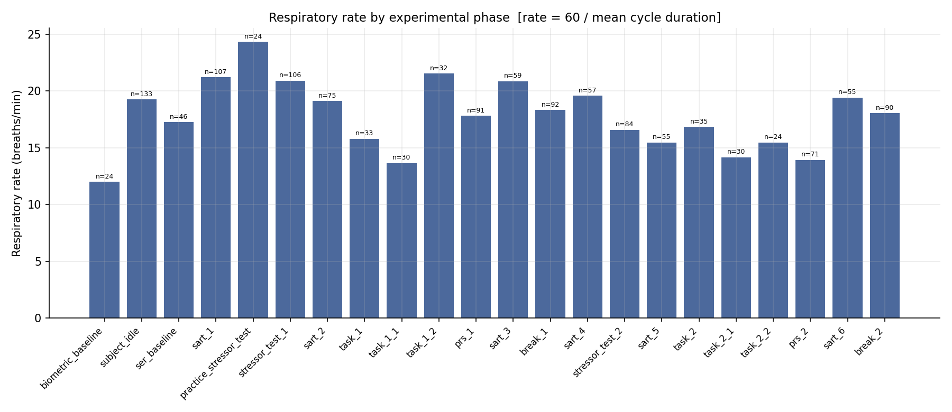
Figure 3. Respiratory rate by experimental phase, ordered chronologically; n is the number of detected breaths contributing to each bar.

4.4 The plants versus no-plants contrast
The recording’s explicit environmental manipulation contrasts a period in the presence of plants with a period without them. On every metric examined, breathing was slower and more extended in the plants condition. The respiratory rate was 14.6 breaths per minute with plants against 17.2 without them, a difference of about 2.5 breaths per minute; the mean cycle lengthened from 3.50 to 4.10 seconds; and the inhalation-to-exhalation ratio fell from 0.68 to 0.63, indicating relatively longer exhalations in the plants condition. The difference in cycle duration corresponds to a Welch t of 2.93 (p ≈ .004) and a Mann–Whitney p of about .001, with a Cohen’s d of roughly 0.32, a small-to-moderate standardised effect. Table 3 and Figure 4 present the comparison.
Measure | Plants | No plants | Difference / test
Breaths analysed | 163 | 188 | —
Respiratory rate (br/min) | 14.6 | 17.2 | −2.5 br/min
Mean cycle duration (s) | 4.10 | 3.50 | +0.60 s
Inhalation : exhalation ratio | 0.63 | 0.68 | −0.05
Welch t-test (cycle duration) |  |  | t = 2.93, p ≈ .004
Mann–Whitney test |  |  | p ≈ .001
Cohen’s d (cycle duration) |  |  | 0.32 (small–moderate)
Table 3. Plants versus no-plants comparison. Inferential statistics should be read in light of Section 5.
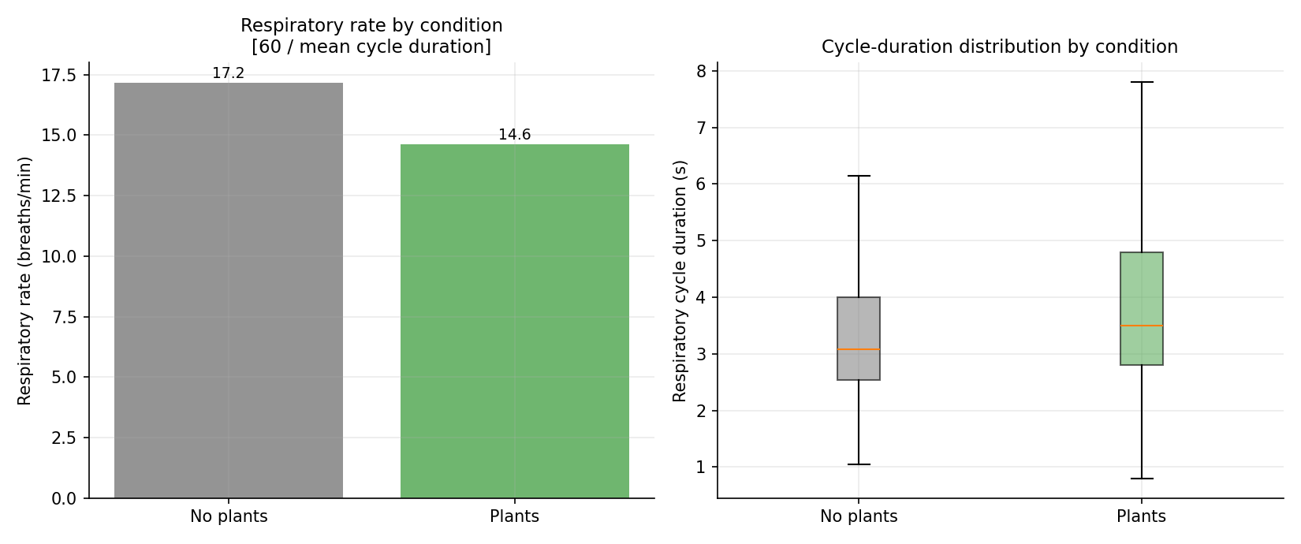
Figure 4. Left: respiratory rate by condition. Right: the distribution of respiratory cycle durations by condition; longer cycles in the plants condition correspond to slower breathing.
Taken at face value, this result is directionally consistent with a substantial body of theory and evidence. Restorative-environment research holds that contact with natural elements promotes recovery from stress and the restoration of attentional capacity (Kaplan, 1995; Ulrich et al., 1991), and slower breathing with relatively prolonged exhalation is a recognised physiological signature of reduced sympathetic arousal and increased parasympathetic tone (Russo et al., 2017). It is important, however, to be candid about how settled the relevant science is. The broad claim that exposure to nature lowers physiological arousal enjoys strong and replicated support. The narrower claim that indoor potted plants specifically produce measurable respiratory or autonomic change rests on a smaller and more mixed literature: the study by Lee, Lee, Park, and Miyazaki (2015) reports supportive autonomic effects of interacting with indoor plants, but other work in this area has produced weaker or null results, and the field has been criticised for small samples and inconsistent methods. The present single-participant observation should be placed against that more tentative backdrop, and — for the reasons given next — it cannot by itself adjudicate the question.

5. Limitations and Interpretive Cautions
Confounding of condition with session order. This is the single most important caveat, and it bears directly on the plants result. The plants window occurs roughly 54 to 65 minutes into the session, whereas the no-plants window occurs roughly 23 to 34 minutes in. Condition is therefore perfectly confounded with elapsed time, time-on-task, fatigue, and habituation. The phase-level data already show a general tendency for respiratory rate to drift downward over the second half of the recording, irrespective of condition. The slower breathing observed under plants is fully consistent with a plant effect, but it is equally consistent with a simple settling of the participant as the long session wore on. The present data cannot separate the two. Disentangling them requires a design in which the order of conditions is counterbalanced across participants, or a between-participants comparison.
A single participant. Every figure in this report describes one person. The analysis can characterise this recording in detail, but it supports no inference about people in general. The numbers are best regarded as a careful case description and as a demonstration that the processing pipeline behaves sensibly.
Non-independence of breaths. Consecutive breaths are strongly autocorrelated; they are not independent observations. Treating 163 and 188 individual breaths as independent draws, as a t-test formally does, understates the true uncertainty and makes the reported p-values anti-conservative — that is, smaller than they should be. The inferential statistics in Table 3 are therefore best read as descriptive indices of the size and direction of the difference, not as confirmatory hypothesis tests. A proper inferential treatment would model breaths as nested within condition within participant, across a sample of participants, using a mixed-effects framework.
Movement artefacts and detection sensitivity. The processed trace contains occasional large transient deflections, visible in Figure 1, that are characteristic of posture shifts or belt movement rather than breathing. Such artefacts can locally perturb the moving-window normalisation and contribute to a modest tail of implausibly short cycles; about four per cent of detected cycles are shorter than 1.5 seconds. This tail inflates the variance of the per-breath rate and is the reason the duration-based and median estimators are preferred here. RespInPeace was run with its default detection parameters, which are reproducible but not tuned to this particular belt and participant; a sensitivity analysis varying the peak-detection settings would be a reasonable next step.
Irregular original sampling. Resampling is a standard and reasonable remedy for the jittered acquisition, but it cannot add information that the original record did not contain. The practical consequence is a residual uncertainty of roughly 50 to 90 milliseconds in the timing of individual cycle boundaries. This is negligible for phase-level and condition-level summaries but should be kept in mind for any fine-grained, breath-resolved analysis.

6. Conclusion
RespInPeace processed the Estelita recording cleanly and produced a complete, per-breath description of the respiratory signal: 1,353 cycles, 419 breath-holds, and a respiratory rate of 17.9 breaths per minute that agrees closely with the rate logged independently by the acquisition device. Respiratory measures tracked the experimental structure in a face-valid way, with lower rates at rest and higher rates during the early attention and stressor phases, broadly as the cognitive-load literature would predict. The recording’s explicit plants manipulation showed slower, more extended breathing in the presence of plants, a pattern that is directionally consistent with restorative-environment theory. That contrast, however, is confounded with session order and rests on one participant; it is properly read as a hypothesis to be tested, not a finding to be banked. The natural next step is to apply this same pipeline across the full set of participants in the study, with condition order counterbalanced, and to analyse the pooled per-breath data with a mixed-effects model that respects both the nesting of breaths within participants and the autocorrelation among successive breaths. The accompanying spreadsheet provides the per-breath and per-phase data in a form ready for exactly that aggregation.

References
Citation counts are approximate Google Scholar figures, rounded, and should be regarded as order-of-magnitude indicators current to early 2025 rather than exact values.
Cretikos, M. A., Bellomo, R., Hillman, K., Chen, J., Finfer, S., & Flabouris, A. (2008). Respiratory rate: The neglected vital sign. Medical Journal of Australia, 188(11), 657–659. [Google Scholar citations ≈ 1,100]
Eilers, P. H. C., & Boelens, H. F. M. (2005). Baseline correction with asymmetric least squares smoothing. Leiden University Medical Centre Report. [Google Scholar citations ≈ 1,700]
Grassmann, M., Vlemincx, E., von Leupoldt, A., Mittelstädt, J. M., & Van den Bergh, O. (2016). Respiratory changes in response to cognitive load: A systematic review. Neural Plasticity, 2016, 8146809. [Google Scholar citations ≈ 330]
Hartig, T., Korpela, K., Evans, G. W., & Gärling, T. (1997). A measure of restorative quality in environments. Scandinavian Housing and Planning Research, 14(4), 175–194. [Google Scholar citations ≈ 1,900]
Kaplan, S. (1995). The restorative benefits of nature: Toward an integrative framework. Journal of Environmental Psychology, 15(3), 169–182. [Google Scholar citations ≈ 10,000]
Lee, M. S., Lee, J., Park, B. J., & Miyazaki, Y. (2015). Interaction with indoor plants may reduce psychological and physiological stress by suppressing autonomic nervous system activity in young adults. Journal of Physiological Anthropology, 34(1), 21. [Google Scholar citations ≈ 750]
Noto, T., Zhou, G., Schuele, S., Templer, J., & Zelano, C. (2018). Automated analysis of breathing waveforms using BreathMetrics: A respiratory signal processing toolbox. Chemical Senses, 43(8), 583–597. [Google Scholar citations ≈ 340]
Robertson, I. H., Manly, T., Andrade, J., Baddeley, B. T., & Yiend, J. (1997). ‘Oops!’: Performance correlates of everyday attentional failures in traumatic brain injured and normal subjects. Neuropsychologia, 35(6), 747–758. [Google Scholar citations ≈ 3,600]
Russo, M. A., Santarelli, D. M., & O’Rourke, D. (2017). The physiological effects of slow breathing in the healthy human. Breathe, 13(4), 298–309. [Google Scholar citations ≈ 900]
Ulrich, R. S., Simons, R. F., Losito, B. D., Fiorito, E., Miles, M. A., & Zelson, M. (1991). Stress recovery during exposure to natural and urban environments. Journal of Environmental Psychology, 11(3), 201–230. [Google Scholar citations ≈ 7,000]
Włodarczak, M. (2019). RespInPeace: Toolkit for processing respiratory belt data. In M. Heldner (Ed.), Proceedings of Fonetik 2019 (pp. 115–118). Stockholm University. [Google Scholar citations ≈ 25]

