Respiratory Markers of Stress in a Single-Session Belt Recording
Analysis of a Vernier Respiration-Belt Recording — Subject Sub-1.13_G2
Recording date: 8 August 2025 · Analysis date: 22 May 2026 · Toolkit: RespInPeace (Włodarczak, 2019)

Abstract. A 75.7-minute respiratory recording from a single participant, acquired with a Vernier respiration belt during a multi-phase protocol of attention tasks, acute stressors, rest breaks, and questionnaires, was analysed for respiratory markers of stress and arousal over time. After the standard RespInPeace processing pipeline, the analysis extracted, for each of 1,353 detected breaths, the full per-cycle timing and amplitude feature set, and then added six families of stress-relevant measures: sigh-like large breaths, breath-holds, breath-cycle irregularity, inspiratory–expiratory structure, a continuous respiratory phase signal, and recovery dynamics after stressors. The recording does not contain a single, fixed stress signature but a changing one. Early in the session, acute arousal appeared as a steep rise in respiratory rate, from about 12 breaths per minute at the opening baseline to 21–24 during the first attention and stressor blocks. Across the session’s second half, rate moderated, but a different pattern emerged: more frequent sighing, more frequent breath-holds, and greater breath-to-breath irregularity. The two rest breaks produced a distinctive recovery signature — not a return of rate to baseline, but a pronounced regularisation of the breathing rhythm. These observations illustrate that respiratory “stress” is best understood as a family of changes whose most informative member shifts as a session unfolds. A preliminary single-exposure comparison of the two rooms found respiratory rate continuing to settle across the biophilic (plants) room while it re-escalated across the non-biophilic room — directionally consistent with faster recovery in the biophilic setting, though confounded with session order and not established. All findings describe one participant and are hypothesis-generating.

1. Introduction and Purpose
This report analyses a respiration-belt recording for evidence of stress and changing arousal over the course of a structured experimental session. It follows an earlier processing run on the same recording, and extends it considerably: where the first pass established that the signal could be processed reliably and described breathing in broad terms, the present analysis is organised specifically around the respiratory phenomena that the stress and psychophysiology literature treats as informative.
The recording was acquired with a Vernier respiration belt, a chest-worn strain sensor whose output rises and falls as the thorax expands and contracts. The breathing signal is a valuable channel for studying stress because it is sensitive on several independent dimensions at once. Respiratory rate responds to cognitive load and to acute threat; the depth and the inspiratory–expiratory shape of breaths respond to emotional state (Boiten, 1998; Homma & Masaoka, 2008); the regularity of the rhythm carries information about mental load and affect; and certain discrete events — sighs and breath-holds — function as markers in their own right. No single one of these is a definitive index of stress, but together they form a profile, and that profile is what this analysis reconstructs across the session.
Two framing points should be stated at the outset. First, this is a research signal-processing exercise, not a clinical assessment; the word “stress” is used throughout in the descriptive sense of physiological arousal and load, not as a diagnosis. Second, the analysis concerns one participant. It can characterise this session in detail and can generate hypotheses, but it cannot support inference about people in general.

2. The Recording and Analytic Methods
The source file contains 45,457 samples spanning 75.74 minutes. Sampling was irregular — nominally about 11 Hz but with intervals ranging from roughly 0.5 to 211 milliseconds — so the belt force signal was first resampled by linear interpolation onto a uniform 20 Hz grid, which the analysis toolkit requires. Processing then followed the RespInPeace pipeline (Włodarczak, 2019): asymmetric least-squares removal of baseline drift, detection of respiratory cycles through moving-window normalisation and peak–trough detection, histogram-based detection of breath-holds, subtraction of a dynamically estimated resting expiratory level, and estimation of the respiratory range. For each breath this yields the inhalation and exhalation durations, the cycle duration and instantaneous rate, the inspiratory-to-expiratory ratio, the duty cycle, and amplitude and slope measures.
On this foundation the present analysis adds six families of stress-relevant measures. Sigh-like large breaths were identified as breaths whose inhalation amplitude exceeded twice the local median amplitude of the surrounding breaths, with a minimum inhalation duration imposed to exclude sharp movement artefacts. Breath-cycle irregularity was quantified within a sliding 21-breath window as the coefficient of variation of cycle duration, the mean successive difference between consecutive cycles, and the lag-one autocorrelation of cycle durations. Inspiratory–expiratory structure was summarised by the I:E ratio and the duty cycle. A continuous respiratory phase signal was computed by the Hilbert transform of the band-pass-filtered trace and is supplied as a time series so that it can later be aligned with a cardiac recording for respiratory sinus arrhythmia analysis. Recovery dynamics were examined by tracking respiratory rate in successive sixty-second bins after each stressor. Finally, an exploratory composite arousal index was formed as the average of the standardised respiratory rate and the standardised irregularity; it is a convenience summary, explicitly heuristic, and not a validated measure.
The session is segmented by an event-marker channel into twenty-two phases: an opening biometric baseline and a separate baseline, six blocks of a sustained-attention task, a practice stressor and two stressor tests, two rest breaks, several task blocks, and two questionnaire administrations. Each breath was assigned the phase that occupied the largest share of its duration. Throughout, the opening biometric baseline is used as the reference against which other phases are compared; the reader should bear in mind that this is a brief two-minute window at the very start of the session and may partly reflect the participant settling in.

3. Respiratory Signatures of Stress: What the Analysis Looked For
It is useful to state plainly, before the results, what the literature regards as a respiratory sign of stress, and how firmly each claim is established. The most important general point is that stress and arousal do not produce one stereotyped respiratory shape. They produce a family of changes, and which member of the family is most visible depends on the nature of the stressor and on how long it has been acting.
Figure 1 makes these features concrete. It contrasts the morphology of a normal resting breath with that of a stress-associated breath, and labels precisely the landmarks on which the analyses in this report are built. A resting cycle rises from an inhalation onset to an inspiratory peak, may hold briefly at an end-inspiratory pause, falls through exhalation to an end-expiratory pause, and then repeats after an inter-breath interval; the vertical extent of the cycle is its amplitude, or excursion, and the balance between inspiratory and expiratory duration is the I:E ratio. The stress-associated cycle shows the family of changes catalogued below — a faster rate, reduced amplitude, a shortened or absent end-expiratory pause, greater cycle-to-cycle irregularity, and the occasional breath-hold. It is worth being explicit that every phenomenon examined in this report is one of the labelled features of this diagram. The end-inspiratory and end-expiratory pauses are the breath-holds quantified in Section 4.4; the inspiratory and expiratory durations are the inspiratory–expiratory structure of Section 4.6; the amplitude is the depth measure of Section 4.7; the inter-breath interval is the respiratory rate of Section 4.2; cycle-to-cycle irregularity is the subject of Section 4.5; and a sigh is simply an occasional breath whose amplitude greatly exceeds the excursion drawn here, treated in Section 4.3. The continuous respiratory phase signal of Section 4.11 is this same cycle re-expressed as a steadily advancing angle, so that any instant of the recording can be located precisely within the inhale–exhale–pause progression.
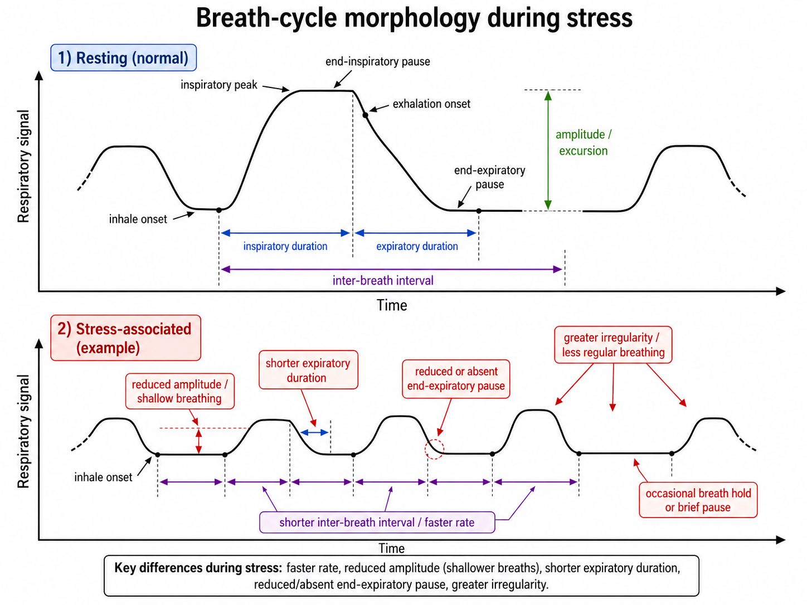
Figure 1. Breath-cycle morphology in rest and in stress — a labelled schematic of the normal respiratory cycle (upper panel) and the stress-associated changes (lower panel). Schematic supplied by the study team; it provides the vocabulary for the feature families analysed in this report.
Increased respiratory rate. Acute stress, anxiety, threat, and effortful cognition commonly raise breathing frequency, and in suffocation-related or panic-like contexts people respond to breath discomfort with faster or deeper breathing (Pappens et al., 2012). The systematic review by Grassmann et al. (2016) confirms that cognitive load tends to raise respiratory rate and minute ventilation, while also emphasising that the effect is heterogeneous across studies and task types. Rate is therefore a well-supported but not invariant marker.
Shallower, upper-chest-dominant breathing. Stress is often said to produce faster, smaller chest excursions. This is a reasonable expectation, but with a single chest belt it can only be assessed suggestively: a single belt cannot separate thoracic from abdominal motion, and the belt’s amplitude is uncalibrated, so only relative within-session changes can be read, never absolute depth.
Greater irregularity or a destabilised rhythm. Mental load and negative affect can alter respiratory variability. Here the evidence is genuinely mixed: some states reduce variability while others increase its random component. Vlemincx and colleagues have noted that respiratory variability during attention and emotion is a less settled matter than cardiovascular variability, even as sighing and altered variability are repeatedly tied to stress and emotion regulation (Vlemincx et al., 2010, 2011). Irregularity is informative, but its direction must be read from the data rather than assumed.
Sighs as regulatory events. Sighs — unusually large breaths, often with a longer inspiration and frequently followed by a change in the breathing rhythm — are especially interesting for a belt signal. They occur more often during stress, emotion, anxiety sensitivity, and relief, and are thought both to express and to help bring about a respiratory reset (Vlemincx et al., 2010, 2017; Severs et al., 2022; Vlemincx et al., 2022). The “resetter” hypothesis holds specifically that a sigh interrupts a spell of breathing that has become either too monotonous or too random, returning it to a more structured variability.
Breath-holding and respiratory freezing. During attention, anticipation, threat monitoring, or cognitive load, breathing may be briefly inhibited — short pauses, reduced amplitude, or temporary holds. These can be very informative when they can be time-locked to specific task events.
Recovery dynamics after a stressor. How quickly rate, amplitude, and variability return towards baseline after a stressor is often more revealing than the stressed state itself. Slow recovery can indicate sustained arousal or poor autonomic down-regulation, although it is not specific to any one cause.

4. Results

4.1 Overall respiratory characteristics
Across the recording RespInPeace detected 1,353 respiratory cycles, 67 sigh-like large breaths, and 419 breath-holds. The mean cycle duration was 3.35 seconds, an overall respiratory rate of 17.9 breaths per minute, and the mean inhalation-to-exhalation ratio was 0.76, indicating that exhalation was on average the longer phase — the expected pattern in relaxed tidal breathing. Table 1 collects the whole-recording figures; the sections that follow take each stress-relevant feature family in turn.
Metric | Value
Recording duration | 75.74 min (45,457 raw samples)
Respiratory cycles detected | 1,353
Sigh-like large breaths | 67 (0.89 per min)
Breath-holds detected | 419 (5.53 per min)
Overall respiratory rate | 17.9 breaths / min
Opening-baseline rate | 12.0 breaths / min
Overall cycle irregularity (CV) | 0.45
Mean inhalation : exhalation ratio | 0.76
Table 1. Whole-recording respiratory metrics.

4.2 Respiratory rate over time
Respiratory rate showed the clearest acute-arousal signature of any measure, and it appeared early. From 12.0 breaths per minute during the opening biometric baseline, rate climbed steeply through the first attention block (21.2) and the first stressor test (20.9), reaching its highest phase value, 24.3, during the brief practice stressor. Relative to the opening baseline these are increases of seventy to one hundred per cent. Across the second half of the session rate moderated substantially, with many later phases falling between 14 and 19 breaths per minute. The interpretation offered here, and developed in Section 5, is that the steep early rise is a genuine acute-arousal response, while the later moderation reflects both adaptation to the task and the general downward drift that a long session tends to produce. Figures 2 and 3 display the phase-by-phase detail.

4.3 Sigh-like large breaths
Sixty-seven breaths met the sigh criterion, an overall rate of 0.89 per minute; a further seven very brief large deflections were set aside as probable movement artefacts. The striking feature of the sighs is their distribution in time. They were nearly absent from the opening of the session — the practice stressor and the first task block contained none, and the early idle and baseline periods very few — and they became markedly more frequent across the second half, peaking in the later attention blocks and the second questionnaire (the highest phase rates were 2.8, 2.1, and 2.0 sighs per minute). This accumulation of sighs under sustained attention is consistent with the pattern reported by Vlemincx et al. (2011), who found sigh rate to rise during mental load and sustained attention.
The breaths immediately following a sigh are informative. Averaged over all sighs, respiratory rate fell from 22.0 breaths per minute in the ten breaths before the sigh to 19.6 in the ten breaths after — a calming of the rhythm consistent with the sigh acting as a regulatory or relief event (Vlemincx et al., 2017; Severs et al., 2022). Breath-cycle variability, however, did not fall after sighs; the coefficient of variation was slightly higher afterwards (0.42) than before (0.37). The “resetter” hypothesis (Vlemincx et al., 2010) predicts that sighs restore a structured, intermediate variability rather than simply reducing it, so a slight rise is not necessarily inconsistent with it; but the present data show a clear post-sigh slowing of rate without a clean reduction in variability, and that mixed result is reported here without overinterpretation.
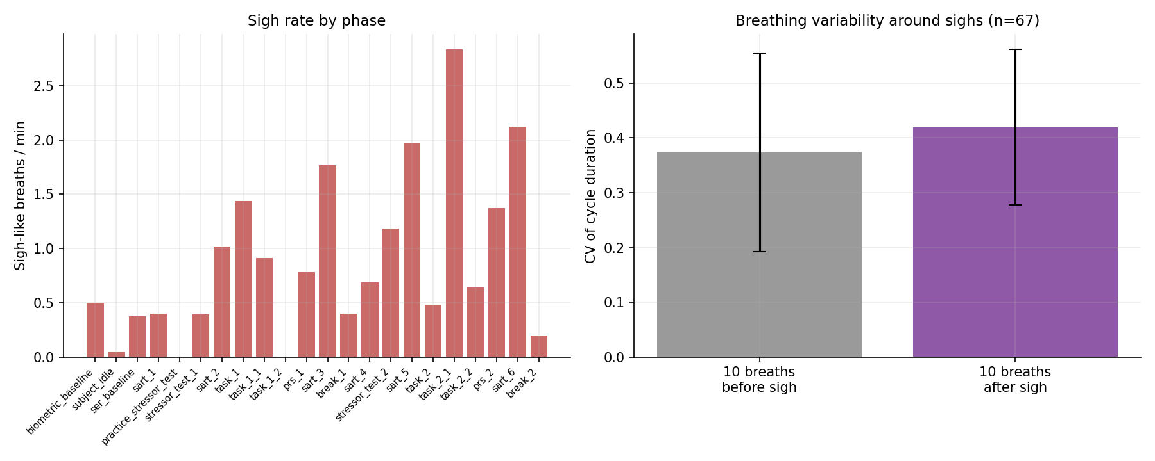
Figure 2. Left: sigh rate by phase — sighs accumulate across the session’s second half. Right: breath-cycle variability in the ten breaths before versus after each sigh.

4.4 Breath-holds and respiratory pauses
RespInPeace detected 419 breath-holds, an overall rate of 5.5 per minute. Holds were not uniformly distributed: they were most frequent during the demanding task blocks, the questionnaire periods, and the later attention blocks (phase rates of 7 to 9 holds per minute), and least frequent during the opening baseline and a few of the lighter phases. Brief respiratory pausing during tasks that require reading, answering, or close monitoring is consistent with the role of breath-holding in attention, anticipation, and cognitive load. Because the present file marks experimental phases rather than individual trial events, these holds can be localised to phases but not yet time-locked to specific task events; doing so would, as Section 3 noted, make them considerably more informative.

4.5 Breath-cycle irregularity
Breath-cycle irregularity produced one of the cleanest and most interpretable results in the analysis. The coefficient of variation of cycle duration was lowest by a wide margin during the two rest breaks (0.20 and 0.26) and highest during the later task and questionnaire phases (up to 0.60). In other words, the breathing rhythm became conspicuously regular when the participant rested and conspicuously irregular when they were cognitively or emotionally engaged. This is consistent with the broad literature linking irregular breathing to mental load and affect, while also illustrating Vlemincx and colleagues’ caution that the relationship is not simple: irregularity here tracks engagement rather than any single emotional valence. Figure 3 shows the phase profile.
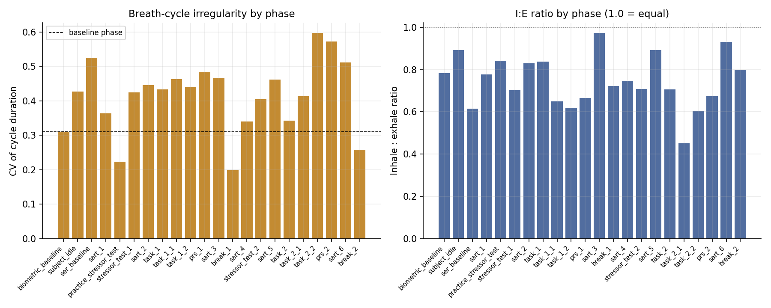
Figure 3. Left: breath-cycle irregularity by phase — lowest during rest breaks, highest during later tasks and questionnaires. Right: inhalation-to-exhalation ratio by phase.

4.6 Inspiratory–expiratory structure
The inhalation-to-exhalation ratio averaged 0.76 over the recording and varied across phases between roughly 0.45 and 0.97. Lower values — relatively longer exhalations — appeared in several of the task blocks, while values closer to unity appeared in some attention blocks and the idle period. The I:E ratio did change with phase, but not as a simple monotone function of arousal, which matches the literature’s more guarded position that changes in inspiratory–expiratory structure “may be informative” (Boiten, 1998) rather than serving as a reliable stand-alone index. It is most useful here as one component of the multi-feature profile rather than as a marker in isolation.

4.7 Breath amplitude and depth
Breath amplitude was smaller during most of the active task phases than during the opening baseline, a pattern that is at least consistent with the shallower task breathing described in Section 3. This observation must, however, be treated as suggestive only. The belt’s amplitude is uncalibrated, a single chest belt cannot distinguish thoracic from abdominal contributions, and amplitude is sensitive to belt tension and posture, all of which can drift over a 75-minute recording. Relative within-session changes are interpretable with caution; absolute claims about breathing depth are not warranted from this sensor.

4.8 The per-phase stress profile and composite arousal index
Table 2 brings the feature families together into a single per-phase profile, and Figure 4 presents the same information as a colour-coded map in which each marker is standardised across phases. Read together they show that no phase is extreme on every marker at once. The opening stressor and early attention blocks are high on rate but not on irregularity or sighing; the later task and questionnaire phases are high on irregularity, sighing, and holds but only moderate on rate; the rest breaks are low on rate variability and low on the composite index. The exploratory composite arousal index — the average of standardised rate and standardised irregularity — was lowest during the two breaks and the opening baseline, and highest during the later task and questionnaire phases. It should be read as a convenient summary of two co-varying measures, not as a validated stress score.
Phase | n | Rate | vs base | Irreg. | I:E | Sigh/min | Hold/min | Arousal z
biometric_baseline | 24 | 12.0 | +0% | 0.31 | 0.78 | 0.50 | 3.0 | −0.65
subject_idle | 133 | 19.3 | +61% | 0.43 | 0.89 | 0.05 | 0.5 | +0.07
ser_baseline | 46 | 17.3 | +44% | 0.53 | 0.61 | 0.38 | 5.6 | +0.44
sart_1 | 107 | 21.2 | +77% | 0.36 | 0.78 | 0.40 | 4.8 | −0.02
practice_stressor_test | 24 | 24.3 | +103% | 0.22 | 0.84 | 0.00 | 4.1 | +0.23
stressor_test_1 | 106 | 20.9 | +74% | 0.42 | 0.70 | 0.40 | 5.9 | +0.18
sart_2 | 75 | 19.1 | +59% | 0.45 | 0.83 | 1.02 | 3.8 | +0.12
task_1 | 33 | 15.8 | +32% | 0.43 | 0.84 | 1.44 | 3.4 | −0.10
task_1_1 | 30 | 13.7 | +14% | 0.46 | 0.65 | 0.91 | 7.3 | −0.04
task_1_2 | 32 | 21.6 | +80% | 0.44 | 0.62 | 0.00 | 8.8 | +0.54
prs_1 | 91 | 17.8 | +48% | 0.48 | 0.67 | 0.78 | 6.3 | +0.34
sart_3 | 59 | 20.9 | +74% | 0.47 | 0.97 | 1.77 | 3.9 | +0.11
break_1 | 92 | 18.3 | +53% | 0.20 | 0.72 | 0.40 | 7.0 | −0.77
sart_4 | 57 | 19.6 | +63% | 0.34 | 0.75 | 0.69 | 2.4 | −0.26
stressor_test_2 | 84 | 16.6 | +38% | 0.40 | 0.71 | 1.18 | 4.9 | −0.11
sart_5 | 55 | 15.5 | +29% | 0.46 | 0.89 | 1.97 | 7.9 | −0.00
task_2 | 35 | 16.9 | +40% | 0.34 | 0.70 | 0.48 | 2.9 | −0.44
task_2_1 | 30 | 14.2 | +18% | 0.41 | 0.45 | 2.83 | 6.1 | +0.05
task_2_2 | 24 | 15.5 | +29% | 0.60 | 0.60 | 0.64 | 7.7 | +0.54
prs_2 | 71 | 13.9 | +16% | 0.57 | 0.67 | 1.37 | 7.3 | +0.50
sart_6 | 55 | 19.4 | +62% | 0.51 | 0.93 | 2.12 | 8.1 | +0.25
break_2 | 90 | 18.1 | +51% | 0.26 | 0.80 | 0.20 | 4.8 | −0.56
Table 2. Stress-marker profile by phase. “vs base” is rate relative to the opening biometric baseline; “Irreg.” is the coefficient of variation of cycle duration; “Arousal z” is the heuristic composite index.
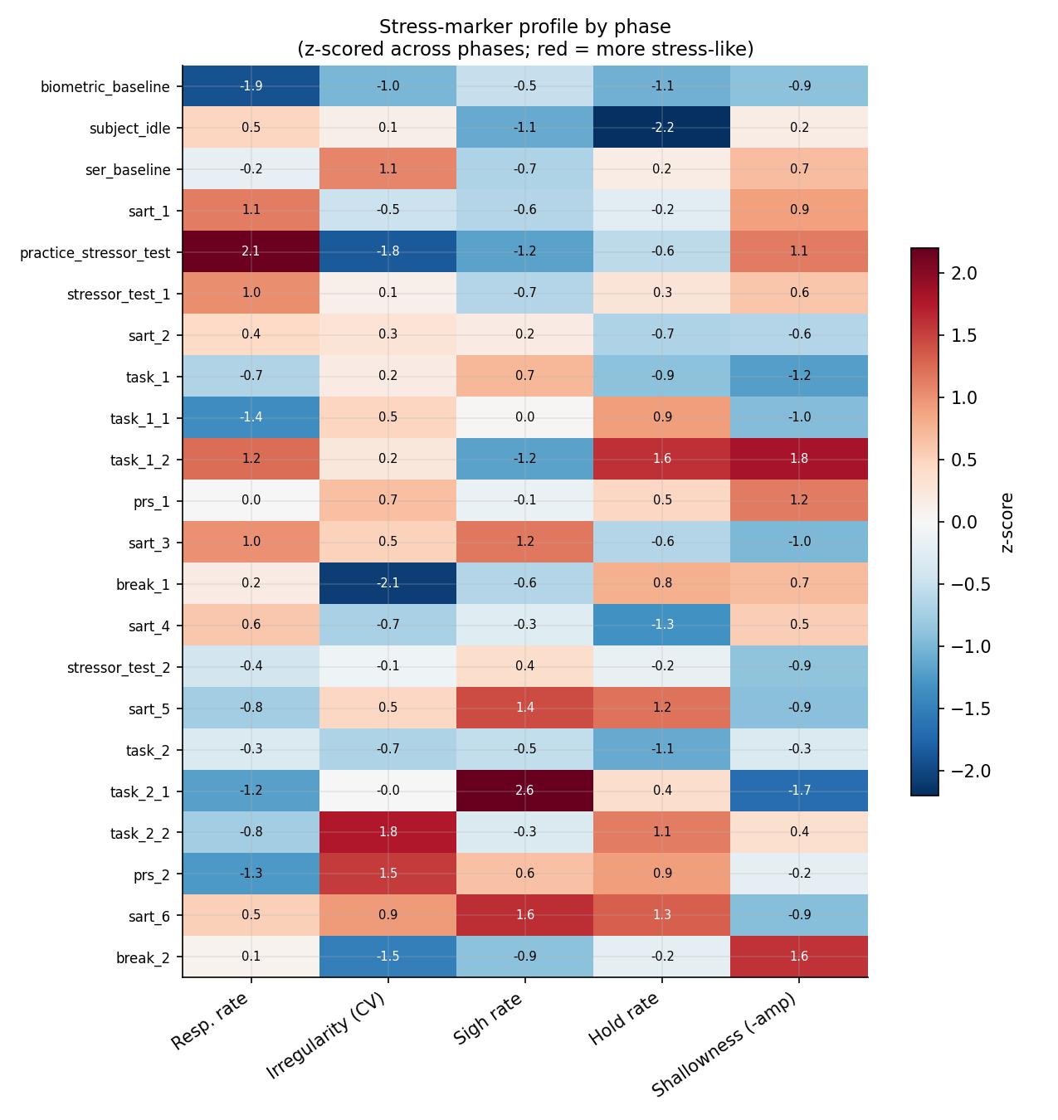
Figure 4. Stress-marker profile by phase, each marker standardised across phases. Redder cells are more stress-like; the rest breaks stand out as uniformly low.
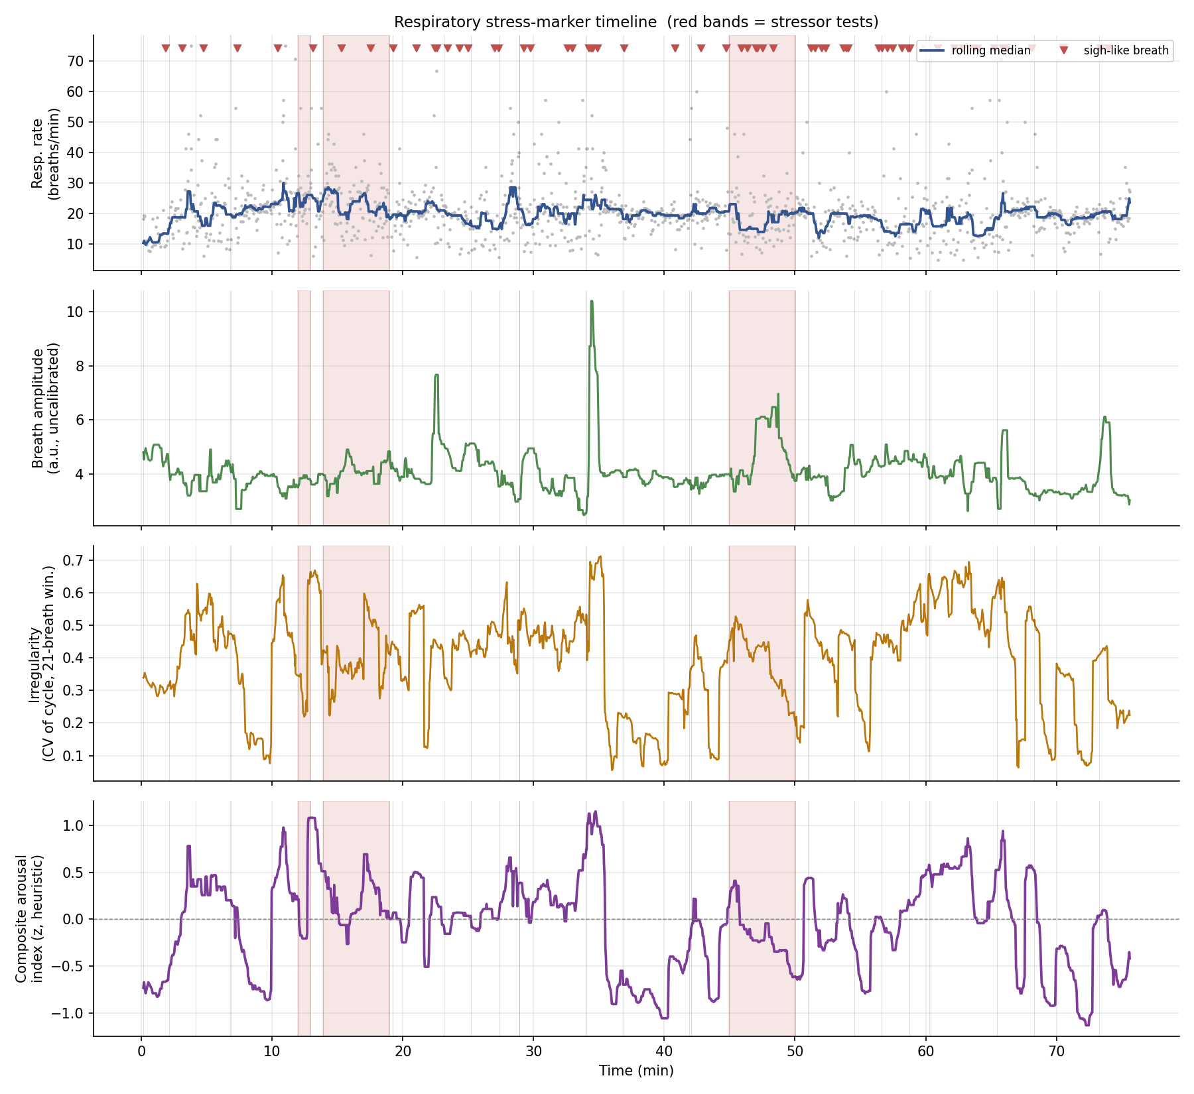
Figure 5. The four stress markers across the whole session: respiratory rate (with sigh-like breaths marked), breath amplitude, breath-cycle irregularity, and the composite arousal index. Red bands mark the stressor tests.

4.9 Breath-cycle morphology by phase
The preceding sections quantified the stress markers one at a time. It is also useful to see them together, in the form in which respiration is most familiarly depicted — the breathing waveform itself. For every phase, each detected breath (sighs excluded) was resampled, with its inhalation and exhalation limbs normalised separately so that the inhalation peak aligns, endpoint-detrended to a clean closed cycle, and averaged across the phase. The resulting ensemble-averaged breath is then tiled across a fixed fourteen-second window on shared axes, so that every phase is drawn to the same scale and can be compared directly. In this single display the stress markers become visual properties of the waveform: the width of a cycle is the breathing rate, so a faster phase visibly packs more cycles into the window; the height is the breath amplitude; the asymmetry between the rising and falling limbs is the inhalation-to-exhalation ratio; and the grey envelope, one standard deviation either side of the mean, is the breath-to-breath variability. Each panel is tinted by the composite arousal index.
Read in this form, the arc of the session is visible at a glance. The opening biometric baseline shows wide, tall, smoothly rounded cycles within a narrow variability envelope — slow, deep, regular breathing. The early attention and stressor phases show visibly narrower cycles, more of them crowded into the fourteen-second window, as breathing accelerates. The later task and questionnaire phases are not the fastest, but their envelopes are conspicuously broad, which is the morphological expression of the irregular breathing reported in Section 4.5. The two rest breaks are immediately recognisable as the panels with the tightest envelopes: regular, low-variability cycles, the signature of recovery already identified in the irregularity analysis.
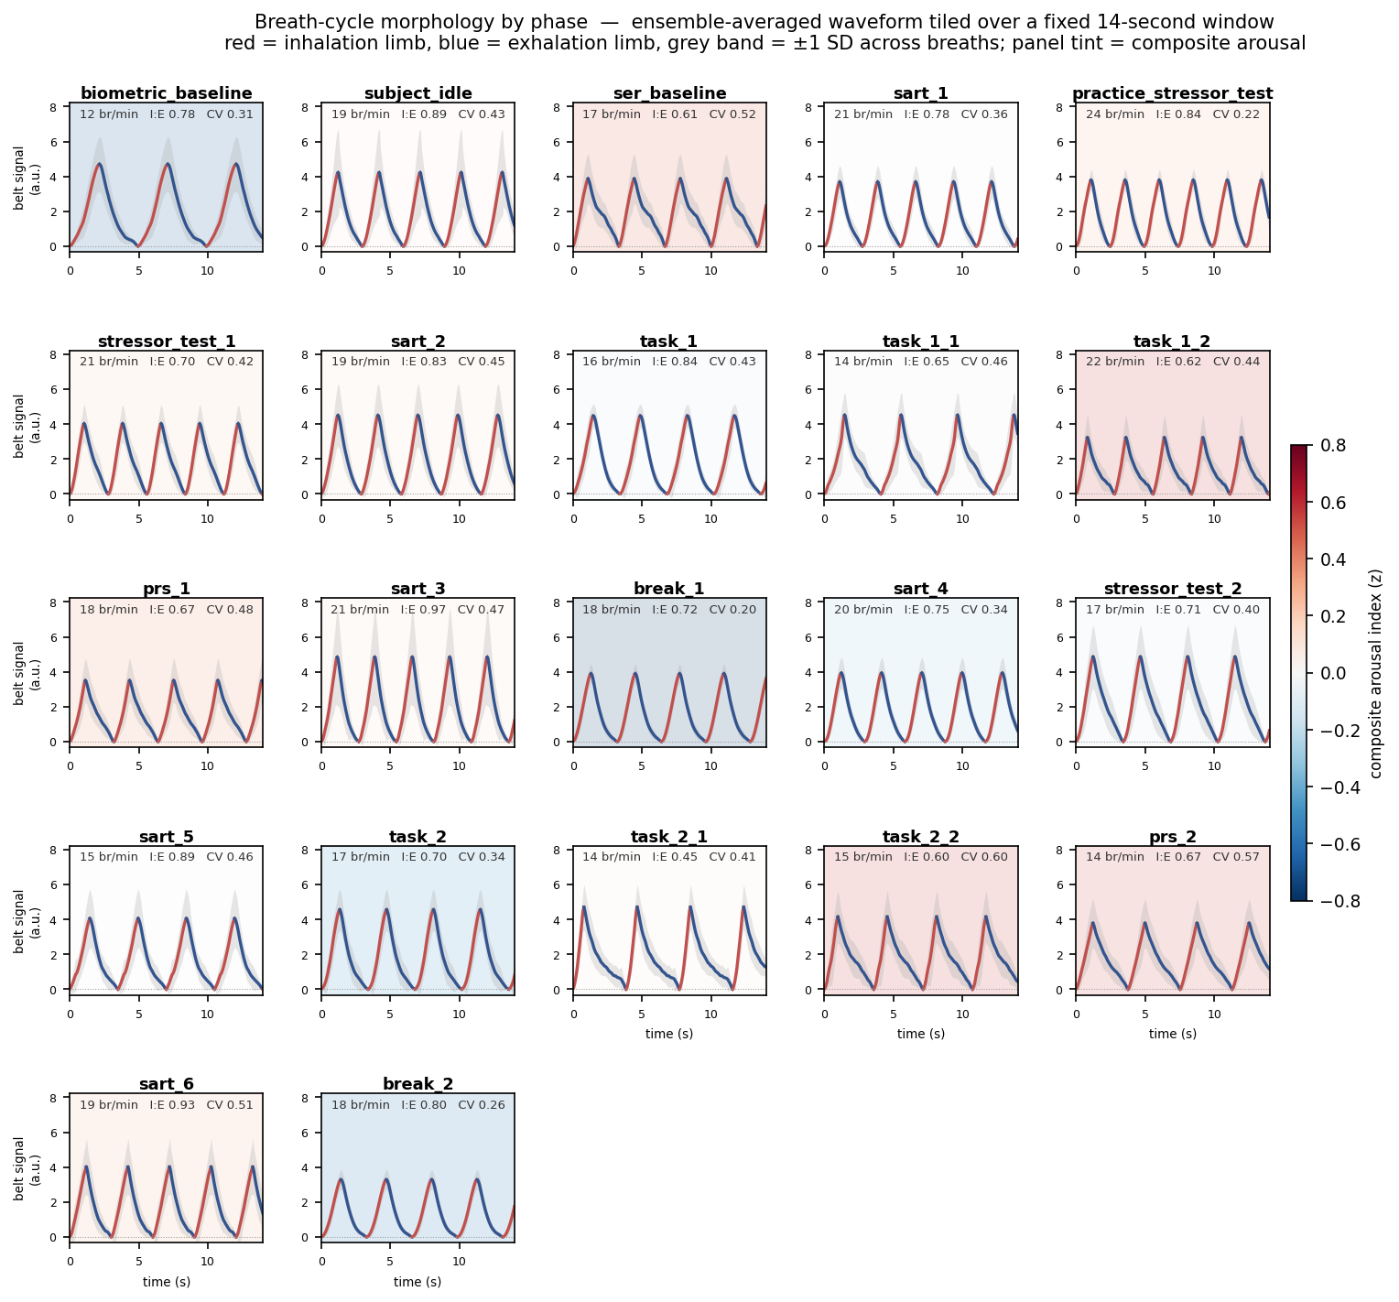
Figure 6. Breath-cycle morphology by phase. Each panel is that phase's ensemble-averaged breath, tiled across a fixed 14-second window on shared axes; red is the inhalation limb, blue the exhalation limb, the grey band is one SD across breaths, and the panel tint is the composite arousal index.
Figure 7 isolates four contrasting phases and overlays a single representative breath from each on a common axis. The comparison is direct. The calm baseline breath is wide and deep within a tight variability band; the early-arousal attention breath is markedly compressed in time; the late questionnaire breath carries much the widest variability band; and the rest-break breath, intermediate in rate, is again tightly constrained. This conveys the same information as the per-phase heatmap of Figure 4, but rendered in the waveform morphology that a physiologist reads directly.
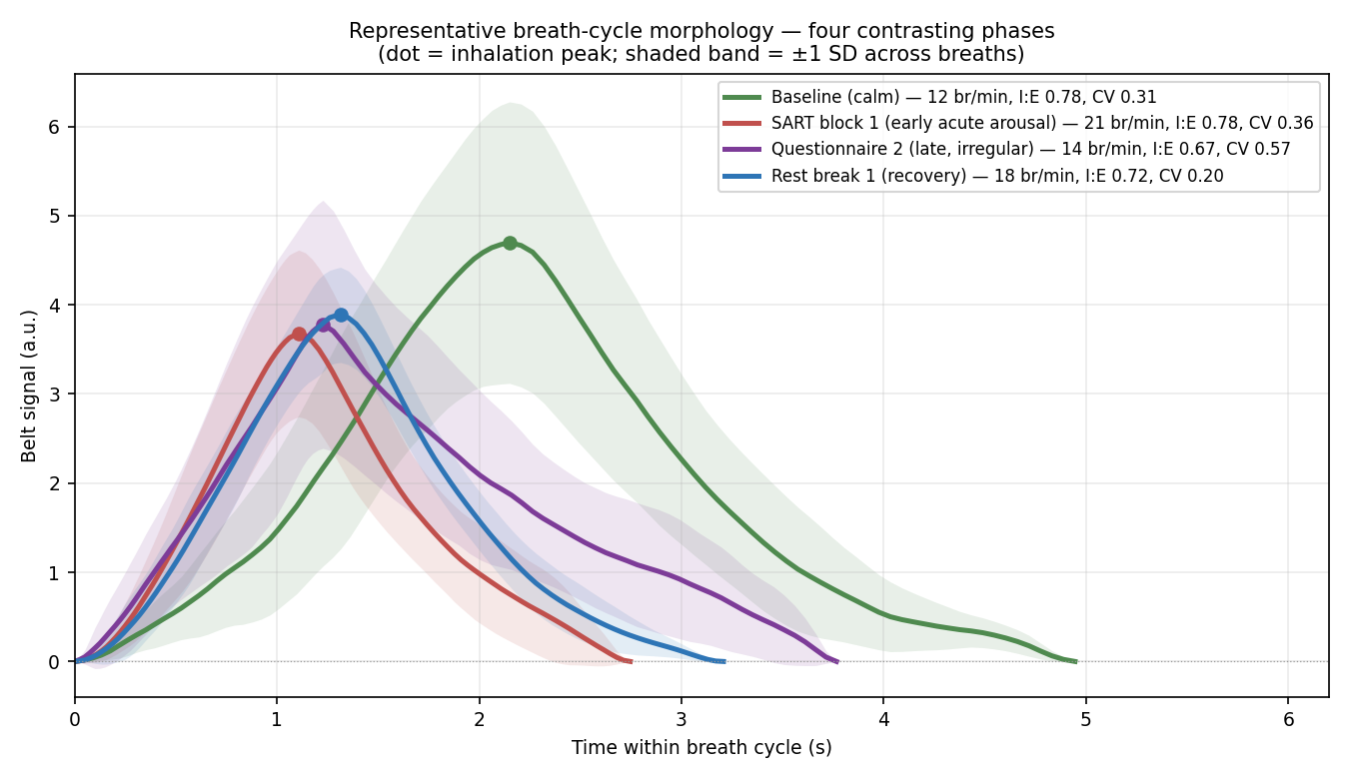
Figure 7. Representative breath-cycle morphology for four contrasting phases, overlaid on a common axis. The dot marks the inhalation peak; the shaded band is one SD across breaths.

4.10 Recovery dynamics after stressors
Recovery after the stressors could not be measured cleanly, and the reason is itself informative. This protocol places further task blocks immediately after each stressor rather than a rest period, so the minutes following a stressor are themselves occupied by cognitive demand. Respiratory rate accordingly remained elevated, roughly four to nine breaths per minute above the opening baseline, throughout the post-stressor windows (Figure 8); this is sustained task-driven elevation, not a failure to recover. The genuine recovery periods in this session are the two designated breaks, and there the recovery signature is clear but unexpected: respiratory rate did not return to the opening-baseline value, remaining near 18 breaths per minute, yet the breathing rhythm regularised dramatically, with irregularity falling to its two lowest values of the entire session. Recovery in this recording is therefore better read in the regularity of the rhythm than in its rate.
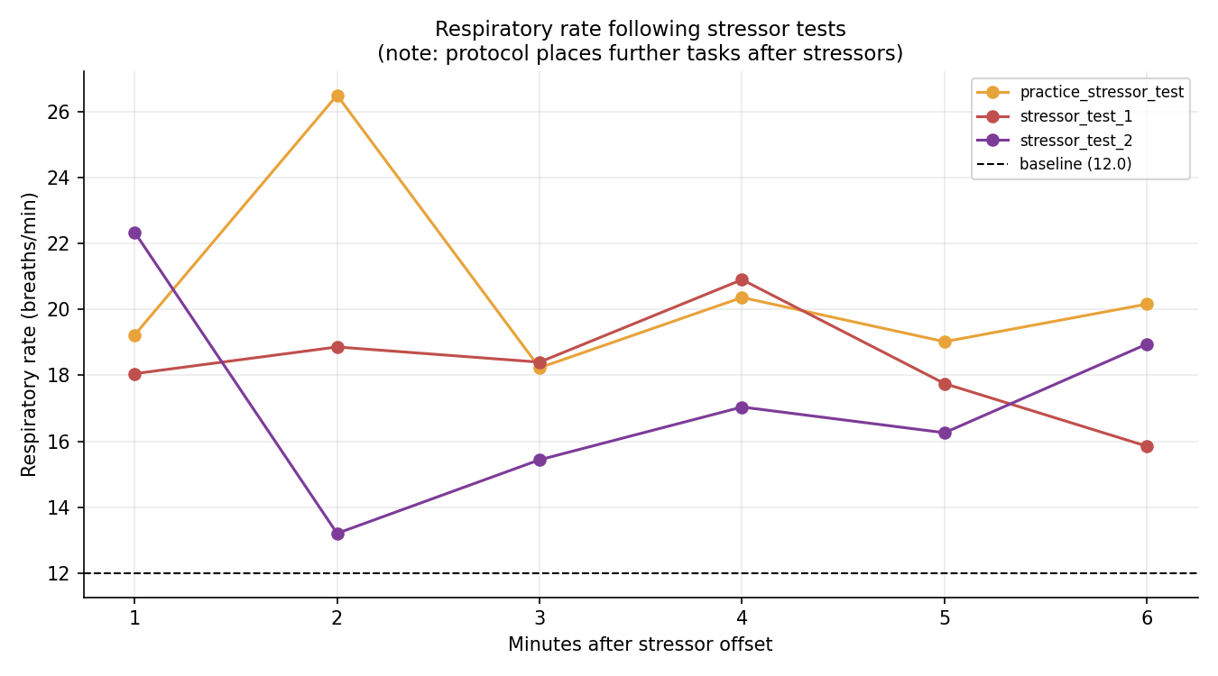
Figure 8. Respiratory rate in the six minutes following each stressor test. Rate remains well above baseline because the protocol schedules further tasks, not rest, after stressors.

4.11 Event-locked responses and respiratory phase
As an exploratory step, respiratory rate was averaged time-locked to the onsets of the stressor tests and the attention blocks (Figure 9). The averaged traces are elevated and somewhat irregular around the event onsets, but with only three stressor onsets and six attention-block onsets the averages are noisy, and no strong claim is made from them; the analysis is included to demonstrate the method, which would become powerful with the finer-grained, trial-level event markers discussed in Section 7. Finally, a continuous respiratory phase signal was computed and is provided as a time series in the accompanying data. It is not interpreted here on its own, because the value of respiratory phase lies in its later alignment with a cardiac recording to quantify respiratory sinus arrhythmia, a premier index of vagal regulation; supplying it now makes that future step straightforward.
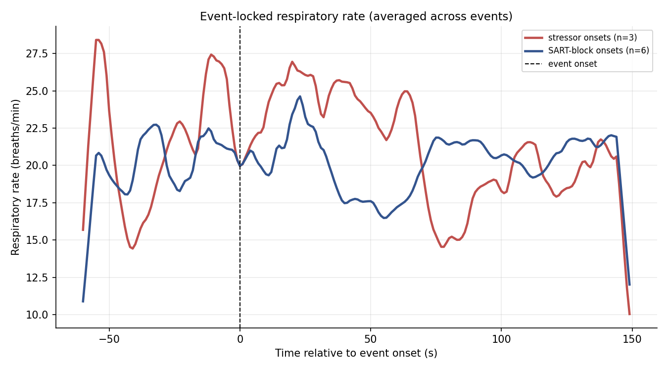
Figure 9. Respiratory rate averaged time-locked to stressor and attention-block onsets. With few events the averages are noisy and the figure is illustrative only.

5. Synthesis: Stress Across the Session
The single most important result of this analysis is that the recording does not show one stress signature but a sequence of them. Early in the session, acute arousal is written almost entirely in respiratory rate: breathing accelerates sharply, from twelve to the low twenties of breaths per minute, as the participant moves from the opening baseline into the first attention and stressor blocks. This is the textbook acute response — the rate increase that Grassmann et al. (2016) and the threat literature (Pappens et al., 2012) would lead one to expect.
As the session continues, the picture changes. Respiratory rate moderates, but it would be wrong to read that moderation as a return to calm, because three other markers move in the opposite direction. Sighs, nearly absent at the start, accumulate steadily and are most frequent in the later attention and questionnaire phases. Breath-holds cluster in the demanding task and questionnaire periods. And breath-cycle irregularity climbs to its highest values late in the session. The later part of the recording is thus characterised not by fast breathing but by irregular, sigh-punctuated, frequently paused breathing — a profile more suggestive of sustained mental load and accumulating fatigue than of acute threat. This is exactly the “family of changes” framing that motivated the analysis: the informative marker is not fixed, and a study that watched only respiratory rate would have concluded, incorrectly, that the participant was most stressed in the first fifteen minutes and progressively settled thereafter.
The rest breaks provide the third element of the picture. They do not return breathing rate to its opening value, but they produce the most regular breathing of the entire session. Regularisation of the rhythm, rather than a drop in rate, is the recovery signature here — a useful reminder that recovery and arousal need not be visible in the same variable. Taken together, the session reads as an arc: acute rate-driven arousal at the start, a long middle of irregular and effortful breathing under sustained load, and brief islands of rhythmic stability at the breaks.

6. Preliminary Comparison: Recovery in the Biophilic and Non-Biophilic Rooms
The recording’s environmental manipulation placed the participant, at two separated points in the session, in a room containing plants — the biophilic condition — and in a room without them. A natural question, and the one this preliminary section addresses, is whether the participant recovered from a preceding stressor more quickly, or more completely, in the biophilic room. The expectation has a substantial basis in the restorative-environments literature: contact with natural elements is associated with faster recovery of physiological arousal following stress (Ulrich et al., 1991) and with the replenishment of directed attention (Kaplan, 1995). The session’s structure permits a rough test, because each room is preceded, a few minutes earlier, by a stressor test — the first stressor test leads, by way of an intervening attention block, into the non-biophilic room, and the second leads by the same route into the biophilic room.
Before the numbers, the limits of this comparison must be stated plainly, because they are severe. There is one participant. Each room was entered exactly once. And the biophilic room always fell later in the session than the non-biophilic room. Any difference between the rooms is therefore perfectly confounded with elapsed time, fatigue, and habituation: a gradual settling over the session is an explanation every bit as good as an effect of the plants. This section can describe what the recording shows, and it can sharpen a hypothesis, but it cannot establish that the plants caused anything. The results are offered in exactly that spirit — as preliminary, single-case observations.
On respiratory rate the comparison is, even so, genuinely interesting. The two stressor tests were not equally activating: the first drove rate to 20.9 breaths per minute, the second only to 16.6, so the participant entered the two recovery sequences from different heights. Both rooms were nonetheless entered at a similar rate, close to 15 breaths per minute. What followed differed. Across the biophilic room respiratory rate continued to settle, drifting downward at about a quarter of a breath per minute each minute and ending the room near 14 breaths per minute. Across the non-biophilic room it did the opposite, climbing by about a third of a breath per minute each minute and ending near 19. The breathing rate, in short, kept recovering through the biophilic room and re-escalated through the non-biophilic room. Table 3 sets out the figures and Figure 10 shows the two trajectories.
Measure | Non-biophilic room | Biophilic room
Preceding stressor test — rate (br/min) | 20.9 | 16.6
Room rate, early third (br/min) | 15.1 | 15.4
Room rate, late third (br/min) | 18.7 | 14.2
Within-room rate trend (br/min per min) | +0.30 | -0.23
Room mean rate (br/min) | 17.1 | 14.8
Recovery toward baseline (stressor to room) | 42.9% | 39.7%
Irregularity (CV), early to late third | 0.42 to 0.49 | 0.41 to 0.56
Table 3. Preliminary post-stressor recovery comparison. The within-room rate trend is the one measure that clearly separates the rooms; the text explains why this cannot yet be read as a room effect.
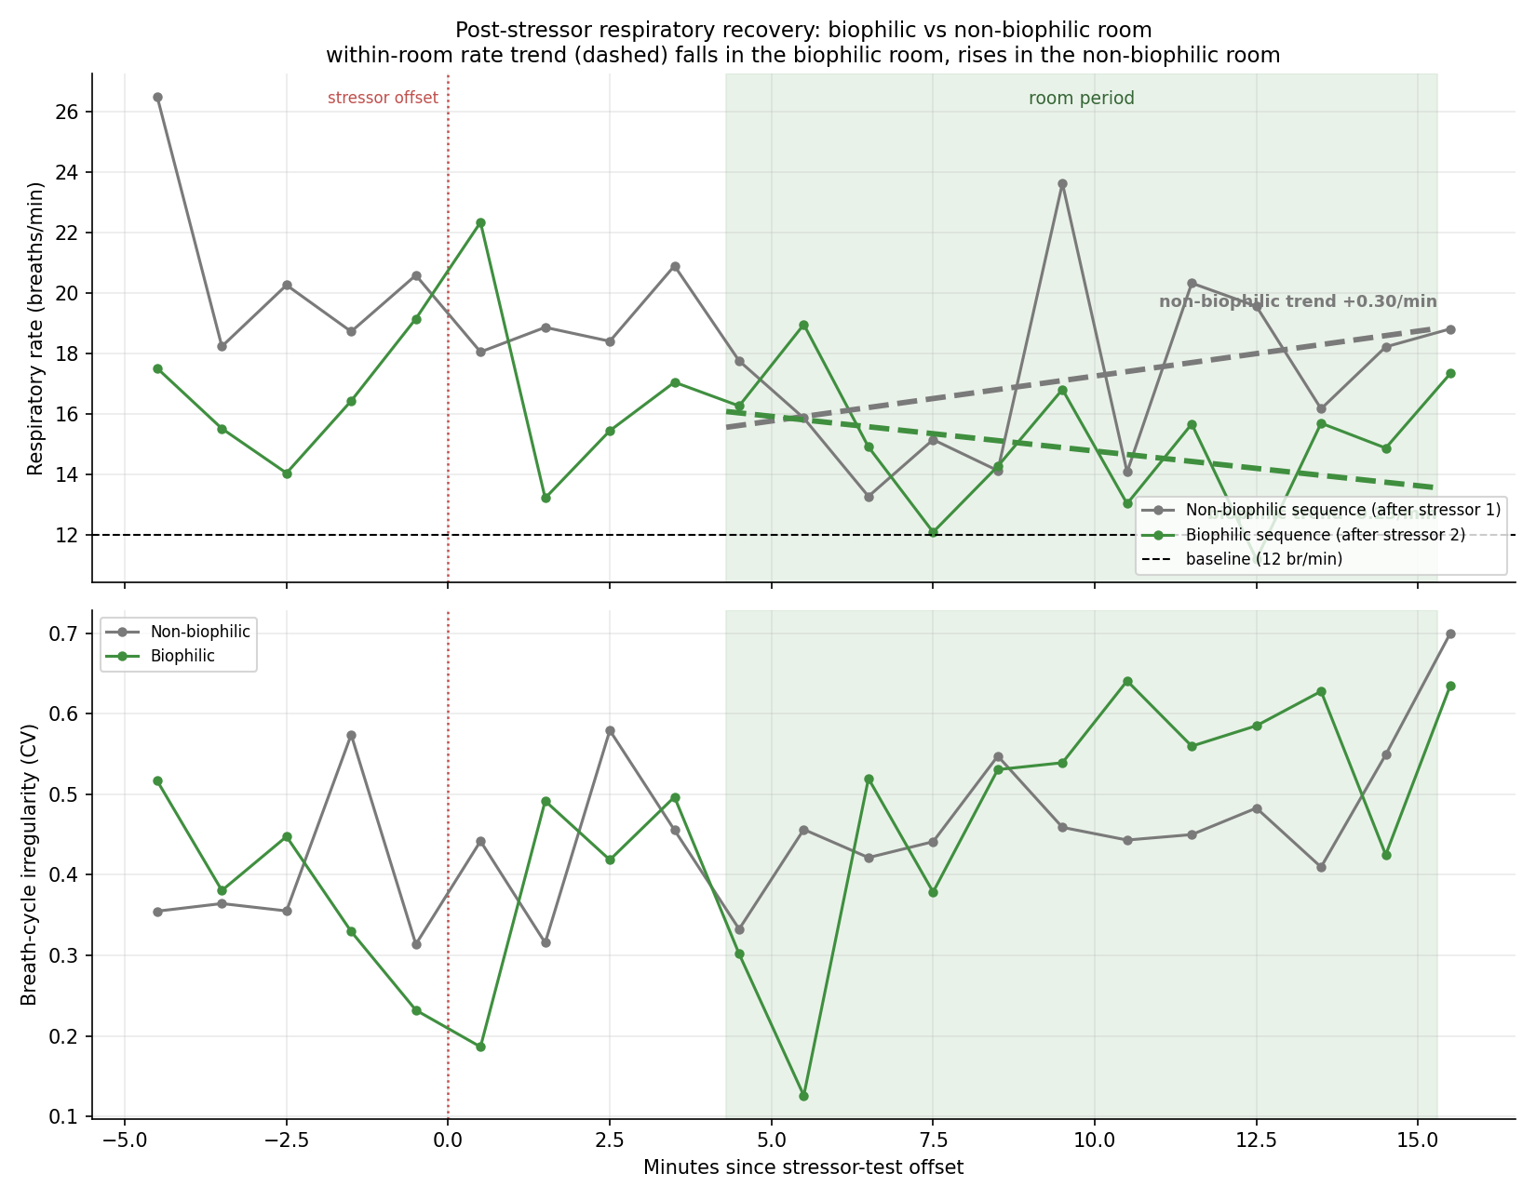
Figure 10. Post-stressor respiratory recovery in the two rooms, aligned at the offset of each preceding stressor test. Upper panel: respiratory rate, with the within-room linear trend dashed; lower panel: breath-cycle irregularity. The biophilic room’s rate trend falls; the non-biophilic room’s rises.
Two considerations weigh against reading this as a clean demonstration of faster recovery. First, when recovery is expressed not in absolute terms but as the fraction of the stressor-induced rate rise that had been reversed by the time the participant was in the room, the two rooms are essentially equal — about 43 per cent for the non-biophilic room and 40 per cent for the biophilic — because the milder second stressor simply left less to recover. Second, breath-cycle irregularity, the other principal stress marker, did not cooperate: it rose across both rooms and ended somewhat higher in the biophilic room than in the non-biophilic one. The picture is therefore mixed. The single most interpretable measure — the within-room trajectory of respiratory rate — points in the direction the restorative-environments hypothesis predicts, with continued settling in the biophilic room and re-escalation in the non-biophilic room, and to that extent these preliminary data are consistent with faster recovery in the biophilic room. But the equality of the normalised recovery fraction, the contrary movement of irregularity, and above all the perfect confound between room and session order mean the observation must be treated as a hypothesis to be tested — with the order of the rooms counterbalanced across a sample of participants — and not as a finding. At this stage it is an encouraging direction rather than a result.

7. Limitations
A single participant. All results describe one person. They form a detailed case characterisation and a source of hypotheses; they do not support inference about any population, and no statistical generalisation should be drawn from them.
Phase-level, not trial-level, markers. The event channel marks experimental phases lasting minutes, not individual task trials. Breath-holds and sighs could be localised to phases but not time-locked to discrete events such as a single stressor presentation or an individual attention-task trial. Trial-level markers would sharpen the event-locked analysis considerably and are the most valuable single addition for future recordings.
An uncalibrated single belt. Breath amplitude is uncalibrated and is measured by one chest belt, so claims about breathing depth and about thoracic versus abdominal balance are necessarily suggestive. A second, abdominal belt and a calibration manoeuvre would make depth a usable marker.
Threshold and parameter sensitivity. The sigh count depends on the chosen amplitude threshold, and the irregularity measures depend on the window length. Sensible, literature-guided values were used and are documented, but the absolute counts should be read as threshold-dependent. Some large breaths may also reflect movement rather than true sighs; a small number of obvious artefacts were excluded, but the separation is not perfect.
Confounded recovery and a brief baseline. Because the protocol schedules tasks rather than rest after the stressors, post-stressor recovery cannot be isolated. The opening baseline used as the reference is only two minutes long and may reflect settling-in, so percentage changes relative to it should be read as indicative. Consecutive breaths are also autocorrelated, so the per-phase figures are descriptive summaries rather than independent samples.

8. Conclusion
This analysis implemented the full set of respiratory stress markers that the recording can support: per-breath timing and amplitude features, sigh detection, breath-hold analysis, breath-cycle irregularity, inspiratory–expiratory structure, a continuous respiratory phase signal, recovery dynamics, and event-locked responses, together with an exploratory composite index. The picture they produce is coherent and, in its main lines, interpretable. Respiratory arousal in this session is a moving target: an early, rate-dominated acute response gives way to a long stretch of irregular, sigh-laden, frequently paused breathing under sustained load, with the rest breaks marked by a striking regularisation of rhythm. The most actionable recommendations for future recordings are to capture trial-level event markers, so that holds and sighs can be time-locked to specific task events, and to add a cardiac channel, so that the respiratory phase signal already provided here can be turned into a respiratory sinus arrhythmia measure of vagal regulation. The accompanying spreadsheet provides every per-breath, per-phase, per-sigh, and per-hold value, together with the binned time series, in a form ready for those next steps.

References
Citation counts are approximate Google Scholar figures, rounded, and should be regarded as order-of-magnitude indicators current to early 2025 rather than exact values.
Boiten, F. A. (1998). The effects of emotional behaviour on components of the respiratory cycle. Biological Psychology, 49(1–2), 29–51. [Google Scholar citations ≈ 380]
Cretikos, M. A., Bellomo, R., Hillman, K., Chen, J., Finfer, S., & Flabouris, A. (2008). Respiratory rate: The neglected vital sign. Medical Journal of Australia, 188(11), 657–659. [Google Scholar citations ≈ 1,100]
Grassmann, M., Vlemincx, E., von Leupoldt, A., Mittelstädt, J. M., & Van den Bergh, O. (2016). Respiratory changes in response to cognitive load: A systematic review. Neural Plasticity, 2016, 8146809. [Google Scholar citations ≈ 330]
Homma, I., & Masaoka, Y. (2008). Breathing rhythms and emotions. Experimental Physiology, 93(9), 1011–1021. [Google Scholar citations ≈ 760]
Kaplan, S. (1995). The restorative benefits of nature: Toward an integrative framework. Journal of Environmental Psychology, 15(3), 169–182. [Google Scholar citations ≈ 10,000]
Noto, T., Zhou, G., Schuele, S., Templer, J., & Zelano, C. (2018). Automated analysis of breathing waveforms using BreathMetrics: A respiratory signal processing toolbox. Chemical Senses, 43(8), 583–597. [Google Scholar citations ≈ 340]
Pappens, M., Smets, E., Vansteenwegen, D., Van den Bergh, O., & Van Diest, I. (2012). Learning to fear suffocation: A new paradigm for interoceptive fear conditioning. Psychophysiology, 49(6), 821–828. [Google Scholar citations ≈ 95]
Russo, M. A., Santarelli, D. M., & O’Rourke, D. (2017). The physiological effects of slow breathing in the healthy human. Breathe, 13(4), 298–309. [Google Scholar citations ≈ 900]
Severs, L. J., Vlemincx, E., & Ramirez, J. M. (2022). The psychophysiology of the sigh: I: The sigh from the physiological perspective. Biological Psychology, 170, 108313. [Google Scholar citations ≈ 65]
Ulrich, R. S., Simons, R. F., Losito, B. D., Fiorito, E., Miles, M. A., & Zelson, M. (1991). Stress recovery during exposure to natural and urban environments. Journal of Environmental Psychology, 11(3), 201–230. [Google Scholar citations ≈ 7,000]
Vlemincx, E., Severs, L., & Ramirez, J. M. (2022). The psychophysiology of the sigh: II: The sigh from the psychological perspective. Biological Psychology, 173, 108386. [Google Scholar citations ≈ 55]
Vlemincx, E., Taelman, J., De Peuter, S., Van Diest, I., & Van den Bergh, O. (2011). Sigh rate and respiratory variability during mental load and sustained attention. Psychophysiology, 48(1), 117–120. [Google Scholar citations ≈ 170]
Vlemincx, E., Van Diest, I., Lehrer, P. M., Aubert, A. E., & Van den Bergh, O. (2010). Respiratory variability preceding and following sighs: A resetter hypothesis. Biological Psychology, 84(1), 82–87. [Google Scholar citations ≈ 180]
Vlemincx, E., Meulders, M., & Abelson, J. L. (2017). Sigh rate during emotional transitions: More evidence for a sigh of relief. Biological Psychology, 125, 163–172. [Google Scholar citations ≈ 65]
Włodarczak, M. (2019). RespInPeace: Toolkit for processing respiratory belt data. In M. Heldner (Ed.), Proceedings of Fonetik 2019 (pp. 115–118). Stockholm University. [Google Scholar citations ≈ 25]

