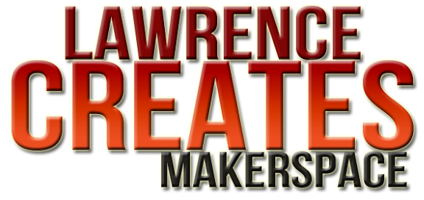
Programmer's Bootcamp
- Looking for a way to break into the tech field?
- Want to learn the tools and techniques professional programmers use?
- Is it time to get serious about learning a marketable skill?
- You've heard about C, C++, and Linux, want to really dive in?

This is your chance!

I'll be your instructor. I'm Dave Klamet, a software engineer who has worked in aerospace and telecommunications for over 25 years, including two years working on Space Shuttle telemetry systems at Kennedy Space Center, Fl.

The organizational meeting for the Programmer's Bootcamp is scheduled for October. See the info below for more information.

email: davek@lawrencecreates.com
http://LawrenceCreates.com/progboot

