## horizontal line

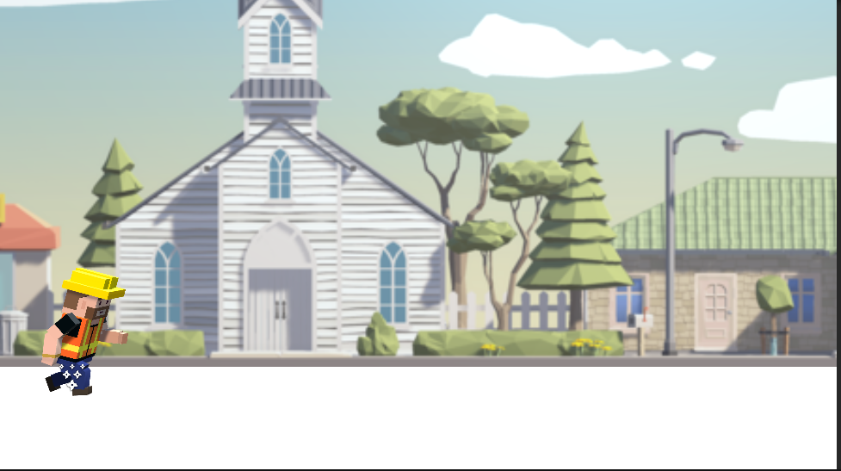

2D Free Runner Game With Unity

**5/18/2023**

**─**

# Overview

**The biggest thing I have been working on is the character’s animations when sprinting, jumping, falling, and dying. This is one of my main focuses because it makes the game feel more fluid and gives it a bit more action and character.**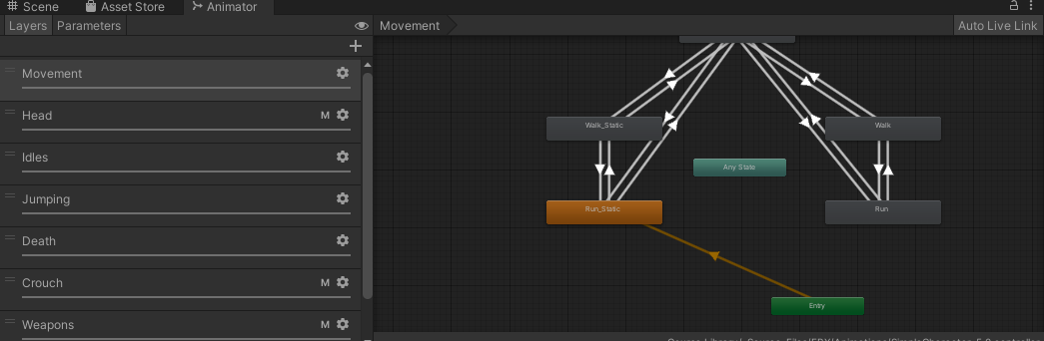

# This is what happens when you fail and hit an obstacle. The game ends and you restart.

# 

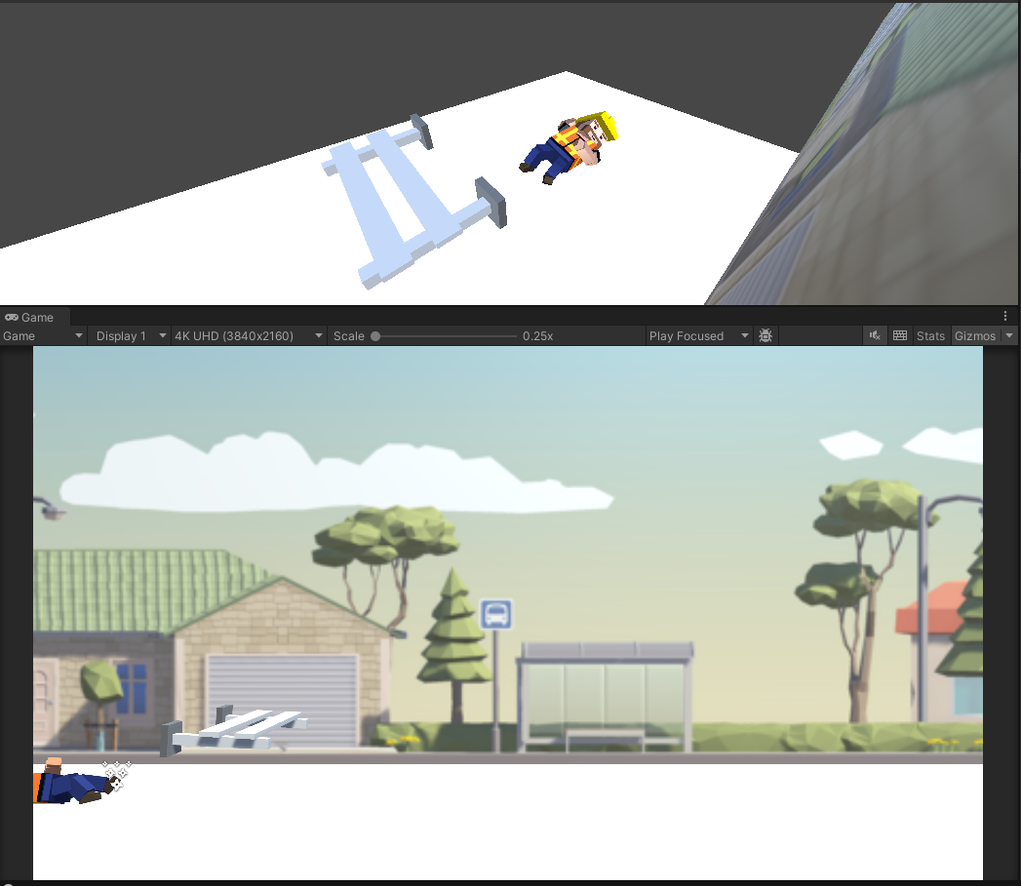

**Milestones**

**I have also done work with particle effects like smoke or fire when you hit an obstacle.**

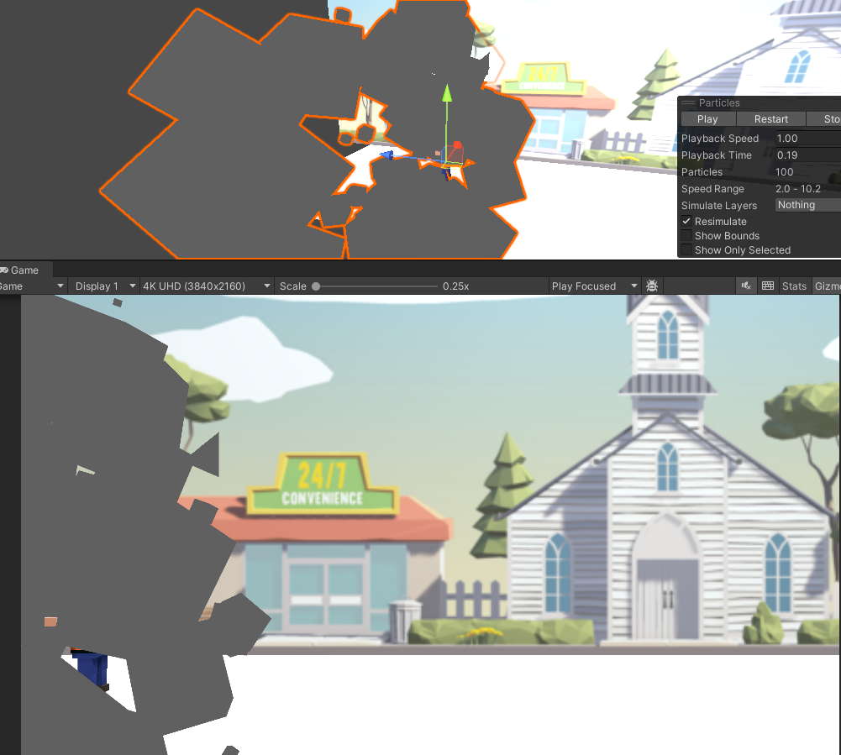

**Sources**

[**https://learn.unity.com/course/create-with-code**](https://learn.unity.com/course/create-with-code)

[**https://learn.unity.com/project/unit-3-sound-and-effects?uv=2021.3&courseId=5cf96c41edbc2a2ca6e8810f**](https://learn.unity.com/project/unit-3-sound-and-effects?uv=2021.3&courseId=5cf96c41edbc2a2ca6e8810f)