ASSIGNMENT 1

**Requirement 1 (5 marks)**

For this requirement you would need to develop a solution in pseudocode for part1 and submit your pseudocode.

IMPORT java.util.Scanner;

DEFINE class Library

Begin the main fuction

DEFINE string author array[20]

DEFINE string title array[20]

DEFINE string publisher array[20]

DEFINE int pages array[20]

DEFINE double price array[20]

DEFINE string ISBN array[20]

Create a scanner object s

Declare a FOR loop for 20 times, inside the for loop ask the user author, title, publisher, pages, price and ISBN

print("Enter the title: ");

title[i] = s.nextLine();

print("Enter the author: ");

author[i] = s.nextLine();

print("Enter the publisher:");

publisher[i] = s.nextLine();

print("Enter the price: ");

price[i] = s.nextDouble();

print("Enter the pages: ");

pages[i] = s.nextInt();

print("Enter the ISBN: ");

ISBN[i] = s.nextLine();

If the user types nomore then break the loop

Print(“title” + “author” + “publisher” + “pages” + “price” + “ISBN”);

Declare a FOR loop to display all the values entered by the user

Print(title[i]+ author[i]+ publisher[i]+ "£" + price[i] + pages[i] ISBN[i]);

**Requirement 2 (20 marks)**

The program must have the ability to prompt the user for input of title, author, publisher price, pages , and ISBN for each book via keyboard.

The program should continuously allow the user to input books details until the user enters “nomore” when the user no longer wishes to type more data. For the purpose of this assignment, you can assume that the maximum number of books the user will enter is 20. The program should store the data (i.e. it is not just echoing the typed in data back to the console) and at the end of data input output the entire library catalogue to the console in the specified format (see below).

The following is an example of the typical output to be displayed.

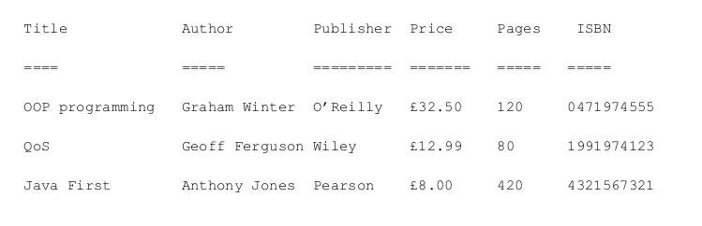

Note: Library catalogue must be display in the format specified above with relevant headings.

**import** java.util.Scanner; //importing scanner to ask user the values

**public** **class** Library { // declaring class

**public** **static** **void** main(String[] args) { // declaring Main

String[] author = **new** String[20]; //creating a string array

String[] title = **new** String[20];

String[] publisher = **new** String[20];

String[] ISBN = **new** String[20];

**int** pages[] = **new** **int**[20]; //creating an int array

**double** price[] = **new** **double**[20]; // creating a double array

**double** sum = 0;

**int** count = 0;

Scanner s = **new** Scanner(System.***in***); //creating a scanner object s

**for** (**int** i = 0; i < 20; i++) { //To ask the user values for 20 times.

System.***out***.print("Enter the title of the book: ");

title[i] = s.nextLine(); // To read next line

System.***out***.print("Enter the name of the author: ");

author[i] = s.nextLine();

System.***out***.print("Enter the publisher of the book: ");

publisher[i] = s.nextLine();

System.***out***.print("Enter the price of the book: ");

price[i] = s.nextDouble(); // To read next double value

System.***out***.print("Enter the pages of the book: ");

pages[i] = s.nextInt(); //To read next int value

s.nextLine();

System.***out***.print("Enter the ISBN of the book: ");

ISBN[i] = s.nextLine();

count++; //counting the iteration

//confirmation from user if he/she wants to continue entering data

System.***out***.print("Enter \"nomore\" to stop entering data: ");

String answer = s.nextLine();

**if**(answer.equalsIgnoreCase("nomore")) //Ignoring the case of the word "nomore".

{

**break**; //to break out of the terminal

}

}

//displaying the format given in the requirement

System.***out***.println("Title \t \t \t" + "Author \t \t \t" + "Publisher \t \t" + "Price \t \t \t" + "Pages \t \t \t "+ "ISBN ");

System.***out***.println("==== \t \t \t" + "===== \t \t \t" + "========= \t \t" + "=======\t \t \t" + "===== \t \t \t"+ "=====");

//displaying the values given by the user

**for** (**int** i = 0; i < count; i++) {

System.***out***.println(title[i]+ "\t \t" + author[i]+ "\t \t"+ publisher[i]+ "\t\t"+ "£" + price[i] + "\t\t\t" + pages[i] + "\t\t\t"+ ISBN[i]);

}

**Requirement 3 (15 marks)**

The third requirement for part1 involves aggregating the values from the input and producing a simple report to the console once the user finished inputting data. The report should identify the following information –

* The total number of books.
* The total cost of books.
* The maximum cost of a book.
* The minimum cost of a book.
* The book with highest number of pages.
* The book with lowest number of pages.
* The average cost of a book.

The output should be in the following format –

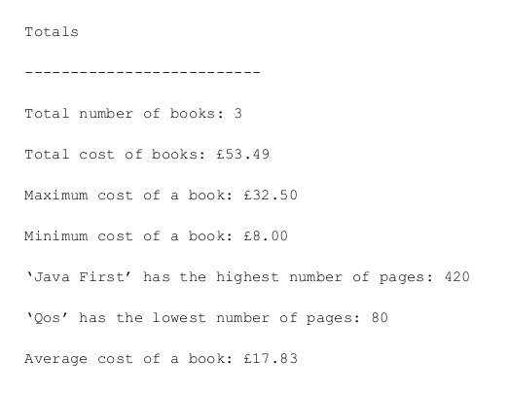

//For the total number of books

**int** total_books = count;

System.***out***.println("The length of the array is: "+ total_books);

//For the cost of total books

**for**( **double** num : price) {

sum = sum + num;

}

System.***out***.println("The total cost of books are: "+sum);

//For the maximum cost of a book

**double** max = price[0];

**for**(**int** i = 0; i < count; i++)

{

**if**(max < price[i])

{

max = price[i];

}

}

System.***out***.println("The maximum cost of the book is: "+ max);

//For the minimum cost of book

**double** min = price[0];

**for**(**int** i = 0; i < count; i++)

{

**if**(min > price[i])

{

min = price[i];

}

}

System.***out***.println("The minimum cost of the book is: "+ min);

//For the book with highest page number

**double** high = pages[0];

String high_book_name= title[0];

**for**(**int** i = 0; i < count; i++)

{

**if**(high < pages[i])

{

high = pages[i];

high_book_name= title[i];

}

}

System.***out***.println("The book with highest number of pages " + high + " is " + high_book_name);

//For the book with lowest page number

**double** low = pages[0];

String low_book_name= title[0];

**for**(**int** i = 0; i < count; i++)

{

**if**(low > pages[i])

{

low = pages[i];

low_book_name= title[i];

}

}

System.***out***.println("The book with lowest number of pages " + low + " is " + low_book_name);

//For the average cost of the book

**double** average = (sum / total_books);

System.***out***.println("Average of the cost of the books = " + average);

}

}

Submitted By: Garima Dhakal

Section: C

ID: 77261088