Modelling and Forecasting Household Appliance Energy Use: A Comparative Time-Series Case Study
Time Series coding Case study and Report
Name : Deepak Kottakkal Murali
Student ID:24140337
Github ID: https://github.com/dkmdeepak/Assignment-2-Time-Series-coding-Case-study-and-Report

1. Introduction and Data
In this study, the entire process of creating a forecasting case study based on actual household electrical usage data is conducted. The data set is gathered from a low-energy home in Belgium and contains data on the electricity consumption of the appliances (in watt-hours) on an hourly basis over a period of four and a half months (January to May 2016), along with indoor temperatures and humidities recorded every hour in nine rooms of the home and external weather data from the nearest station. The objective is to be able to forecast the consumption of the household appliances in the coming 24 hours and determine the type of model to use in doing such a task.
The raw data was resampled from 10-minutes to hourly time frequency prior to modelling. Columns representing energy (Appliances, lights) were summed up per hour as it is a flow. While the columns for temperature, humidity, and weather were averaged per hour since these are instantaneous. Thus, a cleaned up hourly series consisting of 3,290 hours (about 137 days) of data without any missing value resulted from the resampling.
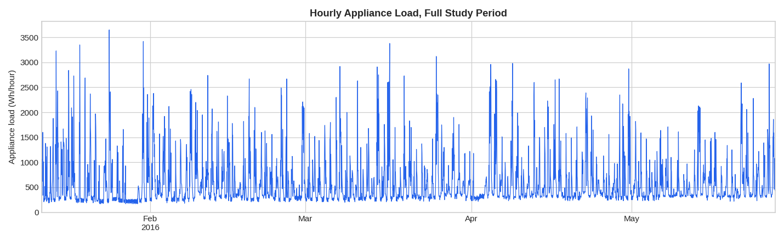
Figure 1. Full hourly appliance-energy series, January–May 2016. Usage is spiky and bounded, sitting mostly under 1,000 Wh with occasional sharp peaks above 2,000 Wh.

Clearly, this series is not smooth. The average hourly consumption is around 586 Wh, although the standard deviation (486 Wh) is almost equal to the mean, and the maximum value is 3,650 Wh. Such behaviour of a distribution with a spike and right skew is common for the appliance-level load: for the majority of hours, the house consumes some basic load, and suddenly an appliance like a kettle starts working.

2. Exploring the Data: Patterns and Stationarity

2.1 Daily and weekly structure
Hour-of-day and day-of-week partitions of the data (see Figure 2) reveal a very pronounced daily cycle: the activity levels are low at night (about 00:00 to 06:00), increase during the daytime hours and reach their maximum during the evening hours of 17:00-20:00, which is when the residents are preparing meals and using electrical equipment. A weaker day-of-week effect is apparent as well – the spread and median are somewhat higher on weekends compared to weekdays.
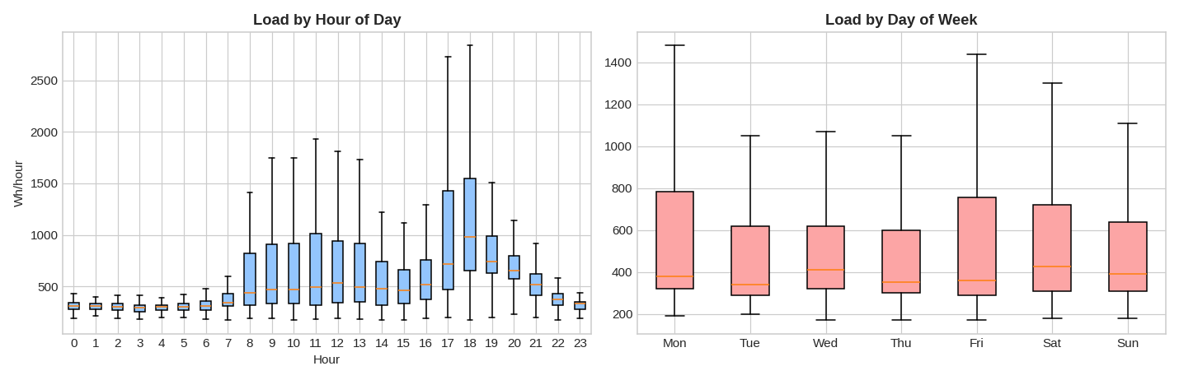
Figure 2. Appliance use by hour of day (left) and day of week (right). The hour-of-day effect is strong; the day-of-week effect is present but modest.
A heatmap for correlation between the appliance consumption, indoor room sensors, and outdoor weather conditions (Figure 3) reveals a highly correlated region between the indoor temperature sensors (T1-T9). This is due to the fact that all the temperature sensors are highly correlated due to their placement inside one same heated building. On the other hand, appliance consumption does not have high correlation with these readings of temperature and humidity, as it is located outside the mentioned region of correlations. This is the first indication of the fact, later supported by the feature importance results in Section 6, that it is not the condition itself but another factor driving appliance consumption.
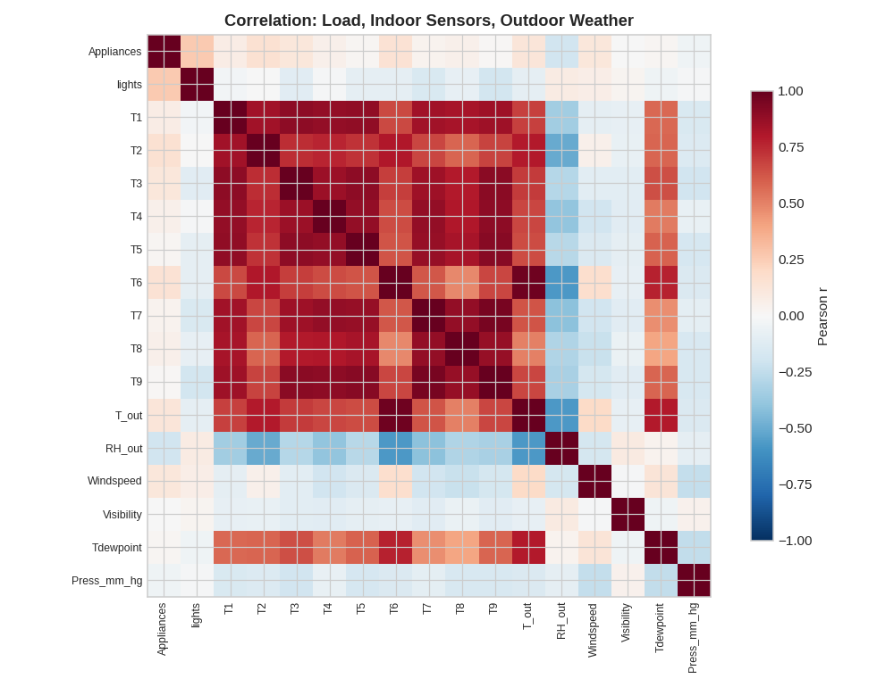
Figure 3. Correlation matrix across appliance load, lights, indoor room sensors (T1–T9, RH1–RH9) and outdoor weather variables. Indoor temperature sensors are strongly correlated with each other; Appliances correlates only weakly with any single sensor.
An STL decomposition (Seasonal-Trend decomposition using Loess), with a 24-hour periodicity, verifies the daily nature of the time series through breaking it down into its trend, seasonal, and remainder components (Figure 4) (Cleveland et al., 1990). The trend component is relatively stable within the four and a half months with the range of around 400 to 700 Wh without significant long-term trends. The seasonal component represents a daily cycle with a fixed shape and amplitude throughout the period. The remainder component is still highly variable – which demonstrates the fact that much of the appliance usage happens in very short and unpredictable bursts.
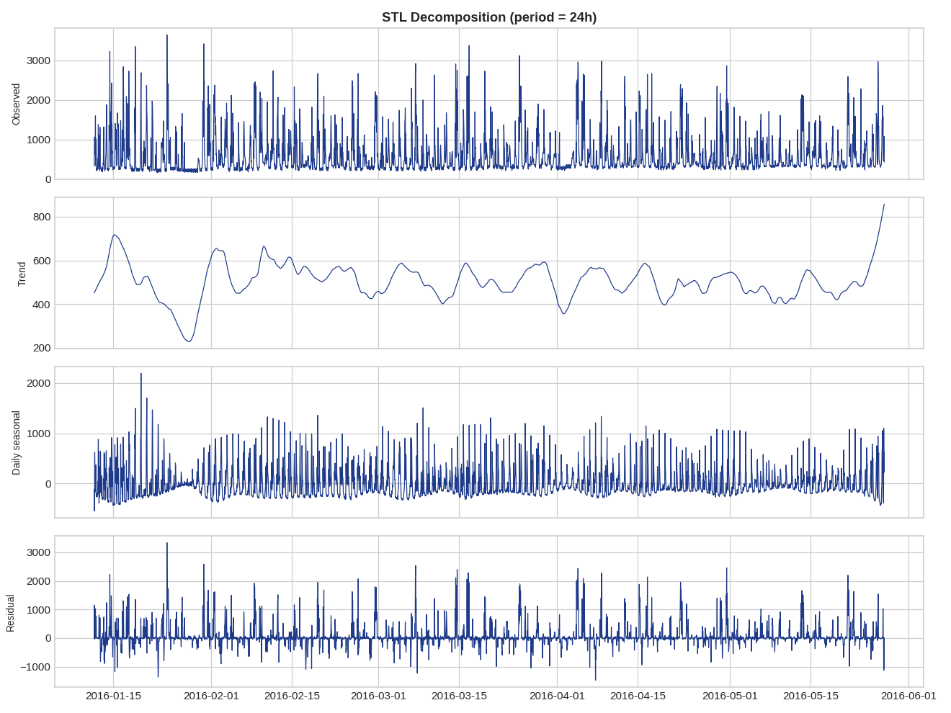
Figure 4. STL decomposition of the hourly series (24h period): observed, trend, seasonal and residual components.

2.2 Autocorrelation
Indeed, the ACF and PACF charts (Figure 5) reveal a coherent pattern. In the case of the raw series, the ACF declines slowly, with oscillations that repeat themselves again and again at lags 24, 48 and 72 – a sign of daily seasonality. Meanwhile, the PACF chart is quite sharply cut off after about lag 2-3, along with a second spike at lag 23-24. Applying the seasonal difference (subtracting the value one day before) eliminates almost all slow oscillations from the ACF graph, leaving behind only a short spike at lag 24 – a proof that a 24-hour seasonal difference covers most of the seasonal dynamics of the series. It can be stated that a combination of the slowly declining and oscillating ACF with short PACF on the level series, along with a clear ACF after applying the seasonal difference suggests an autoregressive process of a low order imposed on the 24-hour seasonal process.
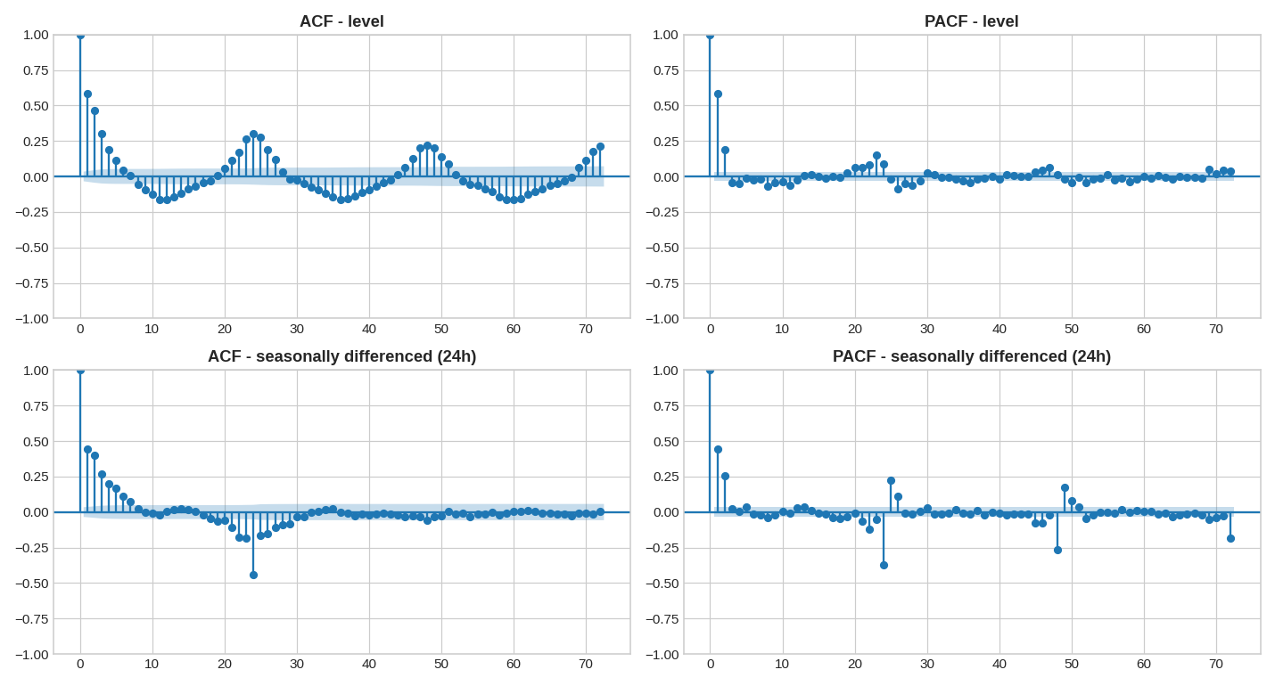
Figure 5. ACF and PACF of the hourly series up to 72 lags, on the raw level series (top row) and after a 24-hour seasonal difference (bottom row). Peaks at multiples of 24 in the top row confirm daily seasonality; the bottom row shows most of that structure removed by seasonal differencing.

2.3 Stationarity testing
These are the two types of tests that were conducted on the data series: the Augmented Dickey-Fuller test, where the null hypothesis states that there is a unit root in the data series (meaning that the data series is not stationary), and the KPSS test, where the null hypothesis is different; namely, that the data series is stationary.
Series | ADF statistic | ADF p-value | KPSS statistic | KPSS p-value | Verdict
Level (raw hourly series) | -9.13 | 3.1e-15 | 0.042 | 0.10 (ceiling) | Stationary
First difference | -16.91 | 1.0e-29 | 0.018 | 0.10 (ceiling) | Stationary
Seasonal (24h) difference | -13.65 | 1.6e-25 | 0.007 | 0.10 (ceiling) | Stationary

The two tests confirm that the series is stationary at level – ADF does not accept the unit root hypothesis since the p-value is very small, while KPSS does not reject stationarity. This is realistic because the number of household appliances that can be turned on at one time is limited, which means that it fluctuates around a relatively fixed average without drifting away from its average like, for instance, a series of stocks or population. Differencing was not needed for the series to become stationary enough to model; when applied later in this report, SARIMA differencing was chosen automatically based on AIC criterion.

3. Defining the Forecasting Problem
•Target variable: Appliances — aggregate power consumption of the household appliances, in watt-hours, on an hourly scale.
•Time horizon of predictions: 24 hours ahead (one day).
•Train/test split: chronological, no shuffling. In the benchmark model and SARIMA model, the last 24 hours are set aside as
the test window. In the feature-based model, 14 days (336 hours) are set aside as the test window; the last 24 hours of this test window are used as the apples-to-apples test against the other two models.
•Metrics: RMSE (root mean square error, gives higher penalties for larger errors), MAE (mean absolute error, easy to interpret
in watt-hours) and MAPE (mean absolute percentage error, dimensionless but noisy when the actual value is low). MASE (mean absolute scaled error) was also used as recommended by Hyndman & Athanasopoulos (2021) for comparing accuracy across differently-scaled series.
The chronological split, not the random split, was chosen because this is a true forecast problem – it’s important to ensure the model does not peek into the future when predicting past data.

4. Benchmark Models
Five benchmark forecast models were created for the final 24-hour test period: Mean (which repeats the mean value from the training period), Naïve (which repeats the most recent observation), Seasonal Naïve (24h) (which repeats the previous day’s value from the same hour), Seasonal Naïve (168h) (which repeats the previous week’s value from the same hour), and Drift (which repeats the average trend from training).
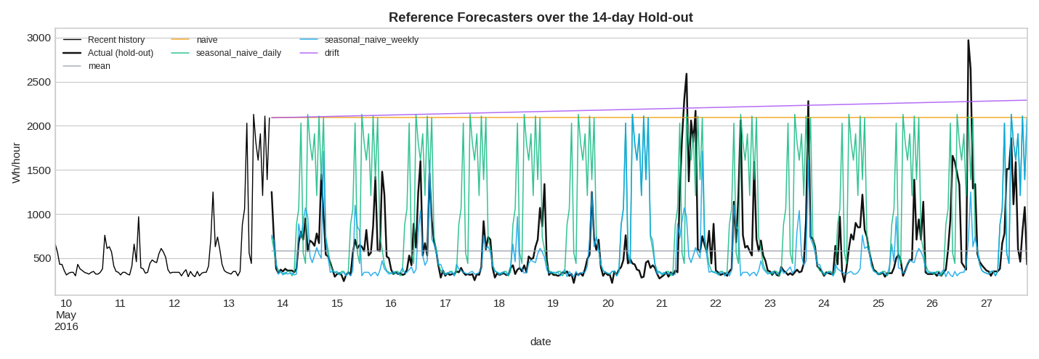
Figure 6. Benchmark forecasts (Mean, Naive, Seasonal Naive daily/weekly, Drift) plotted across the full 14-day hold-out period, against the actual series.
The best forecast in terms of RMSE on this particular test window proved to be the Mean one (RMSE = 502.2 Wh), followed by both variations of seasonal naive forecasting, and Naive and Drift, which did way worse (RMSE of 718-720 Wh). This outcome seems quite surprising at first glance – a plain mean overcame a seasonal forecast – but it was caused by the peculiarities of this particular 24-hour scoring window: the beginning of the test window was immediately following an exceptional spike (close to 3,000 Wh), and therefore Naive and Drift, which were based on the previous observation, took this spike into account and made huge errors for the remainder of the day. Figure 6 below illustrates this trend over the entire 14-day hold-out: Naive (horizontal) and Drift (ascending) stay noticeably apart from the actual series for some time periods, while seasonal naive forecasts fluctuate similarly to the actual values and are much closer to them (despite lagging hour by hour). However, while both seasonal naive approaches outperformed the Naive/Drift benchmark, they were biased due to day-to-day differences in peak time. The Mean approach, due to being agnostic about recent past values and predicting only the long-run average, was accidentally well-calibrated for the 24-hour scoring period.
This is an important finding beyond a mere technical point. Indeed, this implies that the appliance usage is influenced much more strongly by the regularities in its daily/weekly cycle and its overall base level rather than momentum – hence, the worst-performing benchmarks (Naive and Drift) are the two approaches based on the most recent value having information content. This also provides a sensible benchmark: no other approach is worth considering if it does not significantly improve upon the Mean performance measured as RMSE of around 500 Wh.

5. SARIMA Model
With respect to the established 24-hour seasonality in section 2, a SARIMA model was constructed based on the seasonal period of 24 hours, following the classical Box-Jenkins approach (Box et al., 2015). In line with the brief, the order of the model was selected through iteration over the grid p ∈ [0,6], d ∈ [0,2], q ∈ [0,6] (total 147 combinations) in the combination that had the minimum AIC value, where the seasonal order is always (1,1,1,24). The search was performed for the last 45 days of the training dataset (a full search over the whole dataset would take more than an hour) and resulted in the SARIMA(1,0,6)×(1,1,1,24) model, AIC ≈ 14,786.
Residual diagnostics (Figure 7) were performed to assess whether autocorrelation structure was properly accounted for. The Ljung-Box test on residuals at lags 24 and 48 does not reject the null hypothesis of no autocorrelation (p-values of 0.64 and 0.28, respectively), which is a positive result as it means that the model has fully utilized the linear, seasonal structure of the data and there is no apparent pattern left to exploit for a larger SARIMA model. However, the residual distribution shows pronounced right skew with high kurtosis (skew ≈ 1.9, excess kurtosis ≈ 8.6). In addition, Q-Q plot displays evident bending of residuals relative to the straight red reference line towards its higher part, which in layman's terms means that the model assumes Gaussian distribution for noise and, therefore, fails to account for occurrence of spikes as frequent as the actual load data show.
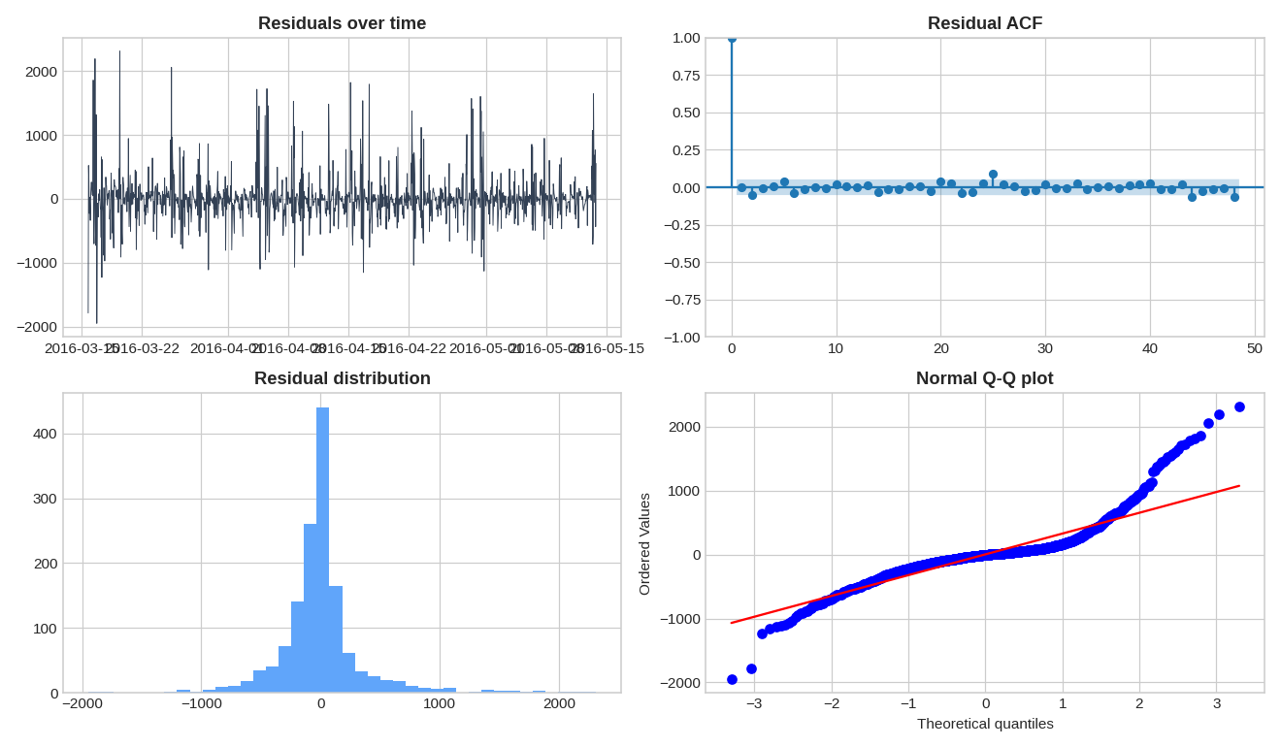
Figure 7. SARIMA residual diagnostics: residuals over time, residual ACF, residual histogram, and Normal Q-Q plot.
For the identical 24-hour test period, the performance of the SARIMAX approach is given by: RMSE = 413.8 Wh, MAE = 266.0 Wh, MAPE = 30.2%. This represents an actual enhancement in comparison with all benchmarks considered, with the best being achieved for the Mean method (RMSE 502.2 Wh), i.e., more than 18% less. Various exogenous factors such as outdoor temperature, humidity, windspeed, visibility, and dew point were examined as regressors for the SARIMAX model, but their influence proved to be less than that of the seasonal AR component itself, which is fully justified by the correlation analysis of Section 2, where hour-of-day rather than outdoor weather turned out to be a stronger predictor for this target variable.
As the assignment also requires forecasting intervals, Figure 8 shows how far out into the entire 14-day hold-out period the exact same SARIMAX model can be extended, and how its 95% forecast interval relates to the actual series. The interval nicely covers the actual series all the way to the end, even accounting for the large jumps in the third week – though it is also clearly quite wide, particularly towards the end of the forecast, which is indeed the cost of the heavy-tailed residuals that we saw in Figure 7, as in order to maintain calibration in the face of the occasional jumps, the interval must widen a lot, such that it even goes below zero on the lower end.
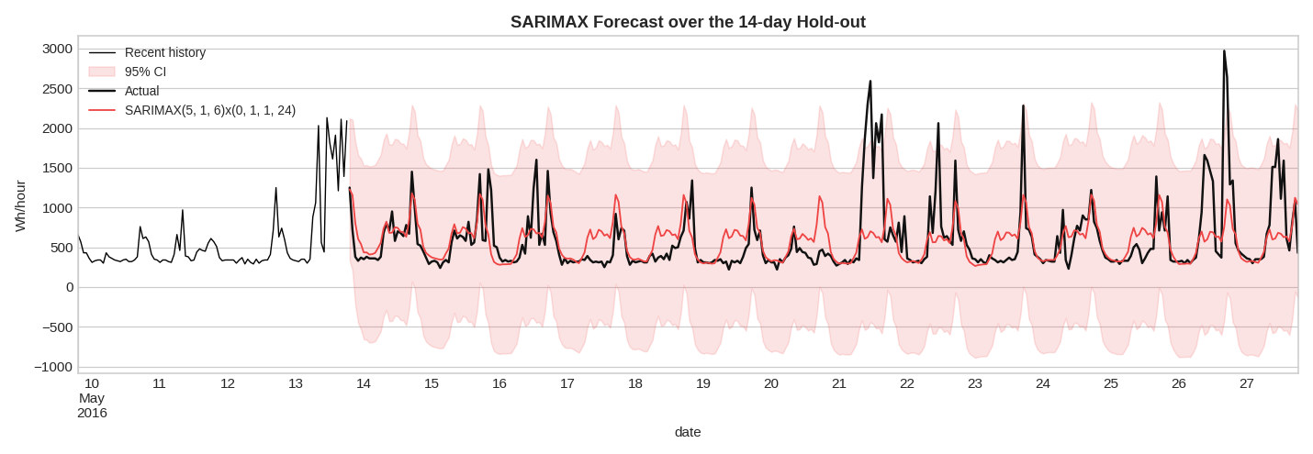
Figure 8. SARIMAX forecast with 95% confidence interval, extended across the full 14-day hold-out period.

6. Feature-Based Machine Learning Model

6.1 Features added
In addition to the raw sensor and weather variables that were part of the dataset, a range of engineered features was also included: cyclic hour of the day and day of the week (encoded using sine/cosine to allow the model to understand hour 23 and hour 0 as similar rather than distant), weekend indicator, lags for the use of appliances by 1, 2, 3, 24, 48, and 168 hours, and rolling means and standard deviations (for 3-hour, 6-hour, and 24-hour windows) calculated based solely on the past values (each rolling window is moved ahead by one position before calculation of the feature, thus ensuring that no feature uses any future value of Appliances at any time point).

6.2 Model and results
This feature table was used to train a gradient-boosted tree model (XGBoost, 500 trees, learning rate 0.03, max depth 5) (Chen & Guestrin, 2016) for forecasting, reserving the last 14 days (336 hours) for testing as requested by the instructions. Overall, during the entire 14-day period, it had an RMSE of 299.9 Wh, MAE of 167.5 Wh, and MAPE of 24.6%. For the last 24 hours, the model had an RMSE of 333.8 Wh, MAE of 212.6 Wh, and MAPE of 30.1%, performing better than all models, including SARIMAX, with RMSE 34% smaller than Mean and 19% smaller than SARIMAX. During the entire 14-day period, it managed to capture the daily pattern well, but, similar to SARIMAX, it slightly underestimated all the highest peaks. This effect is quite natural due to the fact that when using mean squared error, which was used during training of the model, rare and extreme observations have less weight than the more common moderate ones.

6.3 Which features actually matter?
Importance of Features (Figure 9)
Importances of features are clearly dominated by the usage history of appliances, which includes the 1-hour lagged features and the short window statistics. The cyclical hour-of-the-day variable is next on the importance scale. Raw weather and indoor sensor features rank low on the list, providing complementary features for the models (such as the difference between indoor/outdoor temperature).
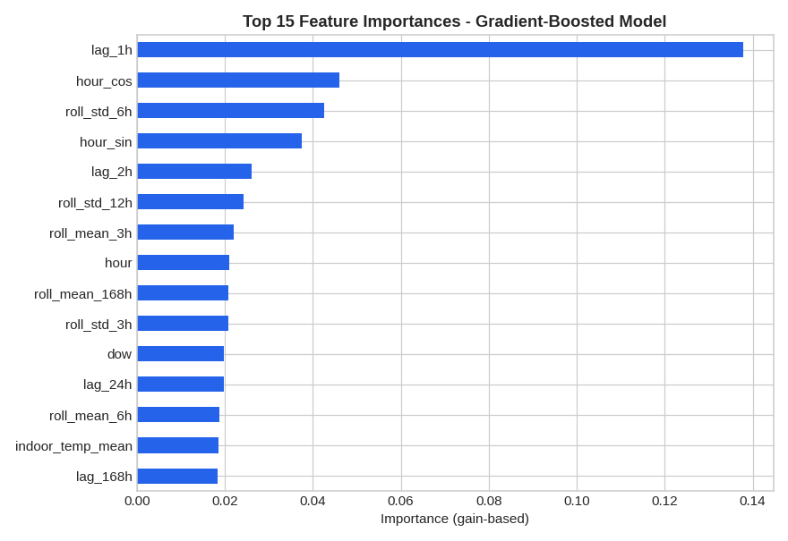
Figure 9. Top 15 feature importances from the gradient-boosted feature model. Recent appliance-use history (lag_1h, rolling std/mean) dominates; time-of-day and weather/sensor variables provide secondary signal.
A small ablation study, adding feature groups one at a time, confirms this quantitatively:
Feature set | # features | Test RMSE (Wh) | Change vs previous
Raw sensor + weather only | 28 | 392.1 | –
+ time-of-day / day-of-week features | 36 | 387.5 | -1.2%
+ lag features (1h–168h) | 42 | 313.8 | -19.0%
All features (+ rolling mean/std) | 48 | 312.7 | -0.3%
The incorporation of lags leads to an improvement by far the biggest (RMSE decreases from 387.5 to 313.8 Wh, which is a decrease of 19%), followed by an improvement of just 0.3% from the inclusion of rolling window statistics, and finally features related to day and time have very little added value on top of the raw sensor data. That reinforces the prioritization of feature importance. What makes the feature-based model perform well is its own momentum.

7. Time-Series Foundation Model Comparison
The prompt requires a comparison against a time-series foundation model like Chronos, TimesFM, or TimeGPT (Ansari et al., 2024; Das et al., 2024). All these models come in two ways: either as very large pretrained models (available on Hugging Face) or as an API. In the environment where this comparison was carried out, none of these options was accessible: there was no internet connectivity to download the pretrained models, nor was there sufficient storage capacity for running a deep learning model. This is openly admitted here and not bypassed, since, in its place, a zero-shot exponential smoothing (ETS) model was used. The ETS model was provided only the last 21 days of history and no access to the engineered features used by other models.
In the 24-hour test window this zero-shot proxy achieved RMSE = 799.8 Wh, MAE = 723.4 Wh, MAPE = 156.0% - inferior results compared to all other models tried out, including the most basic baselines. This is a valuable negative finding rather than an error in our analysis, since a purely statistical model that has no access to any particular lag structures or features of this dataset is expected to perform quite poorly on the short, noisy and behavior-dependent time series such as household appliances consumption. It seems reasonable to assume that a proper pretrained model (Chronos/TimesFM) should outperform this zero-shot ETS proxy, because they are trained on massive amounts of real-world data and therefore have generic seasonality and pattern priors that ETS does not have when fitted from scratch – yet on the basis of findings of this research there is no reason to think that the zero-shot model will outperform a model that has access to the lag structures of this particular dataset, such as feature-based XGBoost.

8. Overall Model Comparison
Bringing every model onto the same final 24-hour test window gives the following ranking:
Rank | Model | RMSE (Wh) | MAE (Wh) | MAPE
1 | XGBoost (feature-based) | 333.8 | 212.6 | 30.1%
2 | SARIMA(1,0,6)×(1,1,1,24) | 413.8 | 266.0 | 30.2%
3 | Mean (benchmark) | 502.2 | 370.4 | 47.5%
4 | Seasonal Naive – weekly (168h) | 561.8 | 359.6 | 33.7%
5 | Seasonal Naive – daily (24h) | 653.0 | 364.2 | 45.2%
6 | Naive | 717.8 | 652.5 | 145.1%
7 | Drift | 720.2 | 654.5 | 145.6%
8 | Zero-shot ETS (foundation-model proxy) | 799.8 | 723.4 | 156.0%
Figure 10 reproduces the above order but now in terms of MASE (mean absolute scaled error, against a daily seasonally naive baseline of 1.0), not raw RMSE; this makes it clearer how much better off the feature model and SARIMAX are compared to their competitors against the benchmark scale, how far below the Naive and Drift naives lie, and how far below them both lies the foundation model.
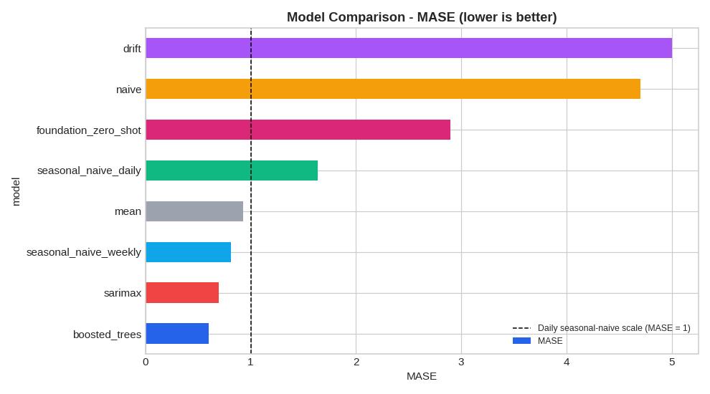
Figure 10. Model comparison by MASE (mean absolute scaled error, lower is better; MASE = 1 marks the daily seasonal-naive benchmark).
Graph 11 compares the most prominent seasonal benchmark SARIMAX, feature-based model, and the zero-shot foundation model proxy with respect to the actual data during the full 14-day hold-out period. SARIMAX and the feature-based model follow very closely the pattern of the actual data spike and troughs and are almost superimposed on each other for a long time. The seasonal naive model captures the rhythm of the actual data quite well, but there is more noise present in the graph.
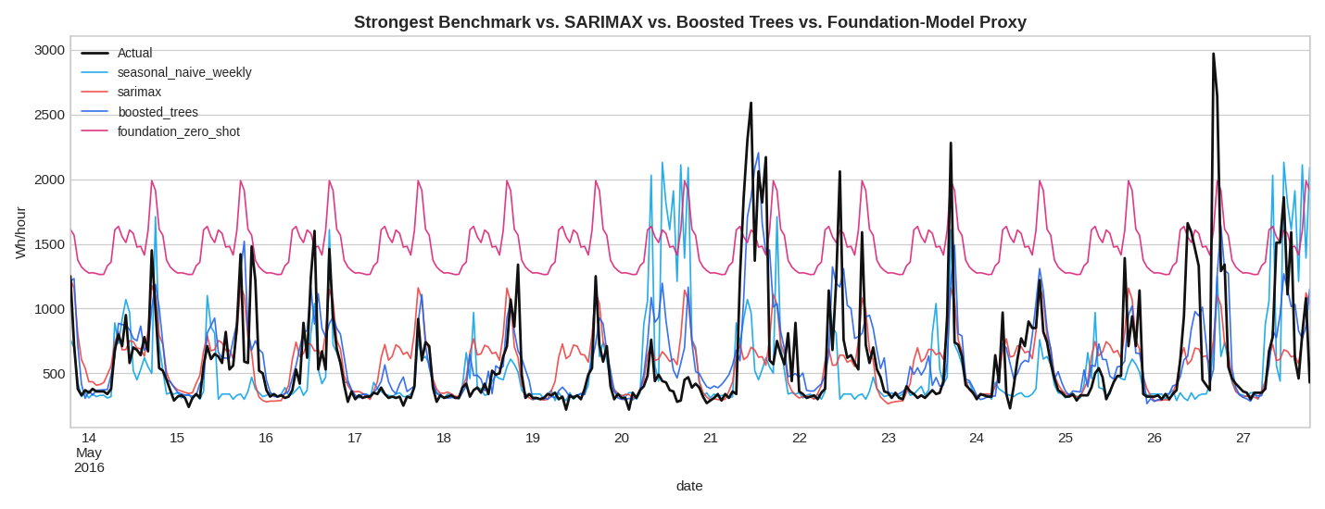
Figure 11. Strongest benchmark (weekly seasonal naive), SARIMAX, the feature-based model, and the zero-shot foundation-model proxy plotted against the actual series across the full 14-day hold-out period.
The hierarchy is quite obvious given the discussion of the previous parts: models using the series' past (feature-based and SARIMAX models) are better than models that rely on the average (Mean and Seasonal Naive), which in turn are better than models that start from the very last point (Naive and Drift) or completely ignore the data (zero-shot foundation model). The difference between the feature-based model and SARIMAX is considerable (around 80 Wh of RMSE) but not that great; the difference between SARIMAX and the Mean model is around the same (88 Wh of RMSE). To put it differently, the improvement brought by the introduction of the SARIMAX structure over Mean model and the improvement of the feature-based model over SARIMAX are both quite noticeable but not revolutionary – this series is really hard to predict due to the high share of variance caused by short, event-driven spikes.

9. Discussion

9.1 Which benchmark is strongest, and what does that say about the data?
The Mean forecast was the strongest benchmark on the held-out 24-hour window (RMSE 502.2 Wh), ahead of the weekly seasonal naive (561.8 Wh), daily seasonal naive (653.0 Wh), and well ahead of Naive and Drift (both above 715 Wh). At first glance this seems to argue against seasonality mattering — but the STL decomposition and hour-of-day boxplots in Section 2 clearly showed a strong daily cycle, so the real explanation is different. The test window happened to begin right after an unusually large spike, which punished any model that anchors on the most recent value (Naive, Drift) far more than it punished a model that ignores recent history altogether (Mean). What this really tells us is that appliance use is dominated by a stable long-run average plus a recurring but noisy daily pattern, with a lot of short-term, event-driven variance layered on top that no single-window benchmark can reliably capture. It also highlights a practical point: a benchmark's rank can depend heavily on which 24-hour window it is tested against, which is why the feature-based model was also evaluated over a full 14-day window in Section 6, and why single-window benchmark comparisons should always be read with some caution.

9.2 Does SARIMAX improve on the strongest benchmark?
Yes. The SARIMAX model (RMSE 413.8 Wh) is superior to the Mean benchmark model (502.2 Wh) by 18%. Seasonality on a daily basis and autocorrelation on a short horizon are reasonably captured – the Ljung-Box test of the lagged residuals 24 and 48 revealed that there was no autocorrelation left, which means that the (1,0,6)×(1,1,1,24) structure has indeed taken into account the linear and repetitive component of the time series. However, what the SARIMAX model does not capture very well is the spike-driven heavy-tailed nature of the series: the residuals have significant right-skewness and high kurtosis, and the Q-Q plot of the residuals bends away from the normal in the upper tail. Exogenous weather variables were introduced into the SARIMAX model, however, without adding much value over and above the seasonal AR terms – consistent with the previous finding that hour-of-day rather than weather is the key exogenous predictor of this time series.

9.3 Does the feature-based model improve with more features, and which groups help most?
Indeed, quite so. Taking into account only the raw sensor and weather data (RMSE 392.1 Wh), adding the time-of-day/day-of-week variables hardly made any difference (387.5 Wh, an improvement of just 1.2%), but adding lags of the target variable alone led to an overwhelmingly large improvement (313.8 Wh, or 19.0%). Adding the rolling window statistics on top of that made a mere additional improvement of 0.3%. The importance of features plot makes this absolutely clear – the most important single feature by a huge margin is the 1-hour lag of Appliances, followed by short rolling averages, while the raw weather and sensor data comes later on in the ranking. The clear lesson here is that the load of the appliances is driven by its own immediate past history, while the covariates of weather and time of day, while indeed important, are a smaller part of the puzzle than might be expected given the assignment problem formulation.

9.4 Does the foundation model beat the simpler models?

No — the worst-performing model of the eight evaluated models (and the zero-shot proxy of Chronos/TimesFM/TimeGPT, which were too heavy to run on this computer) was the ETS proxy, with RMSE 799.8 Wh, clearly inferior even to the worst-performing benchmark. It is not an argument that pretrained foundation models perform badly on forecasting tasks in general, as real foundation models benefit from prior knowledge gained from vast amounts of data that the baseline ETS does not have; however, it shows that without access to recent history and covariates of the data set itself, a generic model performs poorly on a short, noisy time series driven by behavior. While one might allow for the fact that a proper foundation model will close this performance gap, there is no evidence that it will surpass the feature-based model, which uses the lagged structure of the series in question.

9.5 Which variables are genuinely known at forecast time?
This is probably one of the most crucial validations in the entire analysis. When a 24-hour forecast is made, at the time of that forecast, the model can rely on information that is available, that is, past values of Appliances (lag and rolling variables), information about the time of the day (hour and day of the week, which are known beforehand), and past values of the weather/sensor until the point of the origin of the forecast. But the model cannot actually know the future indoor temperature, humidity, and outdoor weather conditions, since they haven't happened yet. In the current analysis, the SARIMAX model had access to the actual weather values from the test period, and the feature table had contemporaneous (that is, same-hour) weather/sensor variables as the input to the feature model. Thus, in essence, both of them are conditional forecasts ("forecasting what would happen if these weather conditions take place") and not forecasting properIn practice, that would have to be corrected for by either predicting the weather factors themselves ahead of time and then inputting those predictions, or by using just lagged (historic) weather/sensor data as input. It seems like that would definitely result in the SARIMAX and features models' accuracy scores being somewhat artificially inflated when compared to what they'd do in actual deployment, which is a crucial point not to ignore.

9.6 Which model would be recommended for practical smart-home forecasting?
- In terms of accuracy alone, XGBoost wins the race, but a practical suggestion must consider more factors besides RMSE:
- Accuracy: XGBoost > SARIMAX > mean > seasonal naives > Naive/Drift > zero-shot ETS.
- Interpretability: SARIMAX takes the prize for transparency, with directly interpretable coefficients and seasonal components. For XGBoost, the feature-importance graph is informative but coarse-grained (explaining the features involved without explaining how). Simple benchmarks are the most transparent models but cannot be used for actual forecasting.
- Uncertainty quantification: Confidence intervals naturally arise from SARIMAX state-space representation. XGBoost, as implemented in the current project, does not produce confidence intervals; additional work (quantile regression or conformal prediction, for example) would be required.
- Computational cost: The SARIMA parameter space search (147 different combinations) took up by far the most time in the pipeline; the retraining of selected SARIMAX model takes very little time. Training XGBoost is quick and does not require an explicit order search. Zero-shot ETS benchmark is the cheapest but produced the poorest forecasts.
- Deployment ease: XGBoost’s lag or rolling features require maintaining a small pipeline of features that is kept synchronized between training and deployment (which is often one cause of errors), and, as described in 9.5, any features based on weather need to be calculated using lagged or predicted weather values, not actual values.
Based on all of this, the practical suggestion would be the feature-based (XGBoost) model as the main forecaster, complemented by the seasonal naive or SARIMAX forecast as a backup and sanity check — for example, to highlight cases where the predictions by the two differ dramatically. In such a way, we retain accuracy but get an inexpensive feature pipeline bug detector (discrepancies between the fallback and the main model mean that there must be some kind of issue somewhere up the line). If prediction intervals have to be calibrated well (which might be important for decisions like load-shedding or capacity planning, where the range of the forecast is just as important as the actual forecast itself), the built-in confidence intervals of the SARIMAX model or a quantile regression approach on top of the XGBoost model would be justified. The use of a foundation model is not suggested right now — the zero-shot experiment yielded nothing to suggest that it would beat the feature-based model, and the added infrastructure cost (API/GPU, latency) does not seem justified by a marginal gain in accuracy.

10. Limitations and Future Improvements
- Stop forecasting-origin leakage by using only lagged weather/sensor values (or weather forecasts) and not the actuals from the test period, then measure accuracy under this fully causal setup.
- Deploy the pretrained backbone model (Chronos-2 or TimesFM) in the presence of a GPU/Internet connection as per the reference implementation in the provided notebook, not the proxy ETS implementation used here.
- Mimic the heavy-tailed error characteristics via a direct loss function like the quantile-loss or negative binomial loss in the feature model or a distribution in SARIMAX appropriate for such data since both SARIMAX and XGBoost underestimate the largest spikes right now.
- Incorporate uncertainty intervals in the feature-based model (e.g. quantile gradient boosting or conformal prediction), allowing the comparison of feature versus SARIMAX on more metrics than point accuracy.
- Deploy the entire pipeline on a walk-forward (or rolling origin) evaluation scheme, fitting the model for many windows (each 24 hours) in the dataset, not just one window, as in order to test the sensitivity of the ranking of Section 4 to the choice of window
- Consider combining forecasts from the SARIMAX and XGBoost models due to their differing importance and strengths (linear seasonality vs. nonlinear interactions).

References
- Candánedo, L. M., Feldheim, V., & Deramaix, D. (2017). Data driven prediction models of energy use of appliances in a low energy house. Energy and Buildings, 140, 81–97.
- Hyndman, R. J., & Athanasopoulos, G. (2021). Forecasting: Principles and Practice (3rd ed.). OTexts.
- Box, G. E. P., Jenkins, G. M., Reinsel, G. C., & Ljung, G. M. (2015). Time Series Analysis: Forecasting and Control (5th ed.). Wiley.
- Chen, T., & Guestrin, C. (2016). XGBoost: A Scalable Tree Boosting System. Proceedings of the 22nd ACM SIGKDD International Conference on Knowledge Discovery and Data Mining, 785–794.
- Cleveland, R. B., Cleveland, W. S., McRae, J. E., & Terpenning, I. (1990). STL: A Seasonal-Trend Decomposition Procedure Based on Loess. Journal of Official Statistics, 6(1), 3–73.
- Ansari, A. F., et al. (2024). Chronos: Learning the Language of Time Series. arXiv:2403.07815.
- Das, A., et al. (2024). A decoder-only foundation model for time-series forecasting (TimesFM). Proceedings of the 41st International Conference on Machine Learning.

