Time Series HW1

104304033 統計四 劉書宏

Chap 1

2.

Trend effects : It is kind of non-experts trend , we can see that happen previously. May go up or go down , also it can stay hold.

Seasonal variations : It is a certain seasonal trend .

Random error : Due to causes like dynamic error, drift, noise.That we can’t get the trend.

4.

Estimating techniques based on the assumption that the variable to be forecast (dependent variable) has cause-and-effect relationship with one or more other (independent) variables.

7.

Forecast horizon : is the length of time into the future for which [forecasts](https://ec.europa.eu/eurostat/statistics-explained/index.php?title=Glossary:Forecasting) are to be prepared.

Forecast interval : is how long that we do new forecasting.

Normally , forecast interval is smaller that the forecastinf is better.

10.

a. I need to know the demand for these products , how the demand change.

b. In 4 – 6 weeks , and in the product manufacturing , I would say that this is kind of long-range forecasts .I need to make decisions in days.

c. I need to have the product manufacturing by day data.

d. Because I will spend 4 – 6 weeks to manufacture a product , I need to think carefully that which one of products demand more.

Chap 2

4.

air

|  |  |
| --- | --- |
| lag | acf |
| 0 | 1 |
| 1 | 0.807195 |
| 2 | 0.694225 |
| 3 | 0.667096 |
| 4 | 0.678753 |
| 5 | 0.623519 |
| 6 | 0.618497 |
| 7 | 0.581749 |
| 8 | 0.553822 |
| 9 | 0.498088 |
| 10 | 0.499599 |
| 11 | 0.473253 |
| 12 | 0.444753 |
| 13 | 0.418798 |
| 14 | 0.399672 |
| 15 | 0.369627 |
| 16 | 0.343419 |
| 17 | 0.311406 |
| 18 | 0.287192 |
| 19 | 0.242756 |
| 20 | 0.254932 |

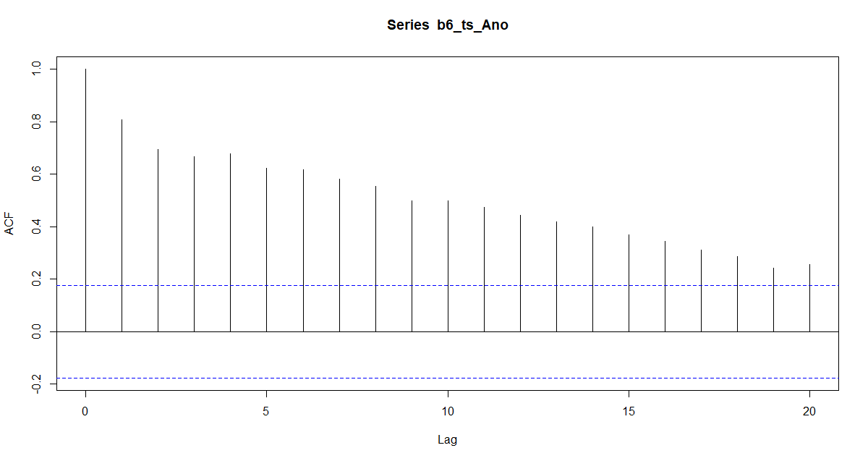

Co2

|  |  |
| --- | --- |
| lag | acf |
| 0 | 1 |
| 1 | 0.807195 |
| 2 | 0.694225 |
| 3 | 0.667096 |
| 4 | 0.678753 |
| 5 | 0.623519 |
| 6 | 0.618497 |
| 7 | 0.581749 |
| 8 | 0.553822 |
| 9 | 0.498088 |
| 10 | 0.499599 |
| 11 | 0.473253 |
| 12 | 0.444753 |
| 13 | 0.418798 |
| 14 | 0.399672 |
| 15 | 0.369627 |
| 16 | 0.343419 |
| 17 | 0.311406 |
| 18 | 0.287192 |
| 19 | 0.242756 |
| 20 | 0.254932 |

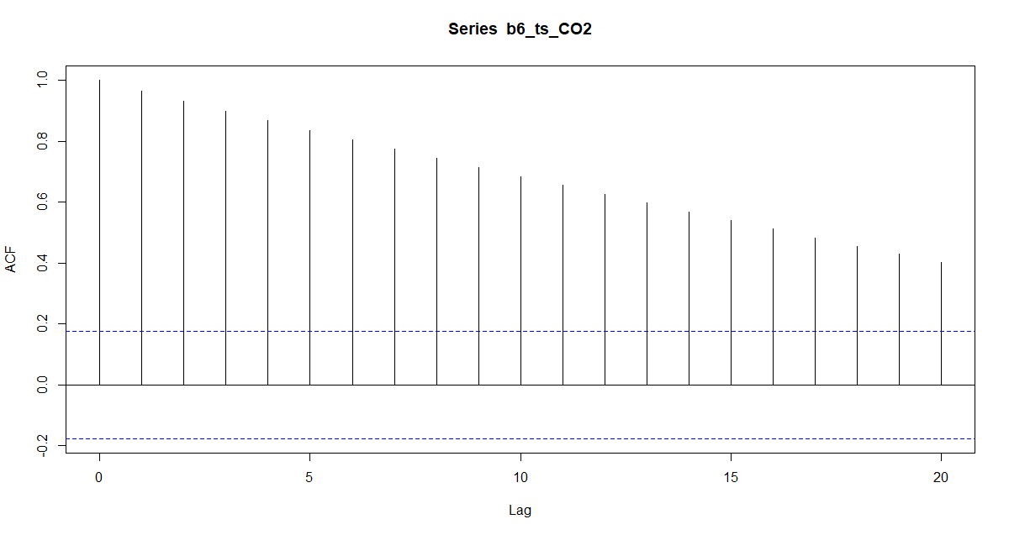

It seems like each of these doesn’t achieve stationary.

5.

Air take the first difference

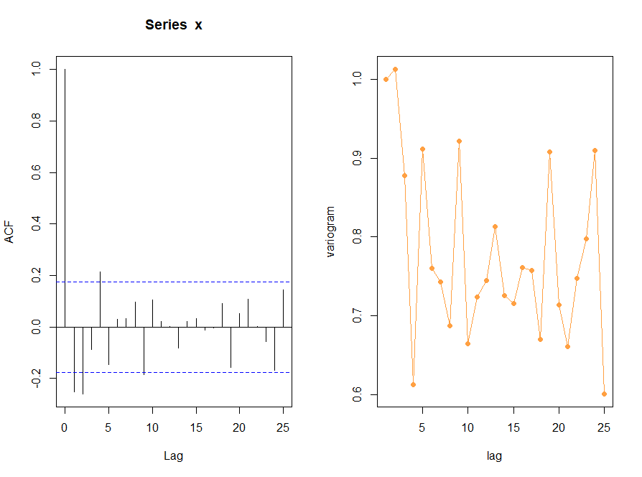

Co2 take the first difference

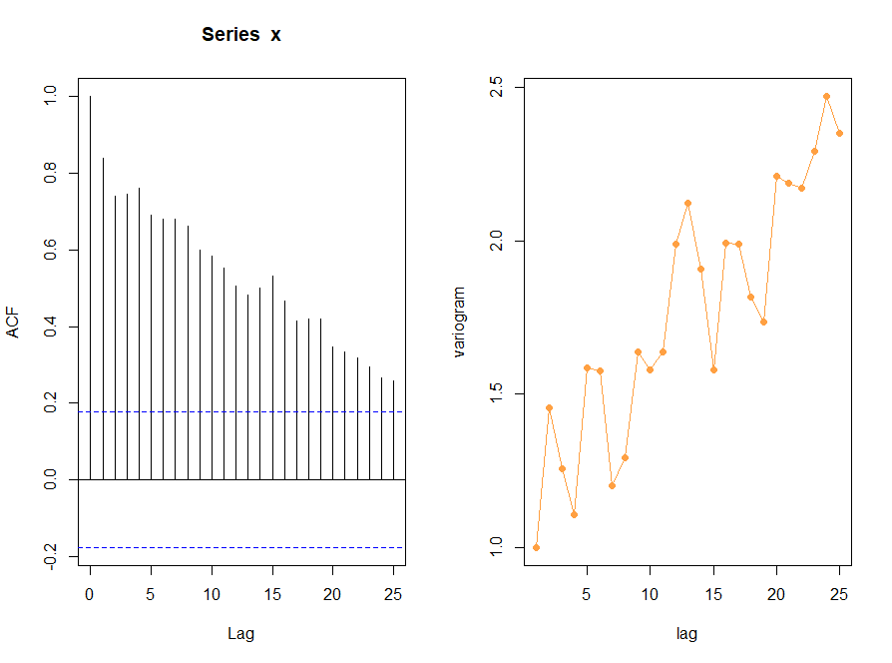

It seems like air temperature is much more stationary than CO2.

26.

|  |  |  |
| --- | --- | --- |
| Lag | ACF | Variogram |
| 1 | 0.91 | 1.00 |
| 2 | 0.89 | 1.04 |
| 3 | 0.87 | 1.20 |
| 4 | 0.85 | 1.35 |
| 5 | 0.85 | 1.19 |
| 6 | 0.84 | 1.18 |
| 7 | 0.83 | 1.17 |
| 8 | 0.81 | 1.27 |
| 9 | 0.79 | 1.33 |
| 10 | 0.78 | 1.32 |
| 11 | 0.75 | 1.46 |
| 12 | 0.76 | 1.19 |
| 13 | 0.73 | 1.39 |
| 14 | 0.72 | 1.38 |
| 15 | 0.70 | 1.47 |
| 16 | 0.67 | 1.65 |
| 17 | 0.66 | 1.62 |
| 18 | 0.64 | 1.73 |
| 19 | 0.63 | 1.71 |
| 20 | 0.61 | 1.87 |
| 21 | 0.59 | 1.97 |
| 22 | 0.58 | 1.89 |
| 23 | 0.56 | 2.08 |
| 24 | 0.57 | 1.68 |
| 25 | 0.52 | 2.15 |

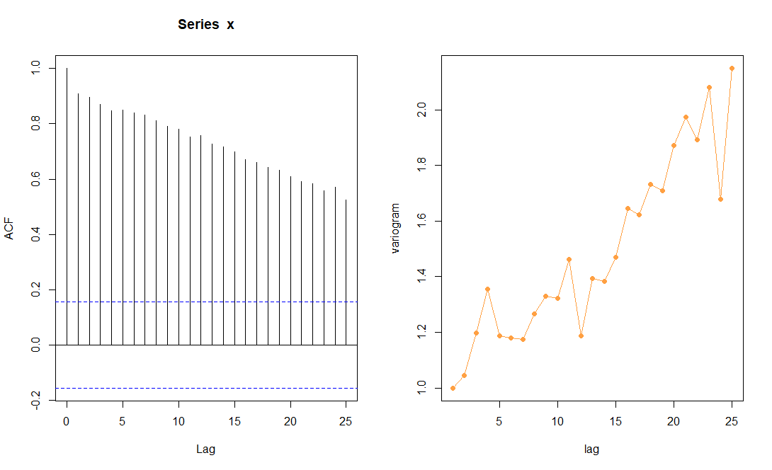

ACF is too big.

27.

|  |  |  |
| --- | --- | --- |
| Lag | ACF | Variogram |
| 1 | (0.48) | 1.00 |
| 2 | 0.06 | 0.64 |
| 3 | (0.00) | 0.68 |
| 4 | (0.16) | 0.80 |
| 5 | 0.10 | 0.61 |
| 6 | (0.01) | 0.69 |
| 7 | 0.04 | 0.64 |
| 8 | (0.00) | 0.67 |
| 9 | (0.04) | 0.70 |
| 10 | 0.08 | 0.62 |
| 11 | (0.18) | 0.81 |
| 12 | 0.21 | 0.53 |
| 13 | (0.11) | 0.77 |
| 14 | 0.05 | 0.65 |
| 15 | 0.04 | 0.66 |
| 16 | (0.09) | 0.76 |
| 17 | 0.05 | 0.66 |
| 18 | (0.05) | 0.73 |
| 19 | 0.06 | 0.64 |
| 20 | (0.02) | 0.70 |
| 21 | (0.06) | 0.73 |
| 22 | 0.11 | 0.61 |
| 23 | (0.24) | 0.89 |
| 24 | 0.38 | 0.40 |
| 25 | (0.22) | 0.88 |

Red means negative.

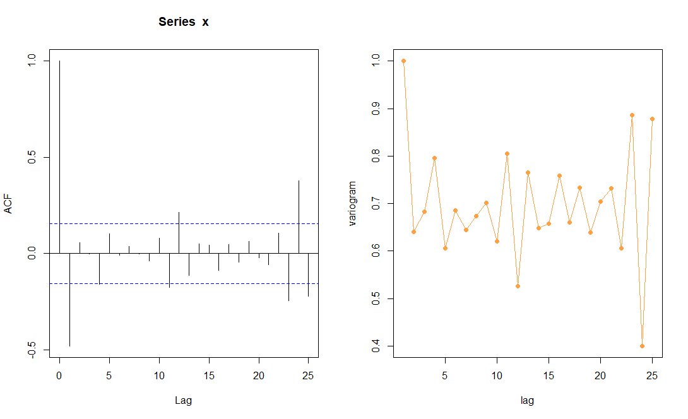

ACF changes a lot from taking the first difference.

28.

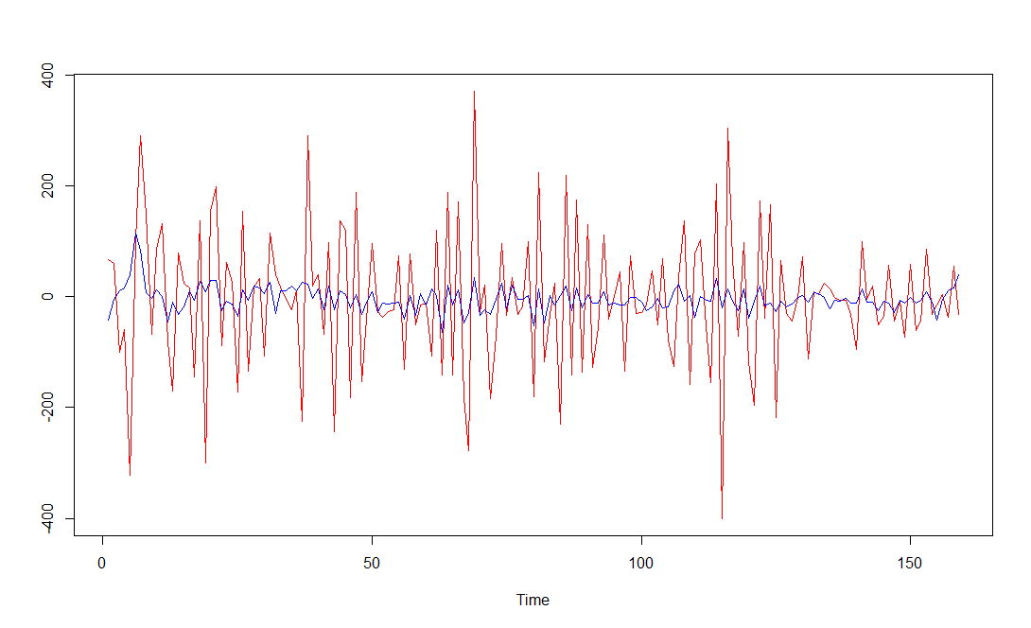

Red line means diff(Oil).

Blue line means average mean for 6 months.

By average mean , we can see that it smooth a lot.