Time Serires hw3

104304033 統計四 劉書宏

Chap3

13

Origin:

Cochrane-orcutt estimation for first order autocorrelation

Call:

lm(formula = y ~ x)

number of interaction: 7

rho 0.43638

Durbin-Watson statistic

(original): 1.08012 , p-value: 7.689e-03

(transformed): 2.06581 , p-value: 4.444e-01

coefficients:

(Intercept) x

-1.184780 0.296519

First Difference:

Cochrane-orcutt estimation for first order autocorrelation

Call:

lm(formula = y.diff ~ x.diff)

number of interaction: 6

rho -0.292592

Durbin-Watson statistic

(original): 2.54272 , p-value: 8.737e-01

(transformed): 1.90010 , p-value: 4.044e-01

coefficients:

(Intercept) x.diff

-0.000480 0.291603

18

a.

Model

Residuals:

1 2 3 4 5 6 7 8

32.35 -12.80 -4.35 -15.20 -15.20 -4.35 -12.80 32.35

Coefficients:

Estimate Std. Error t value Pr(>|t|)

(Intercept) 79.15 11.03 7.175 0.00558 \*\*

x1 41.83 11.03 3.791 0.03219 \*

x2 9.85 11.03 0.893 0.43770

x3 26.38 11.03 2.391 0.09666 .

x4 5.45 11.03 0.494 0.65519

---

Residual standard error: 31.2 on 3 degrees of freedom

Multiple R-squared: 0.8757, Adjusted R-squared: 0.7099

F-statistic: 5.283 on 4 and 3 DF, p-value: 0.1014

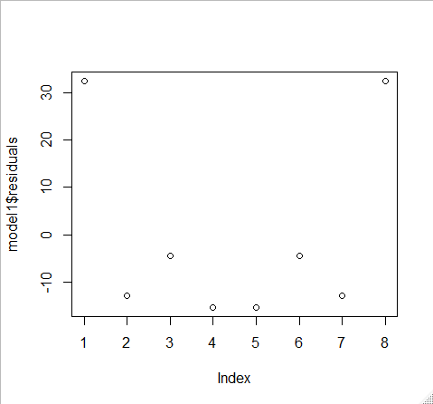

We can see that the first and the last observation has a big residual.

b.

Call:

lm(formula = y ~ x1 + x2 + x3 + x4, data = data, weights = data$V8)

Weighted Residuals:

1 2 3 4 5 6 7 8

14.0337 -1.6235 -0.5652 -10.9463 -9.6885 -0.5640 -6.9578 26.7262

Coefficients:

Estimate Std. Error t value Pr(>|t|)

(Intercept) 75.427 9.268 8.138 0.00388 \*\*

x1 38.391 8.433 4.553 0.01986 \*

x2 7.114 8.660 0.821 0.47160

x3 19.568 7.855 2.491 0.08838 .

x4 -2.053 7.908 -0.260 0.81195

---

Residual standard error: 19.8 on 3 degrees of freedom

Multiple R-squared: 0.8901, Adjusted R-squared: 0.7436

F-statistic: 6.074 on 4 and 3 DF, p-value: 0.08508

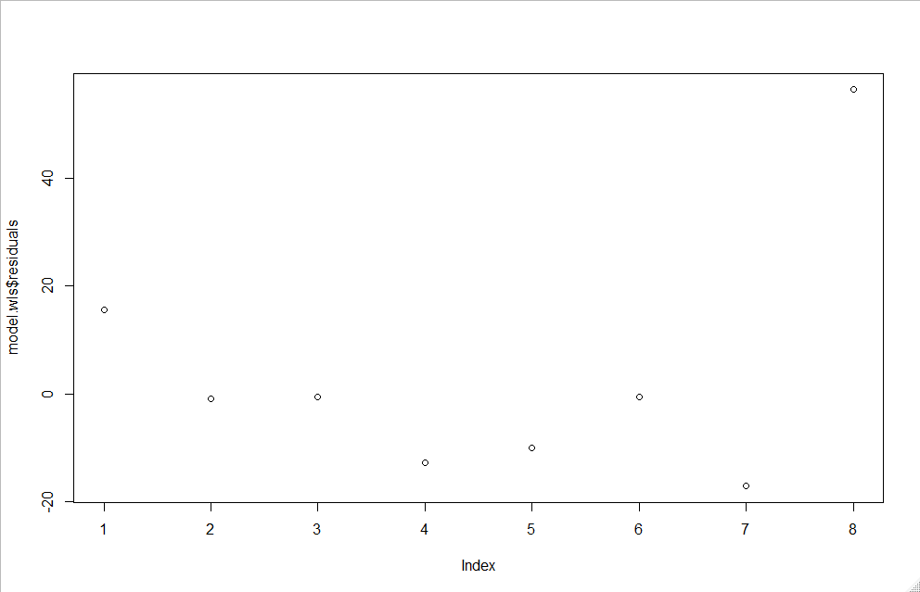

By using weighteing least square with sample variance , we can see that the Adjusted R-squared is improved.

But in residuals plot , the last point is too big.

C.

Call:

lm(formula = V8 ~ x1 + x2 + x3 + x4, data = data)

Residuals:

1 2 3 4 5 6 7 8

-0.4167 0.6483 -0.1217 -0.1100 -0.1100 -0.1217 0.6483 -0.4167

Coefficients:

Estimate Std. Error t value Pr(>|t|)

(Intercept) 0.9333 0.2275 4.103 0.0262 \*

x1 -0.4025 0.2275 -1.770 0.1749

x2 -0.4533 0.2275 -1.993 0.1403

x3 0.2567 0.2275 1.128 0.3412

x4 0.3058 0.2275 1.345 0.2714

---

Residual standard error: 0.6434 on 3 degrees of freedom

Multiple R-squared: 0.7725, Adjusted R-squared: 0.4691

F-statistic: 2.546 on 4 and 3 DF, p-value: 0.2343

By using Sample variance ~ x1 + x2 + x3 + x4, we only have Adjusted R-Squared = 0.4691

Call:

lm(formula = y ~ x1 + x2 + x3 + x4, data = data, weights = data$V8)

Weighted Residuals:

1 2 3 4 5 6 7 8

14.0337 -1.6235 -0.5652 -10.9463 -9.6885 -0.5640 -6.9578 26.7262

Coefficients:

Estimate Std. Error t value Pr(>|t|)

(Intercept) 75.427 9.268 8.138 0.00388 \*\*

x1 38.391 8.433 4.553 0.01986 \*

x2 7.114 8.660 0.821 0.47160

x3 19.568 7.855 2.491 0.08838 .

x4 -2.053 7.908 -0.260 0.81195

---

Residual standard error: 19.8 on 3 degrees of freedom

Multiple R-squared: 0.8901, Adjusted R-squared: 0.7436

F-statistic: 6.074 on 4 and 3 DF, p-value: 0.08508

By using the same weighting like (b), we found that Adjusted R-Squared is improved.

32

Call:

arima(x = y, order = c(1, 0, 0), xreg = x)

Coefficients:

ar1 intercept x

0.7217 26.1878 -0.1075

s.e. 0.2134 1.1997 0.0134

sigma^2 estimated as 0.08523: log likelihood = -3.18, aic = 14.37

Training set error measures:

ME RMSE MAE MPE MAPE

Training set -0.03350246 0.2919393 0.2278712 -0.217486 1.367033

MASE ACF1

Training set 0.2921425 0.2707497

Cochrane-Orcutt

Call:

lm(formula = y ~ x, data = data)

number of interaction: 23

rho 0.76023

Durbin-Watson statistic

(original): 0.81830 , p-value: 1.563e-03

(transformed): 0.85205 , p-value: 1.243e-02

coefficients:

(Intercept) x

26.611277 -0.115793

I don’t know how to compare.

33

36

40