Time series Homework 6

104304033 統計四 劉書宏

Chapter 5

42.

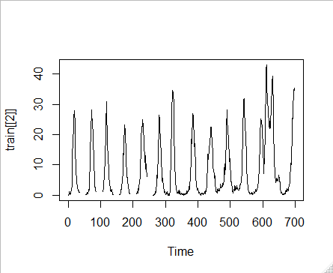

In this plot, we can see that the data has strong seasonality and no trend, so I use seasonal adjustment then mean to do the missing value imputation.

After imputation, trying to find ARIMA model.

Series: train_season

ARIMA(2,0,1) with non-zero mean

Coefficients:

ar1 ar2 ma1 mean

1.7889 -0.8271 -0.4314 8.8413

s.e. 0.0321 0.0314 0.0496 1.0266

sigma^2 estimated as 3.365: log likelihood=-1413.79

AIC=2837.59 AICc=2837.68 BIC=2860.33

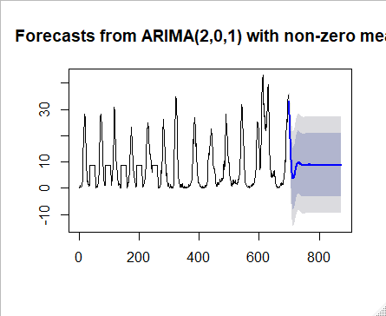

We can see that the forecasts of the last data are similar, but the data has strong seasonality. I think that using mean imputation with seasonal adjustment is still no good for this data.

52.

*̂yt* = 25 + 0*.*8*yt*−1 − 0*.*2*𝜀t*−1 + *𝜀t*

(a)

at T = 100, forecast y100 = 130 and real y100 = 140

so T = 101 , y101 = 25 + 0.8 * 140 + 10 = 147

y102 = 25 + 0.8 * 147 – 0.2 * 10 = 140.6

y103 = 25 + 0.8 * 140.6 = 137.48

y104 = 25 + 0.8 * 137.48 = 134.984

(b)

the shape of this model is decreasing.

(c)

y101 = 132

y102 = 25 + 0.8 * 132 = 130.6

y103 = 25 + 0.8 * 130.6 = 129.48

(d)

variance = 1.5

at T = 101 like (a) y101 = 147 and we need to find 95% confidence interval = 147 ± 1.96 * 1.5 ^0.5 = (144.5995,149.4005)

55.

AR(1):

In AR(1), we only depend on the last point, so the shape of AR(1) model depend on the coefficient, if coefficient are larger than 1, the forecast value will be increasing, on the opposite, decreasing.

AR(2):

In AR(2), we consider the y(t-1) and y(t-2),  If both φ1φ1 and φ2φ2 are positive, the output will resemble a low pass filter, with the high frequency part of the noise decreased.

If φ1  is positive while φ2  is negative, then the process favors changes in sign between terms of the process. The output oscillates. This can be likened to edge detection or detection of change in direction.

MA(1):

The notation MA(1) refers to the moving average model of order 1:

MA(2)

ARMA(1,1)

IMA(1,1)

ARIMA(1,1,0)

56.

yt = 25 + 0.8yt−1 + 𝜀t

(a)

yt only depend on yt-1 and errors are normally (0, 1).

(b)

(c)

(d)