**Assignment No:- 11**

**Assignment Name:- Create a website in ASP.NET that helps the user navigate your website using site maps.**

* **Create sitemap File :-**

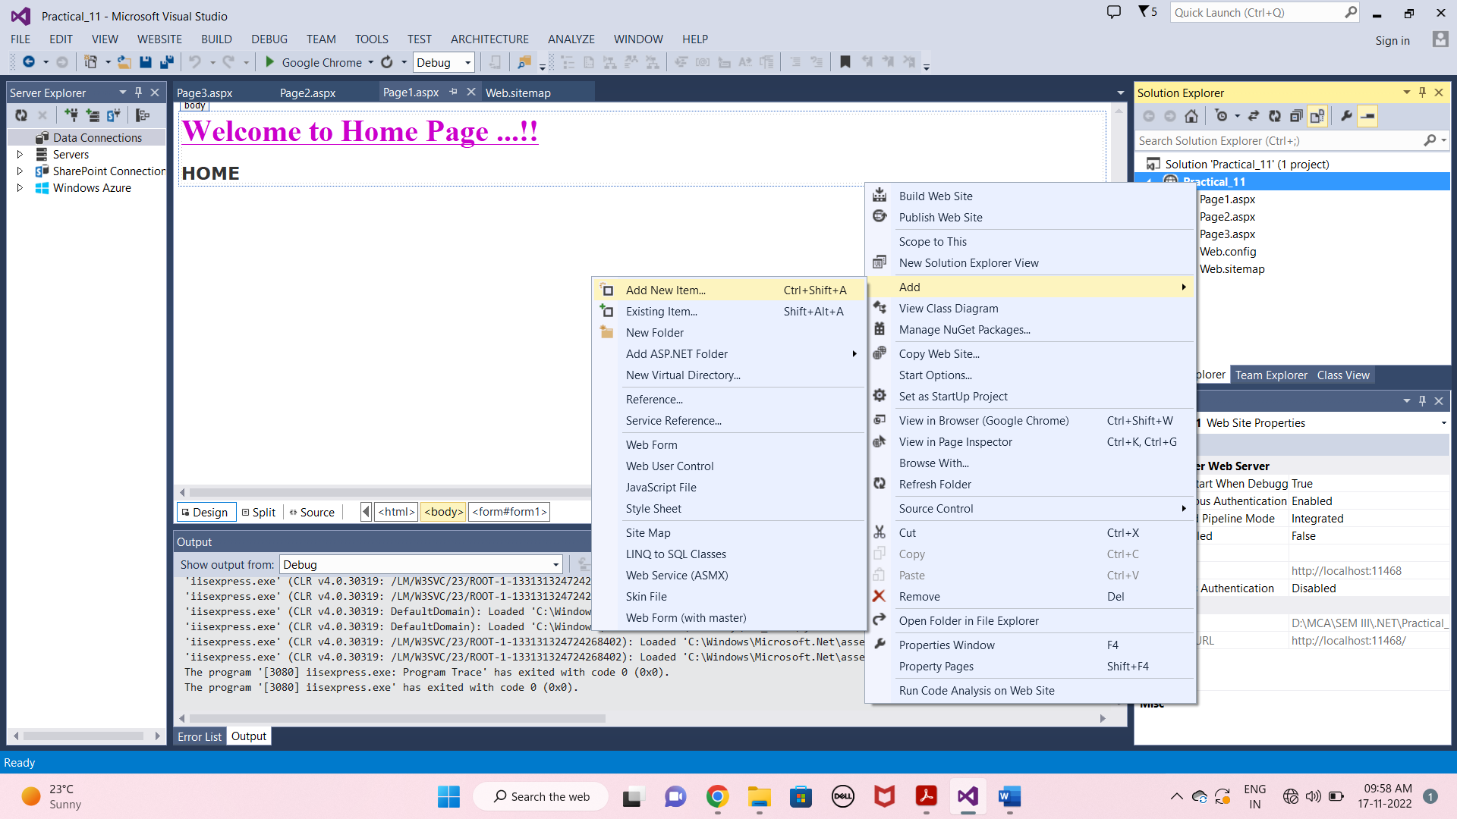

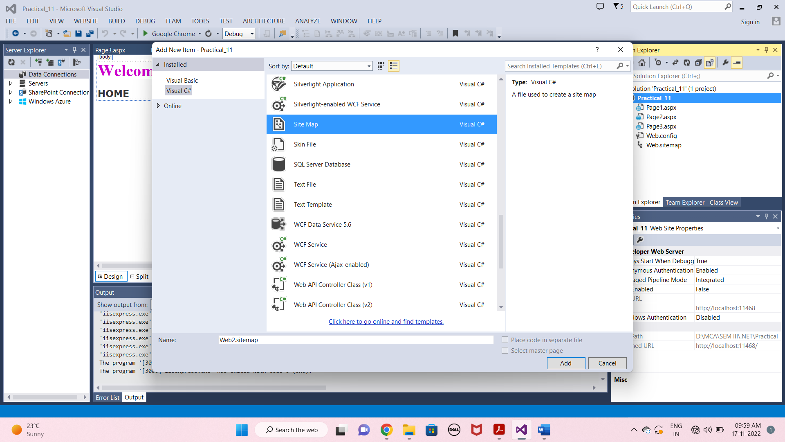

* **Web.sitemap Page :-**

<?xml version="1.0" encoding="utf-8" ?>

<siteMap xmlns="http://schemas.microsoft.com/AspNet/SiteMap-File-1.0" >

<siteMapNode url="Page1.aspx" title="HOME" description="">

<siteMapNode url="Page2.aspx" title="CONTACT" description="" >

<siteMapNode url="Page3.aspx" title="ABOUT" description="" />

</siteMapNode>

</siteMapNode>

</siteMap>

* **Page1.aspx Page :-**

<%@ Page Language="C#" AutoEventWireup="true" CodeFile="Page1.aspx.cs" Inherits="Page1" %>

<!DOCTYPE html>

<html xmlns="http://www.w3.org/1999/xhtml">

<head runat="server">

<title></title>

</head>

<body>

<form id="form1" runat="server">

<div>

<asp:Label ID="Label1" runat="server" Font-Bold="True" Font-Size="XX-Large" Font-Underline="True" ForeColor="#CC00CC" Text="Welcome to Home Page ...!!"></asp:Label>

</div>

<p>

<asp:SiteMapPath ID="SiteMapPath1" runat="server" Font-Names="Verdana" Font-Size="Large" PathSeparator=" : ">

<CurrentNodeStyle ForeColor="#333333" />

<NodeStyle Font-Bold="True" ForeColor="#990000" />

<PathSeparatorStyle Font-Bold="True" ForeColor="#990000" />

<RootNodeStyle Font-Bold="True" ForeColor="#FF8000" />

</asp:SiteMapPath>

</p>

</form>

</body>

</html>

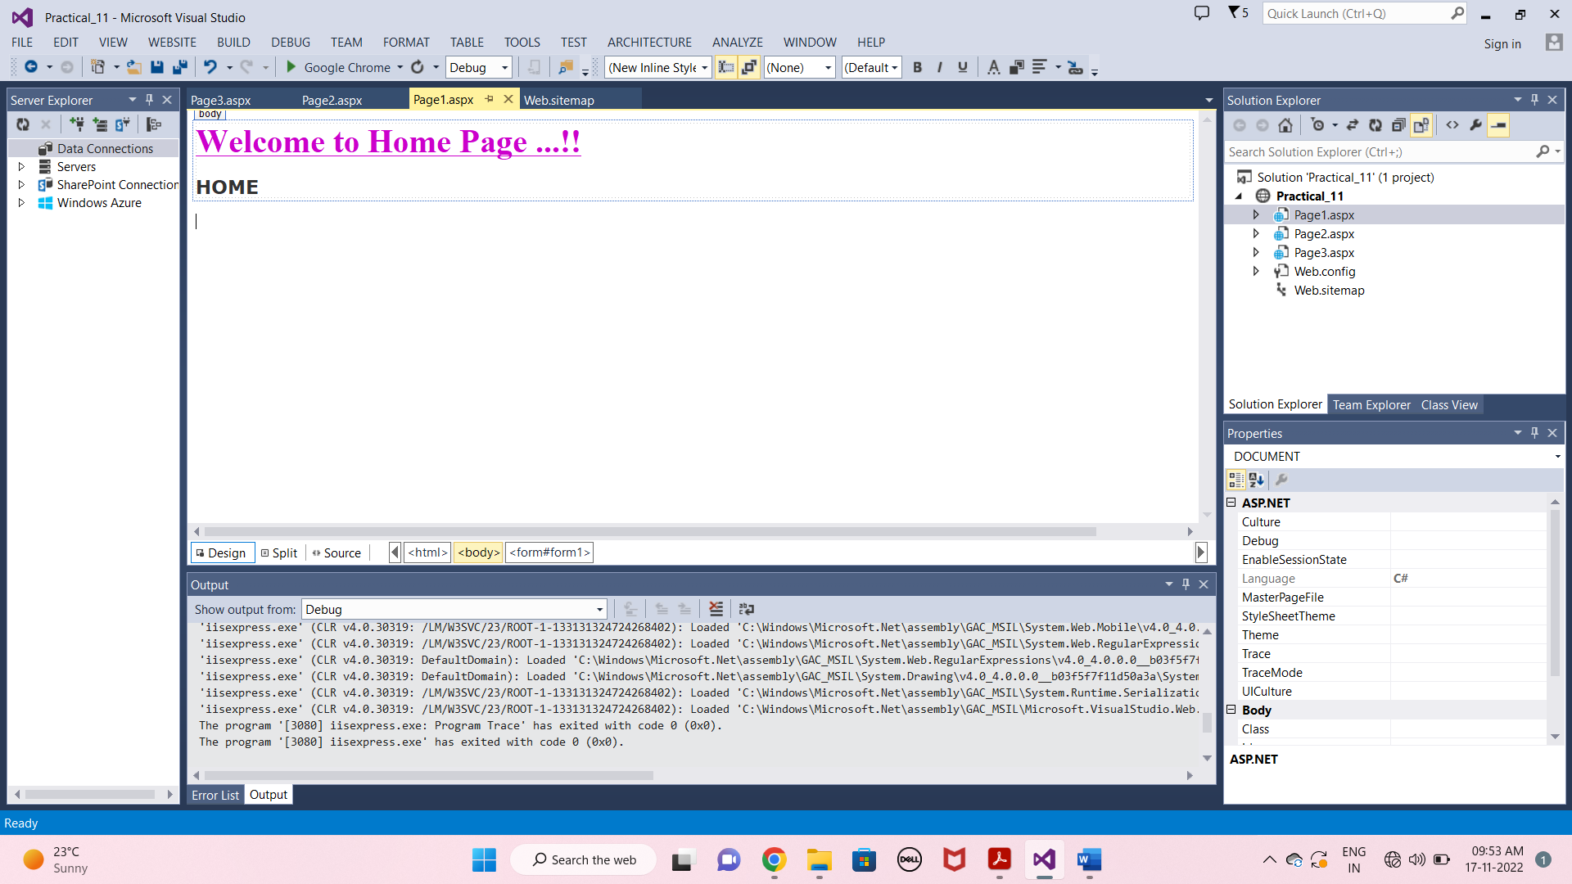

* **Page2.aspx Page :-**

<%@ Page Language="C#" AutoEventWireup="true" CodeFile="Page2.aspx.cs" Inherits="Page2" %>

<!DOCTYPE html>

<html xmlns="http://www.w3.org/1999/xhtml">

<head runat="server">

<title></title>

</head>

<body>

<form id="form1" runat="server">

<p>

<asp:SiteMapPath ID="SiteMapPath1" runat="server" Font-Bold="True" Font-Names="Verdana" Font-Size="Large" PathSeparator=" : ">

<CurrentNodeStyle ForeColor="#333333" />

<NodeStyle Font-Bold="True" ForeColor="#990000" />

<PathSeparatorStyle Font-Bold="True" ForeColor="#990000" />

<RootNodeStyle Font-Bold="True" ForeColor="#FF8000" />

</asp:SiteMapPath>

</p>

<div>

<asp:Label ID="Label1" runat="server" Font-Bold="True" Font-Size="XX-Large" Font-Underline="True" ForeColor="#CC00CC" Text="Welcome to Contact Page ...!!"></asp:Label>

</div>

</form>

</body>

</html>

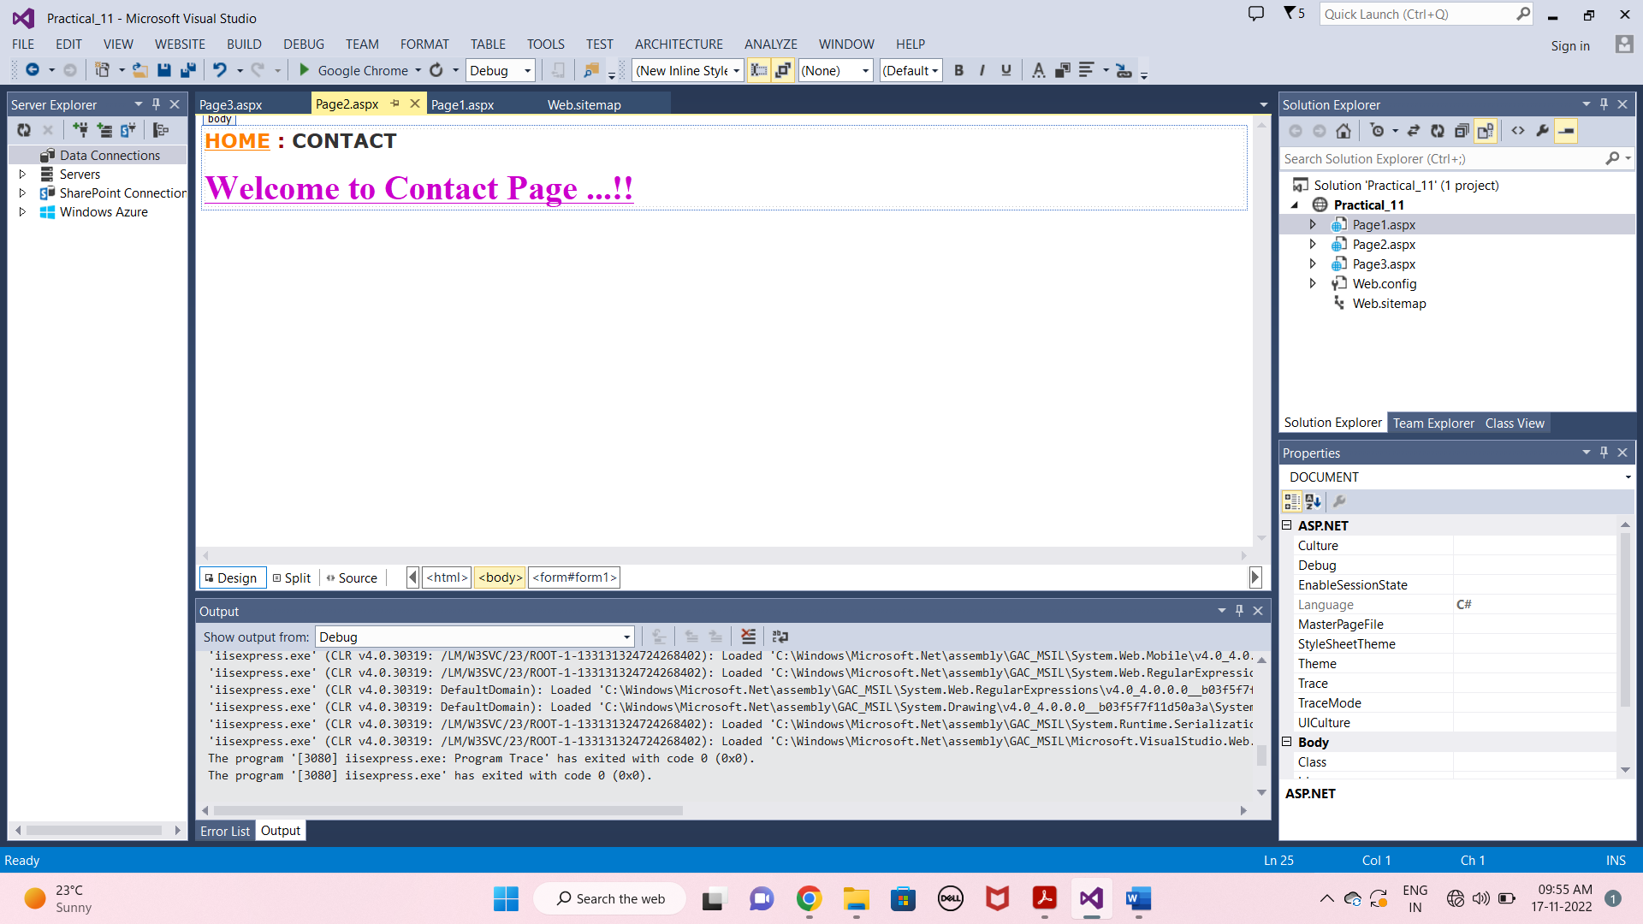

* **Page3.aspx Page :-**

<%@ Page Language="C#" AutoEventWireup="true" CodeFile="Page3.aspx.cs" Inherits="Page3" %>

<!DOCTYPE html>

<html xmlns="http://www.w3.org/1999/xhtml">

<head runat="server">

<title></title>

</head>

<body>

<form id="form1" runat="server">

<p>

<asp:SiteMapPath ID="SiteMapPath1" runat="server" Font-Bold="True" Font-Names="Verdana" Font-Size="Large" PathSeparator=" : ">

<CurrentNodeStyle ForeColor="#333333" />

<NodeStyle Font-Bold="True" ForeColor="#990000" />

<PathSeparatorStyle Font-Bold="True" ForeColor="#990000" />

<RootNodeStyle Font-Bold="True" ForeColor="#FF8000" />

</asp:SiteMapPath>

</p>

<div>

<asp:Label ID="Label1" runat="server" Font-Bold="True" Font-Size="XX-Large" Font-Underline="True" ForeColor="#CC00CC" Text="Welcome to About Page ...!!"></asp:Label>

</div>

</form>

</body>

</html>

