**Assignment No:- 7**

**Assignment Name:- Design the online job portal form with at least 5 ASP.NET Server controls and display the output in the text area.**

* **Job.aspx Page :-**

<%@ Page Language="C#" AutoEventWireup="true" CodeFile="Job.aspx.cs" Inherits="Job" %>

<!DOCTYPE html>

<html xmlns="http://www.w3.org/1999/xhtml">

<head runat="server">

<title></title>

</head>

<body>

<form id="form1" runat="server">

<div>

<asp:Label ID="Label1" runat="server" Font-Bold="True" Font-Size="XX-Large" ForeColor="#6600CC" Text="Job Portal Form"></asp:Label>

<br />

<br />

<asp:Label ID="Label2" runat="server" Font-Bold="True" Font-Size="Large" Text="Name : "></asp:Label>

<asp:TextBox ID="TextBox1" runat="server"></asp:TextBox>

<br />

<br />

<asp:Label ID="Label3" runat="server" Font-Bold="True" Font-Size="Large" Text="Email : "></asp:Label>

<asp:TextBox ID="TextBox2" runat="server"></asp:TextBox>

<br />

<br />

<asp:Label ID="Label7" runat="server" Font-Bold="True" Font-Size="Large" Text="Address :"></asp:Label>

<asp:TextBox ID="TextBox3" runat="server" TextMode="MultiLine"></asp:TextBox>

<br />

<br />

<asp:Label ID="Label4" runat="server" Font-Bold="True" Font-Size="Large" Text="Gradution : "></asp:Label>

<asp:DropDownList ID="DropDownList1" runat="server">

<asp:ListItem>BCA</asp:ListItem>

<asp:ListItem>MCA</asp:ListItem>

<asp:ListItem>BBA</asp:ListItem>

<asp:ListItem>BCOM</asp:ListItem>

<asp:ListItem>MBA</asp:ListItem>

<asp:ListItem>BSc</asp:ListItem>

</asp:DropDownList>

<br />

<br />

<asp:Label ID="Label5" runat="server" Font-Bold="True" Font-Size="Large" Text="Job Position : "></asp:Label>

<asp:CheckBoxList ID="CheckBoxList1" runat="server" RepeatDirection="Horizontal">

<asp:ListItem>Manager</asp:ListItem>

<asp:ListItem>Associate</asp:ListItem>

<asp:ListItem>Developer</asp:ListItem>

<asp:ListItem>Employee</asp:ListItem>

</asp:CheckBoxList>

<br />

<asp:Label ID="Label6" runat="server" Font-Bold="True" Font-Size="Large" Text="Job City :"></asp:Label>

<asp:DropDownList ID="DropDownList2" runat="server">

<asp:ListItem>Delhi</asp:ListItem>

<asp:ListItem>Mumbai</asp:ListItem>

<asp:ListItem>Pune</asp:ListItem>

<asp:ListItem>Nashik</asp:ListItem>

<asp:ListItem></asp:ListItem>

</asp:DropDownList>

<br />

<br />

<asp:Button ID="Button1" runat="server" OnClick="Button1_Click" Text="Button" Height="29px" />

<br />

<br />

<br />

</div>

</form>

</body>

</html>

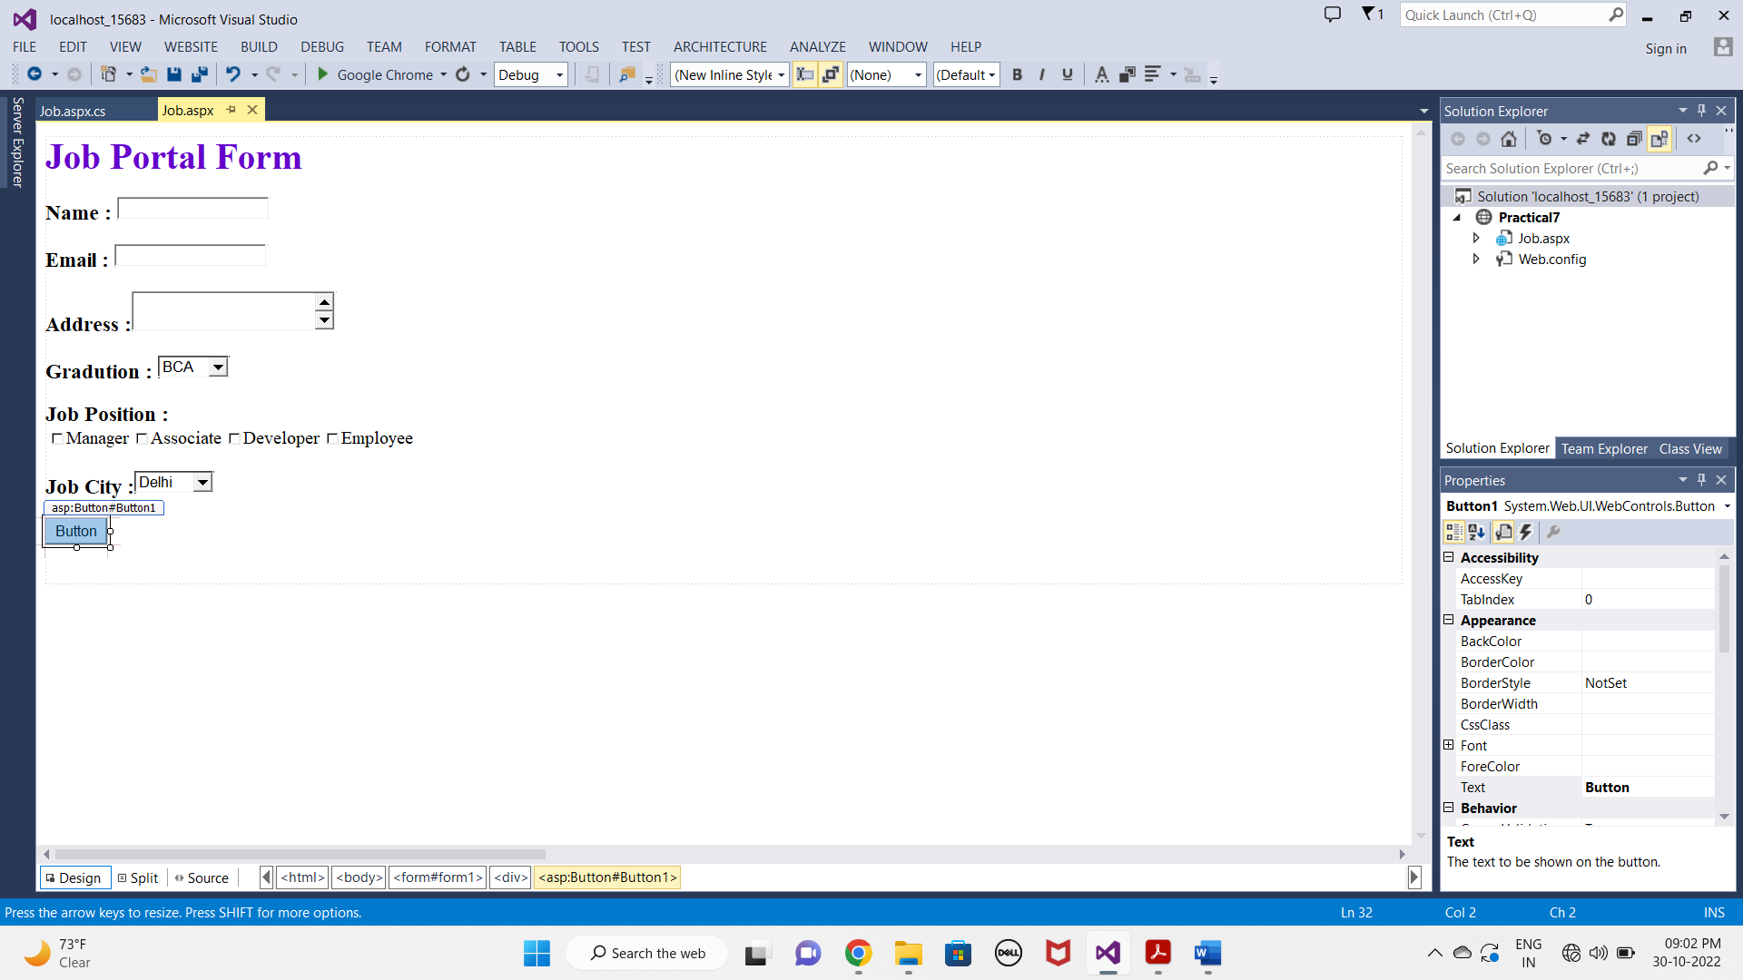

* **Job.aspx.cs Page :-**

using System;

using System.Collections.Generic;

using System.Linq;

using System.Web;

using System.Web.UI;

using System.Web.UI.WebControls;

public partial class Job : System.Web.UI.Page

{

protected void Page_Load(object sender, EventArgs e)

{

}

protected void Button1_Click(object sender, EventArgs e)

{

Response.Write("Name is= " + TextBox1.Text + "<br>");

Response.Write("Email is= " + TextBox2.Text + "<br>");

Response.Write("Address is = " + TextBox3.Text + "<br>");

Response.Write("Gradution is= " + DropDownList1.SelectedItem.Text + "<br>");

Response.Write("Position = ");

foreach (ListItem li in CheckBoxList1.Items)

{

if (li.Selected == true)

{

Response.Write(" " + li + ", " + " <br>");

}

}

Response.Write("City = " + DropDownList2.SelectedItem.Text + "<br>");

}

}

* **OUTPUT :-**

