**Assignment No.: 6**

**Assignment name: Design the online shopping form with at least 5 ASP.NET Server controls and display the output on panel.**

**Default.aspx file:**

<%@ Page Language="C#" AutoEventWireup="true" CodeFile="Default.aspx.cs" Inherits="_Default" %>

<!DOCTYPE html>

<html xmlns="http://www.w3.org/1999/xhtml">

<head runat="server">

<title>online shopping form</title>

</head>

<body>

<form id="form1" runat="server">

<div>

<asp:Label ID="Label1" runat="server" Font-Bold="True" Font-Size="XX-Large" ForeColor="#6600CC" Text="online shopping form"></asp:Label>

<br />

<br />

<asp:Label ID="Label2" runat="server" Font-Bold="True" Font-Size="Large" Text="Name : "></asp:Label>

<asp:TextBox ID="TextBox1" runat="server"></asp:TextBox>

<br />

<br />

<asp:Label ID="Label3" runat="server" Font-Bold="True" Font-Size="Large" Text="Email : "></asp:Label>

<asp:TextBox ID="TextBox2" runat="server"></asp:TextBox>

<br />

<br />

<asp:Label ID="Label7" runat="server" Font-Bold="True" Font-Size="Large" Text="Address :"></asp:Label>

<asp:TextBox ID="TextBox3" runat="server" TextMode="MultiLine"></asp:TextBox>

<br />

<br />

<asp:Label ID="Label4" runat="server" Font-Bold="True" Font-Size="Large" Text="Dresses : "></asp:Label>

<asp:DropDownList ID="DropDownList1" runat="server">

<asp:ListItem>Male Wear</asp:ListItem>

<asp:ListItem>Female Wear</asp:ListItem>

<asp:ListItem>Kids wear</asp:ListItem>

<asp:ListItem>Saree</asp:ListItem>

<asp:ListItem>Wedding</asp:ListItem>

<asp:ListItem>Uniform</asp:ListItem>

</asp:DropDownList>

<br />

<br />

<asp:Label ID="Label11" runat="server" Font-Bold="True" Font-Size="Large" Text="Size "></asp:Label>

<asp:CheckBoxList ID="CheckBoxList1" runat="server" RepeatDirection="Horizontal">

<asp:ListItem>S</asp:ListItem>

<asp:ListItem>M</asp:ListItem>

<asp:ListItem>L</asp:ListItem>

<asp:ListItem>XL</asp:ListItem>

<asp:ListItem>XXL</asp:ListItem>

</asp:CheckBoxList>

<br />

<asp:Label ID="Label12" runat="server" Font-Bold="True" Font-Size="Large" Text="Payment: "></asp:Label>

<asp:DropDownList ID="DropDownList2" runat="server">

<asp:ListItem>UPI</asp:ListItem>

<asp:ListItem>PhonePay</asp:ListItem>

<asp:ListItem>Cash on Delivery</asp:ListItem>

</asp:DropDownList>

<br />

<br />

<asp:Button ID="Button1" runat="server" OnClick="Button1_Click" Text="Book" Height="29px" />

<br />

<br />

<br />

</div>

</form>

</body>

</html>

</div>

</form>

</body>

</html>

**Default.aspx.cs:**

using System;

using System.Collections.Generic;

using System.Linq;

using System.Web;

using System.Web.UI;

using System.Web.UI.WebControls;

public partial class _Default : System.Web.UI.Page

{

protected void Page_Load(object sender, EventArgs e)

{

}

protected void Button1_Click(object sender, EventArgs e)

{

Response.Write("Name is= " + TextBox1.Text + "<br>");

Response.Write("Email is= " + TextBox2.Text + "<br>");

Response.Write("Address is = " + TextBox3.Text + "<br>");

Response.Write("Dresses is= " + DropDownList1.SelectedItem.Text + "<br>");

Response.Write("Size = " + DropDownList1.SelectedItem.Text + "<br>");

Response.Write("payment = " + CheckBoxList1.SelectedItem.Text + "<br>");

}

}

**Design Page:**

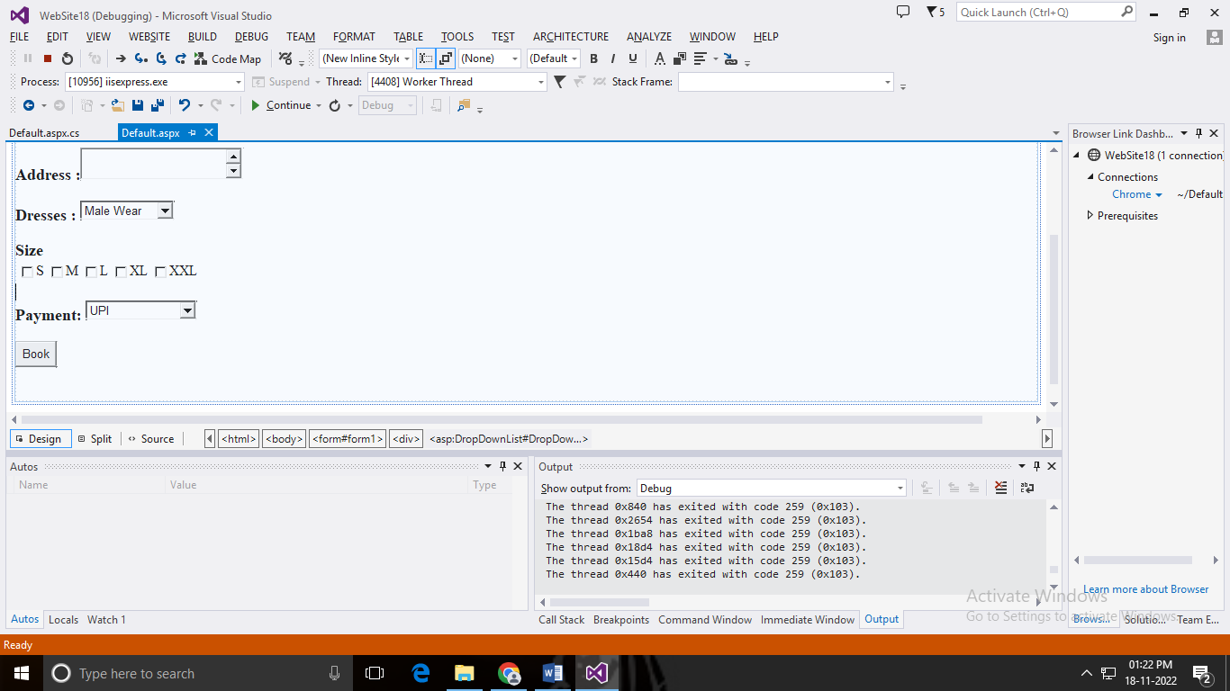

**Output:**

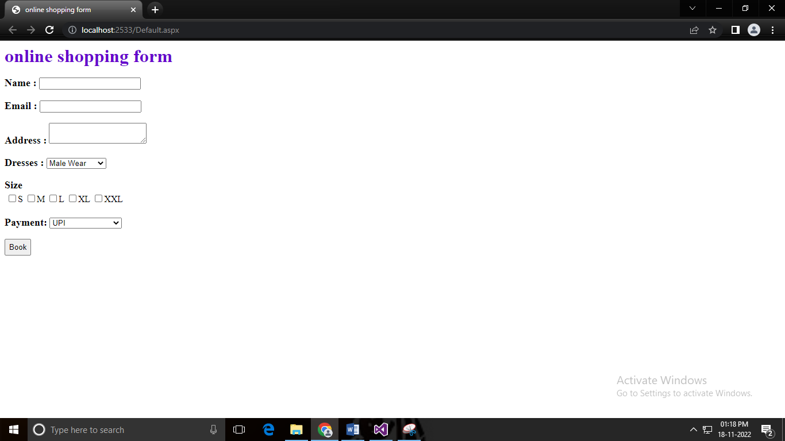

**After filling full information:**

