**Assignment No:- 1**

**Assignment Name:- Demonstrate User control having login form with username (nmu@gmail.com) and password (nmu) and print appropriate message on button click**

* **UserControl Page Code**

using System;

using System.Collections.Generic;

using System.Linq;

using System.Web;

using System.Web.UI;

using System.Web.UI.WebControls;

public partial class WebUserControl : System.Web.UI.UserControl

{

protected void Page_Load(object sender, EventArgs e)

{

}

protected void Button1_Click(object sender, EventArgs e)

{

if (TextBox1.Text == "nmu@gmail.com" && TextBox2.Text == "nmu")

{

Label5.Text = "Successfully Login !! ";

}

else

{

Label5.Text = "Invalid User For Login !!";

}

}

}

* **UserControl Design Page :**

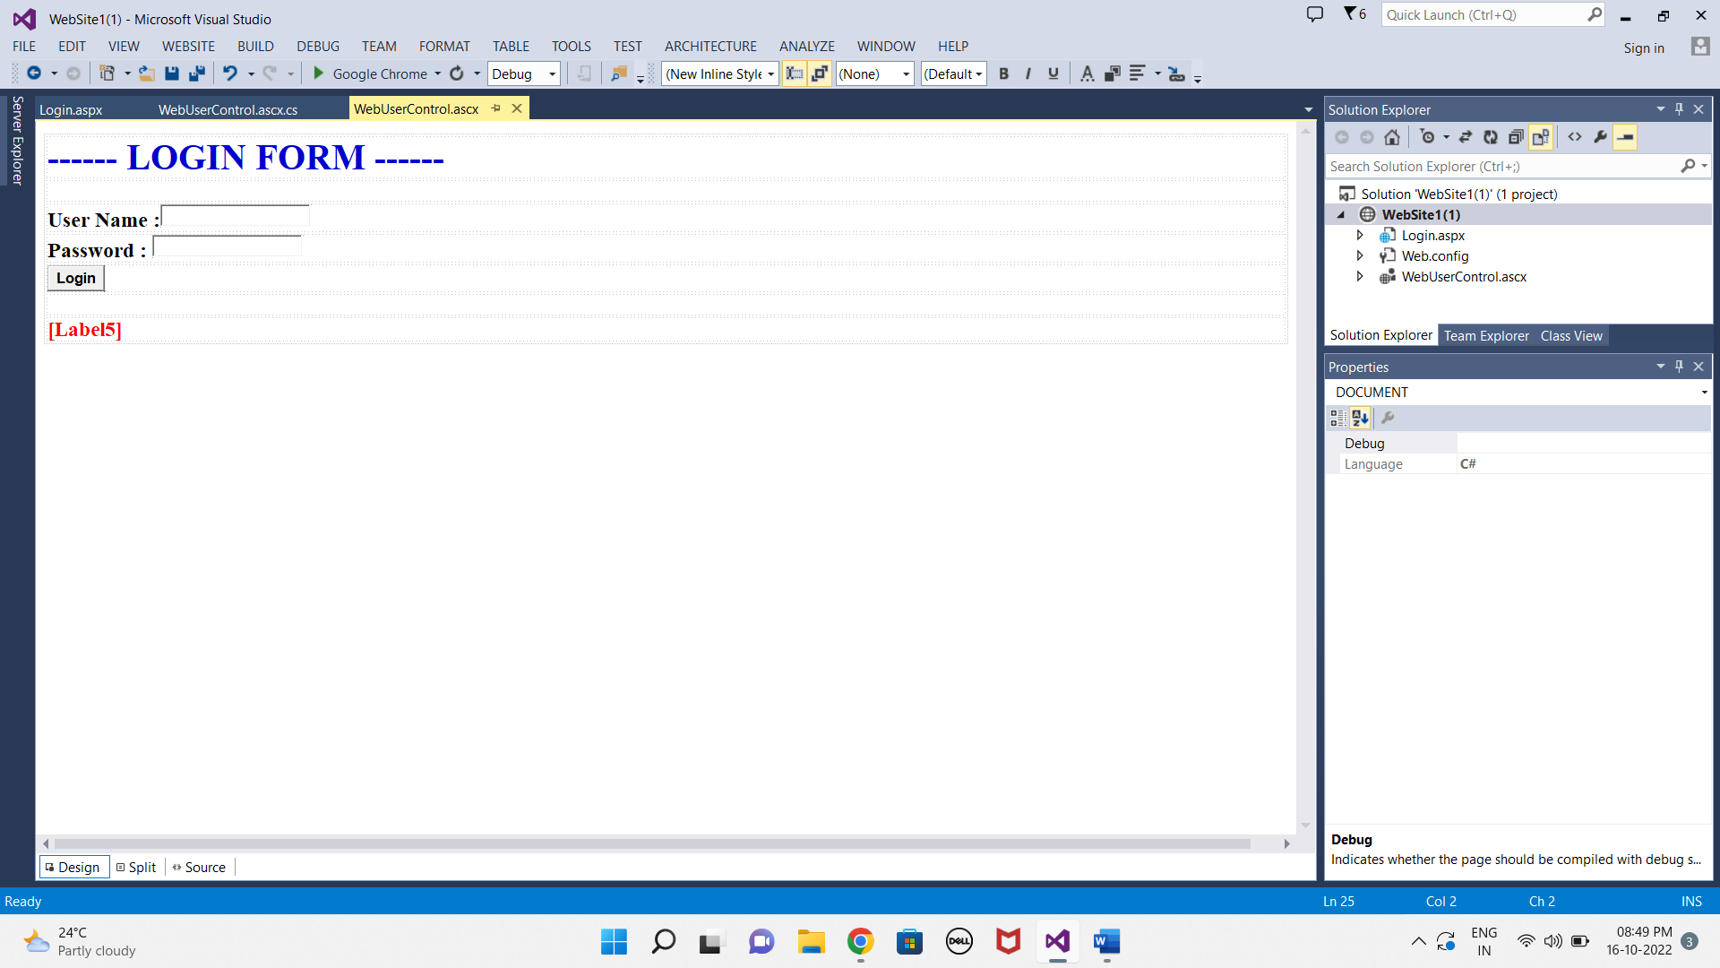

* **.aspx page code :**

<%@ Page Language="C#" AutoEventWireup="true" CodeFile="Login.aspx.cs" Inherits="Login" %>

<%@ Register Src="~/WebUserControl.ascx" TagPrefix ="LOG" TagName ="form" %>

<!DOCTYPE html>

<html xmlns="http://www.w3.org/1999/xhtml">

<head runat="server">

<title></title>

</head>

<body>

<form id="form1" runat="server">

<div>

<LOG:form runat="server" id=nmu >

</LOG:form>

</div>

</form>

</body>

</html>

* **.aspx Design Page :**

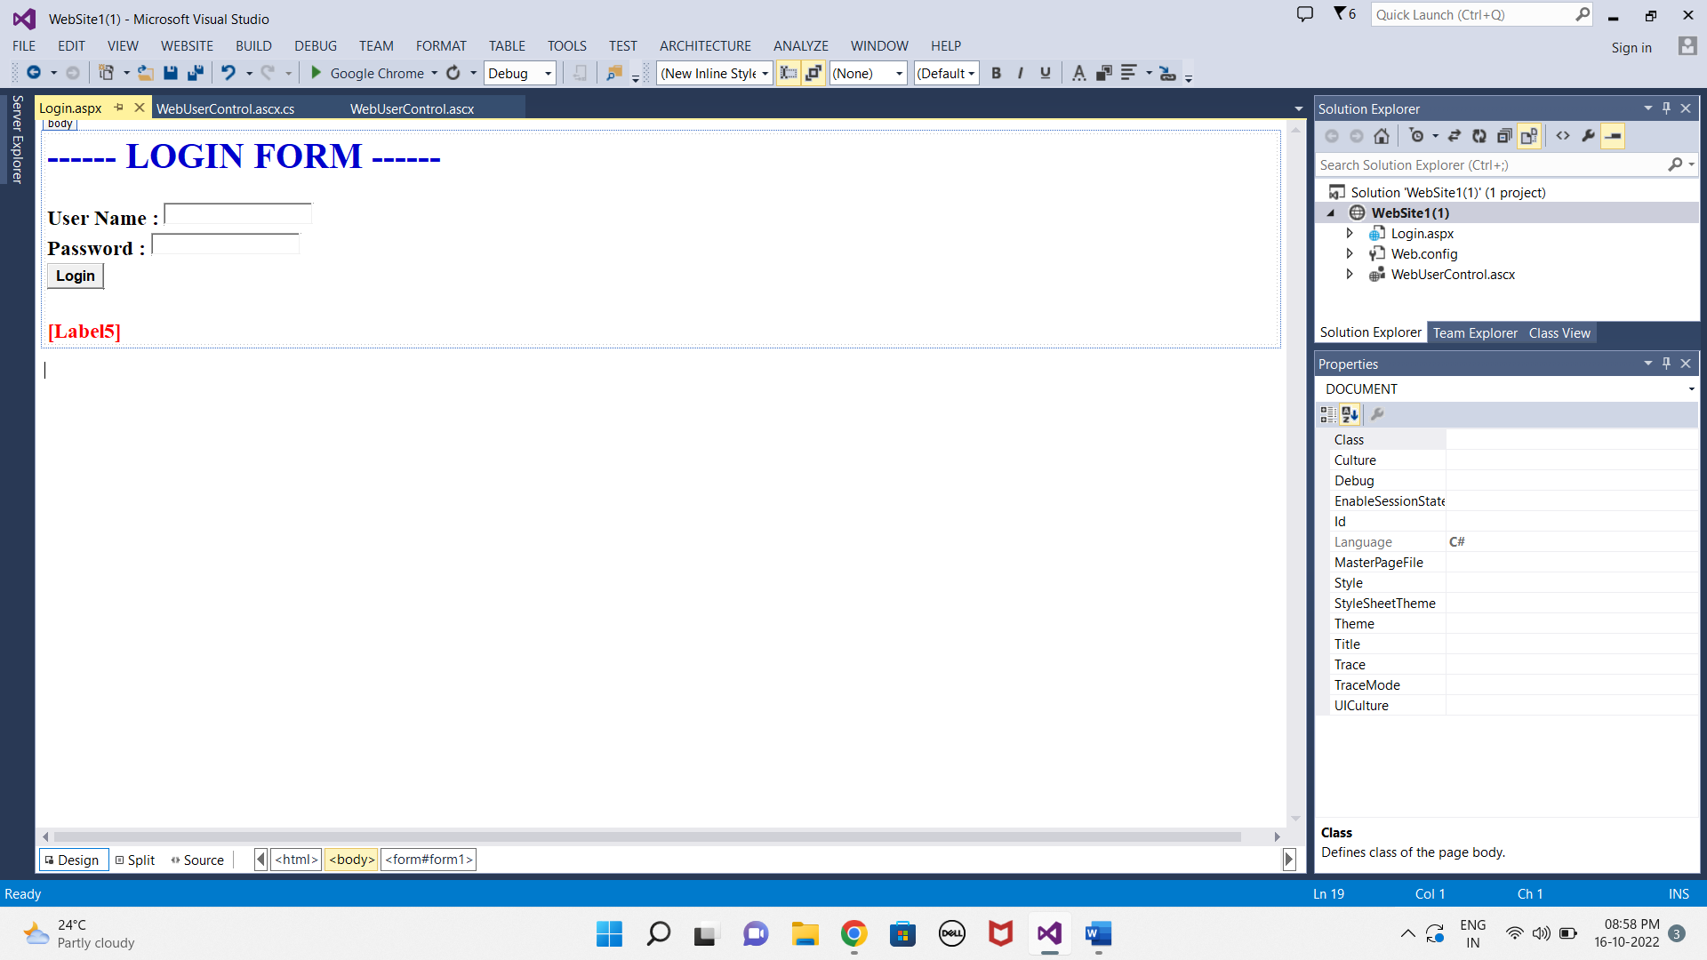

**OUTPUT :**

