**Assignment Name:- write a python program to demonstrate the Exception Handling .**

**Assignment No :- 11**

try:  
 file = open("testfile", "r")  
 file.write("This is my test file for exception handling!!")  
except IOError:  
 print ("Error: can\'t find file or read data")  
else:  
 print ("Written content in the file successfully")  
 file.close()

**output:**

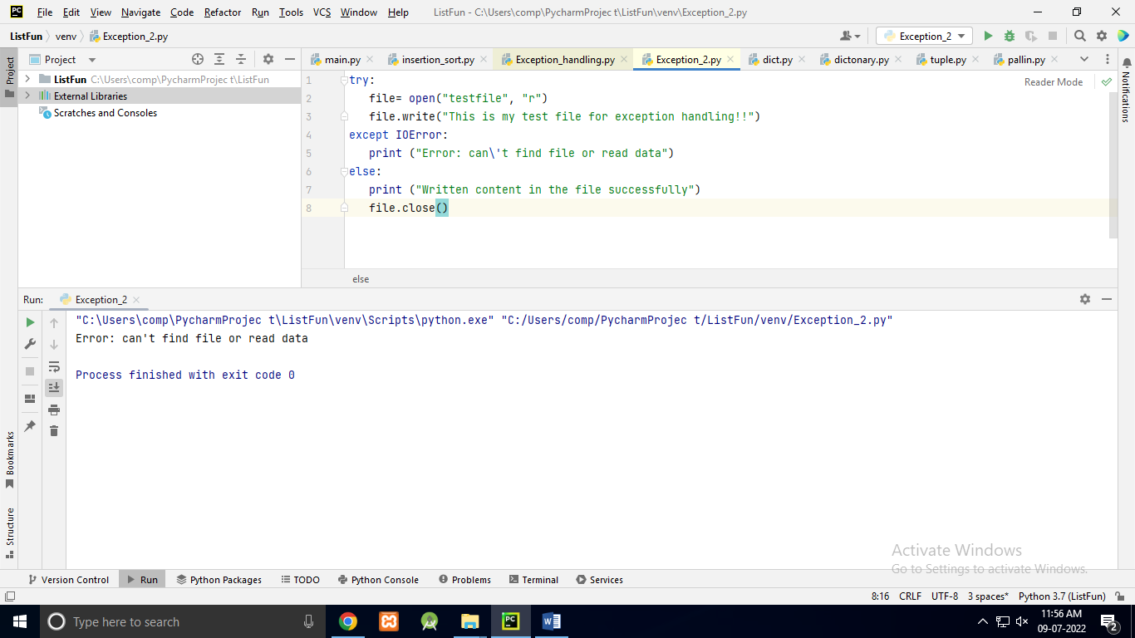

try:  
 file = open("testfile", "w")  
 file.write("This is my test file for exception handling!!")  
except IOError:  
 print ("Error: can\'t find file or read data")  
else:  
 print ("Written content in the file successfully")  
 file.close()

**output:**

