ST 518 Project

Rachel Hencher, Dane Korver, Mohammed Mira

2022-12-01

Table of Contents

# Executive Summary

*A one or two paragraph summary that includes a description of the experiment, significant results (including any interesting numerical results), and any conclusions you draw. The reader should be able to glean all the important aspects of your work from the executive summary. Effectively and succinctly convey objectives, summary of experimental design, and results and conclusions drawn from experiment.*

# Introduction

*Explain what you are trying to learn from the experiment – you may borrow heavily from my description. Effectively describe the purpose of the experiment.*

The purpose of this experiment is to investigate specific factors and their effect on the amount of time it takes to dissolve a cold medicine tablet in water. The data is from an “Effervescent Experiment” designed to compare dissolving times of two different brands of tablets (name brand and store brand) at three different equally spaced water temperatures (6 $​^{∘}$ C, 23 $​^{∘}$ C, and 40 $​^{∘}$ C). The run order number, as well as whether or not the sample was stirred, were also recorded and are investigated in the analysis portions of this report.

Below, we have a brief look at the first 10 of 48 rows of data in order to begin to gain an understanding of the data set we are working with.

First 10 Rows of Effervescence Data

| Brand | Temp | Stirred | Order | Time | OrgTime |
| --- | --- | --- | --- | --- | --- |
| name | 6 | yes | 8 | 77.21547 | 75.525 |
| name | 23 | yes | 3 | 75.37855 | 68.125 |
| name | 40 | yes | 7 | 68.08492 | 44.825 |
| store | 6 | yes | 1 | 77.87371 | 78.350 |
| store | 23 | yes | 2 | 66.38436 | 40.575 |
| store | 40 | yes | 18 | 59.82388 | 27.450 |
| name | 6 | yes | 9 | 75.94293 | 70.325 |
| name | 23 | yes | 4 | 69.08937 | 47.525 |
| name | 40 | yes | 10 | 64.45156 | 36.200 |
| store | 6 | yes | 12 | 77.33947 | 76.050 |

# Experimental Design

*Include a description of the experiment and the data that was collected – you may borrow heavily from my description. Effectively describe the experimental design and factors.*

The experiment carried out was a complete block design where *b* = 2 blocks (by stirred status) were selected with *n* = 4 observations on each of the treatment combinations in each block. In Block I, the water was stirred using a magnetic stirring plate at 350 revolutions per minute, whereas in Block II, the water was not stirred. The time for the tablet to dissolve was measured from the moment the tablet was dropped into the water to the time the tablet was completely dissolved. Each tablet was dropped from a fixed height into 60mL of water. The observation was taken as an average of the times as measured by four experimenters and was recorded, along with the run order for each observation.

# Exploratory Analysis

Summary statistics for each variable can be seen below. For the Brand, Temp, Stirred, and Order variables, we can see counts for each level. For the Time variable, we can see a five-number summary for the variable.

Summary Stats for Variables

|  | Brand | Temp | Stirred | Order | Time | OrgTime |
| --- | --- | --- | --- | --- | --- | --- |
|  | name :24 | 6 :16 | no :24 | 1 : 1 | Min. :58.24 | Min. :24.95 |
|  | store:24 | 23:16 | yes:24 | 2 : 1 | 1st Qu.:66.09 | 1st Qu.:39.88 |
|  | NA | 40:16 | NA | 3 : 1 | Median :70.92 | Median :52.84 |
|  | NA | NA | NA | 4 : 1 | Mean :70.77 | Mean :56.23 |
|  | NA | NA | NA | 5 : 1 | 3rd Qu.:76.93 | 3rd Qu.:74.33 |
|  | NA | NA | NA | 6 : 1 | Max. :80.92 | Max. :92.72 |
|  | NA | NA | NA | (Other):42 | NA | NA |

**Add text here**

Summary Stats for Time by Group

| Brand | Stirred | Temp | Mean | SD | Min | Q1 | Median | Q3 | Max |
| --- | --- | --- | --- | --- | --- | --- | --- | --- | --- |
| name | no | 6 | 78.99 | 0.64 | 78.15 | 78.80 | 79.04 | 79.24 | 79.72 |
| name | no | 23 | 76.36 | 0.33 | 76.07 | 76.20 | 76.28 | 76.43 | 76.83 |
| name | no | 40 | 70.56 | 0.50 | 70.00 | 70.29 | 70.51 | 70.78 | 71.20 |
| name | yes | 6 | 76.20 | 0.68 | 75.81 | 75.83 | 75.89 | 76.26 | 77.22 |
| name | yes | 23 | 72.69 | 2.64 | 69.09 | 71.82 | 73.15 | 74.02 | 75.38 |
| name | yes | 40 | 65.85 | 1.60 | 64.45 | 64.87 | 65.44 | 66.42 | 68.08 |
| store | no | 6 | 79.49 | 1.30 | 77.78 | 79.02 | 79.63 | 80.10 | 80.92 |
| store | no | 23 | 67.52 | 0.45 | 67.08 | 67.14 | 67.52 | 67.90 | 67.93 |
| store | no | 40 | 58.96 | 0.35 | 58.54 | 58.77 | 58.99 | 59.19 | 59.33 |
| store | yes | 6 | 77.34 | 0.77 | 76.24 | 77.07 | 77.61 | 77.88 | 77.89 |
| store | yes | 23 | 66.19 | 0.20 | 65.93 | 66.09 | 66.23 | 66.33 | 66.38 |
| store | yes | 40 | 59.13 | 0.66 | 58.24 | 58.91 | 59.22 | 59.43 | 59.82 |

The box plot below displays a five-number summary of dissolving time for each brand of tablet. The plot displays Time as a function of Brand and indicates that there is an effect of the brand on time.

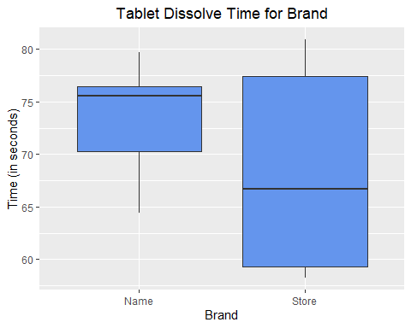

The box plot below displays a five-number summary of dissolving time for each stirred status. The box plot displays Time as a function of Stirred and indicates that there is an effect of the stirred status on time.

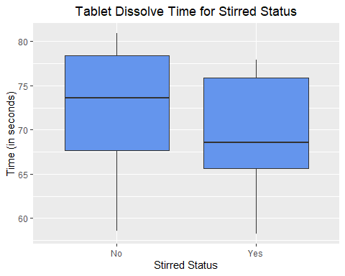

The box plot below displays the dissolving time for different water temperatures. Time is displayed as a function of Temperature, however, we can also see how the Brand and Stirred variables affect the dissolving time by observing the color and shape of the points. It is clear that a warmer temperature reduces the dissolving time. It also appears that, as mentioned above, stirring the water reduces the dissolving time and that at the higher temperatures, the store brand dissolves more quickly than the name brand tablets.

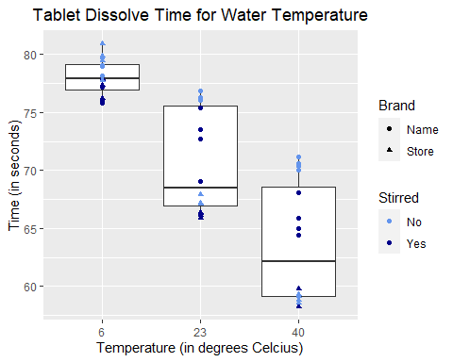

# Analysis and Results

*Fit appropriate models and follow good statistical analysis process to determine the best model to use. Make use of proper diagnostics. Choose the appropriate effects to compare, correctly estimate and test significance of the effects and trends.*

**Model 1**

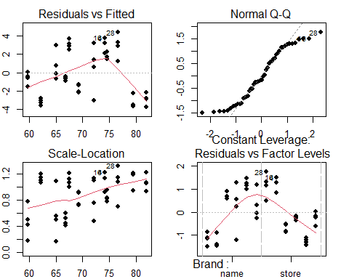

## Df Sum Sq Mean Sq F value Pr(>F)   
## Brand 1 342.0 342.0 48.514 1.44e-08 ***  
## Temp 2 1654.7 827.4 117.364 < 2e-16 ***  
## Stirred 1 69.9 69.9 9.914 0.00298 **   
## Residuals 43 303.1 7.0   
## ---  
## Signif. codes: 0 '***' 0.001 '**' 0.01 '*' 0.05 '.' 0.1 ' ' 1

**Coefficients of Model 1**

## (Intercept) Brandstore Temp23 Temp40 Stirredyes   
## 81.881558 -5.338595 -7.315177 -14.381286 -2.413294

**Model 2**

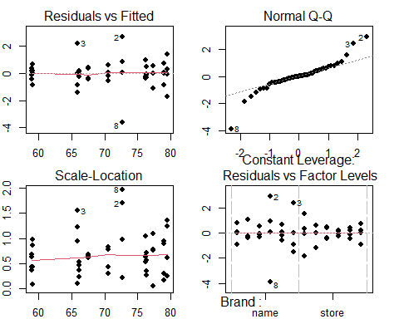

## Df Sum Sq Mean Sq F value Pr(>F)   
## Brand 1 342.0 342.0 296.041 < 2e-16 ***  
## Temp 2 1654.7 827.4 716.169 < 2e-16 ***  
## Stirred 1 69.9 69.9 60.495 3.22e-09 ***  
## Brand:Temp 2 231.9 115.9 100.345 1.90e-15 ***  
## Brand:Stirred 1 20.5 20.5 17.753 0.000161 ***  
## Temp:Stirred 2 0.1 0.1 0.054 0.947535   
## Brand:Temp:Stirred 2 9.1 4.5 3.919 0.028838 *   
## Residuals 36 41.6 1.2   
## ---  
## Signif. codes: 0 '***' 0.001 '**' 0.01 '*' 0.05 '.' 0.1 ' ' 1

**Coefficients of Model 2**

## (Intercept) Brandstore   
## 78.9906136 0.5017854   
## Temp23 Temp40   
## -2.6271025 -8.4355000   
## Stirredyes Brandstore:Temp23   
## -2.7882004 -9.3497720   
## Brandstore:Temp40 Brandstore:Stirredyes   
## -12.0934259 0.6328276   
## Temp23:Stirredyes Temp40:Stirredyes   
## -0.8838592 -1.9134790   
## Brandstore:Temp23:Stirredyes Brandstore:Temp40:Stirredyes   
## 1.7149658 4.2306652

**Model 3**

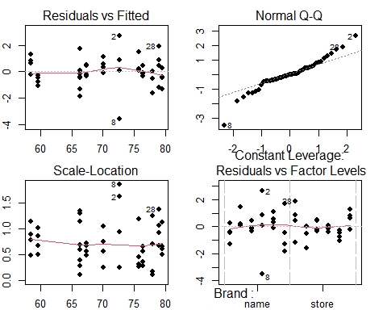

## Df Sum Sq Mean Sq F value Pr(>F)   
## Brand 1 342.0 342.0 269.45 < 2e-16 ***  
## Temp 2 1654.7 827.4 651.85 < 2e-16 ***  
## Stirred 1 69.9 69.9 55.06 4.90e-09 ***  
## Brand:Temp 2 231.9 115.9 91.33 1.22e-15 ***  
## Brand:Stirred 1 20.5 20.5 16.16 0.00025 ***  
## Residuals 40 50.8 1.3   
## ---  
## Signif. codes: 0 '***' 0.001 '**' 0.01 '*' 0.05 '.' 0.1 ' ' 1

**Coefficients of Model 3**

## (Intercept) Brandstore Temp23   
## 79.4568366 -0.4891531 -3.0690321   
## Temp40 Stirredyes Brandstore:Temp23   
## -9.3922395 -3.7206465 -8.4922892   
## Brandstore:Temp40 Brandstore:Stirredyes   
## -9.9780933 2.6147046

**Model selection by AIC criterion**

## Warning: package 'AICcmodavg' was built under R version 4.2.2

##   
## Model selection based on AICc:  
##   
## K AICc Delta_AICc AICcWt Cum.Wt LL  
## Model 3 9 161.65 0.00 0.9 0.9 -69.46  
## Model 2 13 166.04 4.39 0.1 1.0 -64.67  
## Model 1 6 238.73 77.08 0.0 1.0 -112.34

**Tukey’s**

## Tukey multiple comparisons of means  
## 95% family-wise confidence level  
##   
## Fit: aov(formula = Time ~ Brand + Temp, data = data)  
##   
## $Brand  
## diff lwr upr p adj  
## store-name -5.338595 -7.032557 -3.644633 1e-07  
##   
## $Temp  
## diff lwr upr p adj  
## 23-6 -7.315177 -9.812030 -4.818324 0e+00  
## 40-6 -14.381286 -16.878139 -11.884433 0e+00  
## 40-23 -7.066109 -9.562963 -4.569256 1e-07

# Conclusion

*Effectively describe conclusions and reasons for recommendation, analysis limitations, and future work. Address the proper role of the Stirred variable in this analysis.*