A6Q4 – Dimitrios Koutentakis

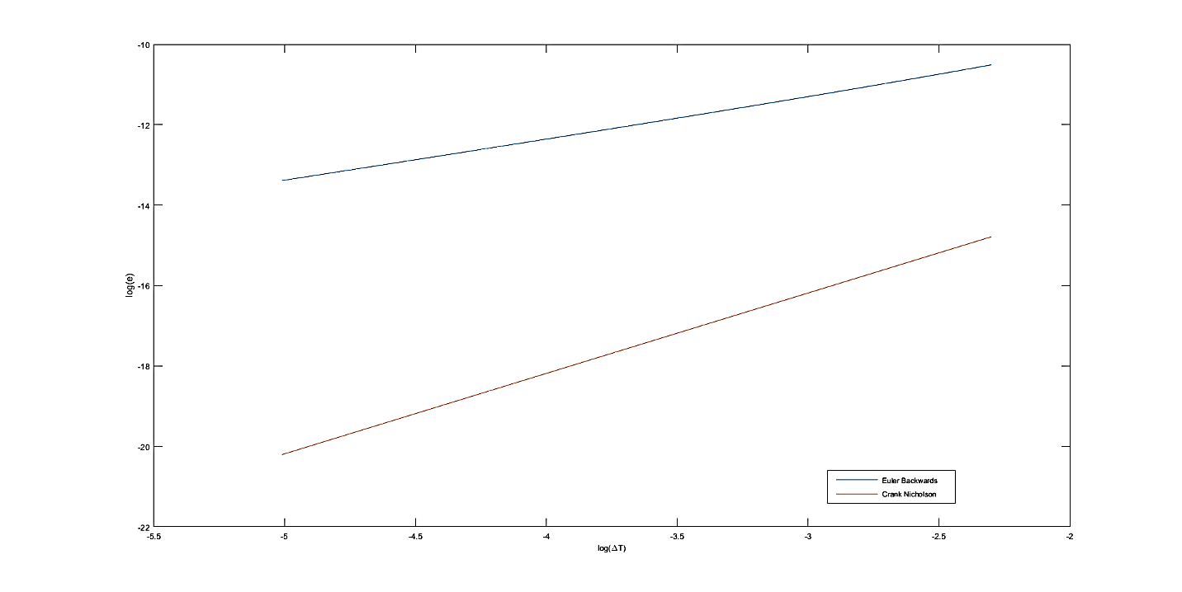

From the above plot, it seems like the Crank Nicholson scheme is higher order than the Euler Backwars. The Crank Nicholson is approximately second order, whereas the Euler Backwards is approximately first order (as calculated from their slopes). These results agree with the theoretical figures. I would prefer the Crank Nicholson scheme because it has less error, and converges faster. The only thing that is a bit surprising is that even though Crank Nicholson converges faster, it also starts from a lower error than Euler Backwards.