Dimitrios Koutentakis – A6Q5

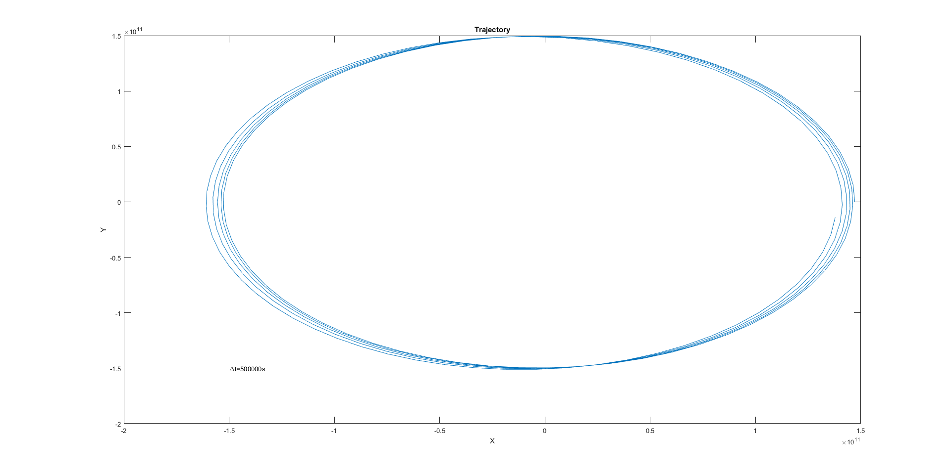1)

The time step chosen was Δt=500000s~5.78 days. I chose that time step because it does a good enough job of plotting the trajectory, while showing that the trajectory is not perfect and still being fast to compute. From this time step and figure, we get a pretty good feel about the error that occurs.

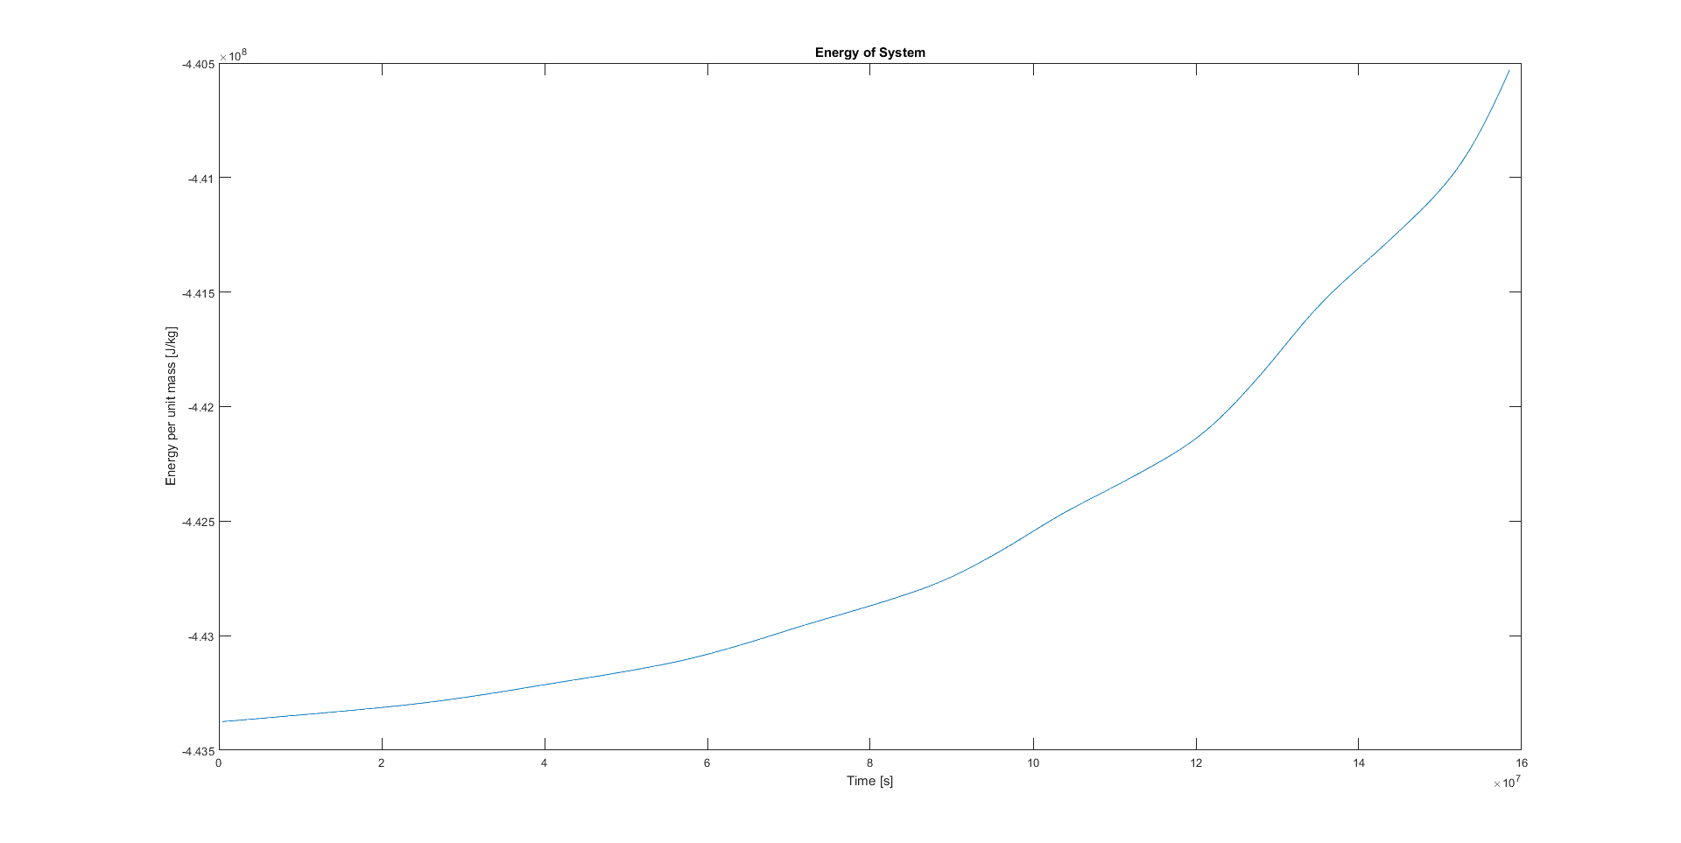



2)

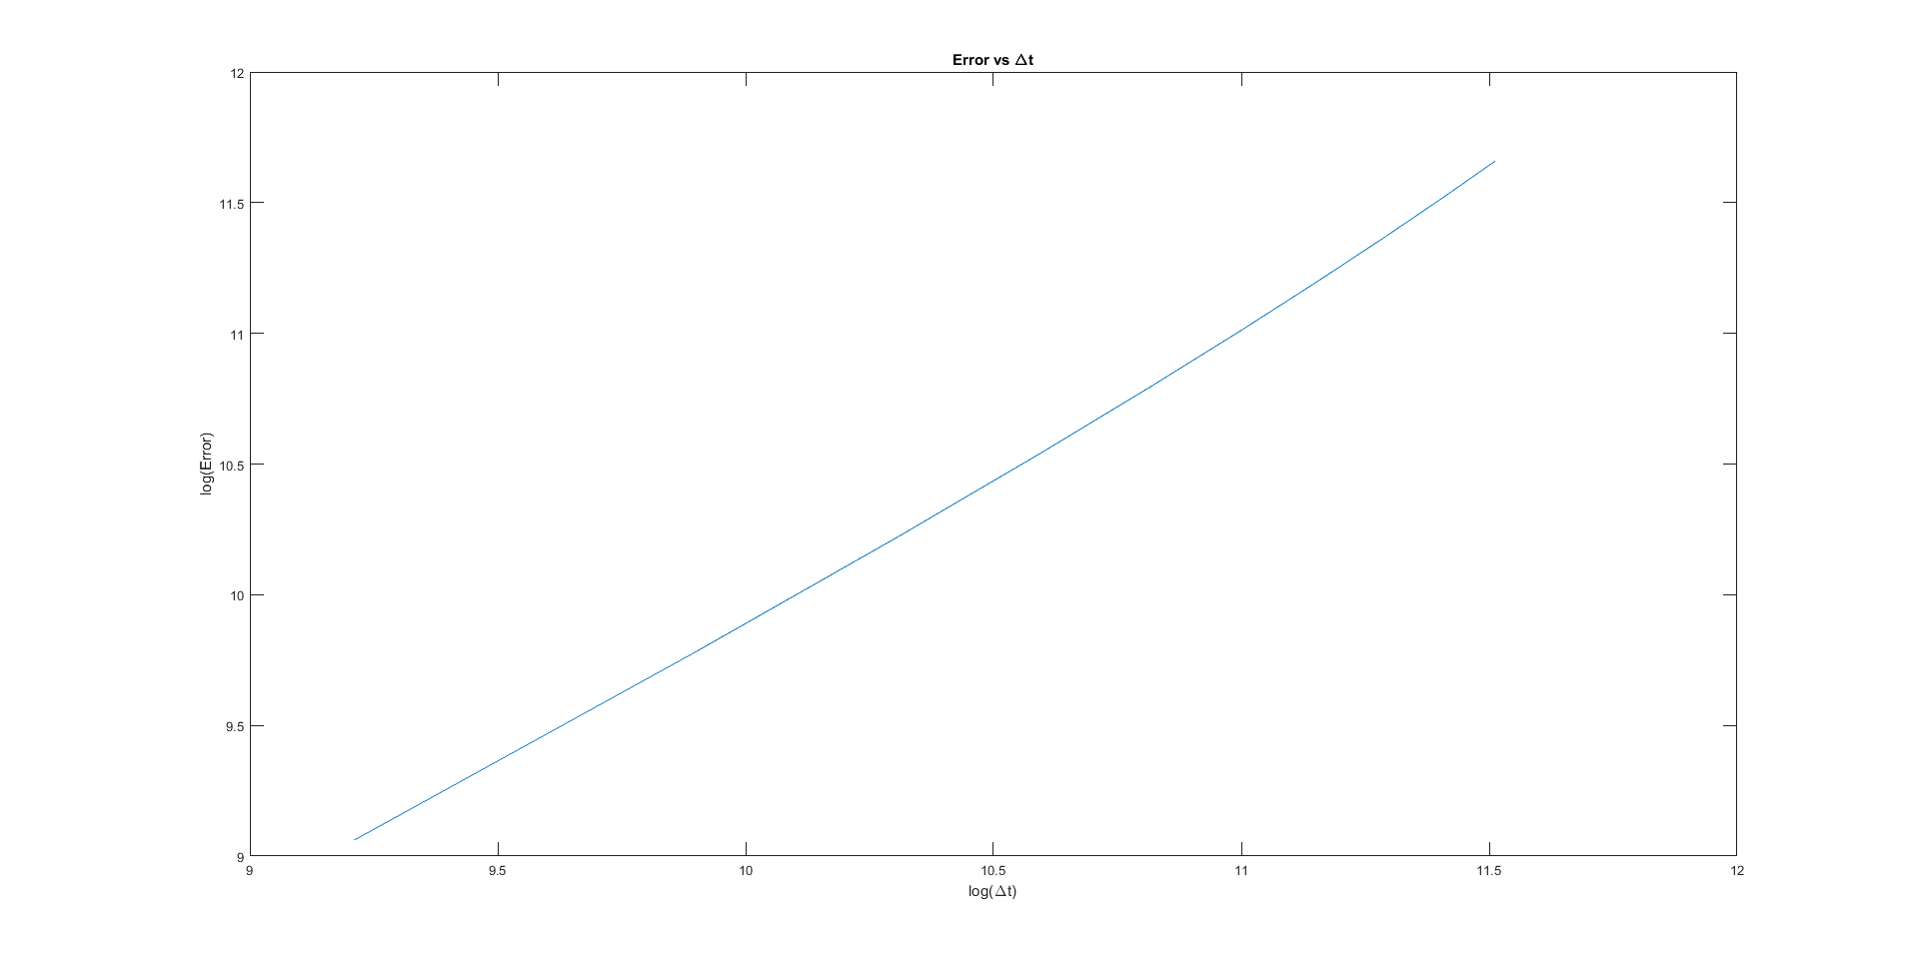

As seen from the plot above, the log of the error depends linearly on the log of Δt, so we can easily determine the order of convergence from the slope of the graph. The smaller the Δt, the smaller the error.