Dimitrios Koutentakis

2.086 Assignment 9

Problem 4

Figure 1: Histogram for n=10000

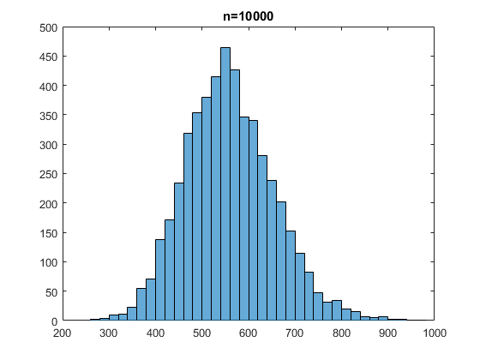

Figure 2: Histogram for n=50000

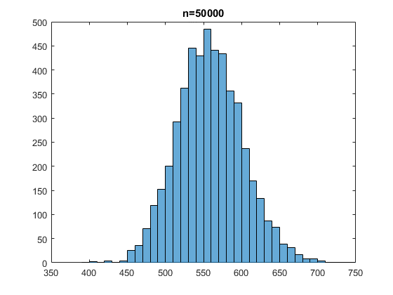

The observed distributions of int_est, are normal distributions, as seen in the two figures above, and as expected theoretically.

From the two histograms above, we can understand that the bigger the size of the random sample, the better is the resulting calculation. This becomes obvious by seeing that the second histogram is more “narrow” signifying that the standard deviation is much smaller in the second calculation (n=50000).

Seeing that there is a very obvious difference in the standard deviation just by making n five times bigger, means that the standard deviation scales somewhat linearly (or faster) with the value of n.

I was expecting that bigger n would mean smaller standard deviation, but I thought it would be less obvious in such small differences in n.