Government Engineering College, Thrissur
CS333– Application Software Development Lab
Documentation -
Exp 1 – DDL & DQL commands

Date of Submission
14 September 2020

Submitted By
Kowsik Nandagopan D
Roll No 31
TCR18CS031
GECT CSE S5

Experiment 1

AIM
Creation of database using DDL Commands and write DQL queries to retrieve information from the database

Description
Creation of table using the DDL commands like CREATE DATABASE. Getting information about the database using DESCRIBE keyword. Here I have created the database for the Open PPM project. As explained in the introductory documentation Open PPM is Project Portfolio Management Tool for small IT companies

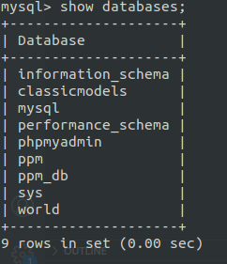
Output / Screenshots
(11 Pages)

