Government Engineering College, Thrissur
CS334 – Network Programming Lab
Documentation -
Exam –
File server to send 400MB+ movie file

Date of Submission
10 July 2021

Submitted By
Kowsik Nandagopan D
Roll No 31
TCR18CS031
GECT CSE S6

AIM
Design and implement a small socket programming application to transfer a large movie file (larger than 400MB) from the server and play at the client?

Prerequisite
- Code is provided in the Server.java and Client.java (Tested and verified on Ubuntu 20.04)
javac Server.java
java Server
javac Client.java
java Client
- Note: Server.java searches for “send” folder and Client.java searches for “receive” folder. Make sure file to be sent exists inside “send” folder. Files will be received in “receive” folder
- Server.java program sends file to every client connected to server socket. To stop transmission/server use CTRL + C
ALGORITHM
Server.java
- Accept client and run a thread for each client
- Accept file name and check whether exists. If exists, go to next step else alert client file does not exists and close thread.
- Read the file requested by the client and send. Each file must be buffered (here 32Kb).
Clent.java
- Accept file name and send it to server.
- Receive file size and PID (Process ID)
- Receive buffered data and append it to file receive previously. Calculate percentage if possible
- After successfully receiving the file exit.

P. T, O

Output / Screenshots
Initial compilation and execution
Server.java
Client.java

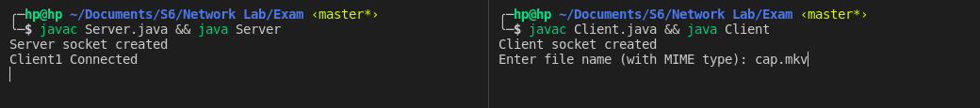
I have combined both compilation and execution command using && operator in terminal

Initial Send Folder and receive folder
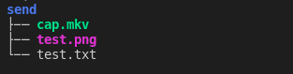
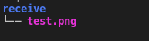

Sending File
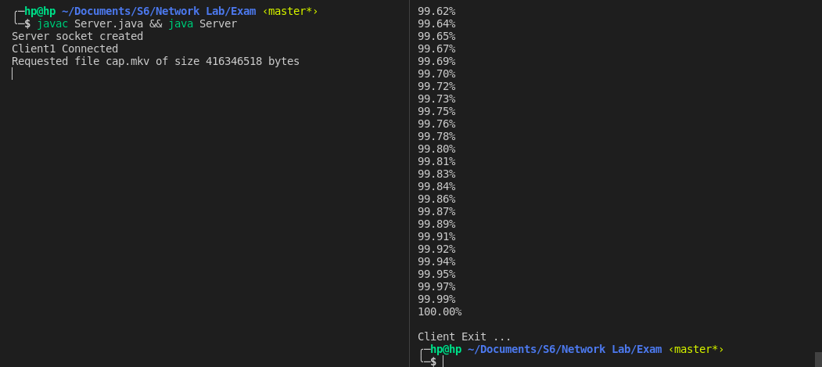
Receive Folder after receiving file from server
