Government Engineering College, Thrissur
CS334 – Network Programming Lab
Documentation -
Exp 5 – Simple Mail Transfer Protocol

Date of Submission
02 May 2021

Submitted By
Kowsik Nandagopan D
Roll No 31
TCR18CS031
GECT CSE S6

Experiment 5
Implement Simple Mail Transfer Protocol.

Executing program
- Code is provided in Client.java and Server.java along with this documentation. You can open the terminal in Linux (Ubuntu 20.04 tested). Then run the command
javac Server.java
java Server
- Open a new terminal and then run. We can run as many clients in parallel.
javac Client.java
java Client
- Server and Client will start their respective sockets and work on the same machine (IP 127.0.0.1, Port 5000).
- Note: Server is fully automated. Client has to verify recipient email address before emailing (as per test case).
- Note: If client receive anytime even he is typing email, then message will be displayed in between two separators.
- We can see output side-by-side in the console

P. T. O

Output / Screenshots

Server
Client 2
bbb@xyz.com
Client 1
aaa@xyz.com
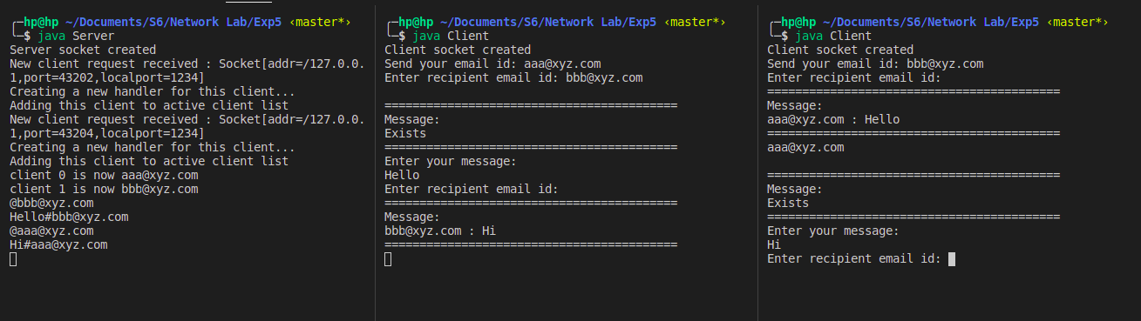
Explanation:
- Client 1 connects to server
- Client 2 connects to server
- Client 1 sets his email id as aaa@xyz.com
- Client 2 sets his email id as bbb@xyz.com
- Client 1 checks whether bbb@xyz.com exists or not, and receives message from server.
- Client 1 sends message Hello to bbb@xyz.com
- During this time Client 2 hasn’t typed recipient email address, but receives mail from aaa@xyz.com. This message is separated by two lines.
- Client 2 was prompted to set recipient email address before message came, that sill works (in thread). Even though there is message in between prompted message and email, Client 2 can still enter recipient email address.
- Client 2 sets recipient email as aaa@xyz.com
- Client 2 sends message Hi to aaa@xyz.com

All the messages are logged by server during communication.

