Government Engineering College, Thrissur
CS334 – Network Programming Lab
Documentation -
Exp 6 – Concurrent File Server

Date of Submission
09 May 2021

Submitted By
Kowsik Nandagopan D
Roll No 31
TCR18CS031
GECT CSE S6

Experiment 6
Develop concurrent file server which will provide the file requested by client if it exists. If not, the server sends an appropriate message to the client. Server should also send its process ID (PID) to clients for display along with file or the message.

Executing program
- Code is provided in Client.java and Server.java along with this documentation. You can open the terminal in Linux (Ubuntu 20.04 tested). Then run the command
javac Server.java
java Server
- Open a new terminal and then run. We can run as many clients in parallel.
javac Client.java
java Client
- Server and Client will start their respective sockets and work on the same machine (IP 127.0.0.1, Port 5000).
- Please save the files should accessible from client in send folder. To store the received files create a receive folder
- Note: Server is fully automated. Client has to send file name along with MIME type to the server.
- We can see output side-by-side in the console

P. T. O

Output / Screenshots

Server
Client
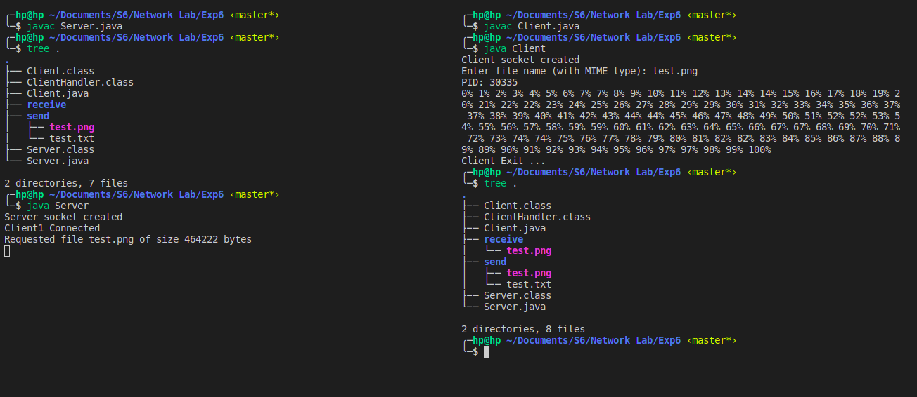
Explanation:
- Compile both source code
- In server tree command we can see that receive folder is empty
- Run Server
- Run Client
- Type the file name available in send folder in server. Else message in client will be display that such file doesn’t exists in server. Here it is test.png is the file name.
- After sending the file name we can see that server returns its PID. Then the actual file transfer occur. It is buffered file transfer so, we have to know how much is received. In order to show that we are printing percentage.
- Tree command in client console shows that test.png is received

