Government Engineering College, Thrissur
CS334 – Network Programming Lab
Documentation -
Exp1 – Socket Programming - TCP

Date of Submission
29 March 2021

Submitted By
Kowsik Nandagopan D
Roll No 31
TCR18CS031
GECT CSE S6

Experiment 1
Implement Client-Server communication using Socket Programming and TCP as transport layer
protocol.

Executing program
- Code is provided in Client.java and Server.java along with this documentation. You can open the terminal in Linux (Ubuntu 20.04 tested). Then run the command
javac Server.java
java Server
- Open a new terminal and then run
javac Client.java
java Client
- Server and Client will start their respective sockets and work on the same machine (IP 127.0.0.1, Port 5000).
- This is a dis-continuous message sending system. So we can send data as the console prompts us to do so.
- We can see output side-by-side in the console
- To terminate program type “Exit” in both program

Output / Screenshots

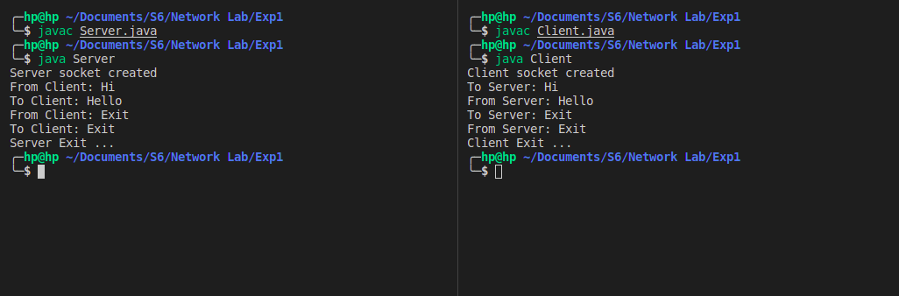
Server
Client

