Government Engineering College, Thrissur
CS334 – Network Programming Lab
Documentation -
Exp 8 – First Reader Writer Problem

Date of Submission
06 June 2021

Submitted By
Kowsik Nandagopan D
Roll No 31
TCR18CS031
GECT CSE S6

Experiment 8
Implement the First Readers-Writers Problem (Using Threads and Shared Memory)

Executing program
- Code is provided in the first.c (Tested and verified on Ubuntu 20.04)
gcc first.c -lpthread -lrt && ./a.out
- NOTE: This program is designed to accept only positive number. If the number is negative or zero, then corresponding error message will be displayed
ALGORITHM
- Get number of readers and writers required from the console
- Initialize threads reader and writer threads
- Run threads,
- In reader thread – Reader should not wait for writer. When ever reader is invoked then, reader must be executed and no writer is allowed to execute until all the readers have been executed. Disadvantage of writer starvation. Count of readers can be maintained by a shared variable and it must be mutex controlled. Anyway algorithm allows parallel execution of readers.
- In writer thread – Writer should wait until all readers in queue have been completed execution. Semaphores must be used to guarantee that only one writer is executing at a time.
- Wait until all threads complete execution
- Destroy semaphores and mutex

P. T, O

Output / Screenshots

Error Messages
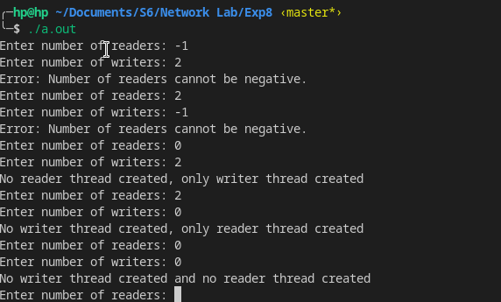
Error messages produced for non positive number of readers and writers

Thread Execution
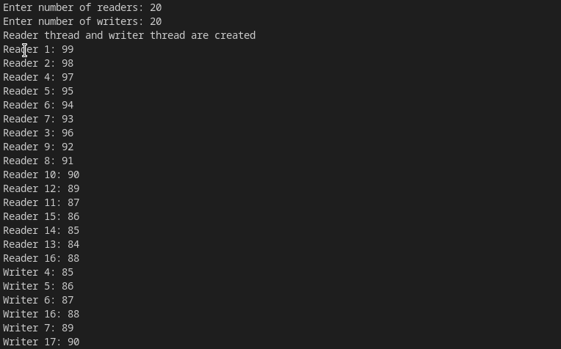
Consider number of readers and writers as 20

Observation and Explanation
- Readers start execution and writers are kept waiting. We cannot see writer in between readers. This is because readers are given higher priority than writes
- We can see readers after writers threads have begun, during this period no writer is allowed to access shared memory space.

