Government Engineering College, Thrissur
CS334 – Network Programming Lab
Documentation -
Exp 10 –
Wireshark to Observer UDP Packets

Date of Submission
26 June 2021

Submitted By
Kowsik Nandagopan D
Roll No 31
TCR18CS031
GECT CSE S6

Experiment 10
Using Wireshark observe data transferred in client server communication using UDP and identify the UDP datagram.

Executing program
- Code is provided in the Server.java and Client.java (Tested and verified on Ubuntu 20.04)
javac Server.java
java Server
javac Client.java
java Client
- Client Server program is not mandatory. We can observer the UDP packets from internet to browser using wireshark. But here for the testing and for sake of simplicity we generate using the java program
- Server.java program sends a message “ABCDE” to client every two seconds. To stop transmission use CTRL + C
PROCEDURE
- Open wireshark in super user mode using the command
sudo wireshark
- Open the Loopback mode. Since the transmission is between two processes in the same system between two ports.

P. T, O

Output / Screenshots
Running server and client
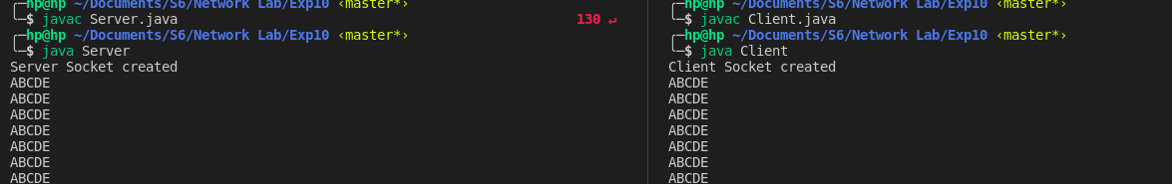
Server
Client

List of UDP Packets Received
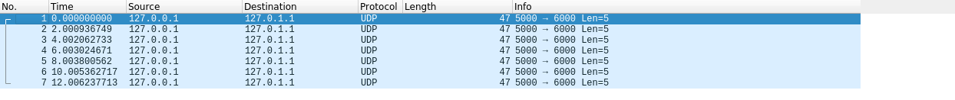
Contents of Packet
