Government Engineering College, Thrissur
CS334 – Network Programming Lab
Documentation -
Exp 9 – Second Reader Writer Problem

Date of Submission
13 June 2021

Submitted By
Kowsik Nandagopan D
Roll No 31
TCR18CS031
GECT CSE S6

Experiment 9
Implement the Second Readers-Writers problem (Using Process along with PIPE and Message Queue)

Executing program
- Code is provided in the second.c (Tested and verified on Ubuntu 20.04)
gcc second.c -lpthread -lrt && ./a.out
- NOTE: This program is designed to accept only positive number. If the number is negative or zero, then corresponding error message will be displayed
ALGORITHM
- Get number of readers and writers required from the console
- Initialize pipe variables
- Initialize threads reader and writer threads
- Run threads
- In reader thread – Readers can execute in parallel, but when ever a writer tries write the reader has to wait. In this problem readers are given less priority compared to writers.
- In writer thread – Writers should not wait for readers. Whenever a writer tries to write into shared memory space readers have to wait. Writers are given more priority in second readers-writers problem
- Wait until all threads complete execution

P. T, O

Output / Screenshots

Error Messages
Error messages produced for non positive number of readers and writers
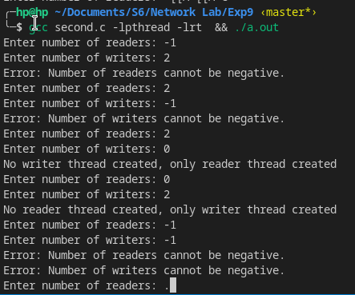

Thread Execution
Consider number of readers and writers as 100
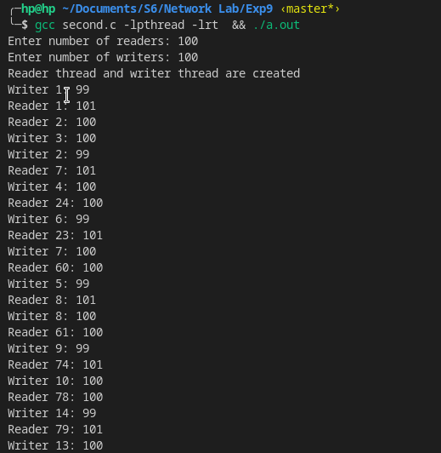

Observation and Explanation
- Writers start execution and readers are kept waiting. We cannot see reader in between writers. This is because writers are given higher priority than readers
- We can see writers after reader threads have begun, during this period no reader is allowed to access shared memory space.

