Government Engineering College, Thrissur
CS331 – System Software Lab Exam
Documentation -
Disk Scheduling SCAN and C-SCAN

Date of Submission
30 January 2020

Submitted By
Kowsik Nandagopan D
Roll No 31
TCR18CS031
GECT CSE S5

AIM
Simulate the disk scheduling algorithms - SCAN and C-SCAN, compare the head movements in each algorithm for forward, random and reverse order of the input.

Compilation of Code

Prerequisite
- The code is provided in the program.c along with this documentation. You can open the terminal in Linux (Ubuntu 18.04 tested). Then run the command
gcc program.c
./a.out
- We can execute the code in console and see the output as soon as we press enter key. There one input file forward.txt. Each requests should be provided in line by line. Please note that last line must NOT be empty.
- We should also provide current head position for each disk scheduling algorithms in the console when there is a prompt.
- Output of the code will be printed on the console

Output / Screenshots
forward.txt
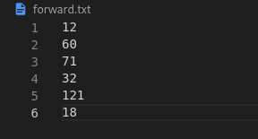

P. T. O
Output in console
