Government Engineering College, Thrissur
CS331 – System Software Lab
Documentation -
Exp 8 – Pass 1 of Two Pass Assembler

Date of Submission
16 October 2020

Submitted By
Kowsik Nandagopan D
Roll No 31
TCR18CS031
GECT CSE S5

Experiment 8
Implement pass one of a two pass assembler

Compilation of Code

Prerequisite
- The code is provided in the program.c along with this documentation. You can open the terminal in Linux (Ubuntu 18.04 tested). Then run the command
gcc program.c
./a.out
- We have two input files. One is optab.txt which denote the OPTAB of the assemblers. Also most importantly the source code is stored in the input,txt. Note in reality this file will be of *.asm extension. For the simplicity here we use *.txt extension
- optab.txt: It stores the operation codes allowed in the assembly language. Format for the input is
<Opcode (String)> <Tab> <Hex Code corresponding to opcode (String)>
- input.txt: We store the assembly language in this file. The assembly language used is SIC (Simple Instruction Computer)
- Output of the code will be printed on the console and the SYMTAB will be stored to symtab.txt file
- Note: Please see the output.txt file for the output I got on my machine.
- Note: There is no specific input file for this program

Output / Screenshots
Input

Source code – input.txt

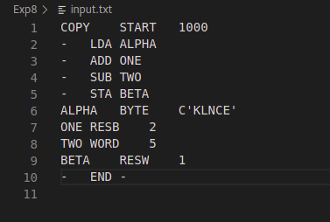

OPTAB – optab.txt

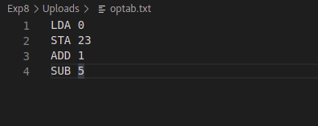

Output

Output to console
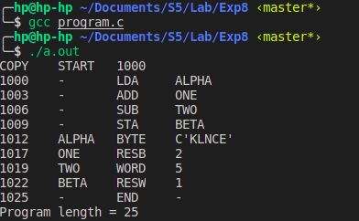

SYMTAB – symtab.txt

