Government Engineering College, Thrissur
CS331 – System Software Lab
Documentation -
Exp3 – File Organization Techniques

Date of Submission
05 September 2020

Submitted By
Kowsik Nandagopan D
Roll No 31
TCR18CS031
GECT CSE S5

Experiment 3
Simulate the following file organization techniques
a) Single level directory b) Two level directory c) Hierarchical

Compilation of Code

Prerequisite
- The code is provided in the program.c along with this documentation. You can open the terminal in Linux (Ubuntu 18.04 tested). Then run the command
gcc program.c
./a.out
- We can execute the code in console and see the output as soon as we press enter key. There are two menu drivers. One for the selection of the technique and one for the doing the operations on the file and directory.
- Single Level Directory Structure: There will be only one main directory here I named it as Main. We can create files in this directory. There are no sub directory creation. The operations allowed here are
Create File, Delete File, Search for file, Traverse the directory structure
- Two Level Directory Structure: We will be able to do file as well as folder. The main directory is called the Main in this program. We can create folder (directory) as the sibling to the main directory. This brings a user level directory creation ability in the operating system. The operation allowed here are
Create Folder, Create File, Delete File, Search for file, Traverse the directory structure
- Hierarchical Directory Structure: When we use this type of strategy we will be able to bring different type of arrangement in storing the files. We can create file/folder as sibling or child of a parent directory. This does not allow users to create folder inside file. The file is the basic unit of storing data. Operations allowed are same as that of Two Level
- Output of the code will be printed on the console
- Note: Please see the my_machine_output.txt file for the output I got on my machine.

Output / Screenshots
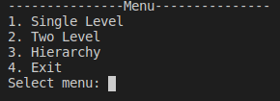
Menu

Output of each menu item
1. Single Level Directory Structure
Menu
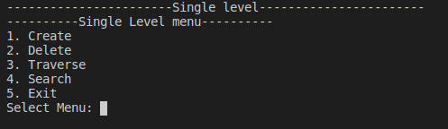
1. Create file in single level directory structure
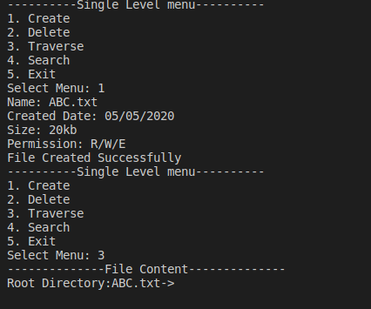

2. Delete File in Two Level Directory Structure
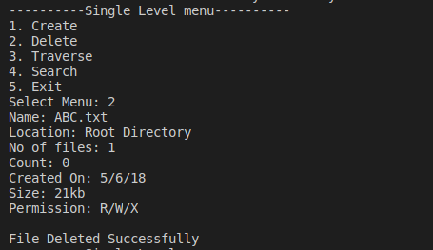

3. Search File in Two Level Directory Structure
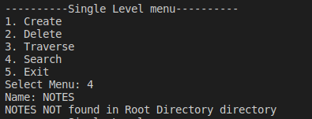

2. Two Level Directory Structure
Menu
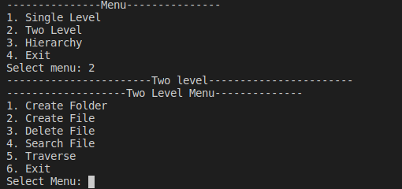

1. Create Directory in Two Level Directory Structure
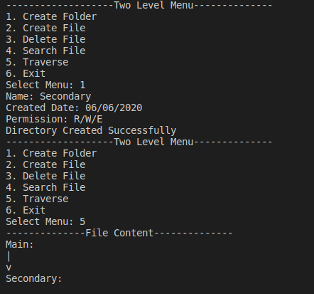

2. Create File in Two Level Directory Structure
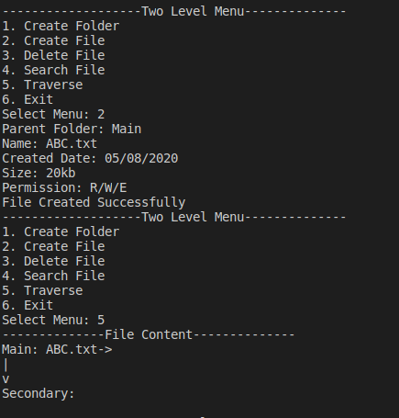

3. Delete in Two Level Directory Structure
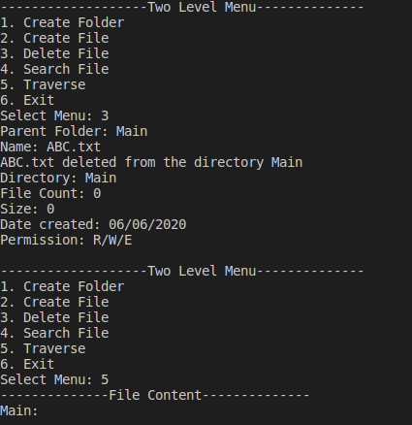

4. Search in Two Level Directory Structure

3. Hierarchical Directory Structure
Menu
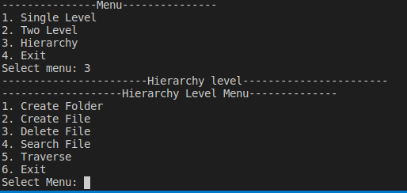
1. Create Directory in Hierarchical Directory Structure
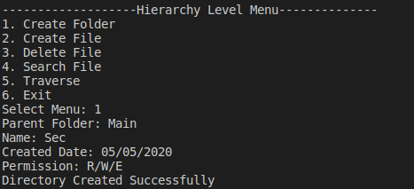

2. Create File in Hierarchical Directory Structure
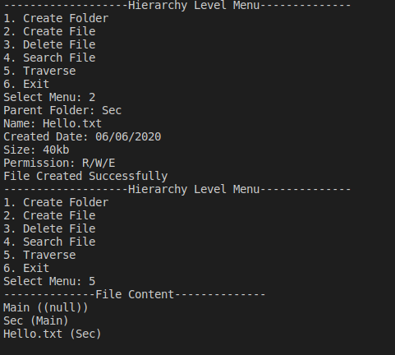

3. Delete File in Hierarchical Directory Structure
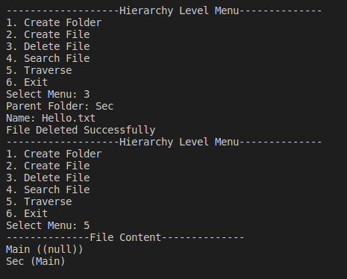

4. Search Directory in Hierarchical Directory Structure
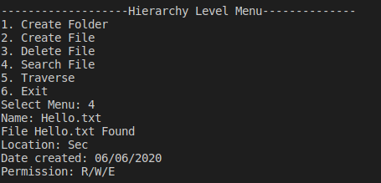

4. Exit
