Government Engineering College, Thrissur
CS331 – System Software Lab
Documentation -
Exp 5 – Disk Scheduling

Date of Submission
21 September 2020

Submitted By
Kowsik Nandagopan D
Roll No 31
TCR18CS031
GECT CSE S5

Experiment 5
Simulate the following disk scheduling algorithms
a) FCFS b) SCAN c) C-SCAN

Compilation of Code

Prerequisite
- The code is provided in the program.c along with this documentation. You can open the terminal in Linux (Ubuntu 18.04 tested). Then run the command
gcc program.c
./a.out
- We can execute the code in console and see the output as soon as we press enter key. There one input file req.txt. Each requests should be provided in line by line. Please note that last line must NOT be empty.
- Output of the code will be printed on the console
- Note: Please see the my_machine_output.txt file for the output I got on my machine.

Output / Screenshots
req.txt
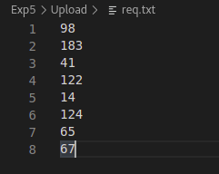

Menu
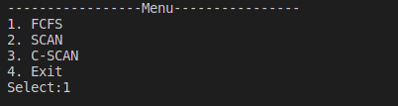

1. FCFS
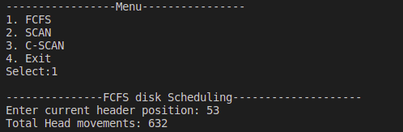

2. SCAN

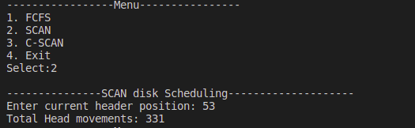

3. C-SCAN

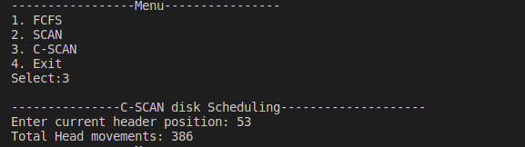

4. Exit
