Government Engineering College, Thrissur
CS331 – System Software Lab
Documentation -
Exp1 – CPU Scheduling Algorithm

Date of Submission
19 August 2020

Submitted By
Kowsik Nandagopan D
Roll No 31
TCR18CS031
GECT CSE S5

Experiment 1
Simulate the following non-preempitive CPU scheduling algorithms to find turnaround time and waiting time
1. FCFS 2. SJF 3. Round Robin(pre-empitive) 4. Priority

Compilation of Code

Prerequisite
- The code is provided in the program.c along with this documentation. You can open the terminal in Linux (Ubuntu 18.04 tested). Then run the command
gcc program.c
./a.out
- You will see the content of the input.txt in the first part. If you want to change input.txt then change the code in the format
Number <Tab> Number <Tab> Number
First number is Arrival Time(AT), second is Burst Time(BT) and last is Priority. You can provide the AT, BT, and priority related to each process in a new line.
Note that there should not be new line and maximum allowed burst time is 10000.
- For QUANTUM in Round Robin please set in program.c #define (Default 3)
- Output of the code will be printed on the console as well as to a text file named output.txt
- Note: Please see the my_machine_output.txt file for the output I got on my machine.

Output / Screenshots
Contents of input.txt and menu
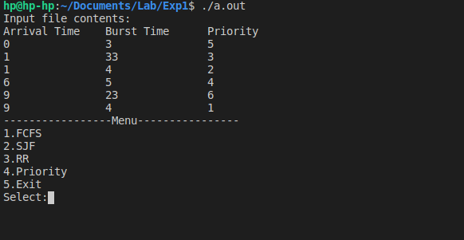

Output of each menu item
1. FCFS – First Come First Served
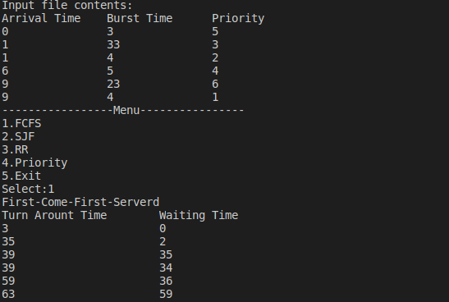
2. SJF – Shortest Job First
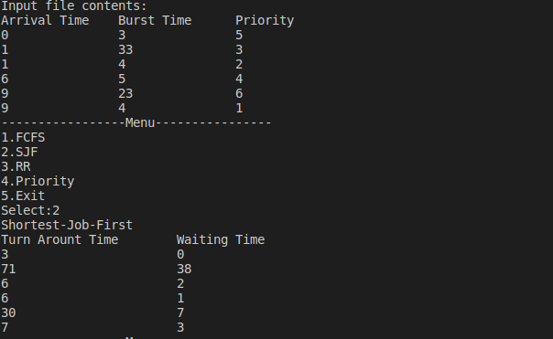
3. Round Robin – Pre-Empitive
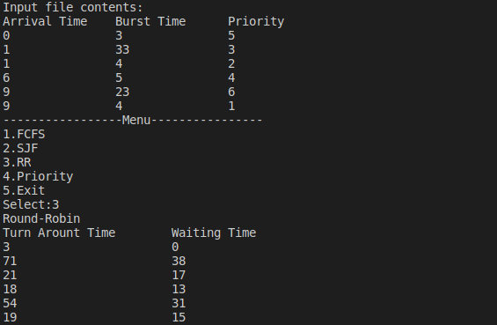
4. Priority Scheduling
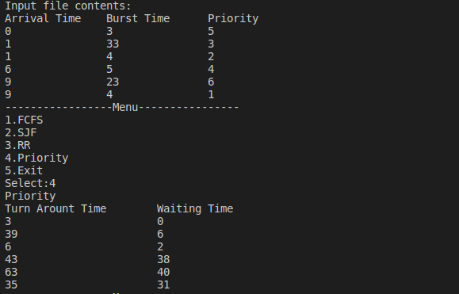
5. Exit
