Government Engineering College, Thrissur
CS331 – System Software Lab
Documentation -
Exp 9 – Pass 2 of Two Pass Assembler

Date of Submission
28 October 2020

Submitted By
Kowsik Nandagopan D
Roll No 31
TCR18CS031
GECT CSE S5

Experiment 9

AIM
Implement pass two of a two pass assembler

Compiling of Code

Prerequisite
- The code is provided in the pass1.c & pass2.c along with this documentation. You can open the terminal in Linux (Ubuntu 18.04 tested). Then run the command
gcc program.c
./a.out
PASS 1
- Compile and run pass1.c using the above code.
- We have two input files. One is optab.txt which denote the OPTAB of the assemblers. Also most importantly the source code is stored in the input,txt. Note in reality this file will be of *.asm extension. For the simplicity here we use *.txt extension
- optab.txt: It stores the operation codes allowed in the assembly language. Format for the input is
<Opcode (String)> <Tab> <Hex Code corresponding to opcode (String)>
- input.txt: We store the assembly language in this file. The assembly language used is SIC (Simple Instruction Computer)
- Output of the code will be printed on the console and the SYMTAB will be stored to symtab.txt and inter.txt
- Length of the program is stored to the flen.txt
- Note: Please see the inter.txt and symtab.txt will be the input for the next step.
PASS 2
- Compile and run pass2.c as usually we do with any normal c file.
- Input for this program will be the out put of the pass 1. So no need of special input and renaming of auto generated files.
- This program uses the intermediate file of the source code, SYMTAB, OPTAB and flen file (File containing the length of program) to generate the output which is the object code. The object code is out put as output.txt
- The output as 3 record sections. First line is the Header Record starting with H. This record contains the name of the program, starting address and the length of the entire program. Note in the actual object code ^ will not be used. But here for the simplicity of reading the instructions are separated by ^ symbol.
- Second part is the Text record which contains the program itself in the object code format. This is generated using the SYMTAB and OPTAB
- Last part or the last line is the End record which denotes the end of the program and provides the address of the first executable instruction. Any instruction written after the End record will not be executed.
- Output of the program are printed into a file named output.txt
- To see the output in console use the code cat output.txt

Output / Screenshots

PASS 1
Input

Source code – input.txt

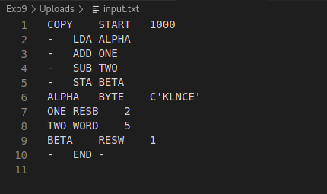

OPTAB – optab.txt

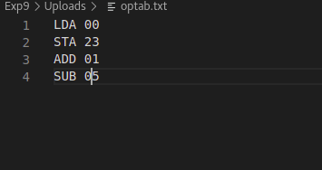

Output

Output to console

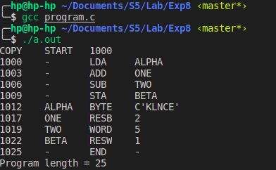

SYMTAB – symtab.txt

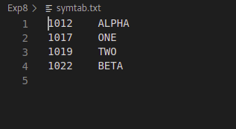

Intermediate file – inter.txt

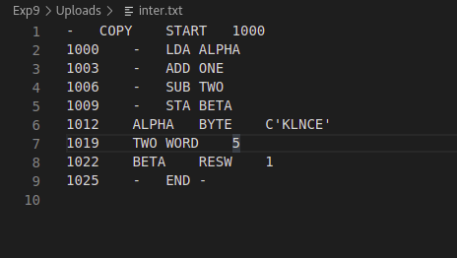

Program Length – flen.txt
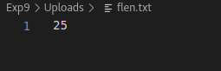

PASS 2

Inputs are inter.txt, symtab.txt, optab.txt and flen.txt (Screenshots are provided above)

Output
Object code – output.txt

