Government Engineering College, Thrissur
CS331 – System Software Lab
Documentation -
Exp 10 – Single Pass Assembler

Date of Submission
11 November 2020

Submitted By
Kowsik Nandagopan D
Roll No 31
TCR18CS031
GECT CSE S5

Experiment 10

AIM
Implement a single pass assembler

Compiling of Code

Prerequisite
- The code is provided in the pass.c along with this documentation. You can open the terminal in Linux (Ubuntu 18.04 tested). Then run the command
gcc program.c
./a.out
- Compile and run pass.c using the above code.
- We have two input files. One is optab.txt which denote the OPTAB of the assemblers. Also most importantly the source code is stored in the input,txt. Note in reality this file will be of *.asm extension. For the simplicity here we use *.txt extension
- optab.txt: It stores the operation codes allowed in the assembly language. Format for the input is
<Opcode (String)> <Tab> <Hex Code corresponding to opcode (String)>
- input.txt: We store the assembly language in this file. The assembly language used is SIC (Simple Instruction Computer)
- There are three output files symtab.txt, output.txt and result.txt
- symtab.txt: Contains the information related to the symbols used in the source code (input.txt)
- output.txt: Contains the information pertaining to opcode, address of opcode and symbols. This file is used to generate the resulting object code
- result.txt: In this file we store the object code. The contents of this file is also shown in console. In actual assembler there will not be’^’ symbol used. For the better demonstration we have used ^ symbol for separating the columns of each record.
P. T. O

Output / Screenshots
Input

1) input.txt

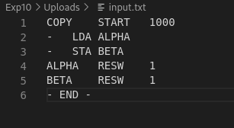

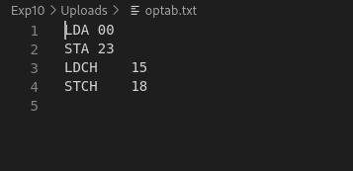
2) optab.txt

Output
1) symtab.txt
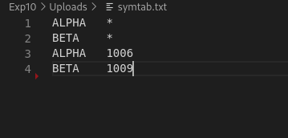

2) output.txt
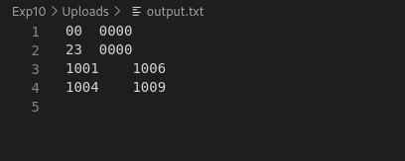

P. T. O

3) result.txt
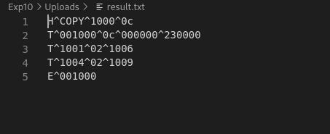

4) Output in console
