Government Engineering College, Thrissur
CS331 – System Software Lab
Documentation -
Exp 11 – Hash table for SYMTAB

Date of Submission
15 November 2020

Submitted By
Kowsik Nandagopan D
Roll No 31
TCR18CS031
GECT CSE S5

Experiment 11

AIM
Implement a symbol table with suitable hashing

Compiling of Code

Prerequisite
- The code is provided in the program.c along with this documentation. You can open the terminal in Linux (Ubuntu 18.04 tested). Then run the command (We have to pass -lm parameter when compiling because we are using math.h header file)
gcc program.c -lm
./a.out
- Compile and run program.c using the above code.
- Input is given in the console. When we execute a.out, menu driven console will be available. Enter the values as given in test case file. Note that the hash table is set to a max size of 11, also max size of name of label is 4. We can change values by editing #define in source code
- Output will be printed onto console. Hash table will be printed to console as well as to symbol.txt

P. T. O

Output / Screenshots
Input
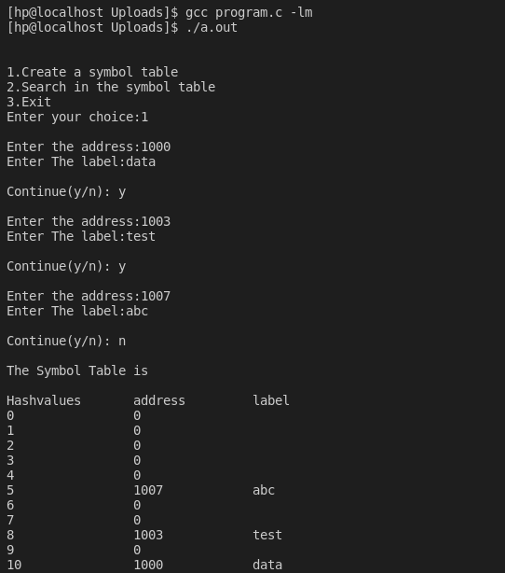

P. T. O

Ouput (Continuation of above screenshot)
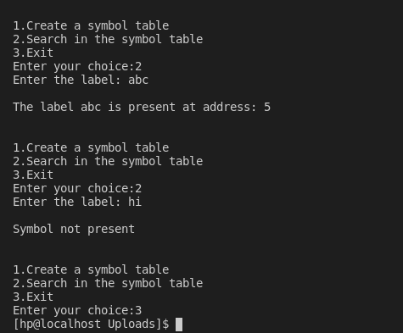

symbol.txt

