Government Engineering College, Thrissur
CS331 – System Software Lab
Documentation -
Exp 12 – Two Pass Macro Processor

Date of Submission
23 November 2020

Submitted By
Kowsik Nandagopan D
Roll No 31
TCR18CS031
GECT CSE S5

Experiment 12

AIM
Implement a two pass macro processor

Compiling of Code

Prerequisite
- The code is provided in pass1.c and pass2.c along with this documentation. You can open the terminal in Linux (Ubuntu 18.04 tested). Then run the command
gcc pass1.c
./a.out
- Compile and run pass1.c using the above code.
- Input is given as text file. The text file contain the SIC or SIC/XE code. This input should be entered in minp2.txt file.
- We will get a success message in console if the code was executed without errors.
- After pass1 we will get some intermediate files as output – dtab2.txt, ntab2.txt
Here dtab2 is the definition tab and ntab is the name tab. Definition tab contains the definition of the macro code and the name tab contains the name of the macro
- Now Compile and run the pass2.c, same as the pass1.c
- Input for the pass 2 are – minp2.txt, dtab2.txt, ntab2.txt. These files are the input files used in pass 1 and the intermediate files generated by the pass 2
- We will get a success message in console if the code was executed without errors.
- We will get 2 output put files – op2.txt and atab2.txt
- In op2.txt we get the EXPANDED code
- In atab2.txt we get the positional argument names used in the macro invocation

P. T. O

Output / Screenshots
Pass1.c
Input –
minp2.txt
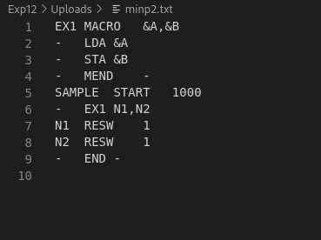

Ouput

dtab2.txt

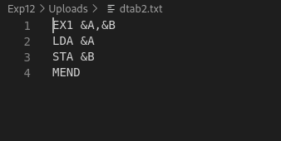

ntab2.txt
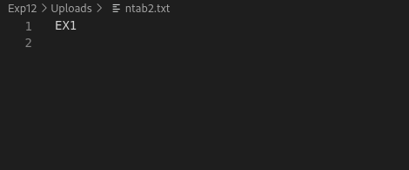

Pass2.c
Input – Same as above input and output

Output
atab2.txt
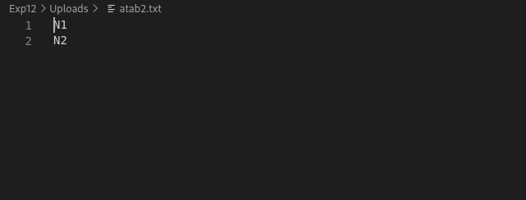
op2.txt
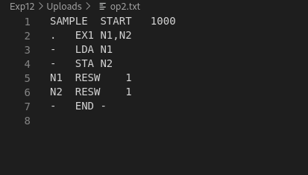

Console
