This is a computer controlled, portable power supply for RF Noise Sources such as the Keysight or Noisecom 346 series devices. It is powered by USB 2.0 and controlled without installing drivers from Linux, Windows, and OSX.

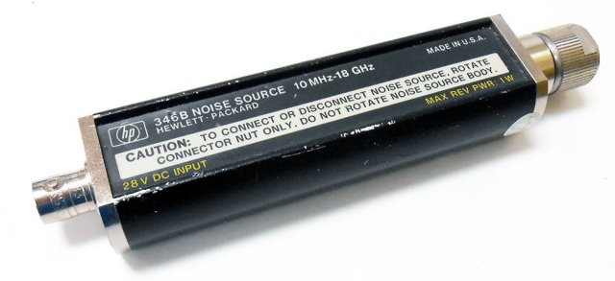Figure 1: HP Noise Source

PCB Requirements

Output:
* 28V +- 1V
* 100mA peak, 30-60mA average
* On/Off switching up to 1 Hz
* BNC female connector

Input:
* USB 2.0 compliant host
* 4.75 to 5.25 V
* 100 mA initial, 500 mA negotiated, 2.5 mA suspended
* USB 2.0 micro socket

Features:
* Output on/off control via USB command
* Optionally a switch to manually control output state
* LED showing output state
* LED showing input power good

USB Interface Circuit

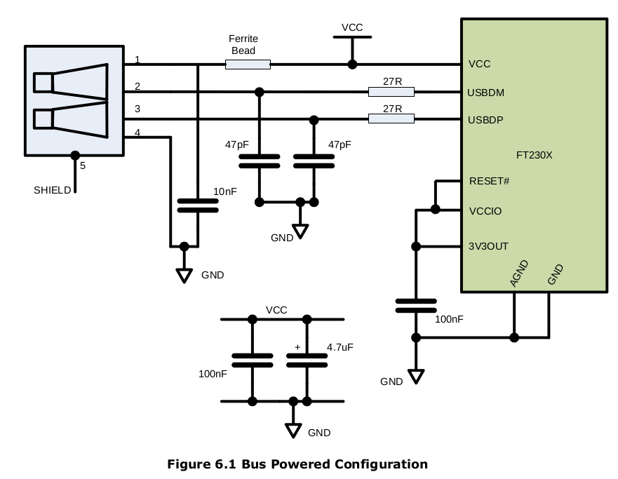
The FTDI FT230X provides a convenient way of properly requesting the full 500mA of USB power and providing easy GPIO access over USB without needing custom drivers on any major OS. It can additionally detect when the USB connection is to a dumb charger.
FTDI’s FT230X Datasheet page 22 shows the above schematic

CBUS pins can be used as status/control indicators of USB connection status or as GPIO from the host computer. They have a configurable drive strength of 4, 8, 12, or 16 mA.

BCD# indicates a dedicated charging port is connected (1A) [open drain]
PWREN# indicates a smart USB host is connected (500mA) [open drain]
SLEEP# indicates the USB host has slept/suspended the device (disable voltage output) [push-pull]

Software Configuration notes for Option bits in the MTP memory:
* Set Force Power Enable to enable PWREN# when a dumb charging port is connected.
* Set De-Activate Sleep to block the sleep signal when a dedicated charging port connection is detected.

TODO: Pull up resistors needed?

Voltage Regulator

Texas Instruments TLV61046 is a 28 volt boost regulator.

It is necessary to limit the current drawn from the USB Vbus to comply with the USB spec (500mA max once negotated). This is done in three steps.
1) Disabling the entire voltage regulator circuit until the FT230X either enumerates or identifies that it is connected to a dedicated charging port
2) Blocking the voltage regulator from operating until the bulk output capacitance has charged to Vbus through a bypass diode and current limiting resistor
3) Continuously monitoring the input current and limiting it to ~450 mA

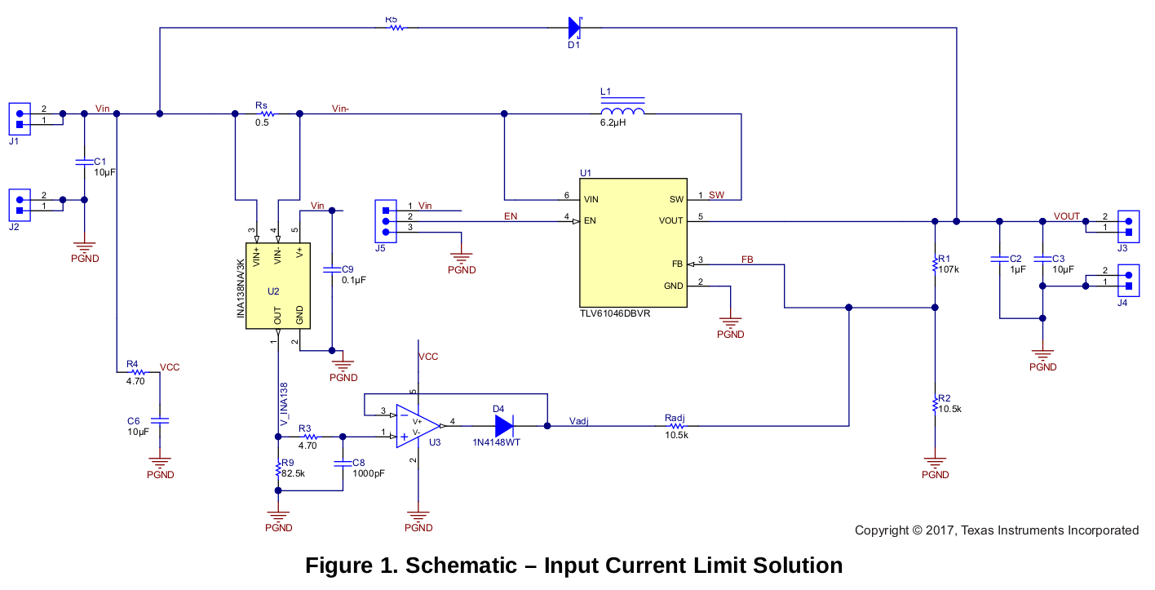
The above schematic is from TI’s app note SLVA912 page 3.

A FET with low Ron will need to be added between the USB Vbus and the Vin of this schematic to disable it’s functionality. The FET can be driven by PWREN# from the FT230X’s CBUS pins.

The enable of the TLV61046 is connected to one of the remaining FT230X’s CBUS pins which will be a computer controlled GPIO.

