University of Michigan Survey of Consumers Gas Expectations and Partisan Affiliation

This memo summarizes the correlational relationship between observed gas prices and predicted gas prices among respondents of the University of Michigan’s Surveys of Consumers Microdata.

The key takeaways are as follows:

1. When regressing expected gasoline price changes by partisan affiliation over 1-year and 5-year windows on the monthly change in gasoline prices, Republicans are roughly 1.3 and 2.7 times, respectively, more sensitive to changes in the observed gasoline price than Democrats during Biden’s presidency.
2. When regressing expected gasoline price changes by partisan affiliation over a 1-year window on the 1-year observed gas price change Republicans are roughly 107.7 times more sensitive to changes than Democrats during Biden’s presidency and 2.3 times more sensitive than Independents.
3. It appears that voters of any partisan affiliations (Democrats, Republicans, and Independents) are much more sensitive to the month-to-month gas price changes than any long-term trends, regardless of whether their predicted price changes are over a 1-year or 5-year horizon.

1.1 Average Gas Price Expectations Over Time by Partisan Affiliation

University of Michigan only began to reliably ask about respondents’ political affiliation starting in late 2017. The 1-year gas and 5-year gas price expectations are based on the questions ’GAS1’ and ’GAS5’ on the survey, asking respondents to predict how much gas prices will have changed within the next 1 and 5 years, respectively.[1]

These plots are simple averages of gas price expectations by partisan affiliation collapsed on month-year. Independents, Republicans, and Democrats’ gas price expectations were similar matching until around Joe Biden’s election/inauguration (denoted by the two red vertical dashed lines), when Republicans’ expectations spiked and, to a lesser extent, so did Independents’. During the Biden presidency, each of the three groups followed roughly similar trends, at different levels.

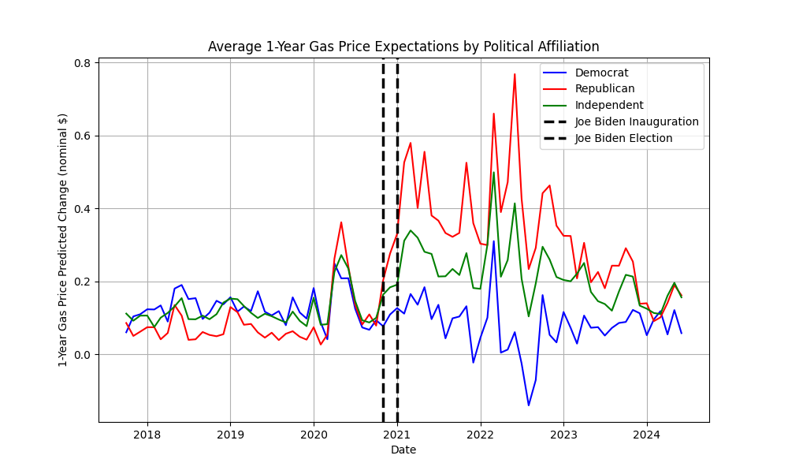

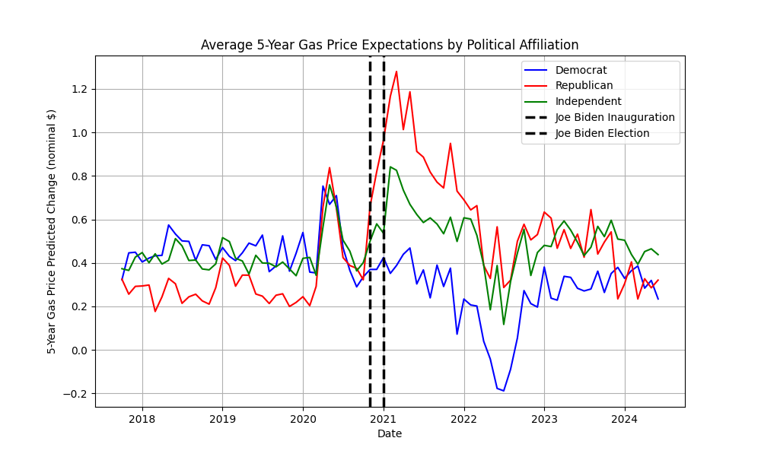

1.2 Comparing Regressors

For context, here is a time-series comparing the regressors used in the various models above:

1.3 Gas Price Monthly Difference Model

For the following models, I run separate regressions for sub-samples organized around 1) partisan affiliation (democrats, republicans, and independents), 2) by whether Joe Biden is president or not (the Biden sub-sample begins January 2021, and 3) for individuals’ 1-year and 5-year gas expectations. Therefore, between models, only the regressor changes.

The gas price monthly difference model is represented by this equation:

GAS_PX_CHG_EXPh,p,t,i = α0+β1GAS_PX_CHGt*BIDENt+εh,p,t,i

where h = {1-year, 5-year}, p ={republican, democrat, independent}, t = time period of survey, i = individual respondent, BIDEN is a dummy variable indicating whether Biden is president in month{t}, GAS_PX_CHG_EXPis a respondent’s expected price change, and GAS_PX_CHG is the observed change in nominal gas price level from the previous month. For both 1-year and 5-year gas price expectations, I use the month-by-month change in gas prices as the independent variable.

The results show that when asked about expected gasoline prices one year into the future, nearly everyone was more sensitive to an increase in monthly gasoline prices during Biden than during Trump. To be sure, some of this is mechanical, as gasoline prices were more volatile under Biden than Trump, but what’s notable is that Republicans sensitivity was substantially greater than that of Democrats or Independents.

This dynamic is even more striking when respondents were asked about expected gasoline price changes five years into the future. During the Trump presidency, respondents of all stripes largely thought the changes would be statistically indistinguishable from zero. Under Biden, Democrats and Independents believed a 10-cent change in monthly gasoline prices would mean gas prices five years out would be roughly 1.5 cents higher. For Republicans, though, this figure was nearly 4 cents—nearly 2.7 times higher than Democrats and Independents. Interestingly, this is roughly what you and Ryan found for overall sentiment in your Asymmetric Amplification work—Republicans were more than 2.5x as biased in their assessment of the overall economy.

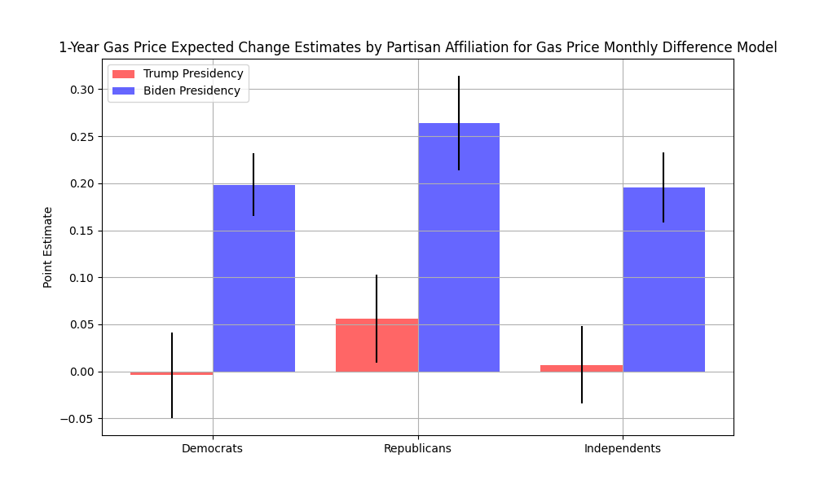

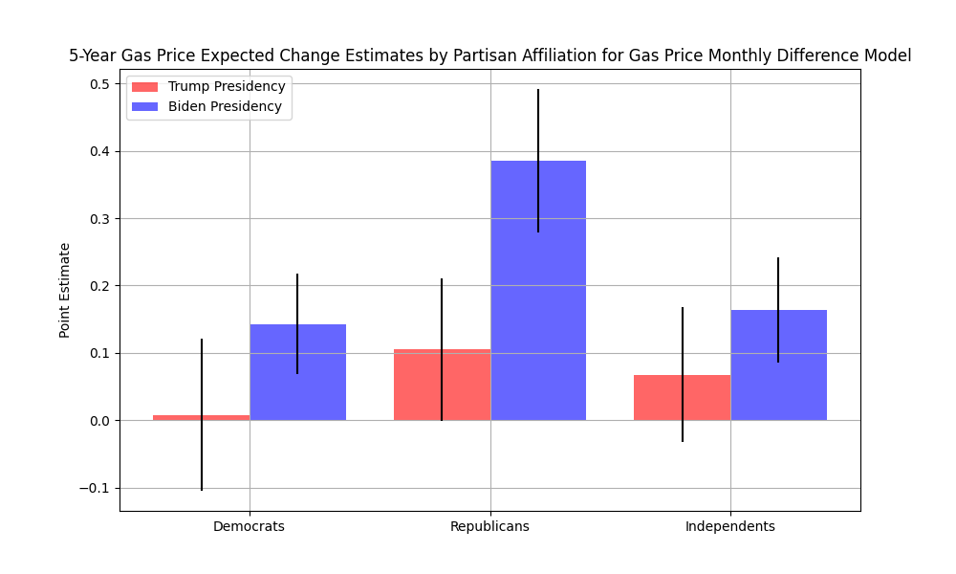

1.4 Gas Price Precise Difference Model

The gas price precise difference model is represented by this equation:

GAS_PX_CHG_EXPh,p,t,i = α0+β1GAS_PX_CHGt-h*BIDENt +εh,p,t,i

where GAS_PX_CHG is the {t-h} historical difference (i.e., either 1-year or 5-year) in gas prices. Therefore, if individuals’ predicted price changes perfectly matched what happened historically, β1 would be 1.

These findings are more drastic: Democrats exhibit largely no responsiveness to one-year gas price changes for either the Biden or Trump Presidency, while Republicans flip the sign of their sensitivity from the Trump to Biden presidency and Independents appear to be somewhere in between Republicans and Democrats in the strength of their correlation. For 5-year gas price changes, the results are complicated by the sign of 5-year gas price changes: during the Trump presidency, 5-year historical gas price changes were almost entirely negative. It’s not clear why the coefficients for the Biden Presidency 5-year expectations are so significantly negative–this requires further data analysis.

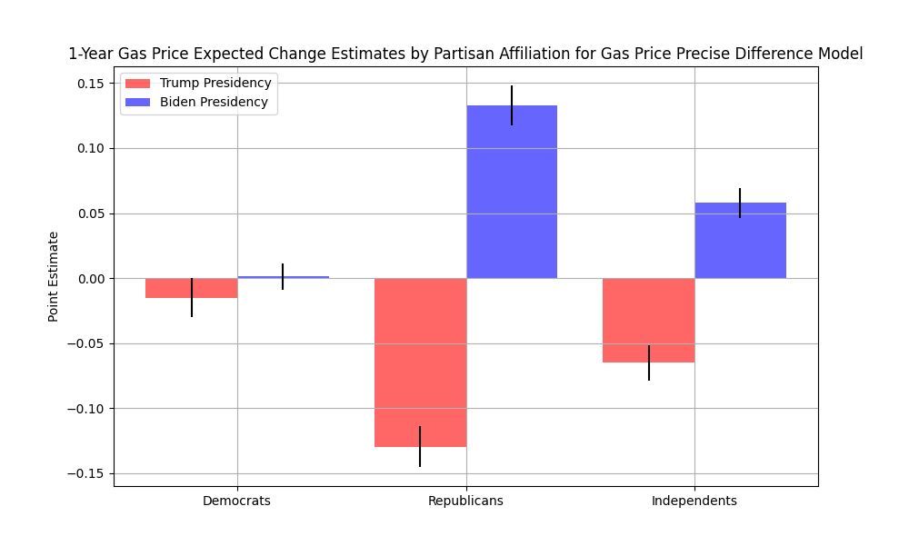

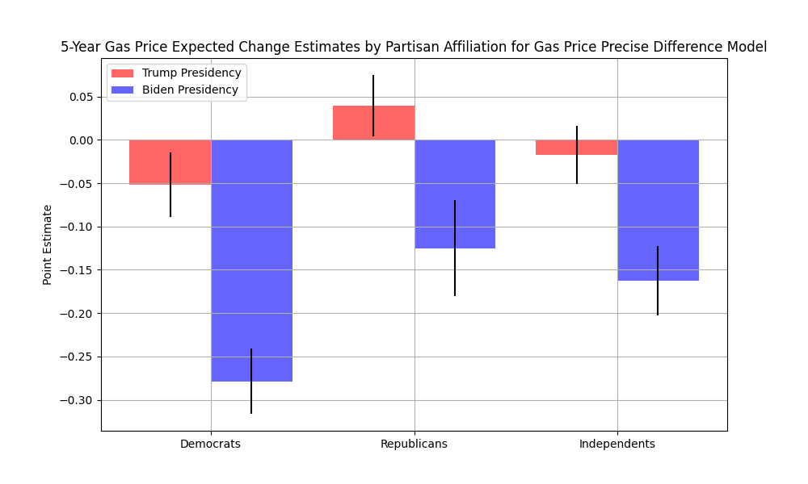

1.5 Gas Price Levels Model

The gas price levels model is represented by this equation:

GAS_PX_CHG_EXPh,p,t,i = α0+β1GAS_PXt*BIDENt +εh,p,t,i

Where GAS_PX is the level price of gasoline in month {t}. The gas price levels model tells a similar story to the gas precise difference model – Republicans flip the correlational direction between their expected change and observed gas prices when Joe Biden became President.

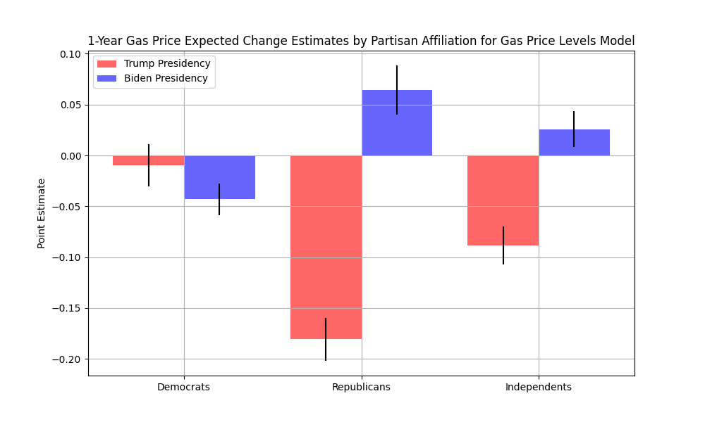

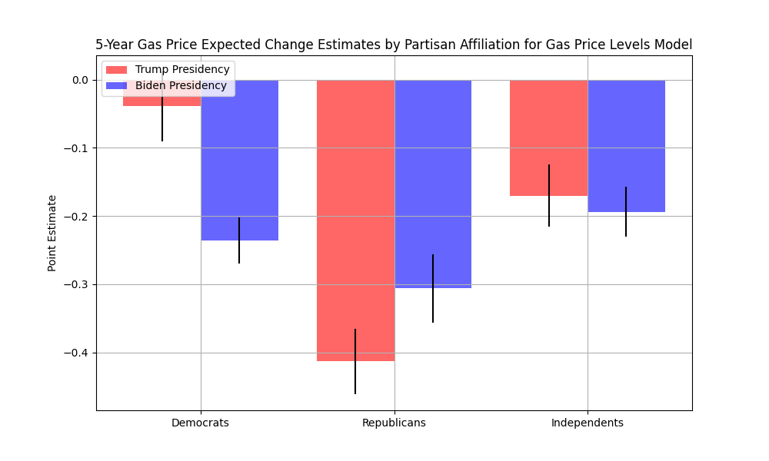

1. Information on respondents’ partisan affiliation is taken from the question ’POLAFF’.  
   Information on the survey variables can be found [here](https://sda.umsurvey.org/sca/Doc/sca.htm).

   All gas price data is taken from the Energy Information Administration ([EIA](https://www.eia.gov/dnav/pet/hist/LeafHandler.ashx?n=pet&s=emm_epm0_pte_nus_dpg&f=m)).