\section{Developing a Model of Debt}

In order to be precise about the likelihood of the need for an ahistorical adjustment (AA), we need to write down and simulate some kind of model that leads to a distribution of fiscal outcomes. In some of these future worlds, an AA will be needed to right the ship; in others, it won't be needed. In some, harsher medicine will be required than in others. The bottom line is that we need to attach to warnings about fiscal unsustainability hard numbers. We attempt to do so by implementing a framework proposed by Olivier Blanchard --- Stochastic Debt Sustainability Analysis (SDSA) \parencite{blanchard2023fiscal}.

Our model consists of straightforward laws of motion for the relevant macroeconomic variables for debt: $r$, $g$, and $s$. These equations allow us --- with assumptions including exogenously defined mean forecasts --- to run Monte Carlo simulations that result in a distribution of future debt paths. We spend the rest of this section explaining these equations and their logic.
\begin{gather}
b_t = b_{t-1} + \frac{r_t^{av} - g_t}{1 + g_t} b_{t-1} - s_t
\label{eq:sdsa_debt} \\
s_t = (1 - c)a_s + c(r_t^{av} - g_t)b_{t-1} + e_t^s,\quad e_t^s \sim \mathcal{N}(0, s_s)
\label{eq:sdsa_deficit} \\
g_t = a_{gt} + x_{gt} + e^g_t,\quad e^g_t \sim \mathcal{N}(0, s_g)
\label{eq:sdsa_growth} \\
x_{gt} = x_{t-1} + e^x_t,\quad e^x_t \sim \mathcal{N}(0, s_x)
\label{eq:sdsa_growth_persistent} \\
r_t = r^{*} + \beta_r b_{t-1} + \rho (r_{t-1} - \bar{r} - \beta_r b_{t-2}) + e^r_t,\quad e^r_t \sim \mathcal{N}(0, s_r)
\label{eq:sdsa_interest} \\
r_t^{av} = \sigma \cdot r^{av}_{t-1} + (1 - \sigma) \cdot r_t
\label{eq:sdsa_average_interest} \\
\end{gather}

\subsection{Our Approach to Modeling Interest Rates $r$}
Here we present a simplified, concise explanation for our modeling of $r$; for a more detailed explanation, see Section \ref{sec:detailed_explanation_r} in the Appendix. We model interest rates as a function of the long-run equilibrium real rate $r^{*}$, lagged debt levels (either lagged one period, $b_{t-1}$, or lagged two periods, $b_{t-2}$), the lagged interest rate $r_{t-1}$, the magnitude of the effect of debt level on interest rate $\beta_r$, and a persistence parameter $\rho$. From there, we estimate the average interest rate paid on all outstanding debt, $r^{av}_t$, as a function of the previous period's average interest rate $r^{av}_t$ and a `stickiness' parameter $\sigma$ that governs how contemporaneous current interest rates are.\footnote{I fix $\sigma = 0.8$. In practice, $\sigma$ will vary in accordance with the maturity of outstanding debt. We do not account for such dynamics in our model.}

This setup requires us to calibrate three parameters: $r^{*}$, $\rho$, and $\beta_r$. First, we have to determine a value for $r^{*}$. This is not an easy task, as $r^{*}$ remains an amorphous value; here, we set $r^{*} = 1\%$. Using estimated natural interest data from \href{https://www.newyorkfed.org/research/policy/rstar}{Holston, Laubach, and Williams}, we find that the average post-Great Financial Crisis (GFC) natural interest rate is approximately 0.98\%, which we round to 1\% in our model \parencite{holston2017measuring}.\footnote{See Figure \ref{fig:mlw_r_star_plots} for the time-series of the MLW-estimated values of $r^{*}$.}

Second, we have to determine $\rho$, which governs the persistence of how the interest rates deviate from its natural value, $r^{*}$. Estimating $\hat{\rho}$ can be achieved via estimation of the following equation (re-arranging the rates equation from above):
\begin{gather}
r_t = (1 - \rho) r^{*} + \beta_r b_{t-1} - \rho \beta_r b_{t-2} + \rho r_{t-1} + e^r_t \\
r_t = \alpha + \rho r_{t-1} + \beta_1 b_{t-1} + \beta_2 b_{t-2} + \epsilon_t
\label{eq:rho_beta_r_estimating_eq}
\end{gather}
where $\alpha = (1 - \rho) \bar{r}$, $\beta_1 = \beta_r$, and $\beta_2 = -\rho \beta_r$. Then, third, we have to estimate $\beta_r$; from estimating Equation \ref{eq:rho_beta_r_estimating_eq}, with $\hat{\alpha}$, $\hat{\beta_1}$, and $\hat{\beta_2}$, we can straightforwardly back out both $\rho$ and $\beta_r$. We include the methods by which we estimate this equation and detailed results in Section \ref{sec:detailed_explanation_r}.

\subsection{Our Approach to Modeling the Primary Surplus/Deficit $s$}

Here we present a simplified, concise explanation for our modeling of $s$; for a more detailed explanation, see Section \ref{sec:detailed_explanation_s} in the Appendix. We model primary deficits as a function of a policy responsiveness parameter $c$, the mean forecasted primary deficit $a_s$, a noise term $e^s_t$, and, in cases where the policy responsiveness parameter $c \neq 0$, the gap between the average interest rate paid on outstanding debt and growth $(r^{av}_t - g_t)$. To reflect the fiscal impacts of the recently-passed One Big Beautiful Bill Act (OBBBA), we adopt The Budget Lab's primary deficit projections conditioned on the permanent enactment of the Senate version of the bill as the first moment (mean) of future distributions of the primary deficit.

One of the key parameters in the models is $c$, the policy responsiveness parameter. Put simply, this parameter dictates the weight of truly stabilizing the debt (so that $b - b_{-1} \sim 0$, absent fluctuations because of noise terms) in determining the primary surplus. Auerbach and Yagan (2025) find that, whereas between 1984-2003 there is evidence of Congress reducing the deficit in reaction to rising projected deficits, any such feedback effect disappeared from 2004-2024 \parencite{auerbach2025robust}. In particular, they find that from 1984-2003, Congress reacted to a 1\% of GDP higher CBO-projected deficit with 0.15\% of GDP deficit reduction. Then, from 2004-2024, a 1\% of GDP higher CBO-projected deficit was associated with deficit reduction equal to -0.03\% (in practice, a null effect).

This result suggests that in its current state, Congress's fiscal policymaking is entirely inelastic with respect to the debt level ($c = 0$). Recent qualitative evidence would support this view. To illustrate the need for fiscal moderation, we run the our model under two assumptions of $c$'s true value. In the first, $c = 0$ and we assume that, as Auerbach and Yagan (2025) found, Congress's fiscal policymaking is entirely unresponsive to the level of debt for the next 10 years. This we refer to as an 'irresponsible' fiscal regime hereafter. Then, as a counterfactual, we model a more 'responsible' fiscal regime, which--effective immediately--returns to the pre-2003 Congressional behavior as estimated by Auerbach and Yagan. For this model of a `responsible' regime, we let $c = 0.15$; this \textit{approximates} 15\% of deficit-setting being accounted for by attempts to stabilize the debt. What we find is that even a return to the fiscal posture of 1984-2003 would be inadequate to sufficiently address debt sustainability.

\subsection{Our Approach to Modeling the Real Growth Rate $g$}

We model growth so that it is composed of three parts. First, the first moment (mean) of growth's distribution in year $t$ is exogenously defined by the vector $a_{gt}$. We set $a_{gt}$ equal to the Congressional Budget Office's (CBO) baseline score of real GDP growth. Second, the growth in any period can be shifted by a \textit{transitory} shock, $e^g_t$, randomly drawn from a normal distribution. Third, the path of growth can be shifted by a \textit{persistent} shock, $x_{gt}$, which moves the growth rate of the economy onto a different path. This results in a range of growth outcomes, including the most favorable (where shocks are consistently positive) and the least favorable (where shocks are consistently negative).

\subsection{Results}

Running the model with 5,000 simulations illustrates a clearly worrying debt situation. Below we've plotted three ways we can visually understand our model's results. First, we've plotted the level of debt as a \% of GDP (with the interquartile range in every year shaded in corresponding color to the median, represented by the singular bold line).
\begin{figure}[htbp!]
\centering
\begin{subfigure}[b]{0.75\textwidth}
\includegraphics[width=\textwidth]{graphics/sdsa_enrichment_1/sdsa_debt_b_comparison.pdf}
\end{subfigure}
\caption{Debt Level Projections (as \% of GDP)}
\label{fig:debt_path}
\end{figure}
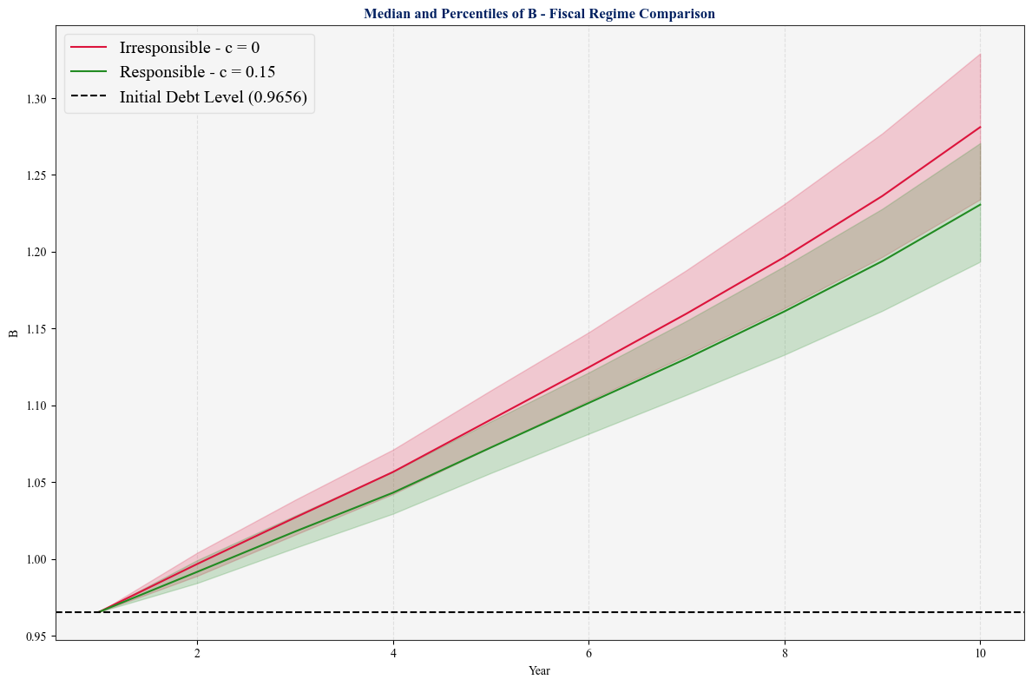
While instructive, this is not particularly helpful for understanding debt \textit{sustainability}. To complement Figure \ref{fig:debt_path}, below we plot the curvature of the debt path in Figure \ref{fig:debt_path_curvature}.

\begin{figure}
\centering
\begin{subfigure}[b]{0.75\textwidth}
\includegraphics[width=\textwidth]{graphics/sdsa_enrichment_1/sdsa_debt_curvature_comparison.pdf}
\end{subfigure}
\caption{Curvature of Debt Path Projections}
\label{fig:debt_path_curvature}
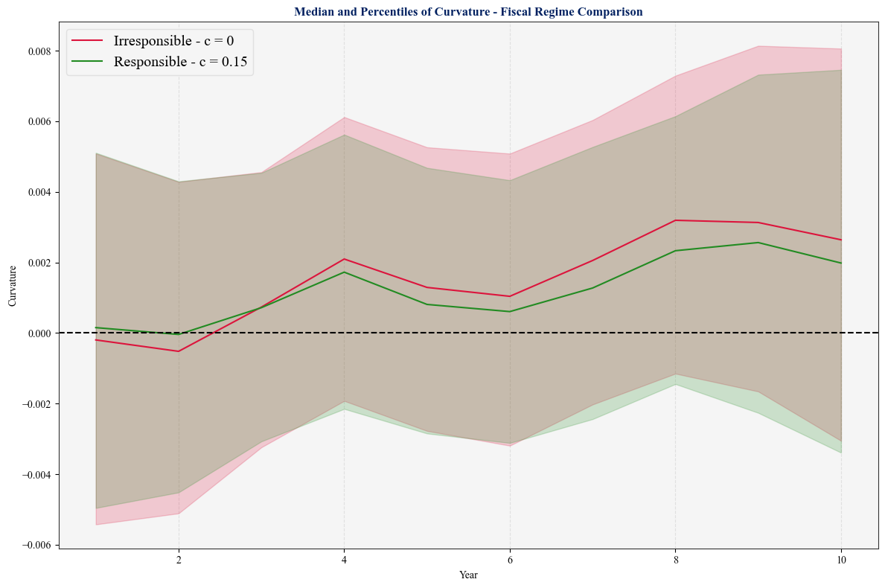
\end{figure}

These results, to say the least, are deeply concerning: they reveal that even were Congress to \textit{suddenly} (as in tomorrow) re-discover the fiscal rectitude of the 1984-2003 period, debt would nonetheless increase out of control. A positive \textit{and increasing} curvature to the debt path suggests a spiral could occur; while not an exact estimate of the cost of debt servicing (a true estimate of the cost of debt servicing would require an enrichment of the model to incorporate the changing composition of outstanding debt), this curvature plot suggests runaway servicing costs in the vast majority of simulated futures. To illustrate how ahistorical this sustained increase in debt would be, below we've included the distribution of 10-year changes (in percentage points terms) for 1) historical data (1970 - present), 2) our irresponsible fiscal regime simulations, and 3) our responsible fiscal regime solutions:

\begin{figure}[hbpt!]
\centering
\includegraphics[width=0.8\textwidth]{graphics/sdsa_enrichment_1/debt_change_10y_history_vs_sims.pdf}
\caption{Distributions of 10-Year Changes in Debt, Historical and Projected}
\end{figure}
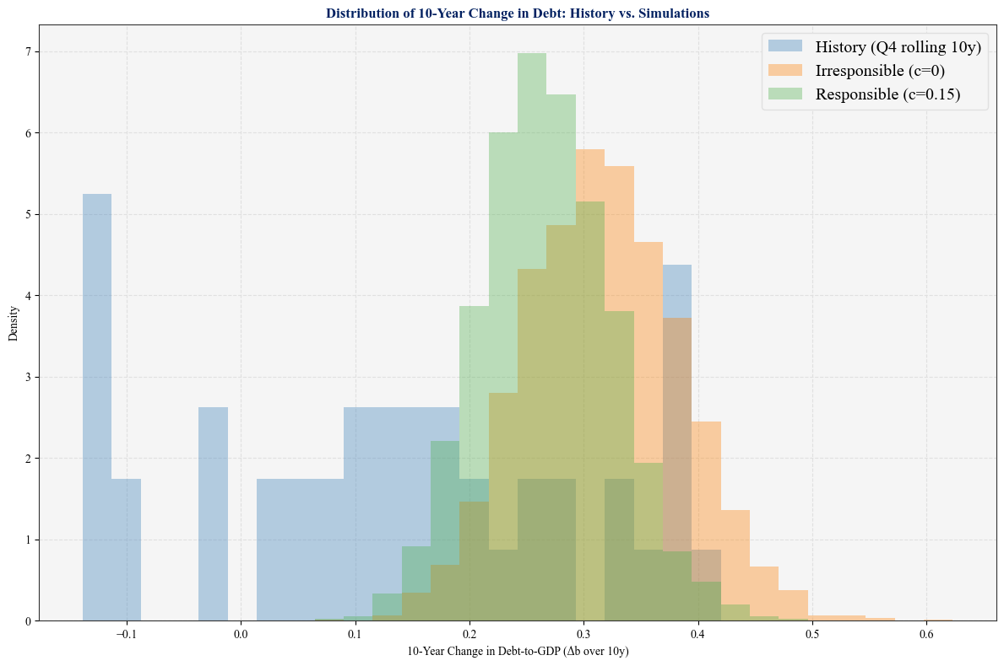
These histograms are particularly helpful because they allow us to observe the far left and right tails of our projected distributions; in Figures \ref{fig:debt_path} and \ref{fig:debt_path_curvature}, we plot the 25th percentile, median, and 75th percentile of outcomes. Here, we can observe that even with the most favorable idiosyncratic shocks to growth (think the advent of AI) and interest rates, the 10-year change in the debt would still lie in the \textbf{far right} tail of the observed historical distribution. Frankly, we are entering uncharted waters.

\clearpage

\section{Strengths and Weaknesses of our Model}

Any model involves tradeoffs and the simplification of reality. In our model, which we view as a starting point, we have opted to emphasize first principles and model straightforward, easily-interpretable laws of motion for $r$, $g$, $s$, and $b$. This straightforwardness is a strength; we believe that this model is more easily digestible to policymakers than other complex (and also deeply helpful) macroeconomic models and, given that the goal of this exercise is to quantify debt sustainability in a way helpful for policymakers with direct control over our fiscal situation, we consider this a strength --- even if this simplification comes at the expense of model richness.

Additionally, the model gives us full control over the mean and distribution of the future path of our key macroeconomic variables $r$, $s$, and $g$. This means that we can use as the first moment of any of these variables projections from external sources; if a bill is proposed, and sources such as the CBO or Budget Lab score these proposed policies on their fiscal/growth/interest rate effects, we can very easily construct counterfactual debt paths that allow us to compare across differing policy baselines. Importantly, this also allows us to model what would happen if, as an example, with the election of a new President in 2028, $c$ went from 0 to 0.15 (i.e., Congress continues its fiscal recklessness until a new administration comes to power, and it returns to its 1984-2003 approach to fiscal matters). We can also simulate policy counterfactuals such as the repeal of the OBBBA (which might very well be on the table in the 2028 campaign).

One weakness of our model, as a result of its simplification, is our reliance on linear, independent modeling of $r$, $g$, and $s$ (although we do allow for some feedback between $r$ and $s$). We know that the economy is deeply interconnected; changes in $b$ will result in crowd out which will not only raise $r$ but also, as a result of higher borrowing costs, lower $g$. Our model accounts (in a simplistic way) for this first step in crowd out; however, we would have to deeply enrich our current framework to break out interest rate effects separately into 1) effects on the policy / federal funds rate and 2) private borrowing rates, each of which would presumably affect growth differently. Thus, while the (infamous) findings of Reinhart and Rogoff have been debunked, there is no consensus on the relationship between $b$ and $g$ -- meaning it is unclear whether by excluding any causal effect of $b$ on $g$ we risk over- or under-estimating the severity of debt unsustainability \parencite{rahman2019does}.

Furthermore, our model does not take a stance on whether the relationship between debt and interest rates (represented by the coefficient $\beta_r$) will fundamentally change in the future; this remains open speculation as we continue to hurdle into uncharted fiscal waters, but it is distinctly possible that in instances of a debt spiral, the relationship between $b$ and $r$ is not linear but instead exponential and thus in the medium- and long-term our deficit projects are \textit{under-estimates}.

One final weakness is that our model does not include the granularity to model changes in the composition of outstanding debt. For example, we make no distinction between the government issuing long-term treasuries or short-term treasures to fund its activities; instead, we model a fixed and time-invariant parameter $\sigma$ which captures the relative strength of the past average interest rate (intended to reflect the average interest rate across all outstanding debt) in determining the future average interest rate. This lack of enrichment prevents our \textit{accurate} projection of debt servicing as a share of GDP (hence our reliance on the curvature of the debt path, which we believe captures in effect the same phenomenon).

What we would like to emphasize is that none of these weaknesses are fundamental to our model; instead, they require enrichments to the template we've laid down and we encourage alterations to this framework to incorporate more non-linear, interrelated, and complex relationships to further enrich this model over time.

