**Gyourko, Hartley, and Krimmel, “The local residential land use regulatory environment across U.S. housing markets: Evidence from a new Wharton index.”**

* Builds off the previous work by Gyourko, Saiz, Summers (2008)
* New survey of residential land ues regulatory environment in nearly 2,500 primarily suburban jurisdictions
  + Wharton Residential Land Use Regulatory Index (WRLURI)
  + WRLURI2018 vs. WRLURI2006
  + Index is standardized so it has mean of zero and standard deviation of one
  + **However, index doesn’t reveal actual regulatory policies and practices of different places**
    - Group communities by rank in overall distribution of WRLURI2018 values
* Feel comfortable creating market-wide regulatory index values

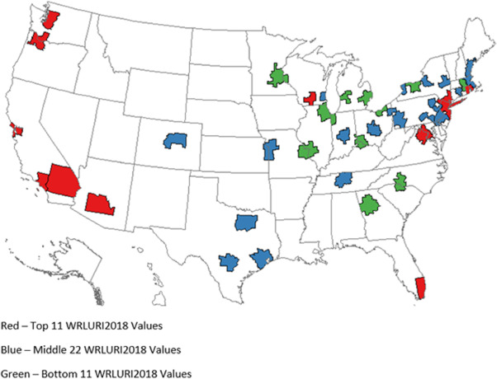

Paper discusses a few stylized facts this new regulatory index reveals:

* Restrictive local land use environments seem highly resistant to weakening
  + **At the metropolitan area level, there is no case of a highly regulated market as of 2006 becoming substantially (or even modestly) less regulated**
* This doesn’t imply the local regulatory environment has been static since mid-2000s:
  + Spread of density controls (i.e., minimum lot size restrictions)
    - Exaction fees decreased between tow surveys
* Among CBSAs that we categorize as highly regulated markets, share of highly-regulated jurisdictions within them rose over time
  + **This change is making it harder than it was only a decade ago for a prospective home buy in the SF Bay Area to find lightly-regulated**

Sub-Index Creation

* **Local Political Pressure Index** (LPPI)
  + LPPI = LocalCouncil + CommunityPressure + Other + BallotInitiatives
  + Low of 3, to high of 15 plus number of ballot initiatives
  + Ballot initiative data is taken from [Trust for Public Land Landvote database](https://tpl.quickbase.com/db/bbqna2qct?a=dbpage&pageID=10)
* **State Political Involvement Index (SPII)**
  + How involved is state legislature in influencing residential building activities and/or growth management procedures?
  + Low of 1 to 5
* **Court Involvement Index (CII)**
  + CII = LocalCourt + StateCourt
  + Low of 2 to 10
* **Local Project Approval Index (LPAI)**
  + LPAI = LocalPlan + LocZone + LocCouncil + CountyComm + CountyZone + Environ + PubHealth + Design + Other
  + Response values for each entity range from 0 to 2
    - 0 indicates entity does not have to approve the project
    - 1 indicates entity *does* have to approve, simple majority
    - 2 indicates entity must not only formally approve the project, but supermajority vote of its decision-makers
  + Pertains to projects that do NOT require any variance to current zoning code
* **Local Zoning Approval Index (LZAI**)
  + SAME scoring as LPAI, but pertains to projects that DO require some type of variance or change to the local zoning code.
* **Local Assembly Index (LAI)**
  + LAI = TownMeet
  + Requires some type of direct democracy of local population
* **Supply Restrictions Index (SRI)**
  + SRI = SFPermits + MFPermits + SFConst + MFConst + MFBuild + MFUnitsDwell
  + Limits on construction for different types of buildings (each binary classification)
* **Density Restriction Index**

* **OpenSpace Index (OSI)**
  + OSI = 1 if some type of mandatory space provision is required, 0 otherwise
* **Exactions Index (EI)**
  + EI = 1 if an impact fee exists
* **Affordable Housing Index (AHI)**
  + AHI = 1 if affordable housing program exists
* **Approval Delay Index (ADI)**
  + Simple averages of review time and aggregate for different types of projects

