Data Inventory Time-Series

# Heating Oil, Dyed Rack Prices, BBG

Graph: Heating Oil, Dyed Rack Prices, BBG

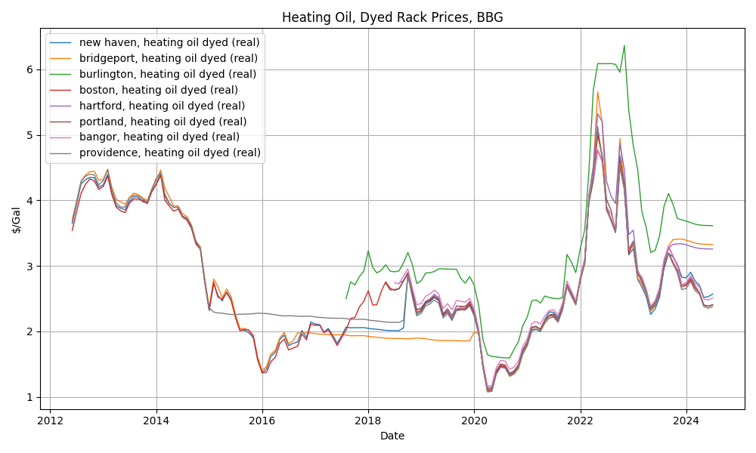

# Residential Heating Oil Retail Prices, BBG

Graph: Residential Heating Oil Retail Prices, BBG

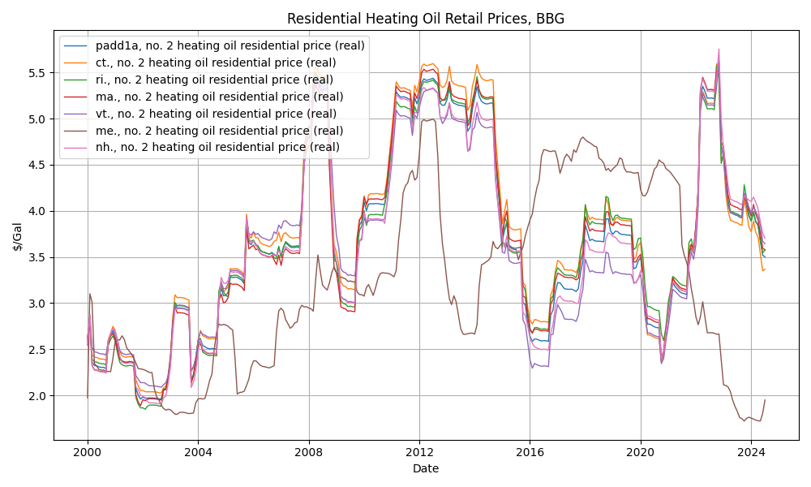

# Colonial Pipeline Tariff Rates

Graph: Colonial Pipeline Tariff Rates

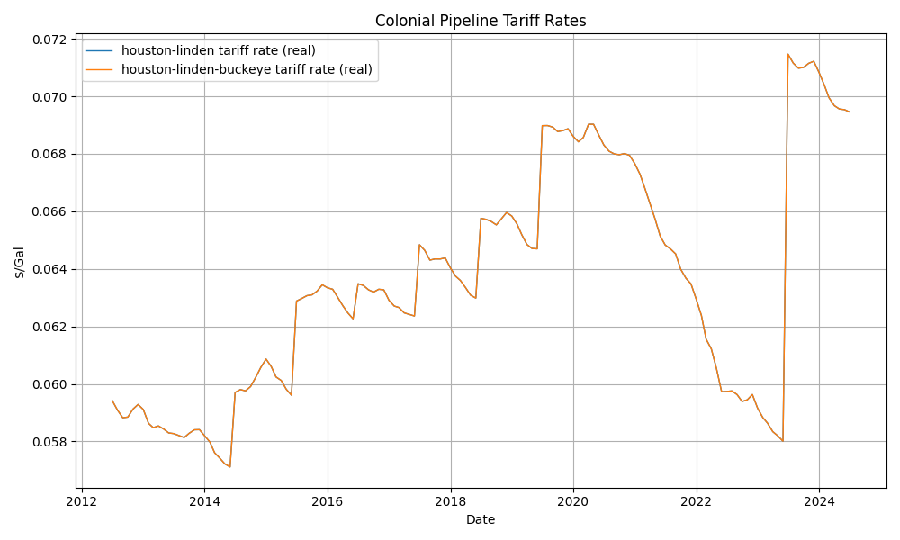

# Retail Refiner Diesel Prices, EIA

Graph: Retail Refiner Diesel Prices, EIA

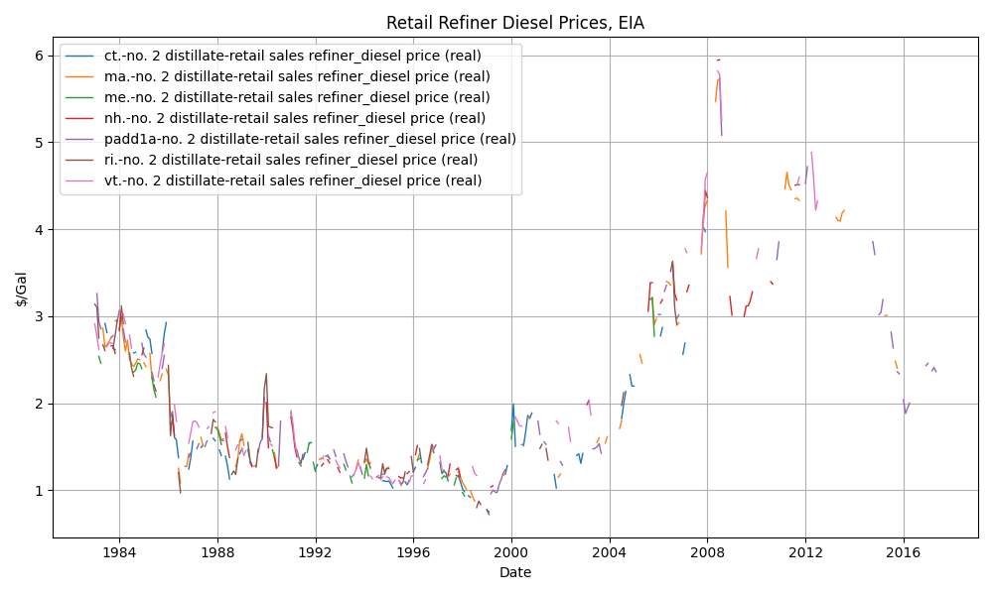

# Wholesale/Resale Refiner Diesel Prices, EIA

Graph: Wholesale/Resale Refiner Diesel Prices, EIA

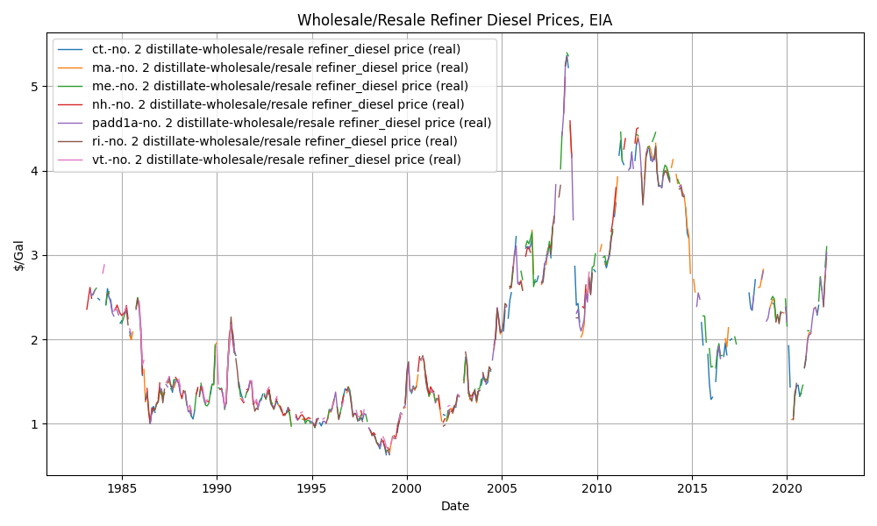

# Through Company Outlets Refiner Gasoline Prices, EIA

Graph: Through Company Outlets Refiner Gasoline Prices, EIA

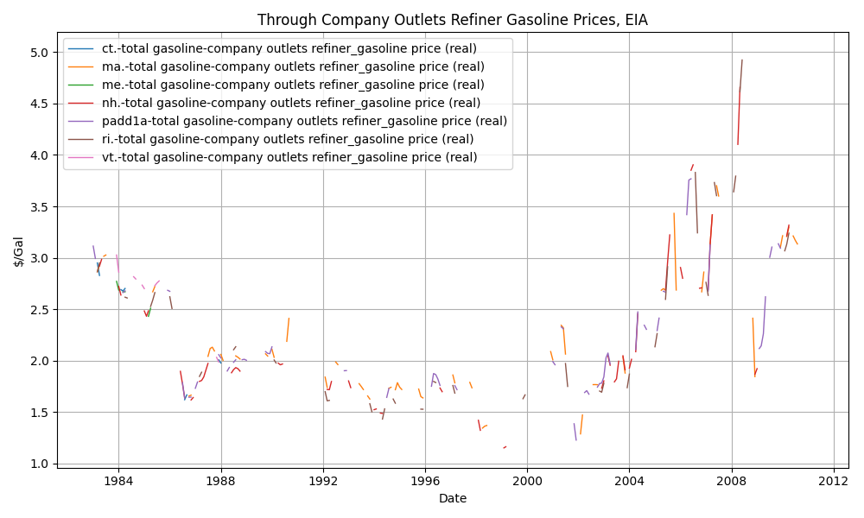

# Other Users Refiner Gasoline Prices, EIA

Graph: Other Users Refiner Gasoline Prices, EIA

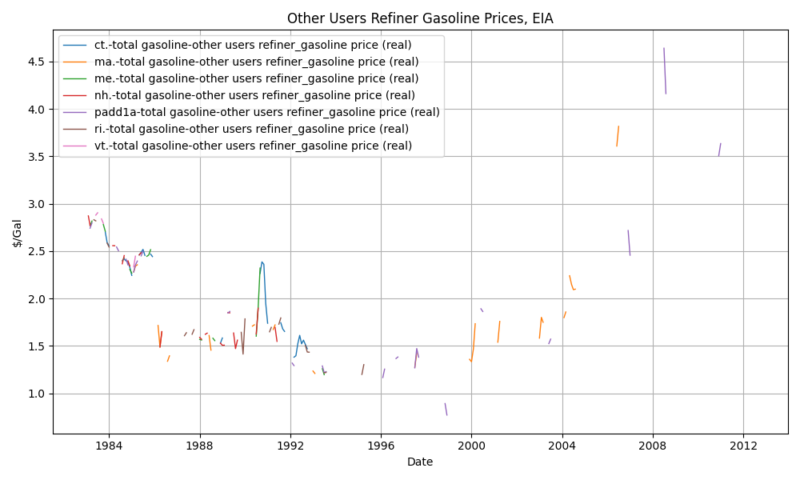

# Wholesale/Resale Refiner Gasoline Prices, EIA

Graph: Wholesale/Resale Refiner Gasoline Prices, EIA

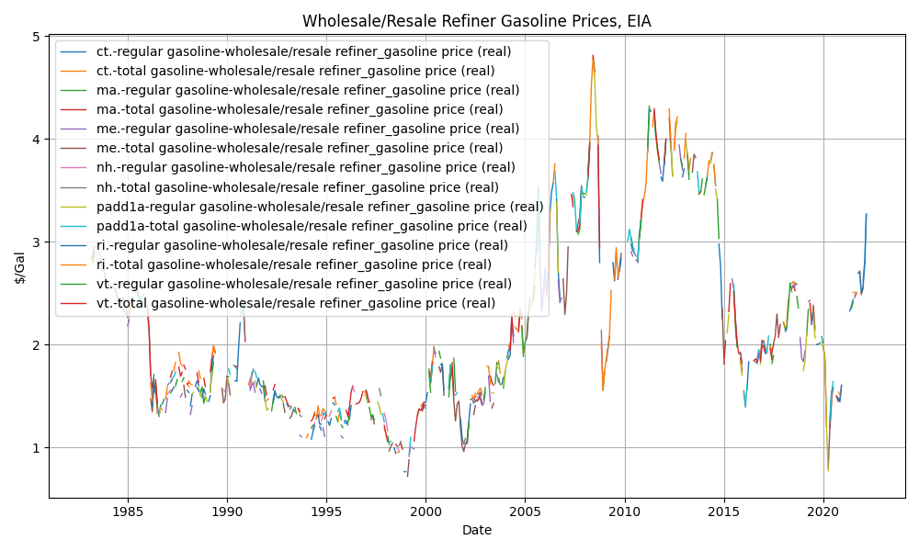

# Spot Prices, EIA

Graph: Spot Prices, EIA

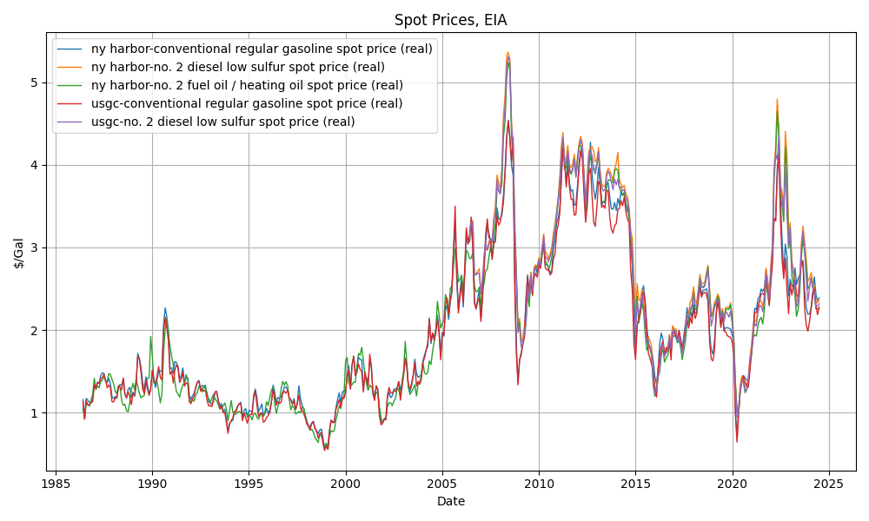

# Weekly Ending Stock, EIA

Graph: Weekly Ending Stock, EIA

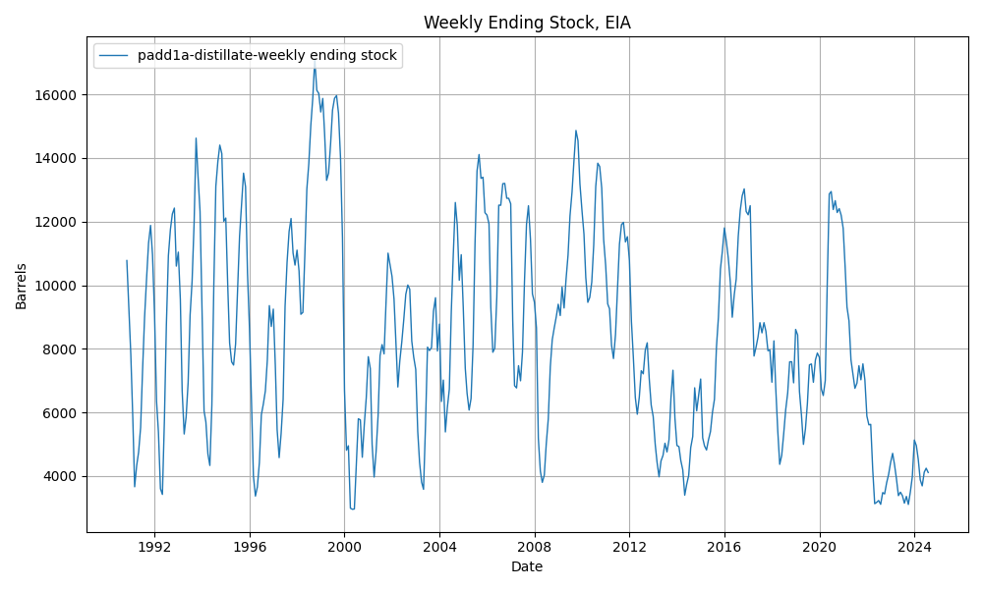

# Distillate Monthly Ending Stock, EIA

Graph: Distillate Monthly Ending Stock, EIA

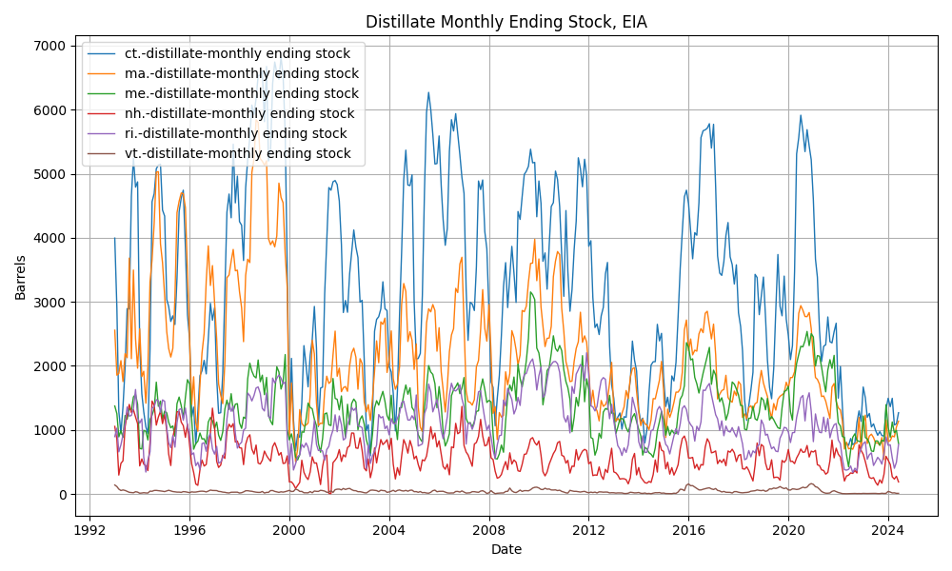

# Conventional Motor Gasoline Monthly Ending Stock, EIA

Graph: Conventional Motor Gasoline Monthly Ending Stock, EIA

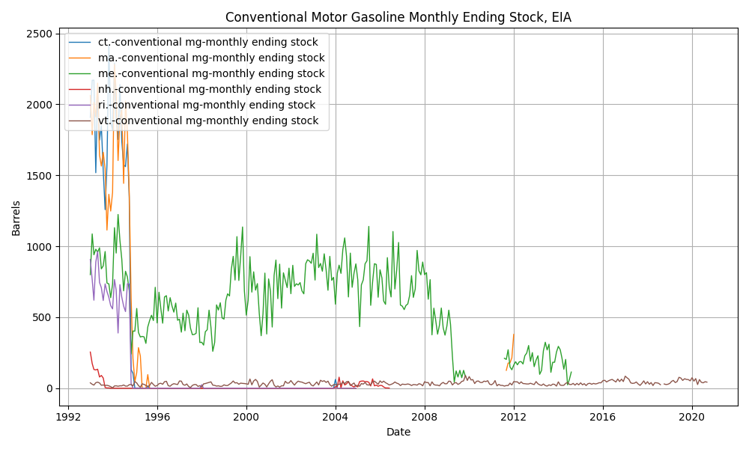

# Reformulated Motor Gasoline Monthly Ending Stock, EIA

Graph: Reformulated Motor Gasoline Monthly Ending Stock, EIA

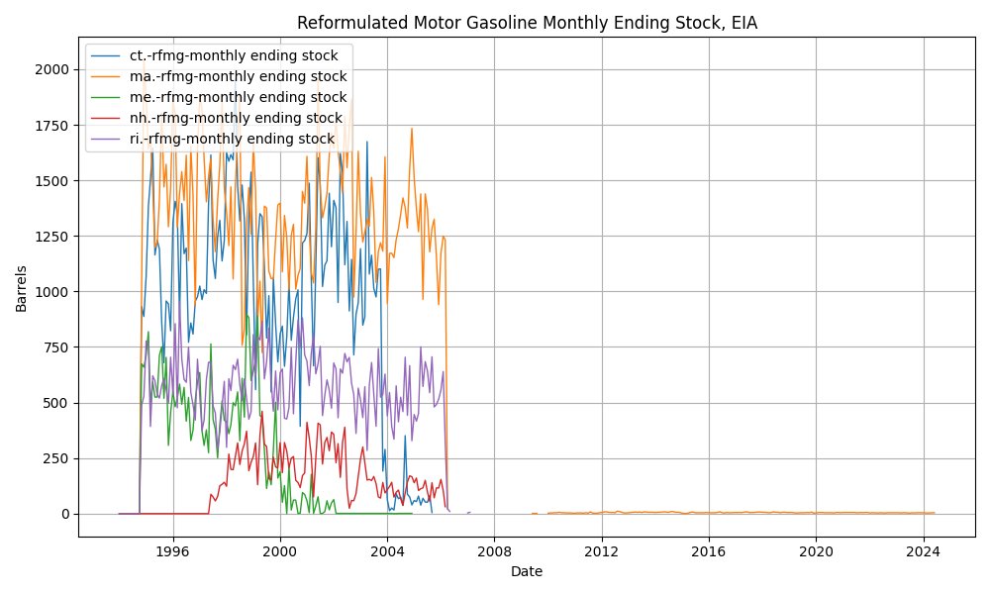

# Distillate Supplier Sales, EIA

Graph: Distillate Supplier Sales, EIA

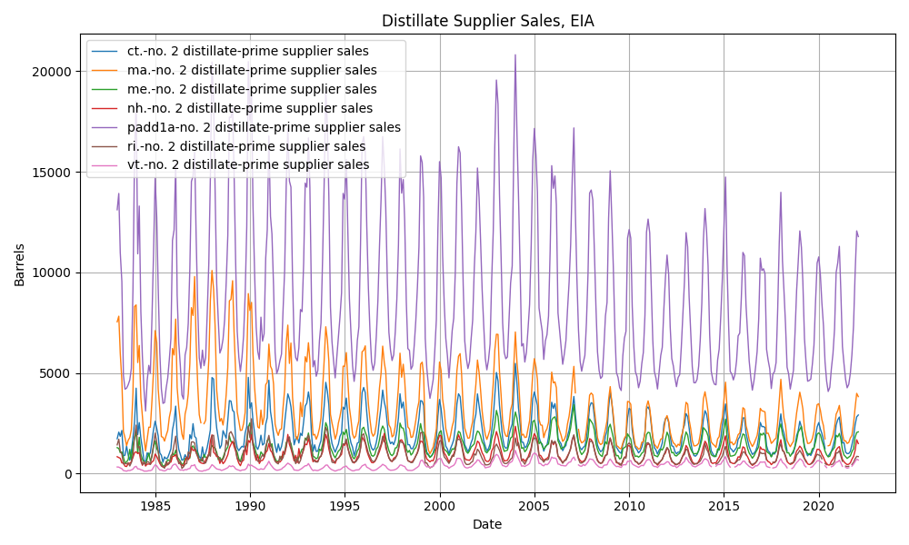

# Fuel/Heating Oil Supplier Sales, EIA

Graph: Fuel/Heating Oil Supplier Sales, EIA

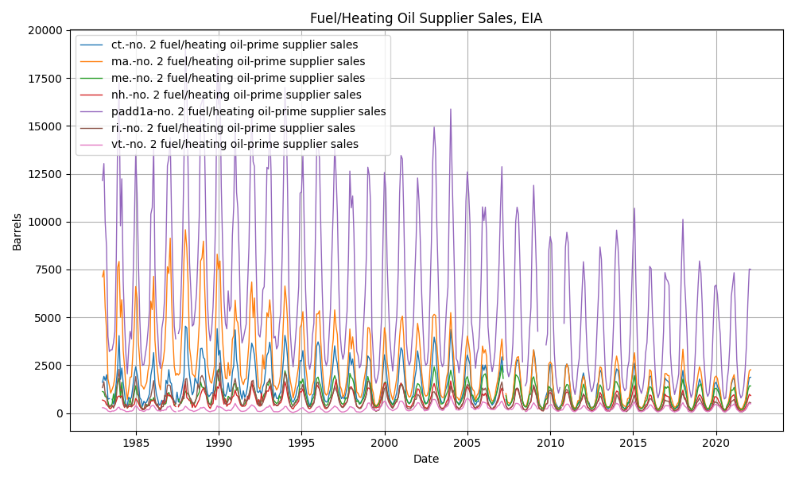

# Diesel Supplier Sales, EIA

Graph: Diesel Supplier Sales, EIA

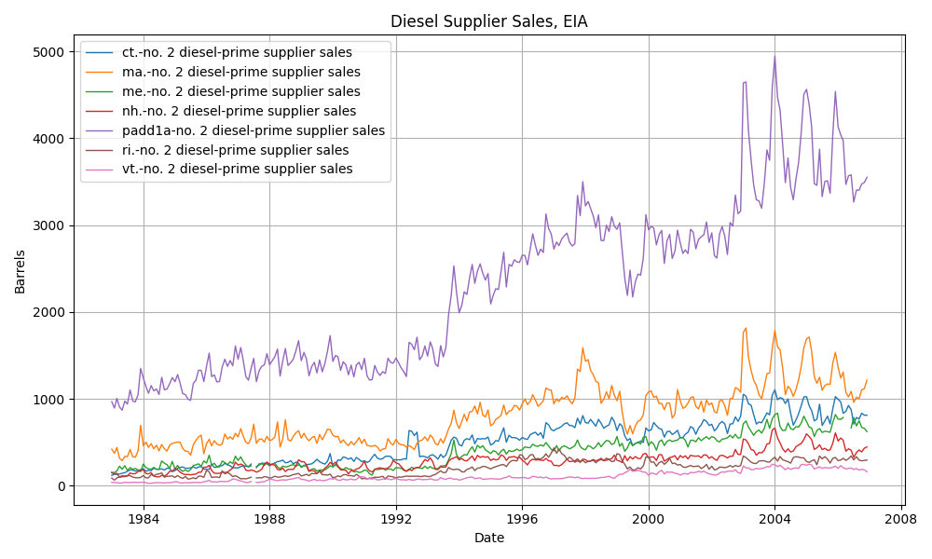

# Diesel Low Sulfur Supplier Sales, EIA

Graph: Diesel Low Sulfur Supplier Sales, EIA

